PRACTICUM TRAINING MANUAL AND GUIDELINES

- PRACTICUM DOCUMENTS
Students are required to submit the following requirements before they can begin the Practicum or On-the-Job Training.
- Student Trainee’s Personal History Statement. This is the standard application form that must be accomplished by the practicum applicant and requires the following information:
- Student Information
- Family Background
- School Information
- Curriculum Vitae. CV is a comprehensive statement of your educational background and relative experiences. It is a written presentation of qualifications and accomplishments of the students. It must be accurate, brief and concise.
- Parental Consent & Waiver for On-the-Job Training. This is the parent or guardians’ explicit permission for a student to be engage in the Practicum or OJT.
- Practicum Letter. This refers to the communication letter which endorses or recommends student-trainees to any establishment for internship training experience.
- Practicum Agreement. This refers to a legal form or statement that absolves both the College and host training establishment from financial or legal responsibility for a variety of eventualities during the conduct of internship training.
- Acceptance Form. This refers to the communication issued by the host training establishment to the College confirming the acceptance of the student trainees.
- Memorandum of Agreement. This is a document written between two or more parties in a formal document.
- Code of Conduct. This is a set of rules around behavior for the student trainees to follow within an organization.
- Narrative Report. This is the chronological factual piece of writing relative to the experiences on the On-the-Job Training.

- COURSE REQUIREMENTS
The following are the requirements of the course which have to be met by the students enrolled in the practicum training:
- Pre-Practicum Orientation
Pre-practicum orientation will prepare the students for their forthcoming training. It will be sponsored by the department and will be held on the third quarter of the academic year.
- Performance Evaluation Report
This report will be used to monitor students’ performance during the practicum. It is a highly confidential report, which must be accomplished accurately to help the practicum coordinator/adviser evaluate properly the performance of the students. The practicum coordinator/adviser of the linkage establishment may send his/her duly accomplished evaluation forms in a sealed envelope to the practicum adviser of the school. Students must furnish evaluators with Performance Evaluation Report Forms
- Certification of Completion
A certification from the linkage establishment regarding the number of work hours, as well as the inclusive dates of training completed by the students, signed by the practicum coordinator of the linkage establishment will be evaluated. The certification will then be submitted to the practicum coordinator/adviser, together with the practicum report.
- Learning Experience Journal
A learning journal is a tool used to account weekly the experience of the student in the linkage establishment. It shall contain the following information such as Department assigned, task assigned, observations, problems, strength/weaknesses, and learning derived from the experiences. The leaning journal should be submitted to the practicum adviser for grading purposes in a computerized form. It will also serve as basis in the preparation of the trainees’ narrative report. All in all, each trainee should submit 16 learning journals. “A sample format of the learning journal is found in Appendix G”.
- Narrative Report
To measure necessary competencies of the students during the practicum training, a narrative report must be prepared and submitted to the practicum coordinator/adviser.
  - Grading
The narrative report will be graded based on the following criteria as shown in Table below.
Grading Criteria of Narrative Report
CRITERIA | PERCENTAGE
Organization  Format, neatness, style & technique of writing | 10%
Content  Completeness of Information | 20%
Visual aids  Picture and Forms with Proper Labeling | 10%
Analysis  Critical evaluation of the standard operating procedures citing strengths and weaknesses of each department and the practicum learning experiences | 30%
Recommendation  Feasible courses of action | 10%
Punctuality  Should be submitted 20 days after the practicum training ends | 20%
TOTAL | 100%
  - Narrative Report Format
The parts of the practicum narrative report are listed below, in the order in which they are to appear in the completed report.
    - Preliminary Pages

The preliminaries of a narrative report include the Title Page, Approval Sheet, Acknowledgement Page, Table of Contents and List of Tables and Figures.

- Title Page. The student gives his/her full legal name as indicated in the records of City College of Tagaytay.
- Approval Sheet. The approval sheet is included in the final bound report. This page of the report is signed by the Practicum Training Adviser/s, Practicum Coordinator, Department Chair and the Dean of the School of Hospitality & Tourism Management.
- Biographical Data. The biographical data sheet is limited to one page only.
- Acknowledgement. This part expresses the author’s gratitude/appreciation to persons/agencies that helped and contributed much in the completion of the report be included.
- Table of Contents. The Table of Contents lists the chapter titles and headings whether major or minor started in exactly the words, which appears in the body of the report. All chapter headings must be capitalized. For sub-headings, only the first letter of major words must be capitalized. A list of all exhibits (forms, journals, manuals) with appropriate numbering is included.
- List of Tables. A List of Tables on a separate page following the Table of Contents lists numerically the number, exact full title and page of every table found in the narrative report.
- List of Figures. If there are figures, charts and illustrations, a separate list for each follows and gives the same information for each as the List of Tables.

    - Organization of the Report
- Introduction
The introduction of the narrative report is subdivided into two parts, namely: Rationale about the Practicum Training and Linkage Establishment.
Rationale about the Practicum Training describes the importance of the training, hours required for the training among others. On the other hand, the Linkage Establishment discusses its general information. The student may wish to include the following information about the cooperating agency.
    - Name and General Location- describes the complete name, address, location map, historical background.
    - Institution’s Objectives/Philosophy- states the general philosophy of the agency.
    - Ownership/ management- describe the name of the owner, lodging company.
    - Organizational Chart- presents the organizational set-up, identifies the holding position.
    - Facilities, number of rooms and types, function rooms (Application Use)
    - Outstanding characteristics of the establishment
- Business Industries
All discussions on organizational structure, standard operating procedures, facilities and equipment, manpower, work, atmosphere, use of material resources, strengths and weaknesses must be concise and stated clearly. Students are advised to seek the assistance of an authorized English critic (identified by the practicum coordinator/ adviser) for technical writing.

DEPARTMENT: __________________________________
Discuss major functions of the department in a brief paragraph. Avoid copying the agency’s operational manual.
  - Organizational Structure. Describe or draw the organizational set-up of the section. Discuss positions as well as how each person in the department interrelates and accomplishes his assigned tasks as against the function of the department.
  - Standard Operating Procedures. Discuss the operational system in which the function of the section is performed and present forms commonly used as a way of communication. Discuss also the sanitation procedure followed by the department.
  - Facilities and Equipment. Describe the facilities used in the section and how do these facilitate performance of function. Evaluate the equipment and facilities in terms of state, unique characteristics and design (include photos. Layout as much as possible)
  - Manpower. Present scheduling of personnel, work method, styles of communication and describe the procedures/ steps undertaken in performing the duties.
  - Work Atmosphere. Discuss the working conditions in the department as well as the interpersonal relationship among employees.
  - Use of Materials. Discuss this in terms of the availability of the forms used in the department which will facilitate fast and efficient service.
  - Strengths. Describe the strong points being practiced in the different departments.
  - Weaknesses/ Improvement Areas. Determine the weak points being experienced in the different departments.
  - Recommendations. Give the suggestions to improve the operation of the different departments.
    - Practicum Experience
This part discusses the actual/ direct experience gained by the trainee. It includes any personal and professional growth or the additional development of skills/ competencies that the student had acquired during the course of the practicum. It also identifies the student’s strengths and weaknesses and suggestions for self- improvement, and any emerging career interests as a result of the experience. The discussion must be specific, concrete, and critical.
    - Summary, Conclusion and Recommendation
This part states the summary of the paper, conclusion drawn from the assessment of the objectives of the practicum and the recommendation relative to the improvement of any area of the practicum training.
    - Literature Cited. This page lists down in alphabetical order the reference books, manuals or textbooks used to explain/ discuss in the report.
    - Appendices. This part presents the pictures, location map, letters, evaluation reports, certificates and forms used to support any discussions in the report.
    - Guidelines in Narrative Report Preparation
To make the narrative report more meaningful, here are some of the guidelines to follow:
- Reports should be computerized (double spaced) using Arial font size 12, in Letter size bond paper and should be properly bound. Student trainees are required to submit one (1) green soft bound copy of the narrative report:
Reports should be submitted on the deadline set by the practicum coordinator/adviser of the department.
- Scanned photos, charts, drawings, and brochures, business forms, menus, etc. that were used to illustrate specific points in certain department should be properly labeled.
- The narrative report is a technical paper thus, the language and the tone used must be in technical form of writing. English critic is required to edit the report.

- GRADING
As basis for computing the grade of the students, the following criteria with the corresponding percentage will be used:
CRITERIA | Percentage
Narrative Report  - - Practicum Report  - - Learning Experience Journal | 50%  (40)  (10)
Performance Evaluation Reports | 50%
Total | 100%

As a student receives an incomplete (INC) grade if he/ she fails to submit any or all the practicum requirements listed above during the semester he/she is enrolled in.
The student with an incomplete grade must follow the rules and regulations pertaining to the completion of INC courses as indicated in the College Code.

Appendix A. Student Trainee’s Personal History Statement

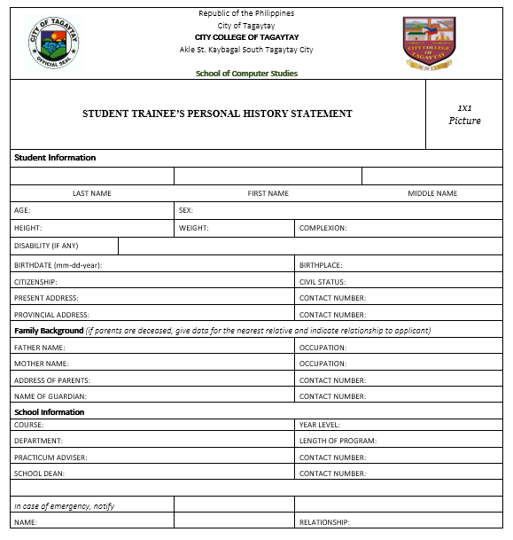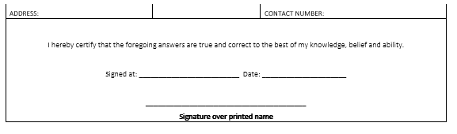

Appendix B. Parental Consent or Waiver for On-the-Job Training
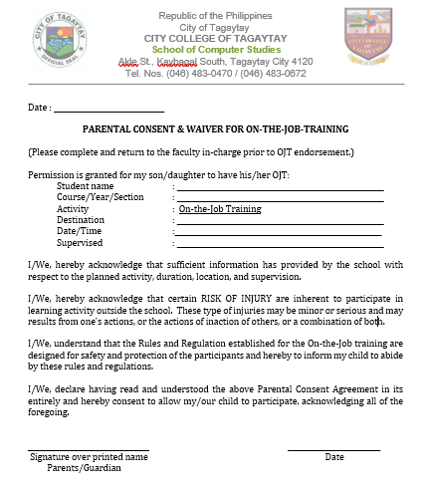

Appendix C. Practicum Letter
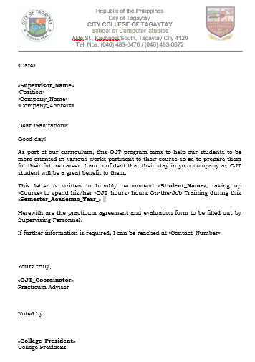

Appendix D. Practicum Agreement
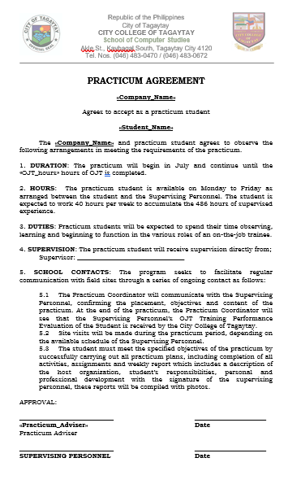

Appendix E. Acceptance Form

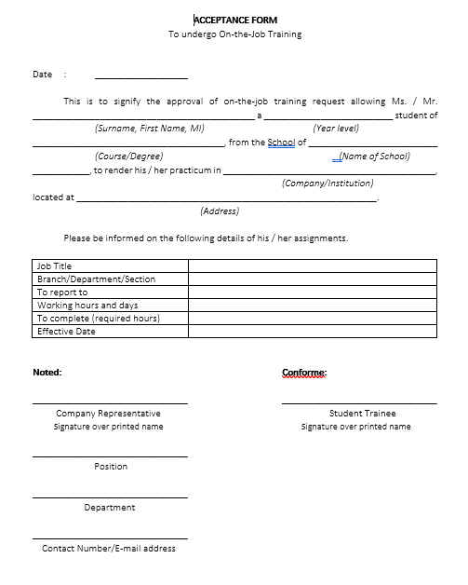

Appendix F. Memorandum of Agreement
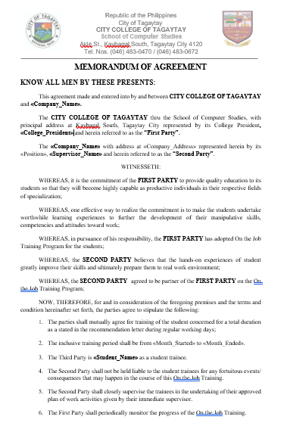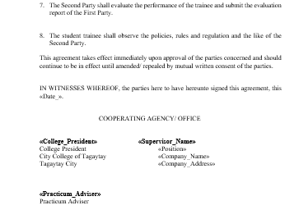

Appendix G. Learning Experience Journal


