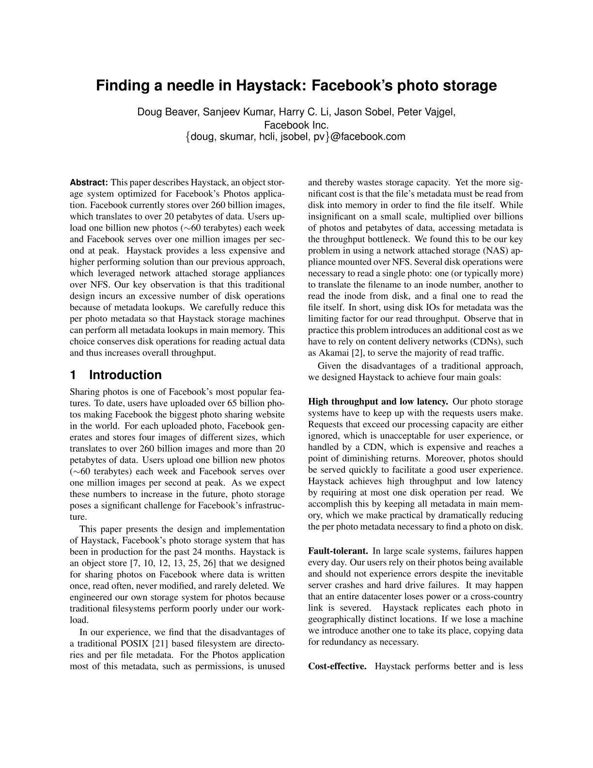
Finding a needle in Haystack: Facebook’s photo storage
Doug Beaver, Sanjeev Kumar, Harry C. Li, Jason Sobel, Peter Vajgel,
Facebook Inc.
{ doug, skumar, hcli, jsobel, pv}@facebook.com
Abstract: This paper describes Haystack, an object stor-and thereby wastes storage capacity. Yet the more sig-
age system optimized for Facebook’s Photos applica-nificant cost is that the file’s metadata must be read from
tion. Facebook currently stores over 260 billion images,disk into memory in order to find the file itself. While
which translates to over 20 petabytes of data. Users up-insignificant on a small scale, multiplied over billions
load one billion new photos (⇠60 terabytes) each weekof photos and petabytes of data, accessing metadata is
and Facebook serves over one million images per sec-the throughput bottleneck. We found this to be our key
ond at peak. Haystack provides a less expensive andproblem in using a network attached storage (NAS) ap-
higher performing solution than our previous approach,pliance mounted over NFS. Several disk operations were
which leveraged network attached storage appliancesnecessary to read a single photo: one (or typically more)
over NFS. Our key observation is that this traditionalto translate the filename to an inode number, another to
design incurs an excessive number of disk operationsread the inode from disk, and a final one to read the
because of metadata lookups. We carefully reduce thisfile itself. In short, using disk IOs for metadata was the
per photo metadata so that Haystack storage machineslimiting factor for our read throughput. Observe that in
can perform all metadata lookups in main memory. Thispractice this problem introduces an additional cost as we
choice conserves disk operations for reading actual datahave to rely on content delivery networks (CDNs), such
and thus increases overall throughput.as Akamai [2], to serve the majority of read traffic.
Given the disadvantages of a traditional approach,
1 Introductionwe designed Haystack to achieve four main goals:
Sharing photos is one of Facebook’s most popular fea-
tures. To date, users have uploaded over 65 billion pho-High throughput and low latency. Our photo storage
tos making Facebook the biggest photo sharing websitesystems have to keep up with the requests users make.
in the world. For each uploaded photo, Facebook gen-Requests that exceed our processing capacity are either
erates and stores four images of different sizes, whichignored, which is unacceptable for user experience, or
translates to over 260 billion images and more than 20handled by a CDN, which is expensive and reaches a
petabytes of data. Users upload one billion new photospoint of diminishing returns. Moreover, photos should
(⇠60 terabytes) each week and Facebook serves overbe served quickly to facilitate a good user experience.
one million images per second at peak. As we expectHaystack achieves high throughput and low latency
these numbers to increase in the future, photo storageby requiring at most one disk operation per read. We
poses a significant challenge for Facebook’s infrastruc-accomplish this by keeping all metadata in main mem-
ture.ory, which we make practical by dramatically reducing
This paper presents the design and implementationthe per photo metadata necessary to find a photo on disk.
of Haystack, Facebook’s photo storage system that has
been in production for the past 24 months. Haystack isFault-tolerant. In large scale systems, failures happen
an object store [7, 10, 12, 13, 25, 26] that we designedevery day. Our users rely on their photos being available
for sharing photos on Facebook where data is writtenand should not experience errors despite the inevitable
once, read often, never modified, and rarely deleted. Weserver crashes and hard drive failures. It may happen
engineered our own storage system for photos becausethat an entire datacenter loses power or a cross-country
traditional filesystems perform poorly under our work-link is severed. Haystack replicates each photo in
load.geographically distinct locations. If we lose a machine
In our experience, we find that the disadvantages ofwe introduce another one to take its place, copying data
a traditional POSIX [21] based filesystem are directo-for redundancy as necessary.
ries and per file metadata. For the Photos application
most of this metadata, such as permissions, is unusedCost-effective. Haystack performs better and is less

