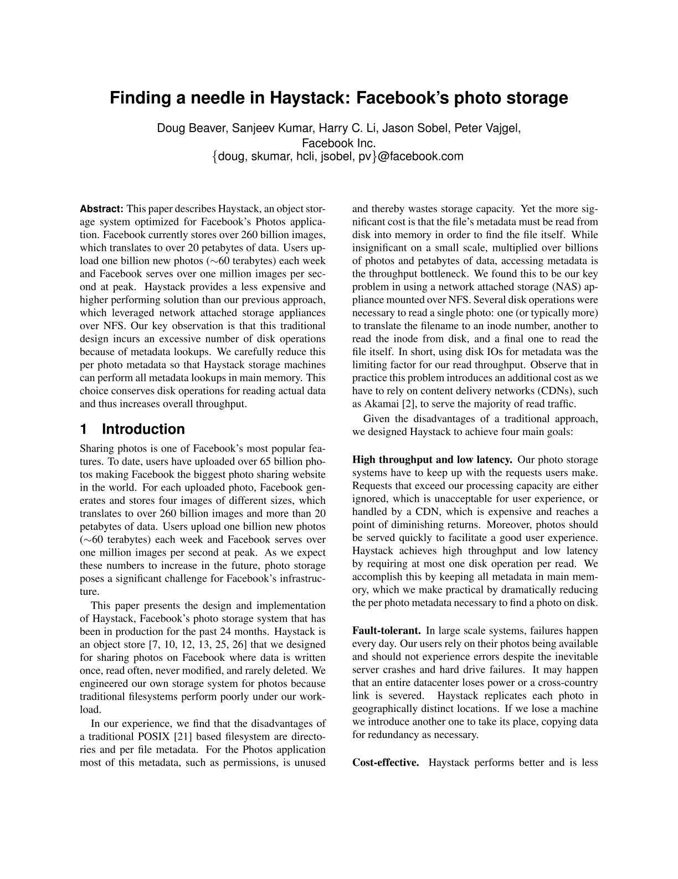
Finding a needle in Haystack: Facebook’s photo storage

Doug Beaver, Sanjeev Kumar, Harry C. Li, Jason Sobel, Peter Vajgel,
Facebook Inc.

{

doug, skumar, hcli, jsobel, pv
}
@facebook.com

Abstract:

This paper describes Haystack, an object stor-
age system optimized for Facebook’s Photos applica-
tion. Facebook currently stores over 260 billion images,
which translates to over 20 petabytes of data. Users up-
load one billion new photos (
⇠
60 terabytes) each week
and Facebook serves over one million images per sec-
ond at peak.

Haystack provides a less expensive and
higher performing solution than our previous approach,
which leveraged network attached storage appliances
over NFS. Our key observation is that this traditional
design incurs an excessive number of disk operations
because of metadata lookups. We carefully reduce this
per photo metadata so that Haystack storage machines
can perform all metadata lookups in main memory. This
choice conserves disk operations for reading actual data
and thus increases overall throughput.

1

Introduction

Sharing photos is one of Facebook’s most popular fea-
tures. To date, users have uploaded over 65 billion pho-
tos making Facebook the biggest photo sharing website
in the world. For each uploaded photo, Facebook gen-
erates and stores four images of different sizes, which
translates to over 260 billion images and more than 20
petabytes of data. Users upload one billion new photos
(
⇠
60 terabytes) each week and Facebook serves over
one million images per second at peak. As we expect
these numbers to increase in the future, photo storage
poses a significant challenge for Facebook’s infrastruc-
ture.
This paper presents the design and implementation
of Haystack, Facebook’s photo storage system that has
been in production for the past 24 months. Haystack is
an object store [7, 10, 12, 13, 25, 26] that we designed
for sharing photos on Facebook where data is written
once, read often, never modified, and rarely deleted. We
engineered our own storage system for photos because
traditional filesystems perform poorly under our work-
load.
In our experience, we find that the disadvantages of
a traditional POSIX [21] based filesystem are directo-
ries and per file metadata.

For the Photos application
most of this metadata, such as permissions, is unused
and thereby wastes storage capacity. Yet the more sig-
nificant cost is that the file’s metadata must be read from
disk into memory in order to find the file itself. While
insignificant on a small scale, multiplied over billions
of photos and petabytes of data, accessing metadata is
the throughput bottleneck. We found this to be our key
problem in using a network attached storage (NAS) ap-
pliance mounted over NFS. Several disk operations were
necessary to read a single photo: one (or typically more)
to translate the filename to an inode number, another to
read the inode from disk, and a final one to read the
file itself. In short, using disk IOs for metadata was the
limiting factor for our read throughput. Observe that in
practice this problem introduces an additional cost as we
have to rely on content delivery networks (CDNs), such
as Akamai [2], to serve the majority of read traffic.
Given the disadvantages of a traditional approach,
we designed Haystack to achieve four main goals:

High throughput and low latency.

Our photo storage
systems have to keep up with the requests users make.
Requests that exceed our processing capacity are either
ignored, which is unacceptable for user experience, or
handled by a CDN, which is expensive and reaches a
point of diminishing returns. Moreover, photos should
be served quickly to facilitate a good user experience.
Haystack achieves high throughput and low latency
by requiring at most one disk operation per read.

We
accomplish this by keeping all metadata in main mem-
ory, which we make practical by dramatically reducing
the per photo metadata necessary to find a photo on disk.

Fault-tolerant.

In large scale systems, failures happen
every day. Our users rely on their photos being available
and should not experience errors despite the inevitable
server crashes and hard drive failures.

It may happen
that an entire datacenter loses power or a cross-country
link is severed.

Haystack replicates each photo in
geographically distinct locations. If we lose a machine
we introduce another one to take its place, copying data
for redundancy as necessary.

Cost-effective.

Haystack performs better and is less

