MULTIVENT
  - Programmer’s Chapter Manuscript — Black-and-White Print Edition
System Architecture, System Design, User Interface,
Testing, and Evaluation

Implementation-grounded manuscript draft
Prepared from the current MULTIVENT source code, database migrations,
Supabase functions, and sentiment-training artifacts

Repository evidence reviewed: October 8, 2026
Application workspace: D:\Multivent\Project-CaPoy\Capstone
ML workspace: D:\Sentiment Training\multivent-sentiment

For manuscript integration by the programmer/researcher

Document Scope and Evidence Rule
This manuscript answers every item assigned in HARVEY&CAANG.pdf that concerns the programmer: system architecture and its network, database, module, security, integration, and deployment views; system design; user-interface and input-screen layout; and system testing and evaluation. The text describes the system as implemented in the reviewed repository. Proposed features, live-service claims, and evaluation scores that are not supported by stored evidence are intentionally excluded.
Important reporting boundary
The repository implements an internal payment-record and accounting workflow, but the reviewed code uses generated demo payment references rather than a confirmed external payment-gateway integration. Likewise, the Azure container files establish a deployment target for the sentiment service; they do not, by themselves, prove that a production instance is currently online. UAT, Lighthouse, and ISO/IEC 25010 instruments are provided, but their scores must be filled only after actual evaluation.

System Overview
MULTIVENT is a role-based event-services marketplace and planning application implemented with React Native/Expo and Supabase. Clients create events, distribute a budget, browse budget-aware recommendations, select one active service per category, optionally engage a paid event coordinator or a coordinator-curated package, submit booking requests, record payments, communicate, and review completed services. Providers manage listings, packages, availability, booking decisions, earnings, and payout requests. Coordinators operate as independently bookable providers and manage profiles, curated packages, assignments, tasks, and remittance views. Authorized staff manage accounts, access, listings, support, finance, audit, and configuration through role and permission controls.
The current revision centralizes event-aware pricing. Catering uses a provider-defined menu option and the event guest count. Venue selection uses provider-defined venue options and the client’s requested booking hours while enforcing capacity, minimum/maximum duration, schedule, setup, and operating rules. Selected values and calculated amounts are snapshotted so later listing edits do not silently rewrite the transaction history.

Table of Contents
Open in Microsoft Word and update this field to generate the table of contents.

3.6 System Architecture
MULTIVENT follows a layered client–backend–service architecture. A single Expo codebase supplies the mobile and web interface, while Supabase supplies authentication, PostgreSQL persistence, RPCs, Row Level Security (RLS), Edge Functions, object storage, and realtime-capable communication. A separate FastAPI sentiment service performs NLP inference and is reached only through server-side Edge Functions. This separation keeps role-specific presentation, transactional business rules, durable data, and machine-learning inference in independently controlled layers.
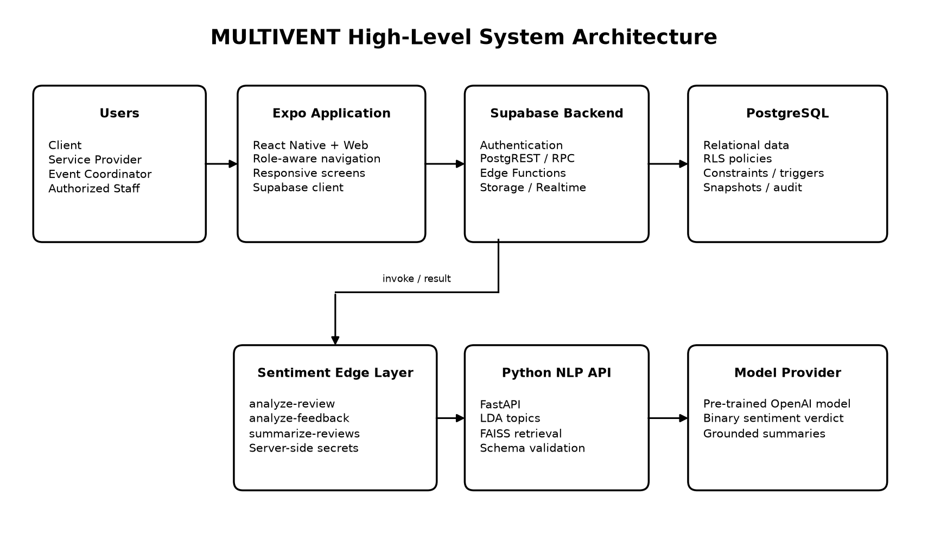
Figure 3.6-1. High-level architecture of the implemented MULTIVENT system.
Layer | Implemented responsibility | Principal technology
Presentation | Responsive client, provider, coordinator, and staff screens; validation feedback and state | React Native 0.86, React 19, Expo 57, React Native Web
Application access | Session handling, role routing, data requests, Edge Function invocation | TypeScript, Supabase JavaScript client
Business/data | RLS, transactional RPCs, constraints, triggers, snapshots, audit and notification records | Supabase PostgreSQL
Serverless integration | Privileged account tasks and secure review/feedback analysis orchestration | Supabase Edge Functions (Deno/TypeScript)
NLP service | Normalization, LDA topic inference, FAISS retrieval, structured sentiment and summaries | Python, FastAPI, scikit-learn, Sentence Transformers, FAISS, OpenAI API

3.6.1 Network Architecture
The client communicates with Supabase through its hosted HTTPS interfaces. Authentication produces a session/JWT used by PostgREST, RPC, Storage, and Edge Function calls. PostgreSQL applies the token’s user identity to RLS and function-level ownership tests. The application never receives the service-role key, sentiment-service URL secret, or analysis API key. For comment analysis, an authenticated client invokes an Edge Function; the function validates the user and record, calls the protected Python service with an X-Analysis-Key header, validates the JSON result, and writes the approved fields back to PostgreSQL.
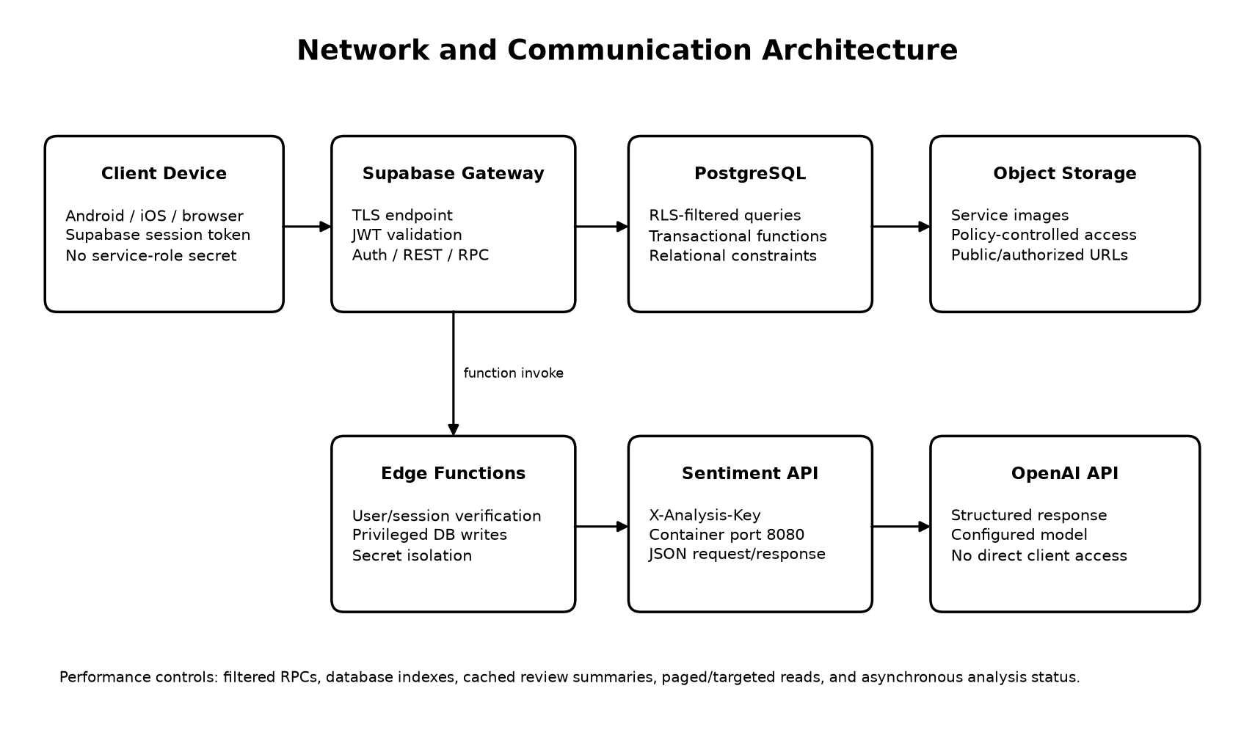
Figure 3.6.1-1. Network paths, trust boundaries, and data exchange.
Connectivity, performance, and security are addressed as follows:
- Connectivity: the Expo application can run on Android, iOS, and the web and uses environment-configured Supabase endpoints.
- Performance: targeted RPCs and database indexes reduce client round trips; review summaries are cached and analysis exposes explicit pending/failed/completed states.
- Security: authenticated requests carry user identity; RLS and owner-aware RPCs limit records; privileged secrets remain in Edge Function or container configuration.
- Consistency: pricing, booking responses, package application, financial allocation, and category locking execute in database transactions rather than independent browser writes.
- Failure handling: application modules return explicit errors, sentiment calls record retry/failure state, and financial actions either commit together or roll back.

3.6.2 Database Model
The relational model organizes users, marketplace supply, event demand, selections, bookings, finance, communication, governance, and review analysis. UUID primary keys identify major records. Foreign keys define ownership and lifecycle rules; unique and check constraints prevent invalid states; indexes support owner, status, schedule, and category access paths. JSONB is used only for structured category-specific details, immutable option/pricing snapshots, analysis metadata, and extensible audit payloads. Core identity, ownership, status, amounts, and relationships remain relational.
Domain | Principal tables | Purpose
Identity and access | profiles, roles, permissions, role_permissions, user_roles, user_permissions | Accounts, status, role assignment, and fine-grained staff authorization
Marketplace | provider_profiles, service_categories, services, service_packages, service_package_items | Provider identity, listings, category details, provider packages, and composed services
Planning | events, event_requirements, event_budget_items, event_service_selections, event instructions/schedule checks | Event specification, category budgets, one-per-category choices, instructions, and conflict checks
Coordinator | coordinator_service_profiles, coordinator_availability, coordinator_packages/items, assignment_attempts | Paid coordinator profiles, availability, curated packages, and explicit accept/reject attempts
Booking and finance | bookings, payments, financial_transactions, cash_remittances, payout accounts/requests | Booking state, payment snapshots, held/earned/released amounts, remittance, and payout workflow
Communication | conversations, participants, messages, notifications, support_tickets/messages | In-app communication, alerts, and scoped customer support
Quality and governance | reviews, event_feedback, service_review_summaries, audit_logs, system_settings | Ratings/comments, NLP outputs, cached summaries, audit trail, and configuration

A typical data flow begins with a client-owned event. Category allocations are attached to the event. A service selection references the real provider listing and captures selected catering or venue options. A booking then preserves the financial and option snapshots. Payment records feed the ledger, which keeps platform revenue, held provider funds, earned provider balance, and externally released payout values separate. Reviews are accepted only for qualifying booking relationships and may receive sentiment/topic metadata through the protected analysis workflow.
Integrity and consistency are enforced through foreign keys, status and non-negative amount checks, unique indexes, one-service-per-category triggers, budget-total validation, event-aware quote RPCs, row locks, and versioned immutable snapshots. Security is enforced through RLS and explicit grants; sensitive administrative or financial mutations are exposed through authorized functions rather than unrestricted table writes.

3.6.2.1 Entity–Relationship Diagram
The implemented schema is divided into three ERD views so every foreign-key path and cardinality remains readable in print. Repeated entities represent the same physical table. Connector ends use both crow's-foot symbols and explicit minimum..maximum labels. All connector routes use horizontal and vertical segments.
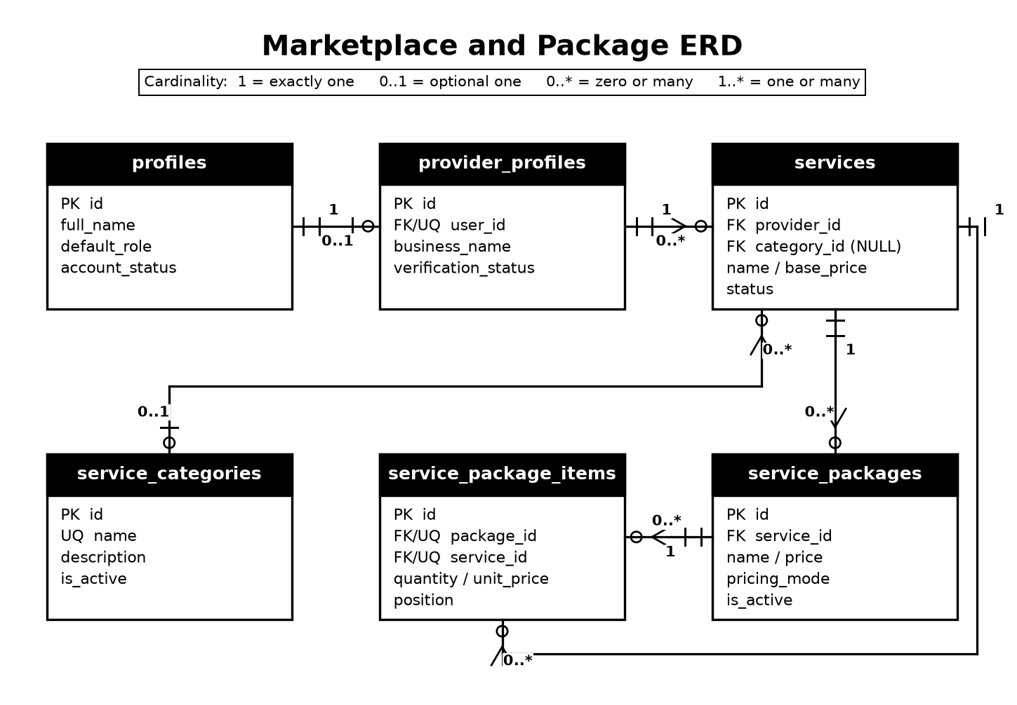
Figure 3.6.2.1-1. Marketplace and provider-package ERD with implemented cardinalities.
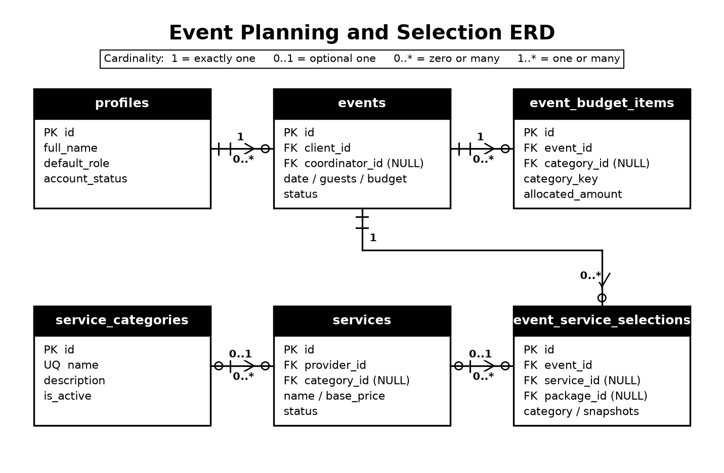
Figure 3.6.2.1-2. Event planning and service-selection ERD.
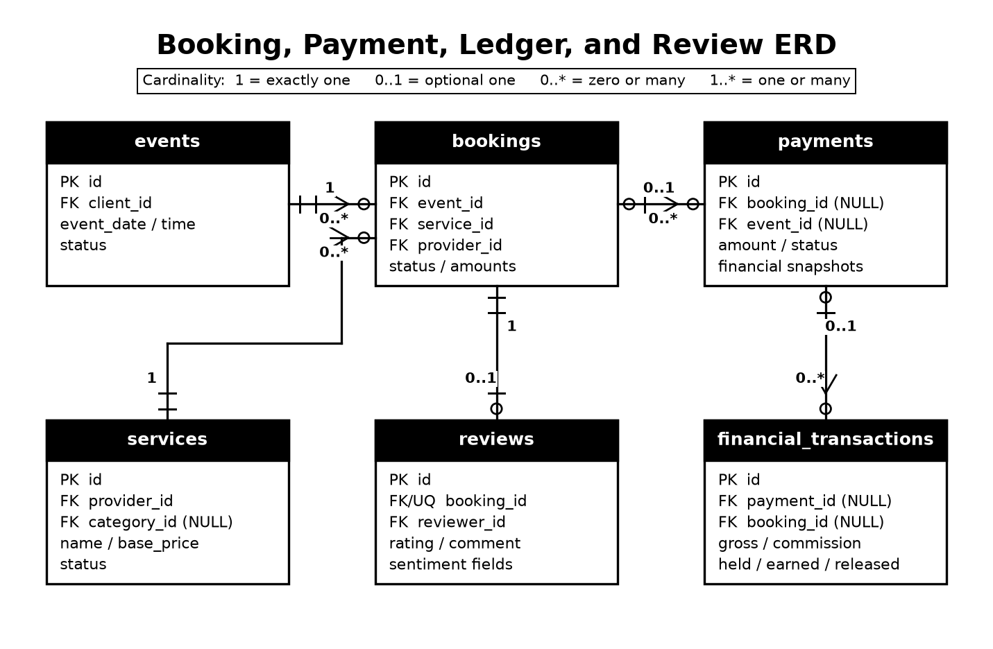
Figure 3.6.2.1-3. Booking, payment, ledger, and review ERD.
Relationship | Cardinality | Implementation meaning
Profile — Provider profile | 1 : 0..1 | A user account may own one provider business profile.
Provider profile — Service | 1 : 0..* | Every service has one provider; a provider may publish many service listings.
Service category — Service | 0..1 : 0..* | The category FK is nullable; a category may group many services.
Client profile — Event | 1 : 0..* | Each event is owned by one client; a client may plan multiple events.
Event — Budget item | 1 : 0..* | An event may have category allocations; Phase 7/9 keeps one versioned allocation per category.
Event — Service selection | 1 : 0..* | An event may select services across categories; active Phase 9 choices are unique per category.
Service — Event selection | 0..1 : 0..* | The selection FK may be cleared when a listing is removed; a service may appear in many selections.
Event — Booking | 1 : 0..* | A booking belongs to exactly one event; an event may create multiple booking records.
Service — Booking | 1 : 0..* | Every booking references one service; a service may be booked many times.
Booking — Payment | 0..1 : 0..* | A payment may reference one booking or use event scope; a booking may have multiple payment attempts.
Payment — Financial transaction | 0..1 : 0..* | A ledger row may retain one payment reference; a payment may produce multiple classified ledger entries.
Coordinator — Curated package | 1 : 0..* | A coordinator may own multiple packages that reference actual provider services.
Curated package — Service | many : many through items | Package items reference listings without copying provider ownership.
Booking — Review | 1 : 0..1 per allowed review context | A completed relationship can yield a rating/comment with optional analysis.

3.6.3 Application/Module Architecture
The application is organized around role-aware screens and shared TypeScript data libraries. App.tsx owns session-level navigation and routes users into client, provider, coordinator, or staff experiences. Screen components collect input and present states; library modules call Supabase tables, RPCs, and functions; SQL functions remain authoritative for cross-record rules and financial calculations. This design prevents a visual client from becoming the sole enforcement point.
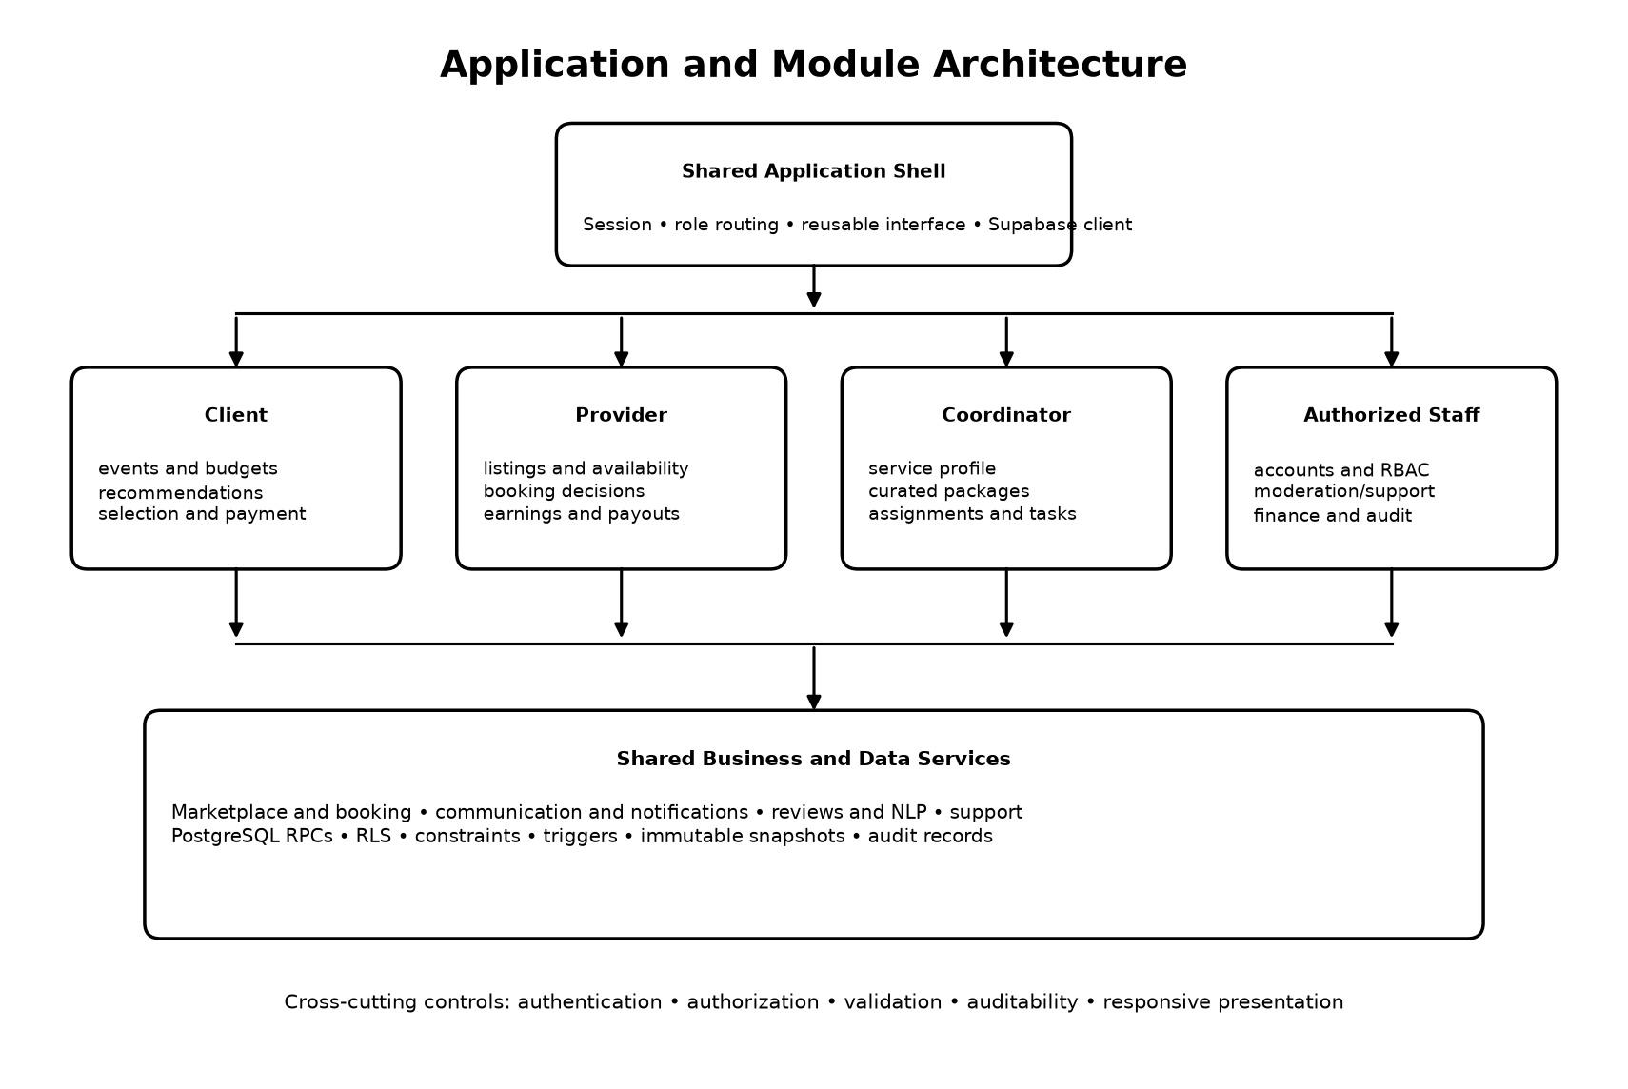
Figure 3.6.3-1. Functional modules and their shared application/data services.
Module | Responsibilities | Key interaction
Client planning | Create event; specify schedule, guests, venue status; allocate budget | Feeds event-aware recommendation and pricing RPCs
Marketplace and selection | Browse categories/details, view provider options, choose one service per category | Stores option IDs, calculated totals, and immutable snapshots
Coordinator marketplace | Optional coordinator choice, fee preview, package selection | Creates explicit assignment request; providers still decide individually
Booking and payment | Review selections, record payment choice, create requests, show receipt/status | Uses 5% fee, 40% initial requirement, 30% provider allocation and held-fund rules
Provider operations | Manage service listings/packages/availability, respond to requests, track earnings | Atomic response RPC credits only the accepting provider’s eligible initial share
Coordinator operations | Manage paid profile/packages, accept/reject assignments, view event tasks | Uses the same notification, financial, and event records
Communication/support | Chat, notifications, instructions, support tickets | Scopes participants and related event/booking references
Reviews and NLP | Submit ratings/comments, display sentiment metadata and summaries | Edge Functions mediate the external Python service
Staff governance | Account/RBAC, listing review, finance/remittance, support, audit | Permission-checked functions and views expose only authorized operations

Data security is maintained by using the current authenticated identity in database policies and RPCs. Network security is maintained by hosted TLS endpoints and by keeping privileged keys outside the client. The application layer displays authorization-aware navigation, but database enforcement remains the final control even if a client screen is bypassed.

3.6.4 Security Architecture
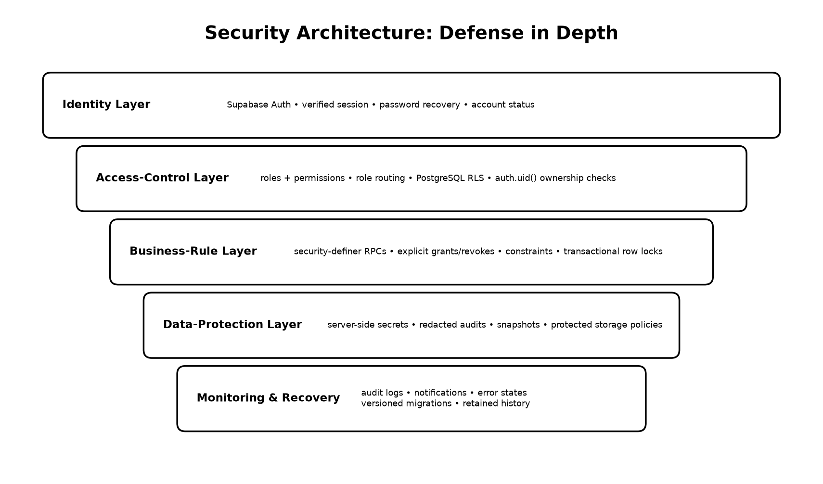
Figure 3.6.4-1. Implemented defense-in-depth controls.
Security objective | Implemented controls | Effect
Confidentiality | Supabase authentication; RLS; owner/participant tests; RBAC; server-side service-role and analysis secrets; audit redaction | Limits personal, financial, message, support, and analysis data to appropriate users and services
Integrity | Foreign keys; check/unique constraints; transactional security-definer RPCs with restricted grants; immutable snapshots; audit triggers | Prevents malformed relationships, unauthorized state changes, duplicate category choices, and silent historical repricing
Availability | Hosted Supabase services; indexed queries; explicit retry/failure states for NLP; container health endpoint; retained transaction history | Supports recovery and diagnosis while allowing core ratings to exist even if optional text analysis fails
Accountability | User IDs on writes, audit logs, timestamps, assignment attempts, payment/ledger references, notifications | Connects consequential actions to actors and preserves an inspectable history
Least privilege | Client uses anon/session credentials; elevated operations run only in Edge Functions or narrowly granted RPCs | Reduces exposure of administrative or service credentials

Security limitation to report honestly
The repository demonstrates application/database controls, but a full security assessment still requires deployed-environment configuration review, dependency scanning, penetration testing, backup/restore testing, and operational incident procedures.

3.6.5 Integration Architecture
MULTIVENT integrates components through typed JSON/HTTPS calls and relational RPCs. The Expo client uses the Supabase JavaScript SDK for authentication, database, storage, and Edge Function operations. SQL RPCs provide authoritative calculations and multi-table transactions. Review and feedback Edge Functions convert application records into the Python API contract, attach server-held credentials, validate the response, and persist only expected analysis fields. The Python service loads versioned local LDA, encoder, and FAISS artifacts and calls the configured pre-trained model provider for schema-constrained sentiment or summaries.
Integration | Exchange | Interoperability / protection
Expo ↔ Supabase Auth | Credentials, session, recovery/verification state | Supabase SDK and JWT session; password values are not stored in public profile tables
Expo ↔ PostgreSQL | Typed records and RPC parameters/results | PostgREST/SQL types, RLS, UUID keys, JSONB only where flexible structure is necessary
Expo ↔ Storage | Service cover/gallery images | Image picker uploads and policy-controlled object access
Expo ↔ Edge Functions | Review/feedback analysis requests and privileged user creation | Authenticated invocation; service role remains server-side
Edge Functions ↔ Python API | Comment text and structured analysis/summary JSON | Protected endpoint with X-Analysis-Key; response shape validation
Python API ↔ OpenAI | Prompt context and schema-constrained result | Server-side API credential; no direct device access
Offline data sources ↔ ML build | Pinned/source-registered HiliSenti, MAMS, Booking, and UCI files | Checksums, licenses, manifests, deterministic splits, and leakage guards

No confirmed live PayMongo or equivalent payment-processor call was found in the reviewed runtime. The current payment flow creates internal records and a generated demo reference, then exercises allocation, hold, acceptance, balance, remittance, and payout-request logic inside MULTIVENT.

3.6.6 Deployment Architecture
The application can be built for Android, iOS, or the web through Expo/EAS profiles. The managed backend is a Supabase project to which ordered SQL migrations and Edge Functions are deployed. The NLP service has a Dockerfile configured for Python 3.13, CPU PyTorch, FastAPI/Uvicorn, packaged model/data/vector-store artifacts, and a configurable PORT defaulting to 8080. The repository documents Azure Container Apps as the intended container target. Secrets and endpoint values must be supplied as deployment configuration rather than embedded in the client bundle.
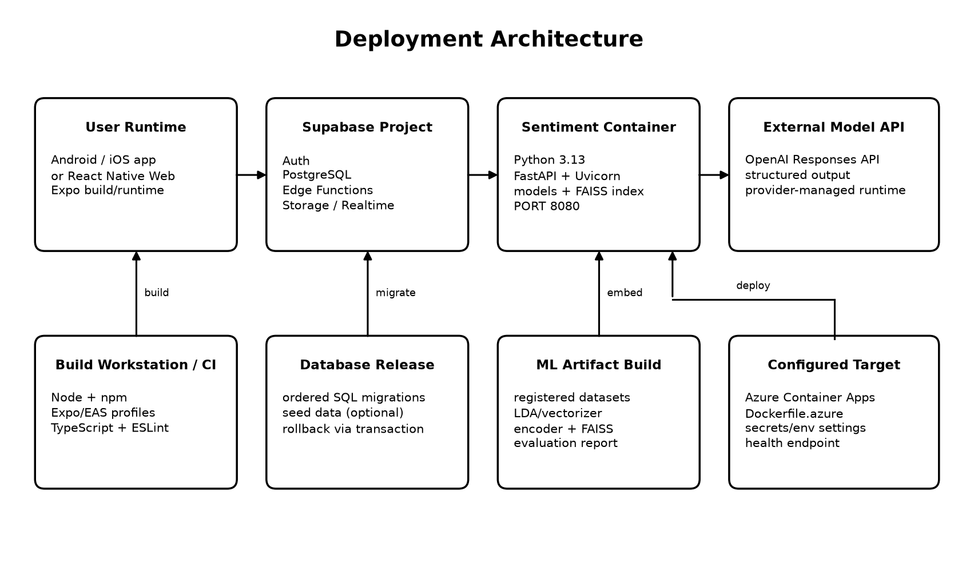
Figure 3.6.6-1. Runtime and release/deployment topology.
Node | Minimum software / service | Configuration responsibility
User device | Supported Android/iOS device or modern browser; network connection | Install/open built application; grant selected media permissions
Application build | Node/npm, Expo CLI/EAS-compatible environment | Supply public Supabase URL/anon configuration; build profile
Supabase | Auth, PostgreSQL, Storage, Edge Functions | Apply migrations in order; deploy functions; configure policies and server secrets
Sentiment container | Docker-compatible runtime; CPU/memory sufficient for encoder/index | Mount packaged artifacts; set provider/API secrets and analysis key; expose health/analyze endpoints
External provider | Reachable OpenAI API account and model access | Store API key only in server environment; monitor provider errors and quotas

3.8 System Design
Both permitted design views are included because they answer different questions. The use case diagram defines what each actor can do, while the data flow diagrams show how information moves through major processes and stores.

3.8.1 Use Case Diagram
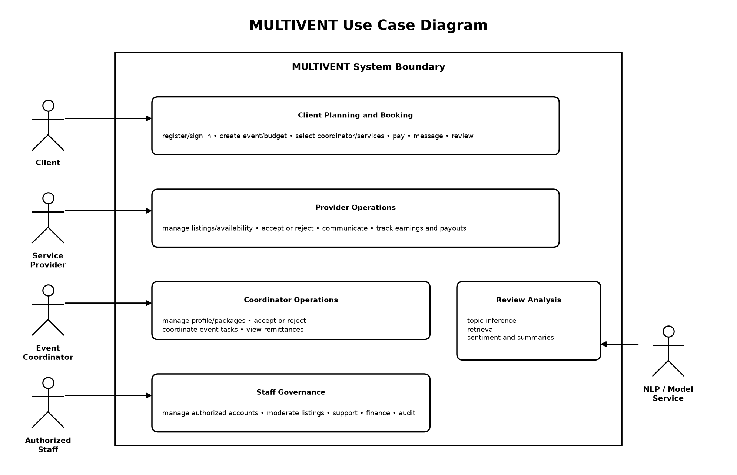
Figure 3.8.1-1. Role-oriented use cases within the MULTIVENT boundary.
Actor | Implemented use cases | Authorization boundary
Client | Account access; event and budget planning; coordinator/service selection; payment records; messaging; instructions; reviews/feedback; support | Owned events, bookings, conversations, tickets, and allowed marketplace reads
Service Provider | Provider profile; service/package creation; calendar/hours; booking acceptance/rejection; payment confirmation; earnings/payout account/request; messages/reviews | Records linked to the authenticated provider profile
Event Coordinator | Paid profile; availability; assignment response; package curation; accepted-event details/tasks; remittance and communications | Pending/accepted assignments and coordinator-owned packages/profile
Authorized Staff | Accounts, roles/permissions, listing moderation, support, finance/remittance, audit and settings | Permission-based staff operations; no blanket client-side privilege
NLP/model service | Analyze comments; infer topic; retrieve examples; produce binary sentiment and grounded summaries | Reached by server-side functions, not directly by end-user devices

3.8.2 Data Flow Diagram

Level 0: Context Diagram
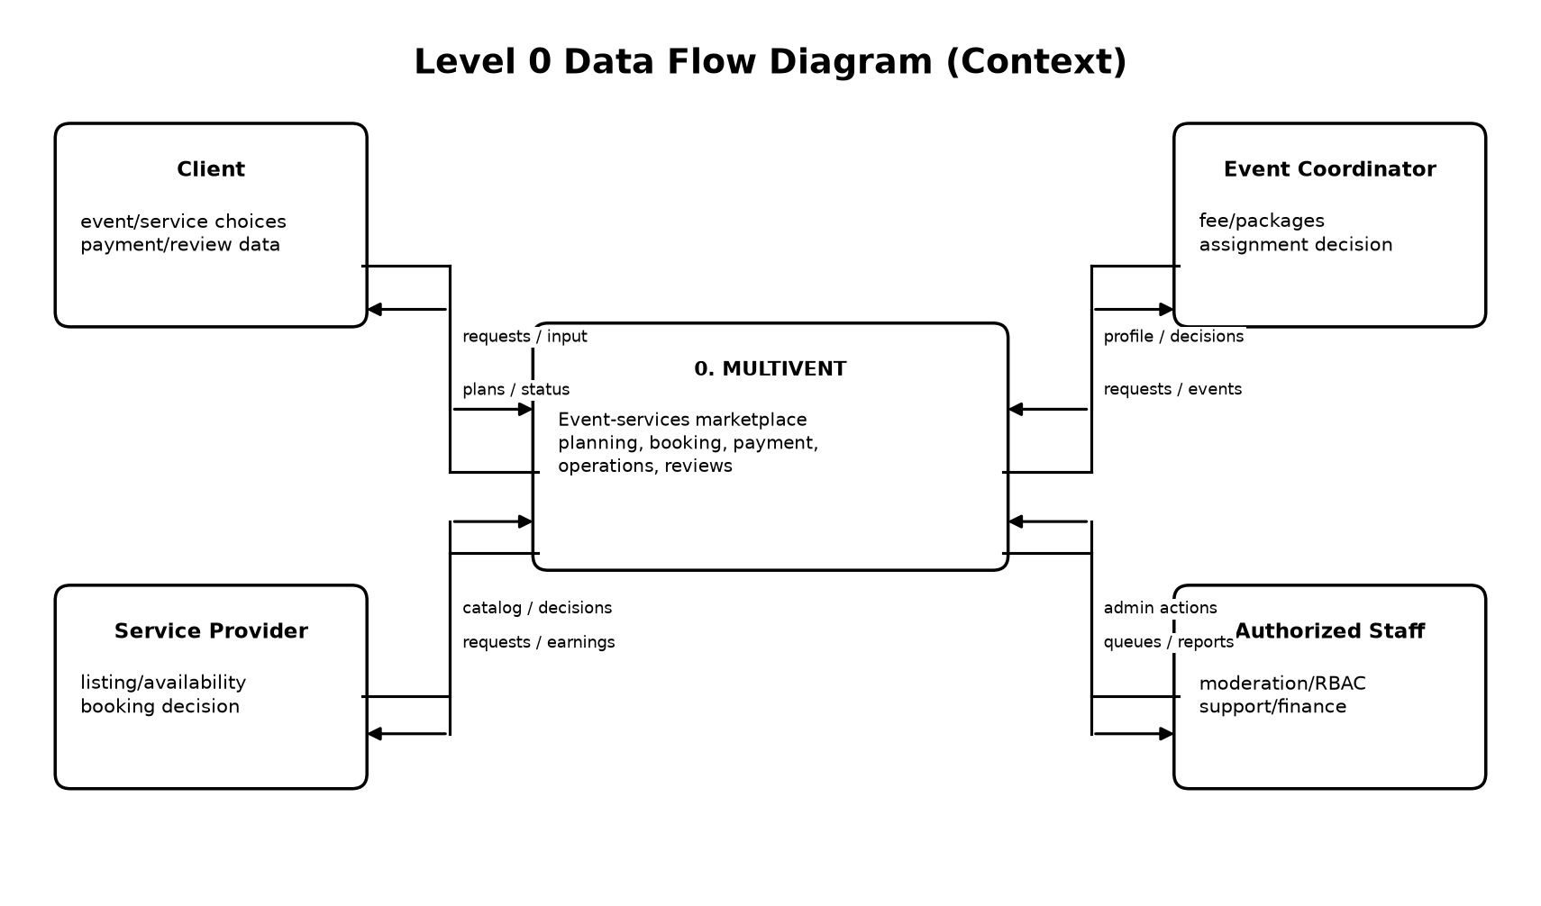
Figure 3.8.2-1. Level 0 context diagram.
At Level 0, MULTIVENT is treated as one process. Clients submit planning, service, payment, and review data and receive plans, quotes, booking states, receipts, and notifications. Providers and coordinators exchange marketplace definitions, availability, requests, decisions, balances, and event information. Staff receive controlled operational queues and submit authorized governance actions.

Level 1: Major Processes and Data Stores
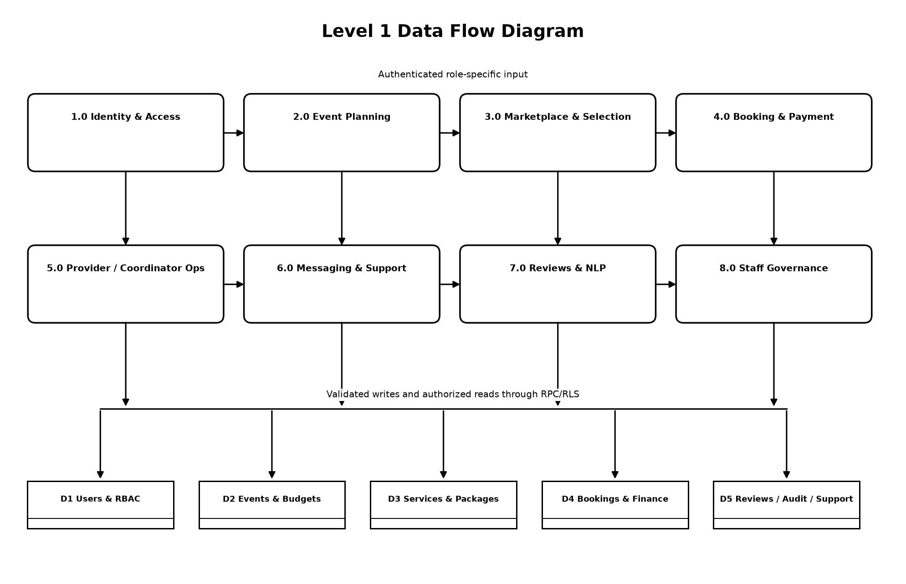
Figure 3.8.2-2. Level 1 processes and logical data stores.
Process | Input | Output / store
1.0 Identity and Access | Registration, login, verification, role choice | Authenticated profile and role/permission relationships (D1)
2.0 Event Planning | Event details, guest count, date/time, budget allocations | Event, requirements, schedule and category budget records (D2)
3.0 Marketplace and Selection | Category, budget, option/package, catering menu, venue hours | Calculated quote and snapshotted event selection (D2/D3)
4.0 Booking and Payment | Reviewed selections and payment choice | Booking requests, payment snapshot, held/provider/platform ledger entries (D4)
5.0 Provider/Coordinator Operations | Listings, availability, accept/reject, packages, payout data | Marketplace changes, decisions, balances, tasks and payouts (D3/D4)
6.0 Messaging and Support | Participant messages, instructions, support concerns | Scoped conversations, notifications and tickets (D5)
7.0 Reviews and NLP | Rating and optional comment | Review, sentiment/topic metadata, references and cached summary (D5)
8.0 Staff Governance | Permission-checked moderation and operational actions | Account/listing/support/finance state changes and redacted audit records (D1–D5)

3.9 User Interface Design
MULTIVENT uses a shared visual system across client, provider, coordinator, and staff experiences. The interface is implemented with React Native components that also render on the web. Screens use cards, step indicators, bottom or role-specific navigation, clear primary actions, inline validation, empty/loading/error states, and responsive spacing. Wine and gold brand colors identify primary actions and headings while neutral surfaces preserve readability.
Design principle | Implemented application of the principle
Role relevance | After authentication, navigation exposes the client, provider, coordinator, or authorized staff workflow appropriate to the active role.
Progressive disclosure | Event planning, service listing, payment, and package configuration use steps or focused screens rather than one unbounded form.
Input prevention | Pickers, switches, modals, date/time controls, category options, numeric keyboards, limits, and disabled actions reduce invalid submission.
Immediate feedback | Helper text, loading states, conflict screens, unavailability reasons, price breakdowns, confirmations, and toast/error messages explain the result of an action.
Financial clarity | Service subtotal, 5% platform fee, client total, 40% initial payment, 30% provider allocation, held amount, balance and payout status are labeled separately.
Responsive presentation | The shared React Native codebase adapts to handheld and web surfaces, with compact cards and scrollable forms.
Historical clarity | Booking, payment, option, and provider snapshots display the values accepted at transaction time rather than silently adopting current listing values.

3.9.1 Input Screens Layout
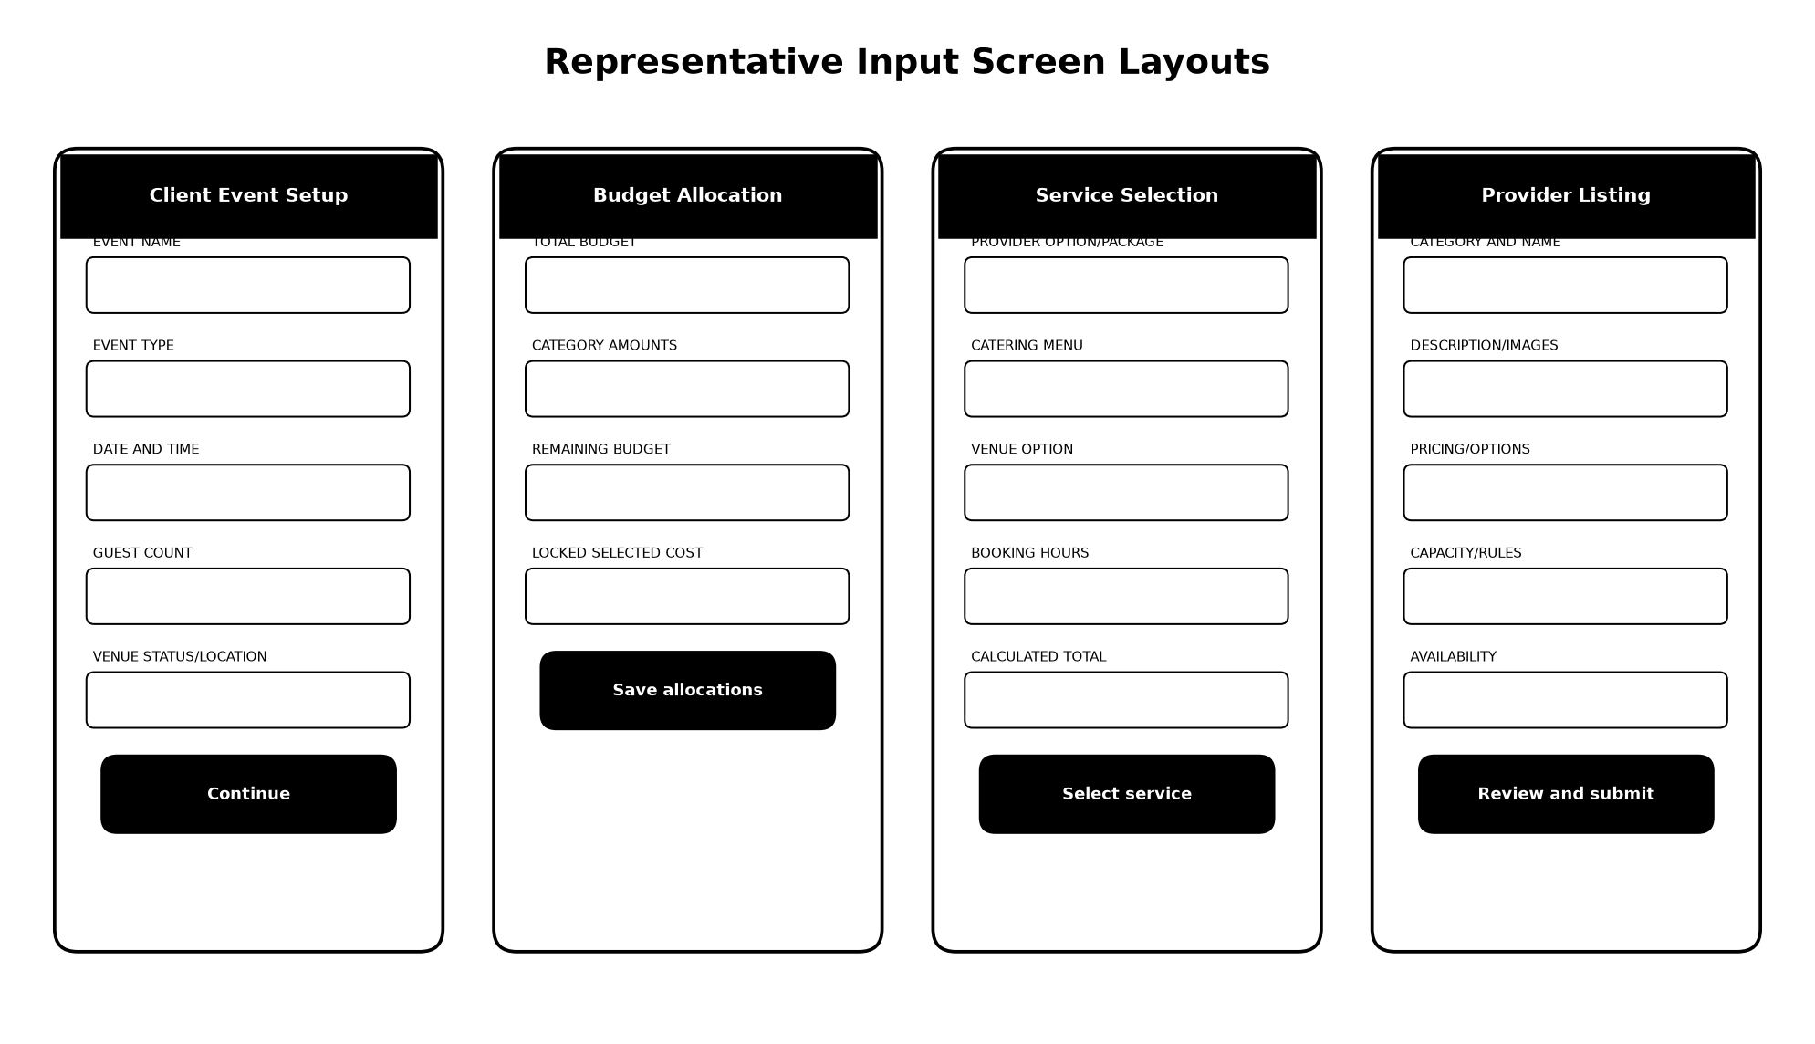
Figure 3.9.1-1. Representative layout pattern derived from implemented input screens.
The wireframes summarize the actual input hierarchy rather than replacing the detailed application screens. Each form starts with a descriptive header, groups related inputs, presents validation close to the field, shows a calculated summary when money or schedule is affected, and ends with one clear primary action.
Input screen | Principal implemented fields/controls | Validation and usability behavior
Client registration/login | Full name, email, phone, password/confirmation; email/password login; recovery code/new password | Email/password checks, secure entry toggles, verification and recovery states
Provider registration | Business/contact names, category/service interests, email, phone, password | Role-specific approval state and field-level validation
Event creation | Event name/type, date, time, expected guests, venue status/location | Step presentation, date/time validation, guest-dependent downstream pricing
Budget allocation | Total budget and amounts for venue, catering, coordinator, photo/video, attire, host, sound/lights, floral | Running allocated/remaining total; selected-service category values become locked to the calculated amount
Coordinator choice/details | Browse/skip, coordinator profile, fee, packages; package-specific catering and venue options/hours | Availability and event-type checks; conflict confirmation before replacement
Service details/selection | Provider package, catering menu, venue option, venue booking hours, instructions | Central quote RPC validates capacity, guest range, hours, operating window, availability, one-per-category, and budget
Provider service listing | Category, service name/description/images, price/packages, category-specific details, availability | Multi-selection modals reduce tag clutter; pending-review workflow preserves staff moderation
Provider booking response | Event facts, service/request details, accept or decline, optional response note | Only the owning provider may respond; eligible held allocation moves atomically on acceptance
Coordinator profile/package | Coordination fee, description, specializations, accepting status; package name/type/description/services/status | References only active real services; duplicate/unavailable package content is rejected or deactivated
Payment | Initial or full option and payment summary | Separate service subtotal, platform fee, client total, provider allocation, held/unallocated value and receipt reference
Reviews and feedback | Rating, optional comment, service/event/coordinator feedback | Comment analysis is optional/asynchronous; rating persists independently
Support and account | Ticket subject/description/reply/context; profile/contact; password; payout account | Length limits, scoped related records, sensitive-number masking, current/new password checks

Detailed-screen appendix guidance
For the final bound manuscript, place exported screenshots of the running application after Appendix F using the same screen order shown above. Screenshots should use non-sensitive demonstration data. This DOCX includes the implemented field inventory and layout diagram without fabricating runtime screenshots.

3.10 System Testing and Evaluation
Testing and evaluation are reported in two layers. First, repository evidence verifies implemented rules, types, migrations, and the reproducible NLP evaluation. Second, standardized instruments are supplied for respondent acceptance, deployed-web Lighthouse measurement, and ISO/IEC 25010 quality assessment. No score is inserted without an actual run or completed response set.
Evaluation layer | Current evidence | Required final evidence
Application correctness | TypeScript compiler/lint scripts; database constraints/triggers/RPCs; explicit UI error states | Executed regression cases in the final configured Supabase environment and recorded pass/fail evidence
NLP pipeline | Generated manifests, leakage checks, tests, LDA/FAISS artifacts and held-out evaluation report | Full held-out and production-representative MULTIVENT comment validation
UAT | Instrument and task scenarios included below | Signed/completed respondent forms and summarized results
Web performance | Expo web build path and responsive implementation | Lighthouse runs against a deployed production build under documented conditions
System quality | Evidence mapping and ISO/IEC 25010 instrument | Qualified evaluator/user responses and computed characteristic means

3.10.1 User Acceptance Evaluation
User Acceptance Testing (UAT) should use role-based task completion followed by a five-point questionnaire. Suggested participants are actual or representative clients, service providers, event coordinators, and authorized staff. Each participant should test only the workflows relevant to the assigned role.
Role | Acceptance tasks | Observable success criterion
Client | Register/sign in; create event; allocate budget; optionally choose coordinator; select catering/venue options; review quote; record payment; inspect booking; submit review | Task completes with the correct event, one active service per category, matching option/hours snapshot, total and status
Provider | Create/edit a listing; set availability; inspect request; accept/decline; view credited/held amounts; submit payout request | Only owned records change; acceptance credits only the eligible share; rejection does not credit provider
Coordinator | Configure profile/fee; create package; answer assignment; inspect accepted event/tasks | Package references valid provider services; assignment remains explicit; fee and status match the client record
Authorized staff | Review listing/account; use permission-based operations; handle support/finance item; inspect audit | Allowed task succeeds and disallowed task remains unavailable/denied; audit avoids sensitive free text

Response scale: 5 – Strongly Agree, 4 – Agree, 3 – Neutral, 2 – Disagree, 1 – Strongly Disagree.
No. | UAT statement | Quality focus
1 | I could complete my assigned role’s main task without assistance. | Effectiveness
2 | The labels, instructions, and navigation made the next action clear. | Learnability
3 | Required fields and validation messages helped me correct invalid input. | Error prevention
4 | Event, service, provider/coordinator, date, time, guest, and option details were accurate. | Functional correctness
5 | The displayed service subtotal, platform fee, payment requirement, held amount, and balance were understandable. | Financial clarity
6 | Catering price changed correctly according to the chosen menu and guest count. | Domain correctness
7 | Venue price and schedule reflected the chosen venue option and booking hours. | Domain correctness
8 | The system prevented or clearly explained schedule, capacity, budget, availability, and category conflicts. | Safety / feedback
9 | Booking and assignment states clearly showed who still needed to respond. | Workflow visibility
10 | Notifications/messages gave enough information without exposing unrelated records. | Communication / privacy
11 | The interface remained readable and usable on the device or browser I tested. | Accessibility / responsiveness
12 | I trust that my role can access only the functions and records it should use. | Perceived security
13 | The system responded within an acceptable time for the tested tasks. | Performance perception
14 | Errors or unavailable states explained what I could do next. | Recoverability
15 | Overall, MULTIVENT is acceptable for managing the tested event-service workflow. | Overall acceptance

For analysis, compute each item’s frequency and weighted mean, then group means by role and quality focus. Report the sample size, role distribution, device/browser, test date, and any task failures. The researchers must define and obtain adviser approval for the final verbal interpretation and acceptance threshold before collecting responses. Open comments should be coded separately and must not be converted into invented scores.

3.10.2 Performance Evaluation
Google Lighthouse should be executed against the deployed production web build, not the Metro development server. Record at least three runs under the same desktop and mobile profiles, clear the cache or use an incognito profile as required by the protocol, and report the median. Because no reproducible Lighthouse report was present in the reviewed repository, the matrix below is intentionally unscored.
Lighthouse area / metric | Target or interpretation | Desktop median | Mobile median | Evidence/status
Performance score | Report 0–100; project target to be adviser-approved | To be measured | To be measured | Attach HTML/JSON report
Accessibility score | Report 0–100 and failed audits | To be measured | To be measured | Attach report and remediation notes
Best Practices score | Report 0–100 and failed audits | To be measured | To be measured | Attach report
SEO score | Report 0–100 for public/deployed web surface | To be measured | To be measured | Attach report
First Contentful Paint | Lower is better; compare with Lighthouse classification | To be measured | To be measured | Milliseconds/seconds
Largest Contentful Paint | Lower is better; identify the dominant element | To be measured | To be measured | Milliseconds/seconds
Total Blocking Time | Lower is better; investigate long JavaScript tasks | To be measured | To be measured | Milliseconds
Cumulative Layout Shift | Lower is better; identify unstable elements | To be measured | To be measured | Unitless
Speed Index | Lower is better; compare same deployment/network profile | To be measured | To be measured | Milliseconds/seconds

- Export the Expo production web bundle and deploy it to the intended HTTPS host.
- Document URL, commit/release, browser/Lighthouse version, device profile, network/CPU throttling, and run time.
- Run Lighthouse three times for the login/onboarding surface and representative authenticated routes that the test setup can access.
- Store the HTML or JSON reports, compute the median, list failed audits, and connect remediation work to a tracked issue.
- Repeat after material performance changes; do not combine results from different builds or profiles as one sample.

3.10.3 System Quality
The recommended evaluation model is ISO/IEC 25010 because its product-quality characteristics align with the implemented application and the adviser’s requirement for a recognized quality standard. Respondents should use the same five-point scale, while technical evaluators should attach evidence for claims that end users cannot directly observe.
ISO/IEC 25010 characteristic | Implemented evidence to inspect | Evaluation statement
Functional suitability | Role workflows, central quote/payment RPCs, constraints, snapshots | The system provides the functions needed for the assigned event-service task and produces correct results.
Performance efficiency | Indexed queries, targeted RPCs, summary cache, measured Lighthouse/API behavior | The system uses time and resources acceptably for the tested workload.
Compatibility | Expo Android/iOS/web targets; JSON/HTTPS and SQL interfaces | The system operates and exchanges data correctly in the tested device/browser and service environment.
Usability | Progressive forms, helper text, conflict explanations, responsive cards | The interface is understandable, learnable, operable, and prevents common errors.
Reliability | Transactions, row locks, retries/failure states, retained history | The system maintains correct state and recovers or explains failure during tested operations.
Security | Auth, RBAC, RLS, grants/revokes, secret isolation, redacted audit | The system protects records and actions according to identity and role.
Maintainability | TypeScript modules, ordered migrations, centralized calculations, versioned artifacts | The implementation is modular, analyzable, and can be changed without duplicating critical rules.
Portability | Expo targets, environment configuration, Dockerized sentiment API | The system can be built or deployed to the documented supported environments with configuration changes.

Compute a mean per characteristic and an overall descriptive mean only after completed forms are collected. Keep user-perception responses separate from objective test evidence such as Lighthouse output, database authorization tests, and ML metrics. Include evaluator role, environment, sample size, and limitations in the final chapter.

Appendix A. Implementation Traceability Matrix
Manuscript claim | Implementation evidence | Status
Cross-platform role-aware application | package.json; app.json; src/App.tsx; src/screens | Implemented
Supabase relational backend and RLS | database/initial_supabase_schema.sql; security and role migrations | Implemented
Optional paid coordinator with explicit response | database/53_coordinator_marketplace.sql; coordinator screens/libraries | Implemented
Coordinator-curated packages reference real services | database/54_coordinator_packages.sql; 23.3-CoordinatorPackages.tsx | Implemented
Guest-aware catering options and snapshots | database/55_catering_pricing_revision.sql; service details/listing screens | Implemented
5% fee, 40% initial requirement, 30% provider allocation | database/56_payment_revenue_revision.sql; 12-Payment.tsx | Implemented in internal accounting workflow
Funds held until individual provider/coordinator acceptance | database/57_payment_hold_provider_acceptance.sql; booking request and earnings screens | Implemented
Category budget allocations | database/58_budget_allocation_revision.sql; 05-BudgetAllocation.tsx | Implemented
Budget/guest/availability-aware recommendations | database/59_budget_aware_recommendations.sql; browse flow | Implemented
One service per category; venue option/hours; locked category amount | database/60_service_selection_revision.sql; 08-ServiceDetails.tsx | Implemented
Messaging, notifications, instructions and support | conversation/message/notification/support schema; screens 03, 10, 22.5, 25 | Implemented
Sentiment/topic/RAG integration | Supabase analyze/summarize functions; sentiment API workspace and artifacts | Implemented; optional comment analysis
Live external payment gateway | src/lib/planning.ts uses generated demo reference | Not confirmed / must not be claimed
Production Azure sentiment deployment | deployment/sentiment/Dockerfile.azure and deployment documentation | Configured target; live deployment not proven by repository
Completed UAT/Lighthouse/ISO results | No completed response set or Lighthouse report found | Instrument supplied; results pending actual evaluation

Appendix B. Programmer Responsibility and Deliverables
Responsibility | Concrete deliverable reflected in the manuscript
Requirements translation | Converted coordinator, pricing, payment, budget, recommendation, venue, security, and ML rules into application/database behavior
Architecture | Defined and implemented the Expo–Supabase–PostgreSQL–Edge–FastAPI component boundaries
Database engineering | Maintained normalized relationships, RLS, transactional RPCs, triggers, indexes, snapshots, audit and ordered migrations
Application engineering | Implemented role-aware screens and data libraries for clients, providers, coordinators and staff
Financial correctness | Centralized versioned fee/payment/allocation logic and separated held, earned, released and revenue amounts
ML/NLP integration | Connected reviews/feedback to protected server-side analysis and preserved provenance and failure state
Verification | Provided type/lint/build commands, role-based UAT cases, Lighthouse procedure and ISO quality instrument
Documentation | Produced architecture, ERD, use case, DFD, deployment, UI and traceability descriptions based on source evidence

Appendix C. Sentiment Training and Evaluation Evidence
The NLP feature analyzes optional written comments. It does not train or fine-tune a supervised sentiment classifier. The local corpus fits an unsupervised LDA topic model and builds a training-only FAISS retrieval index. The active configuration records the pre-trained OpenAI model name gpt-5.6-terra, which produces the final schema-constrained positive/negative verdict using the original comment, LDA context, and retrieved labeled examples. Star ratings remain separate.
Artifact / population | Recorded value | Meaning
Original source records examined | 31,704 | Registered records across HiliSenti, MAMS, Booking Hotel Reviews and UCI restaurant subset
Neutral records excluded | 7,154 | Excluded from the binary experiment; never relabeled
Valid deduplicated binary units | 23,171 | All-binary processed corpus
Realized corpus split | 18,411 train; 2,376 validation; 2,384 test | 79.46% / 10.25% / 10.29%; publisher HiliSenti partitions are preserved
Domain-filtered units | 5,649 | Event/service-relevant examples
LDA fitting rows | 4,462 | Training-only text; sentiment label not used to fit topics
FAISS/RAG rows | 3,050 | Balanced: 1,525 positive and 1,525 negative
Encoder | paraphrase-multilingual-MiniLM-L12-v2 | Frozen pretrained multilingual, 384-dimensional embeddings
LDA | 10 topics; max 10,000 features; min_df 2; max_df 0.95; 20 iterations; seed 42 | Current saved topic configuration; labels remain Topic 0–9 pending human naming

Held-out sample | N | Accuracy | Macro F1 | Confusion matrix [negative, positive]
HiliSenti | 100 | 0.9500 | 0.9494 | [[53, 4], [1, 42]]
Hospitality/restaurant domain proxy | 100 | 0.9400 | 0.9400 | [[48, 2], [4, 46]]

The recorded report states that leakage checks passed. These results are promising but preliminary: each set contains only 100 evaluated records, the domain set is a proxy rather than native MULTIVENT feedback, and some hotel labels are weakly supervised. The feature must not control ranking, penalties, or other high-impact decisions until a manually labeled production-representative MULTIVENT set is evaluated.

Appendix D. Core Database Entity Data Dictionary
Entity | Selected key attributes | Data retained for correctness
profiles | id, full_name, email, phone, default_role, account_status | Application identity linked to auth.users
provider_profiles | id, user_id, business_name, contact/location, verification | Provider business identity and moderation state
services | id, provider_id, category_id, name, base_price, pricing model/unit, category_details, status | Provider-controlled listing and configurable options
events | id, client_id, coordinator IDs/status, name/type/date/time, guest_count, total_budget | Client plan and coordinator pricing snapshot
event_budget_items | event_id, category_key, allocated_amount, lock/selection ID, version | Category ceiling and committed selected cost
event_service_selections | event/service/package/provider/category, amount, catering/venue IDs and snapshots, status | Event-specific option and calculated-price commitment
bookings | event/client/provider/service, date/time, amount/provider/platform snapshots, status | Provider request and immutable transaction terms
payments | booking/event/coordinator, scope, subtotal/fee/initial/held allocations, status/reference | Payment attempt and versioned financial breakdown
financial_transactions | booking/payment/event/provider/coordinator, platform revenue, provider net/held/released, status | Internal ledger that separates custody, earnings and payout
coordinator_packages/items | coordinator, name/type/status; package/service/position | Curated references to real services
reviews/event_feedback | booking/event/service/coordinator, rating/comment, sentiment/topic/metadata | User feedback and optional analysis provenance
audit_logs | actor, action, resource, redacted before/after, timestamp | Accountability without copying designated sensitive content

Appendix E. Verification Checklist for Final Submission
- Apply database migrations in documented order through 60_service_selection_revision.sql to a clean staging project and retain the execution log.
- Run npm run typecheck, npm run lint, and npm run build:web; record command, date, environment and result.
- Run the sentiment service test suite and compare artifact hashes/evaluation report with the deployed container image.
- Execute role-isolation tests for client, provider, coordinator and each staff permission set; attempt both allowed and denied operations.
- Complete the UAT scenarios and questionnaire with representative respondents; compute descriptive results without fabricating missing answers.
- Deploy the production web build and capture three Lighthouse runs per documented profile; attach HTML/JSON reports.
- Complete the ISO/IEC 25010 evaluation, keeping user perception, technical tests and NLP metrics as separate evidence sources.
- Replace demonstration names/contact/payment references in screenshots and reports with non-sensitive test data.
- Update this manuscript’s status statements if a live payment gateway or production sentiment deployment is later verified.

Appendix F. Repository Evidence Reviewed
Evidence path | Purpose in this manuscript
HARVEY&CAANG.pdf | Required manuscript sections and evaluation items
package.json, app.json, eas.json | Application stack, targets and build profiles
src/App.tsx; src/screens; src/lib | Implemented role navigation, screens, inputs and application data flows
database/initial_supabase_schema.sql | Foundational relational entities and relationships
database/30–60 migrations | RBAC, support, finance, security hardening, coordinator, package, catering, payment, budget, recommendation and selection revisions
supabase/functions/* | Privileged account and sentiment integration boundaries
deployment/sentiment/Dockerfile.azure | Container software and intended Azure deployment target
docs/ML_METHODOLOGY_IMPLEMENTATION.md | Current, reconciled ML methodology and recorded metrics
D:\Sentiment Training\multivent-sentiment | Source registration, processed corpus, LDA/encoder/FAISS artifacts, API code, tests, manifests and reports

Appendix G. Detailed Input-Screen Layout Specification
Screen | Header/top region | Body order | Bottom/terminal action | Responsive and feedback behavior
Login / registration | Brand/title and role context | Identity/contact fields → password fields → terms/verification context | Sign in / create account / recovery link | Keyboard-aware scrolling, secure-entry toggle, inline helper/error text
Create Event | Back navigation, step label, Create Event title | Name/type → date/time → guest count → venue status/location | Continue to budget | Scrollable step form; invalid schedule/input blocks progression
Budget | Budget step and event context | Total budget → category allocation cards → allocated/remaining summary | Save/continue | Currency formatting, running totals, locked selected-cost explanation
Coordinator Choice | Optional coordinator prompt | Browse coordinators/packages or explanatory skip path | Select coordinator/package or continue without | Choice is not forced; unavailable reasons remain visible
Category Browse | Category or replacement context and search | Recommendation/filter controls → service cards → budget/availability indicators | Open service details | Loading/empty/error states; replacement context is explicit
Service Details | Service/provider identity and media | Description → provider options/packages → catering/venue configuration → quote → instructions | Select or replace service | Guest/capacity/hour/schedule/budget errors appear before commit
Review Services | Event and review-step context | One card per selected category → option snapshots → coordinator → totals | Proceed to booking/payment | Selection changes return to the relevant category without losing event context
Payment | Event summary | Payment mode → subtotal → 5% fee → client total → held/provider allocation explanation | Record payment | Disabled while processing; confirmation shows generated reference and status
Provider Listing Wizard | Step indicator and category context | Basic details/images → pricing/packages/options → category-specific fields → review | Save draft / submit for review | Compact multi-select dialogs, field validation, review before submission
Booking Request | Request status and event/service title | Client event facts → selected options/instructions → financial share/status | Accept or decline with optional note | Atomic response, progress state, ownership error handling
Coordinator Package | Package-management context | Name/type/status → description → marketplace-service selector → selected list | Save package / activate/deactivate | Unavailable services cannot be activated; references stay linked to provider listings
Support Ticket | Ticket list/detail context | Subject → description → optional event/booking reference → threaded replies | Create ticket / send reply | Length limits, closed-state notice, role-scoped related records

End of implementation-grounded programmer manuscript

