Figure 1. Condensed MULTIVENT live database ERD overview
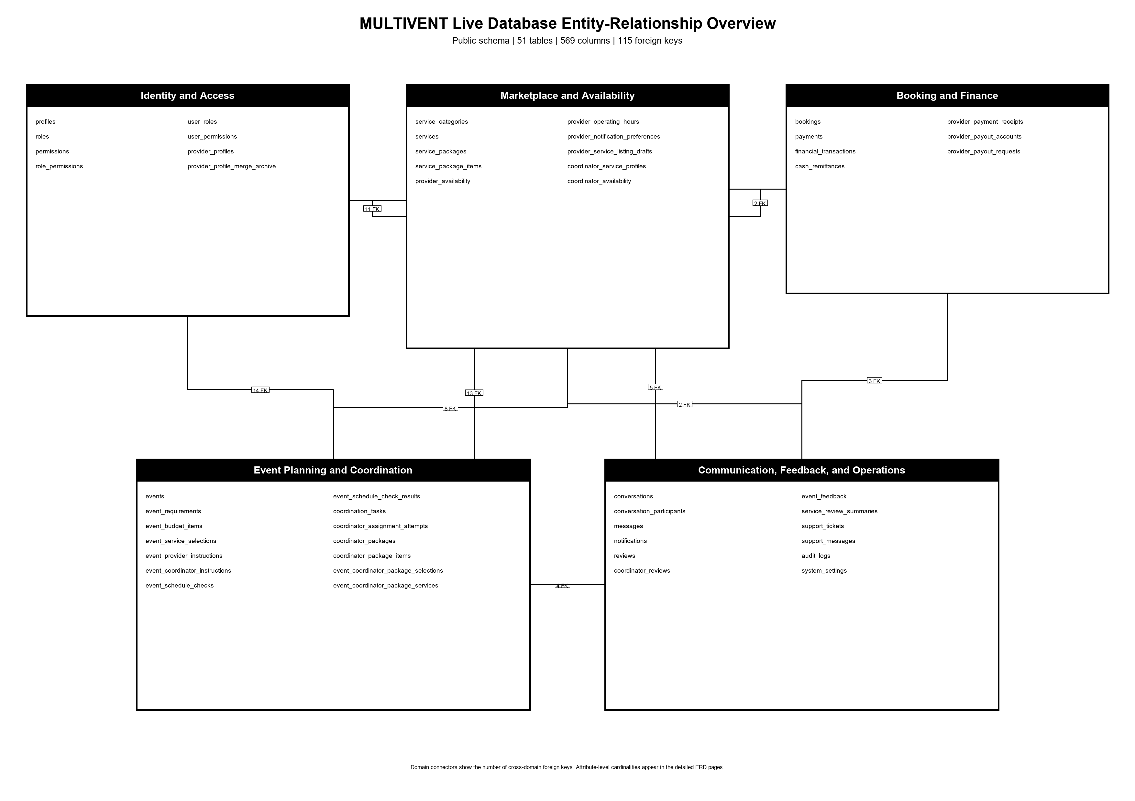
Source: MULTIVENT live Supabase public schema, captured 2026-10-08.

Figure 2. MULTIVENT ERD - Identity and Access
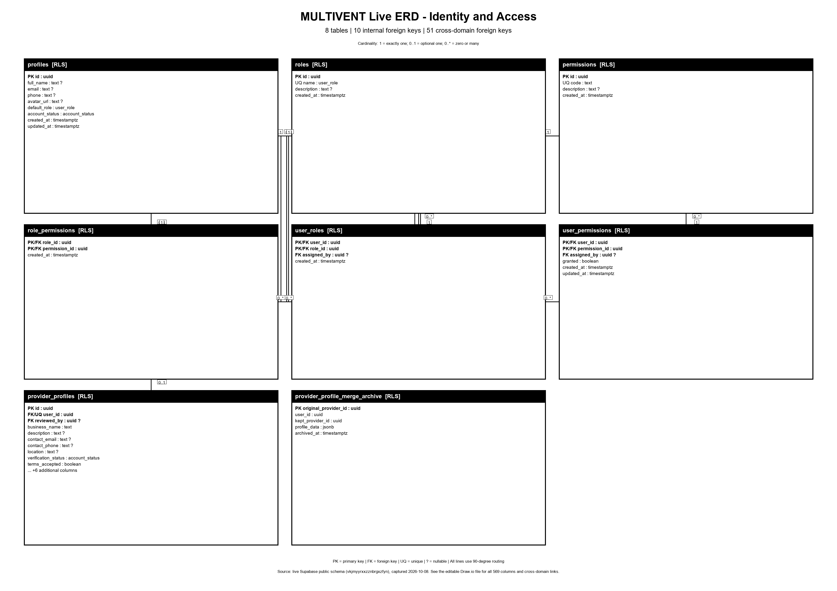
Source: MULTIVENT live Supabase public schema, captured 2026-10-08.

Figure 3. MULTIVENT ERD - Marketplace and Availability
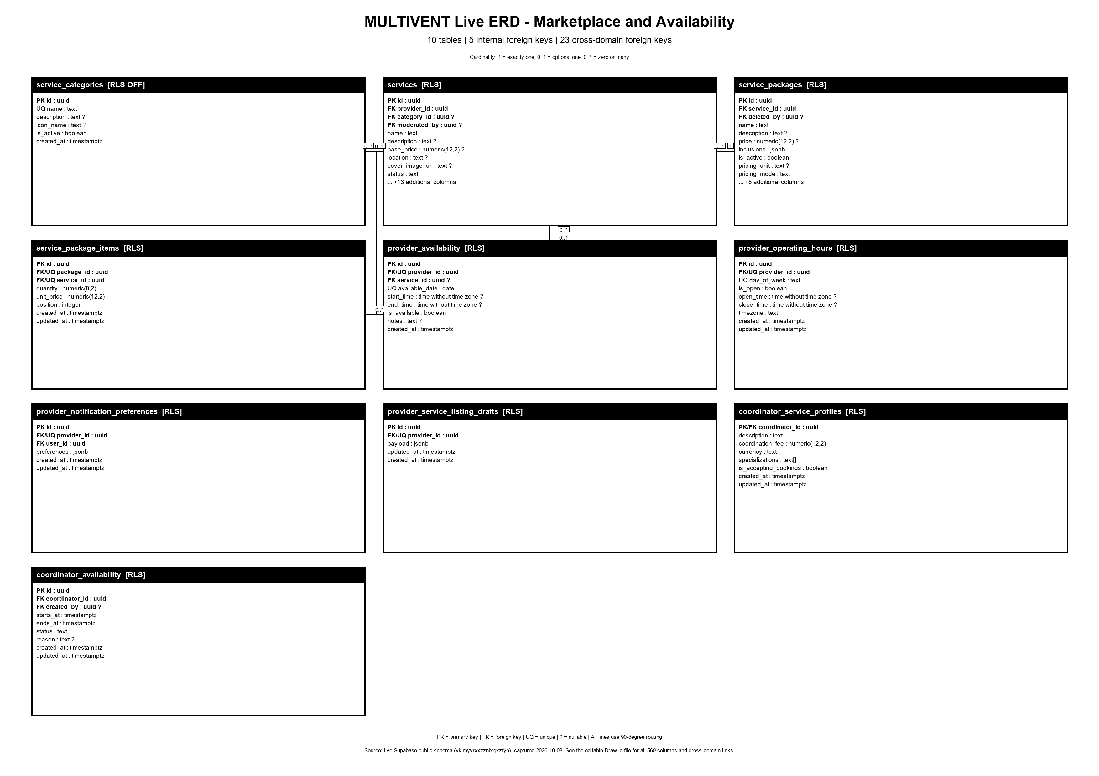
Source: MULTIVENT live Supabase public schema, captured 2026-10-08.

Figure 4. MULTIVENT ERD - Event Planning and Coordination
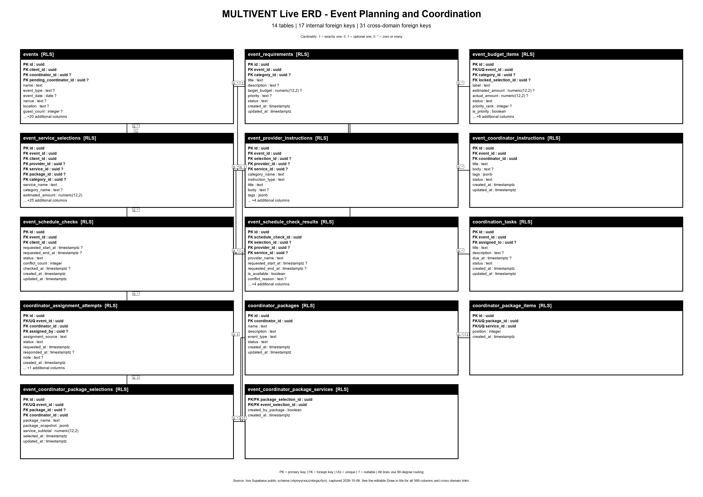
Source: MULTIVENT live Supabase public schema, captured 2026-10-08.

Figure 5. MULTIVENT ERD - Booking and Finance
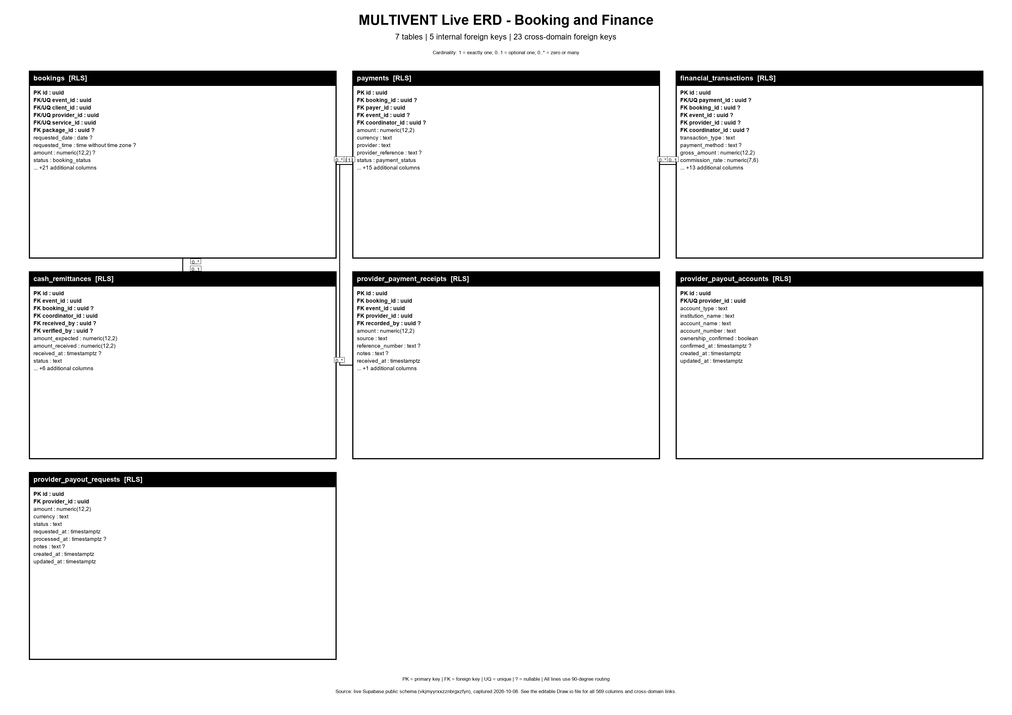
Source: MULTIVENT live Supabase public schema, captured 2026-10-08.

Figure 6. MULTIVENT ERD - Communication, Feedback, and Operations
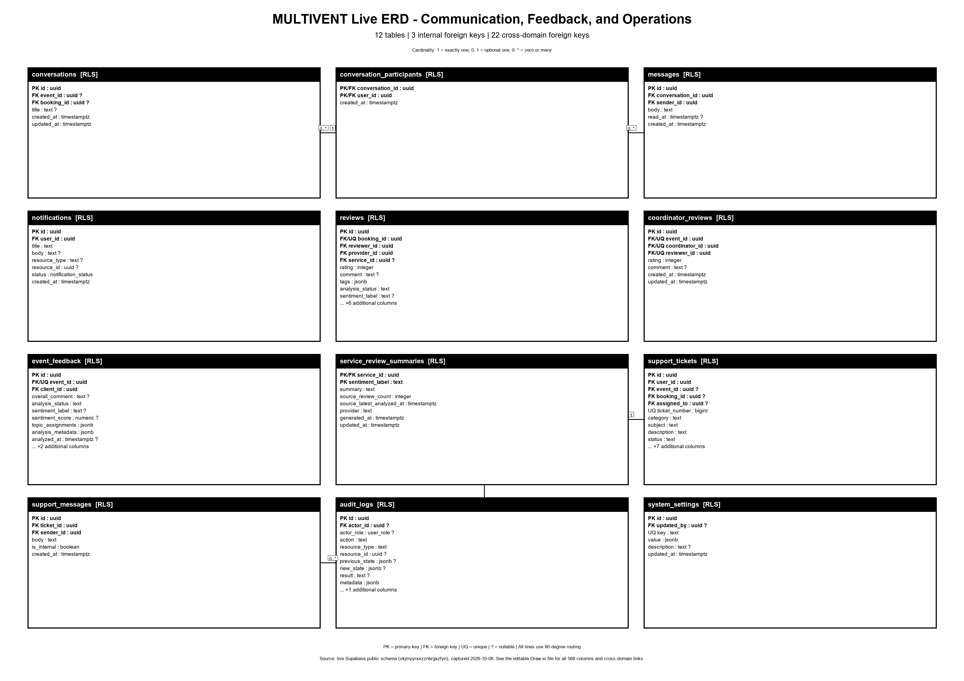
Source: MULTIVENT live Supabase public schema, captured 2026-10-08.

