MULTIVENT ERD - Overview
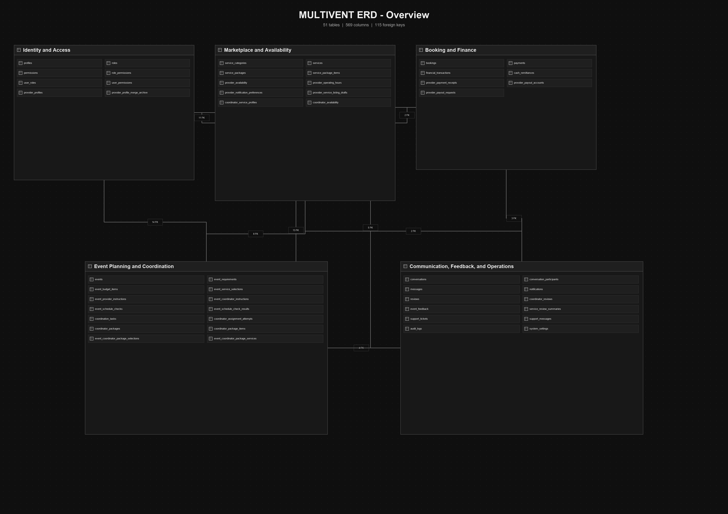

MULTIVENT ERD - Identity and Access
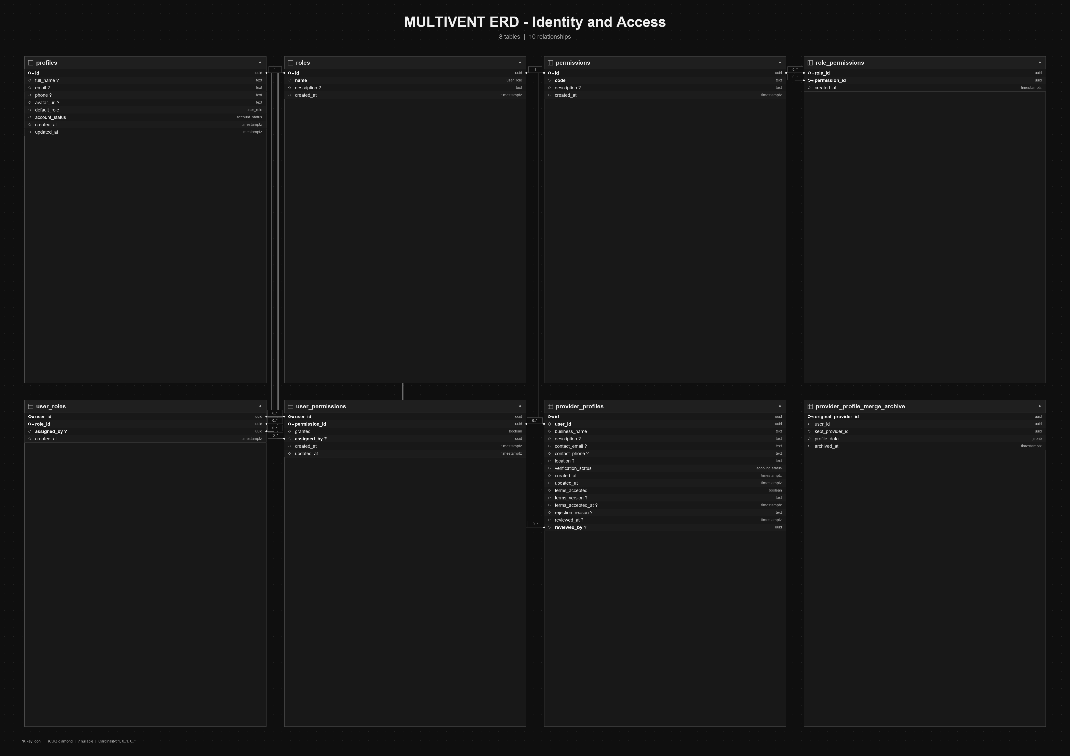

MULTIVENT ERD - Marketplace and Availability
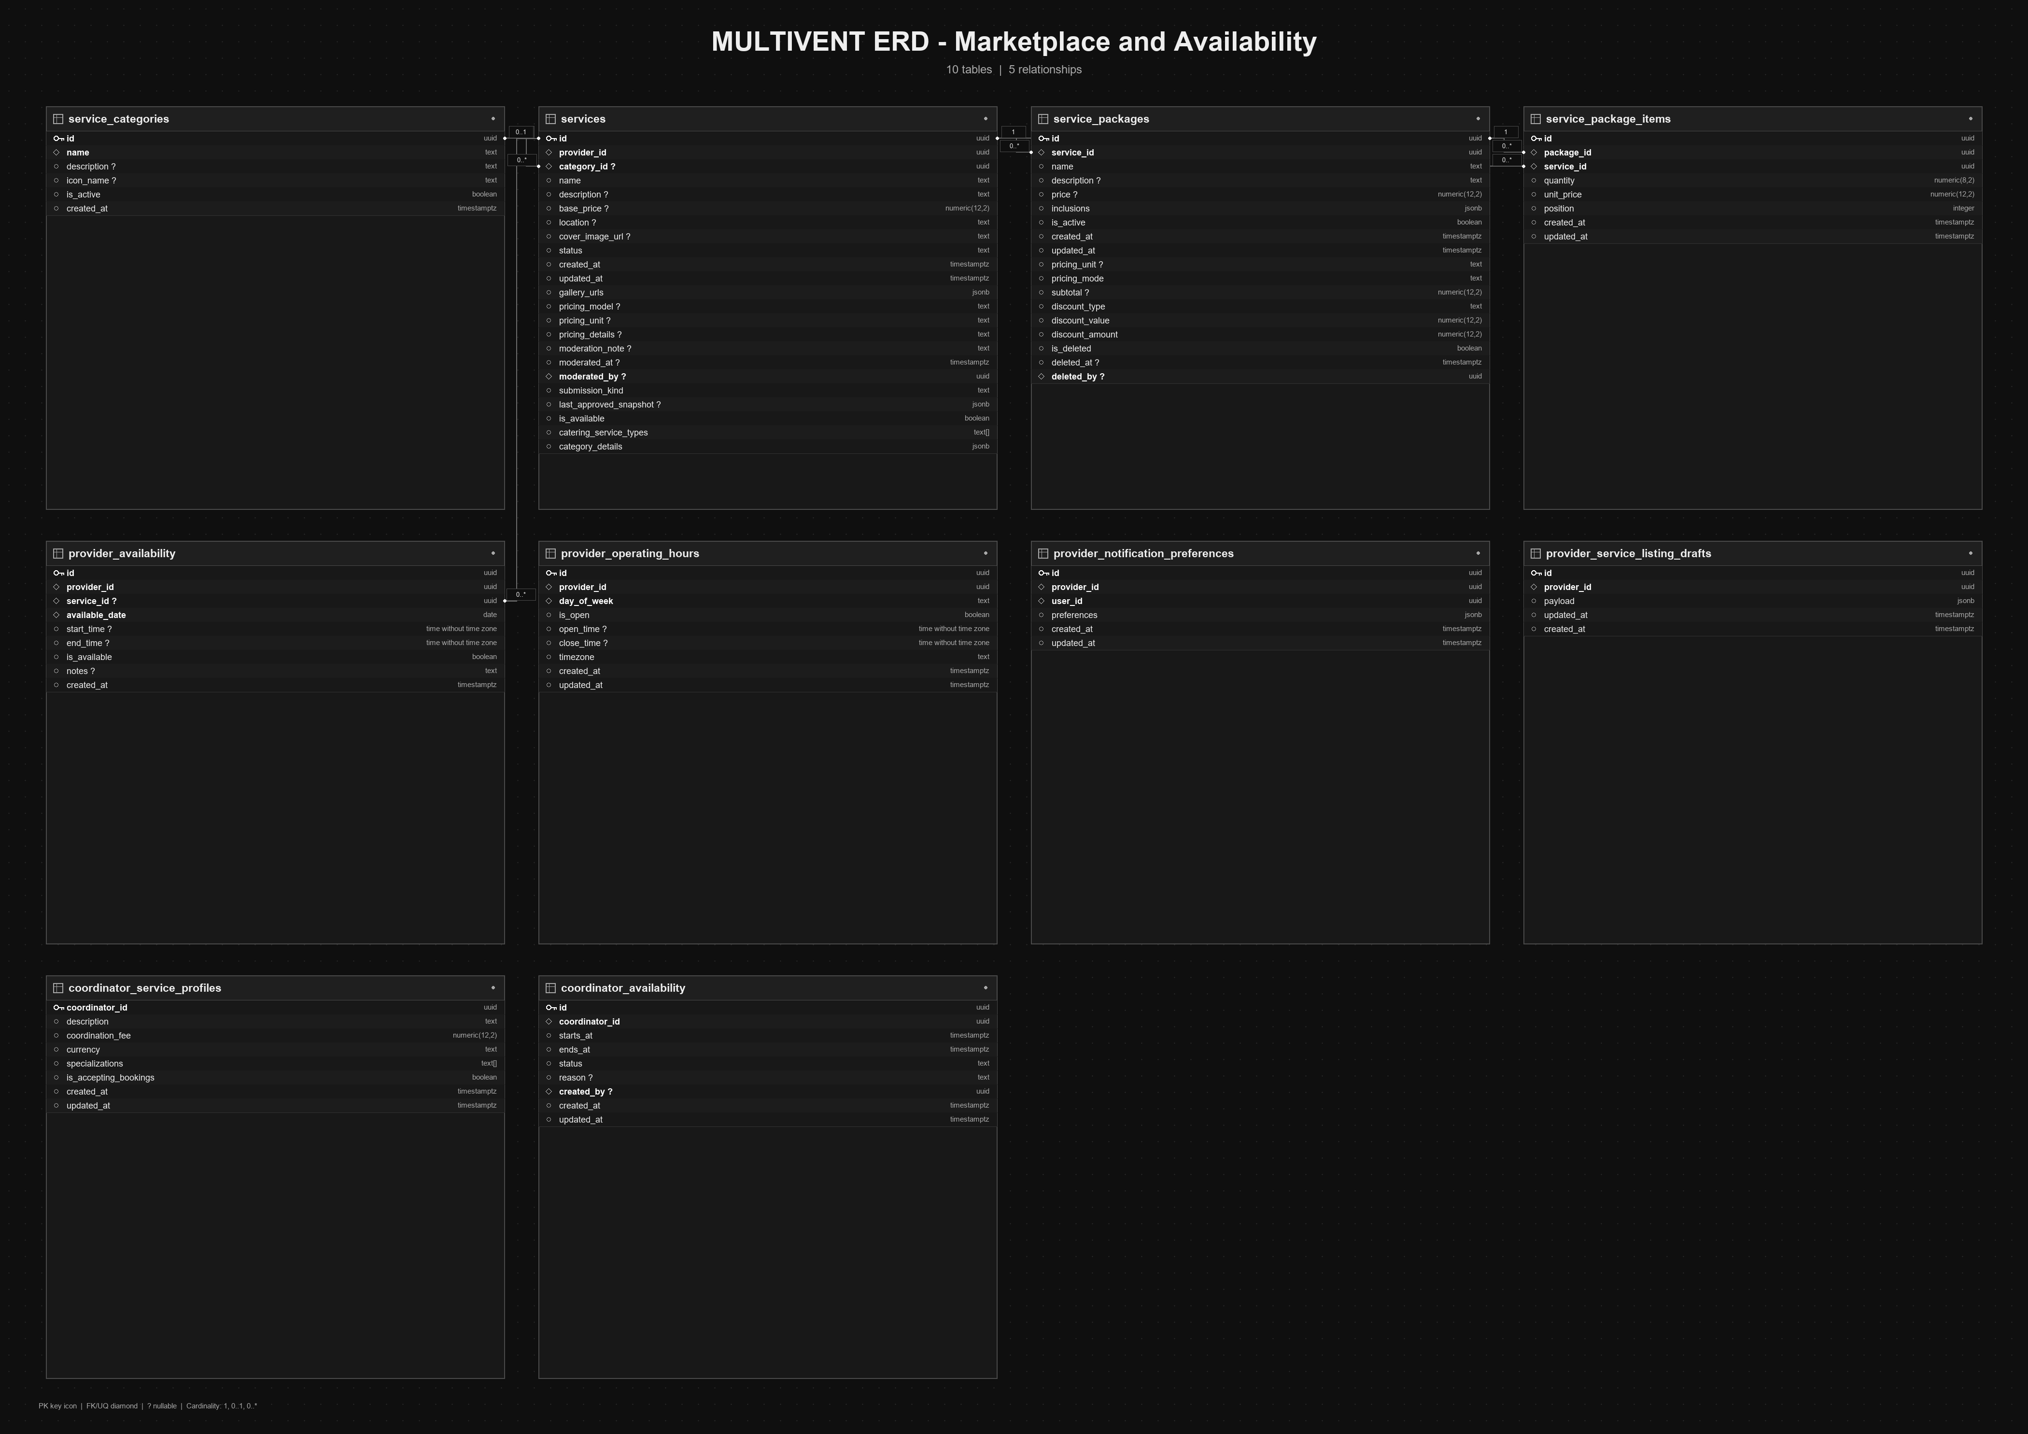

MULTIVENT ERD - Event Planning and Coordination
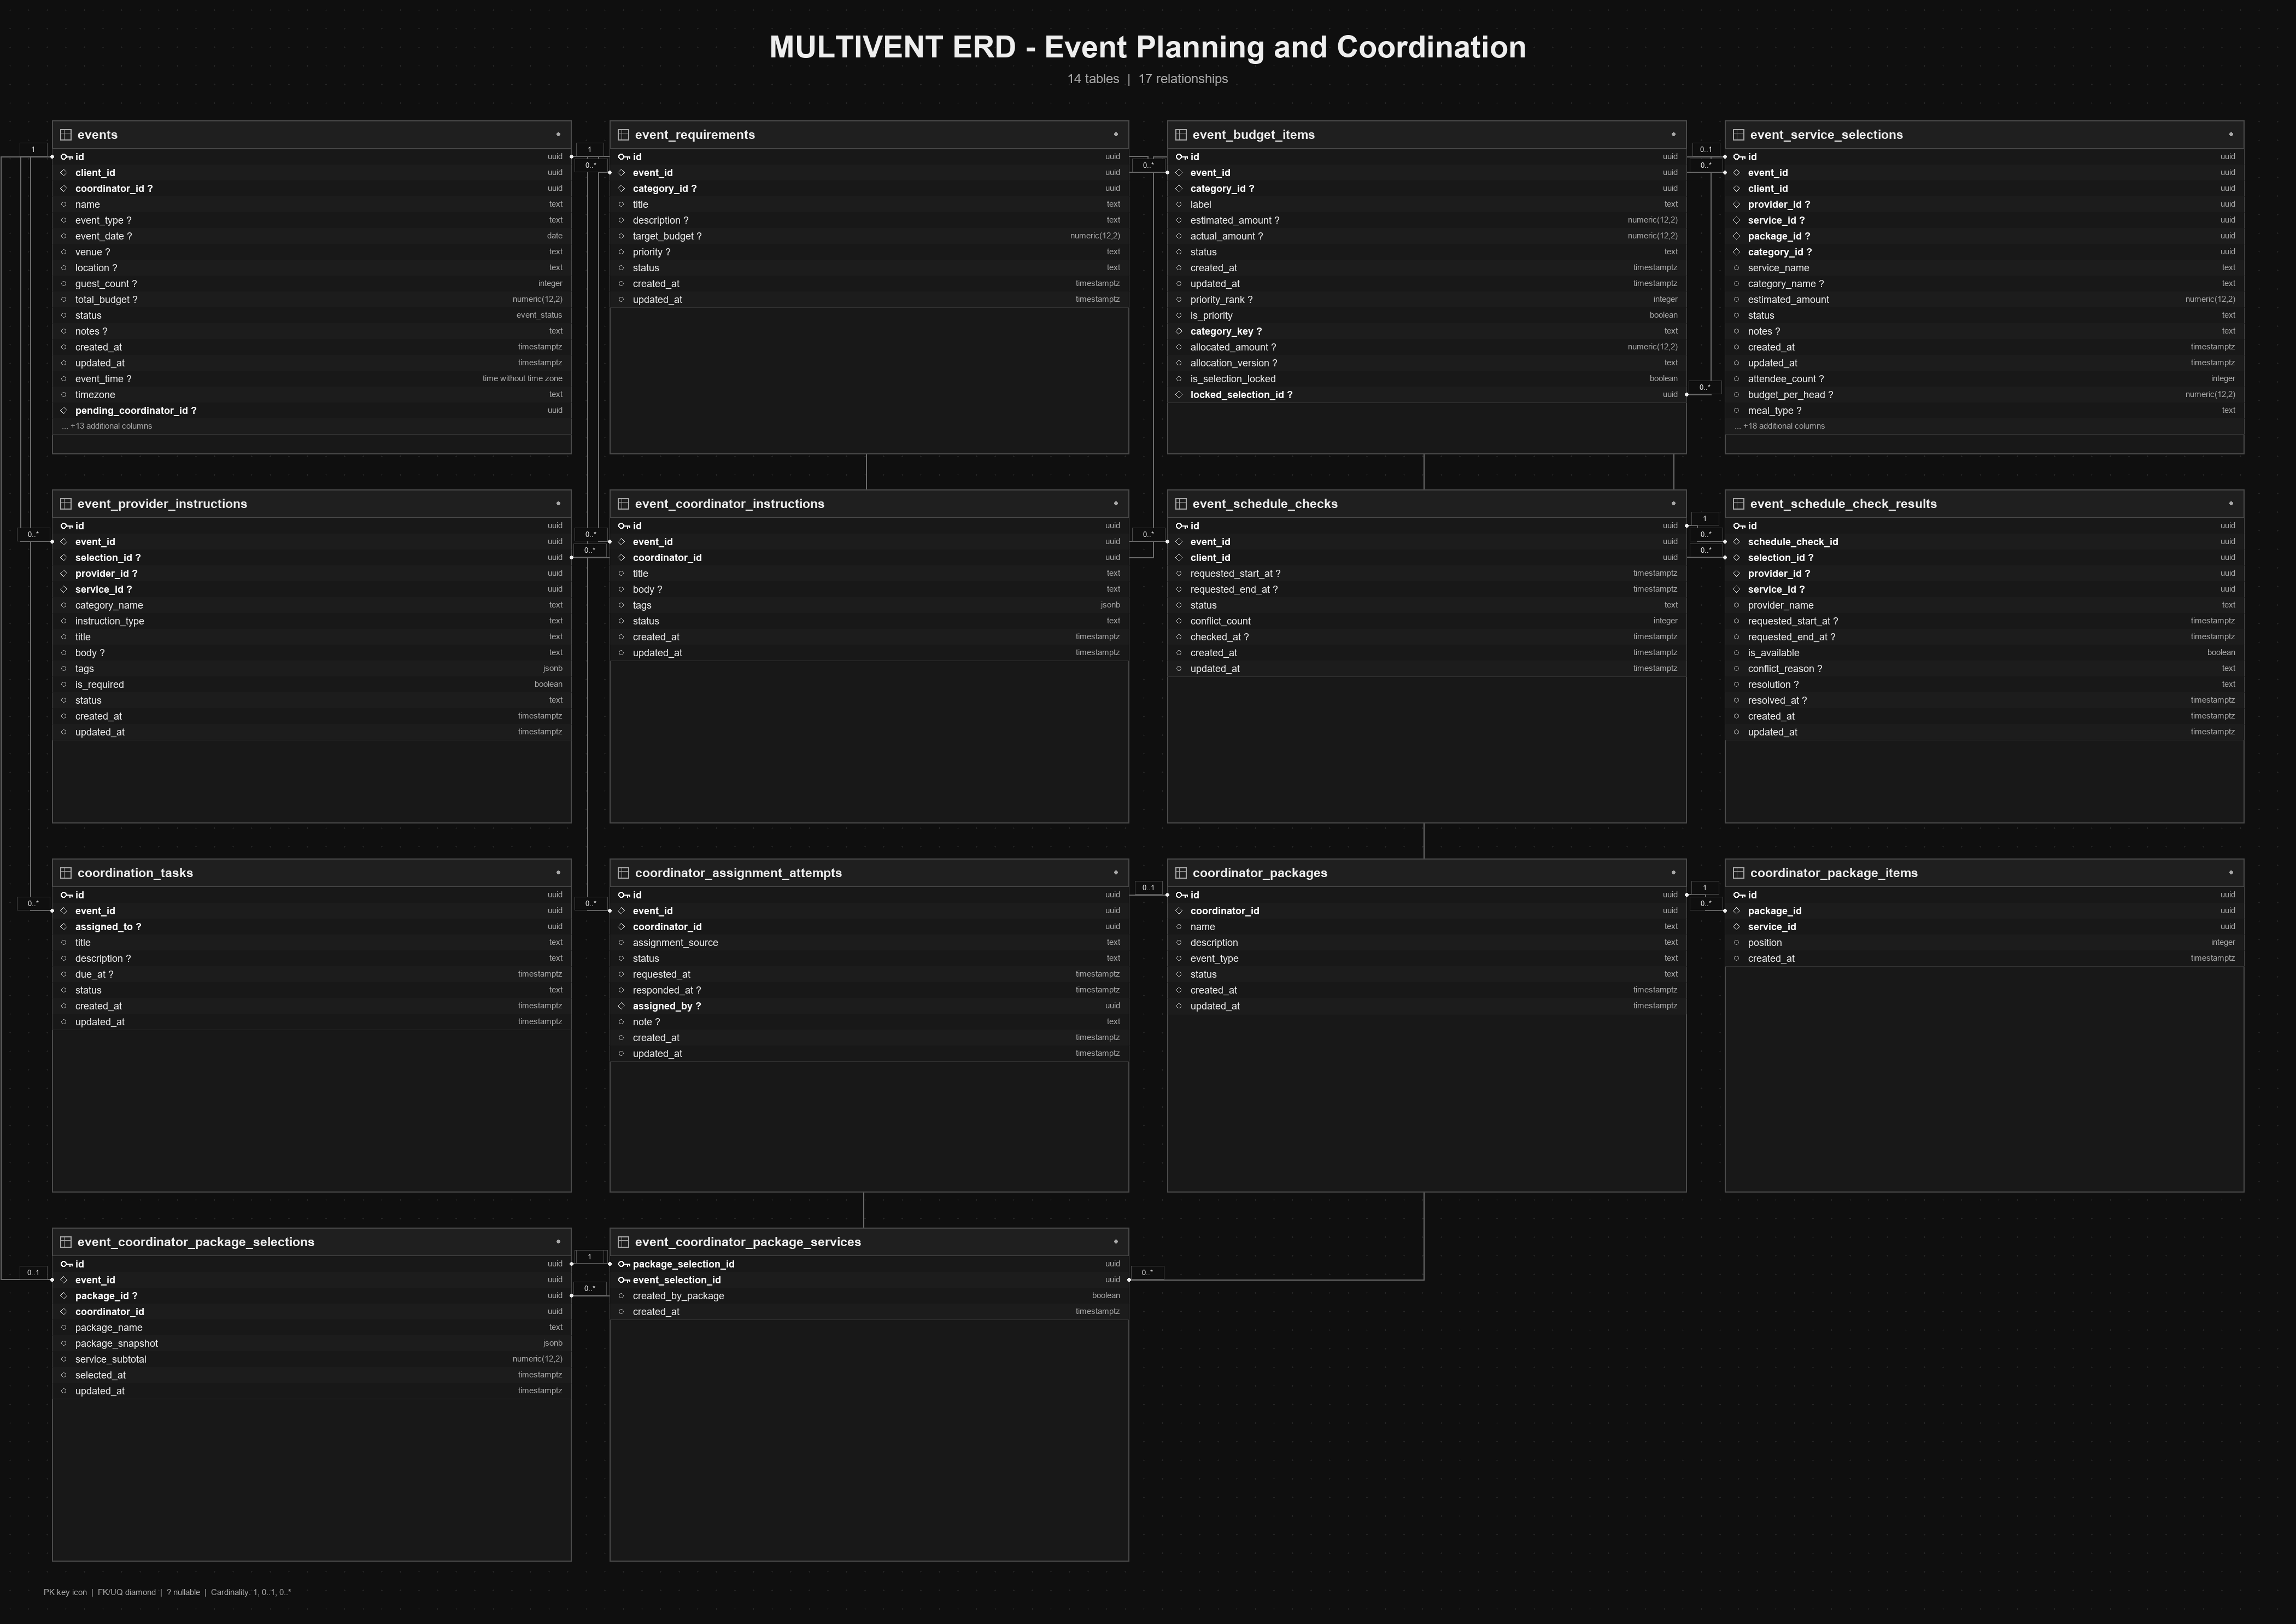

MULTIVENT ERD - Booking and Finance
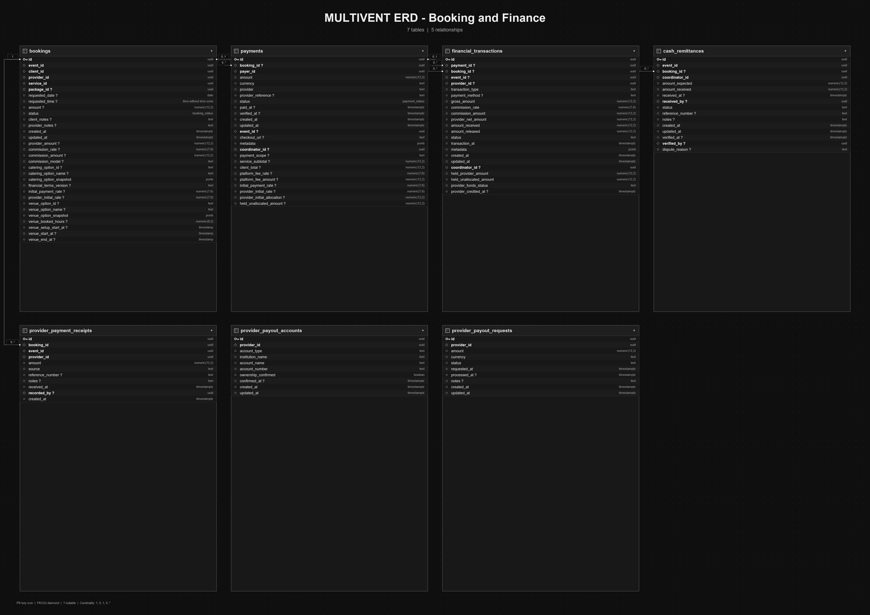

MULTIVENT ERD - Communication, Feedback, and Operations
