MULTIVENT ERD - Overview
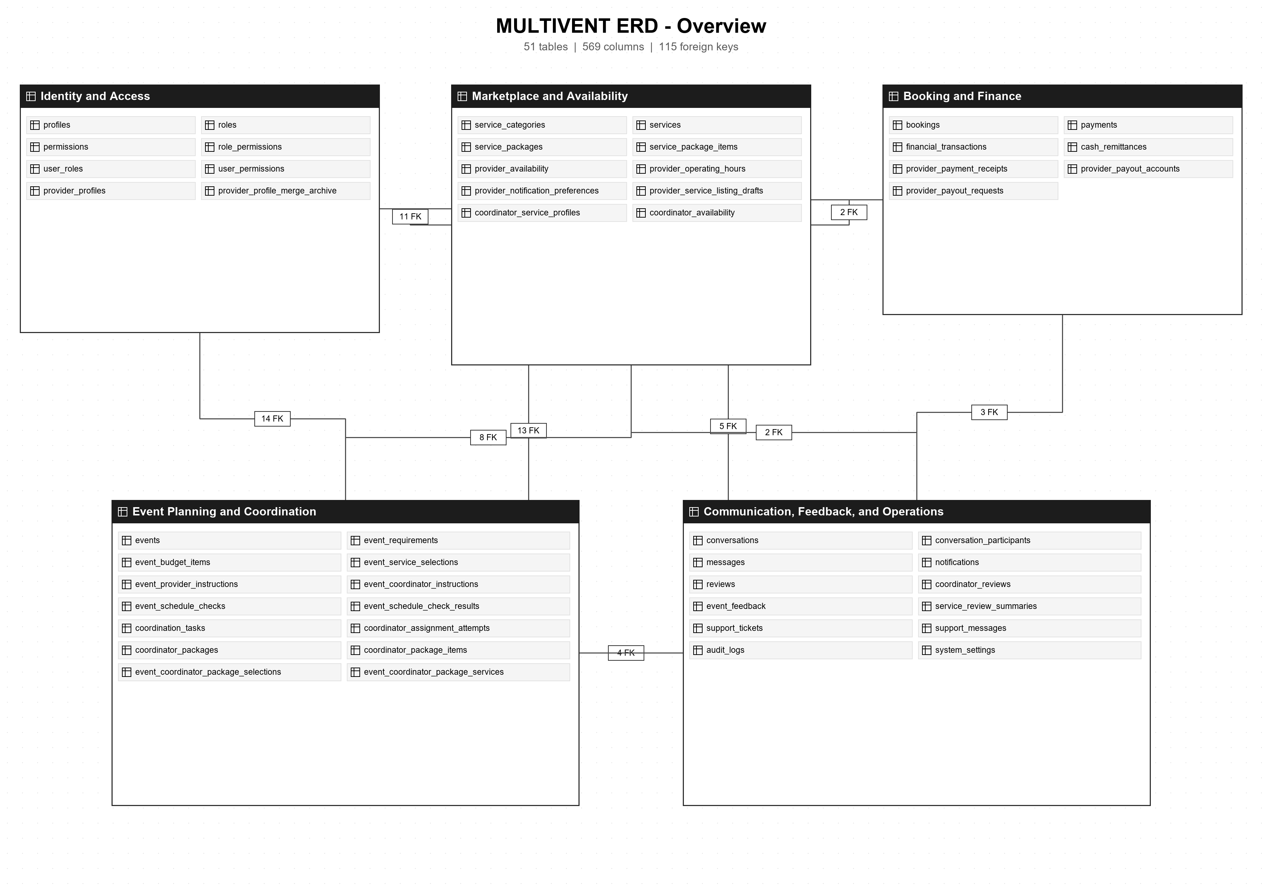

MULTIVENT ERD - Identity and Access (1 of 2)
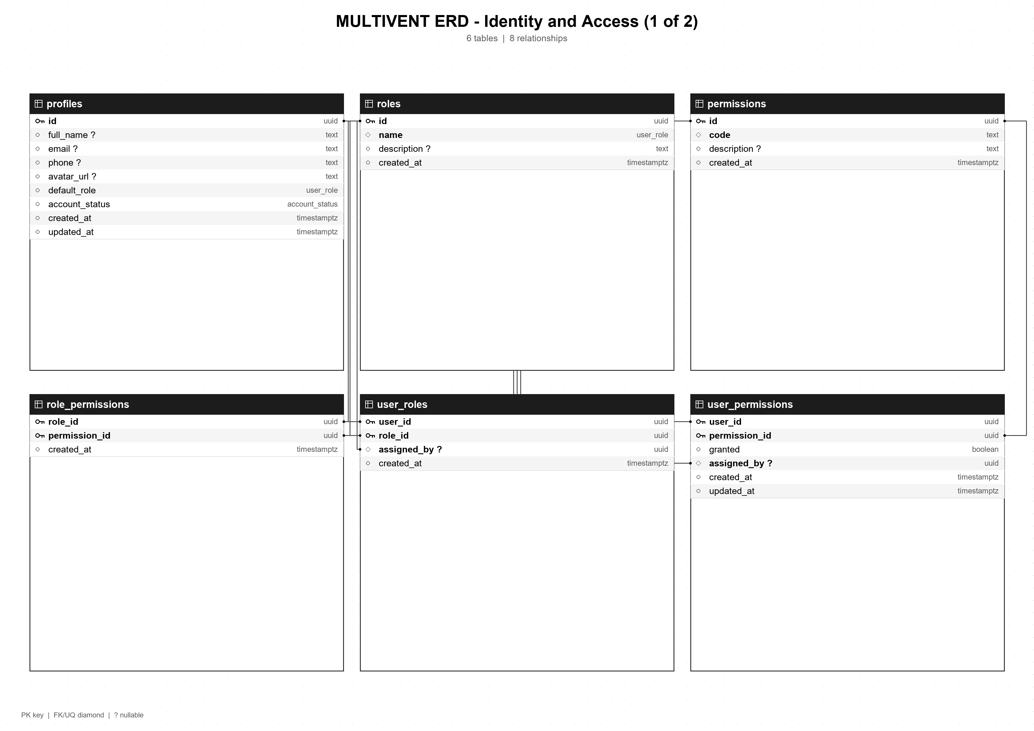

MULTIVENT ERD - Identity and Access (2 of 2)
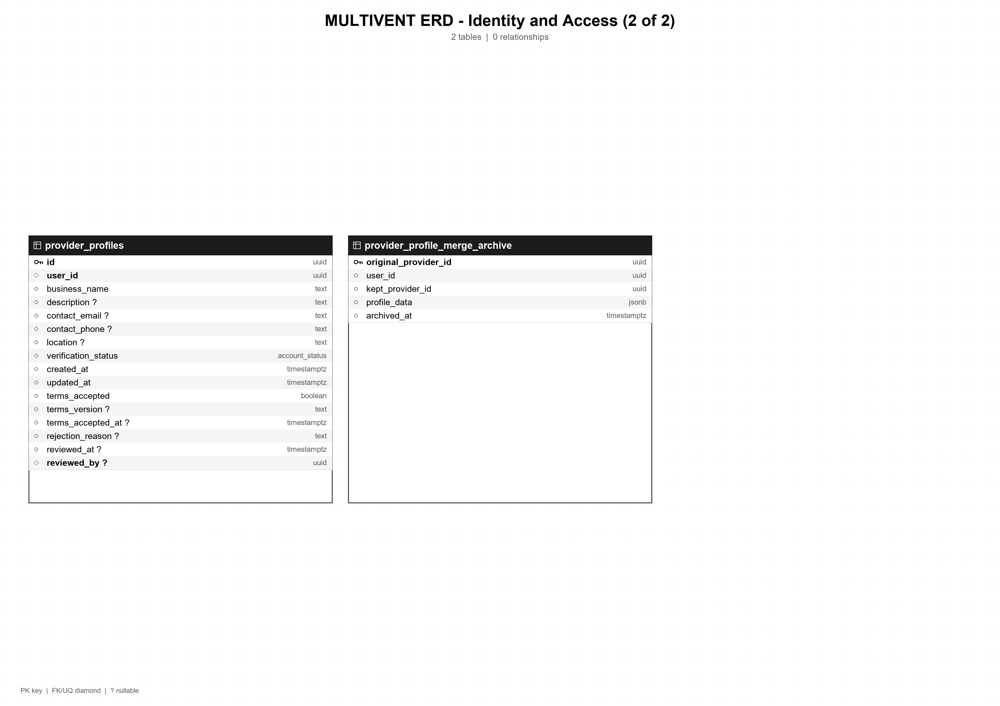

MULTIVENT ERD - Marketplace and Availability (1 of 2)
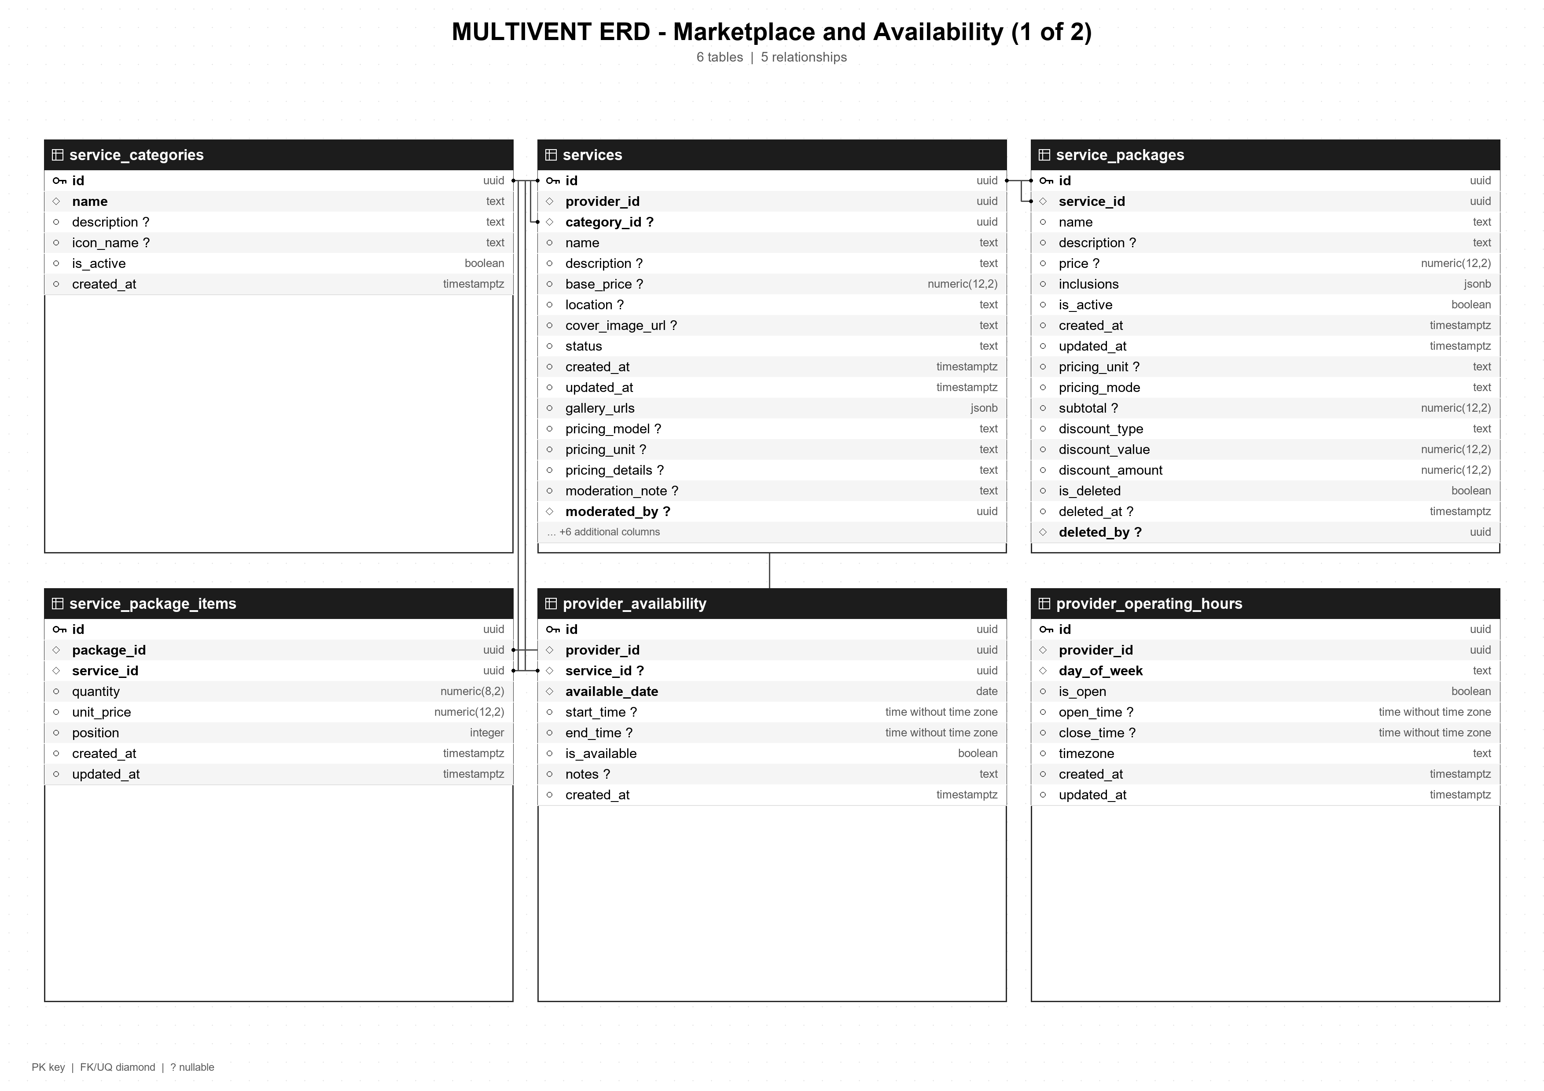

MULTIVENT ERD - Marketplace and Availability (2 of 2)
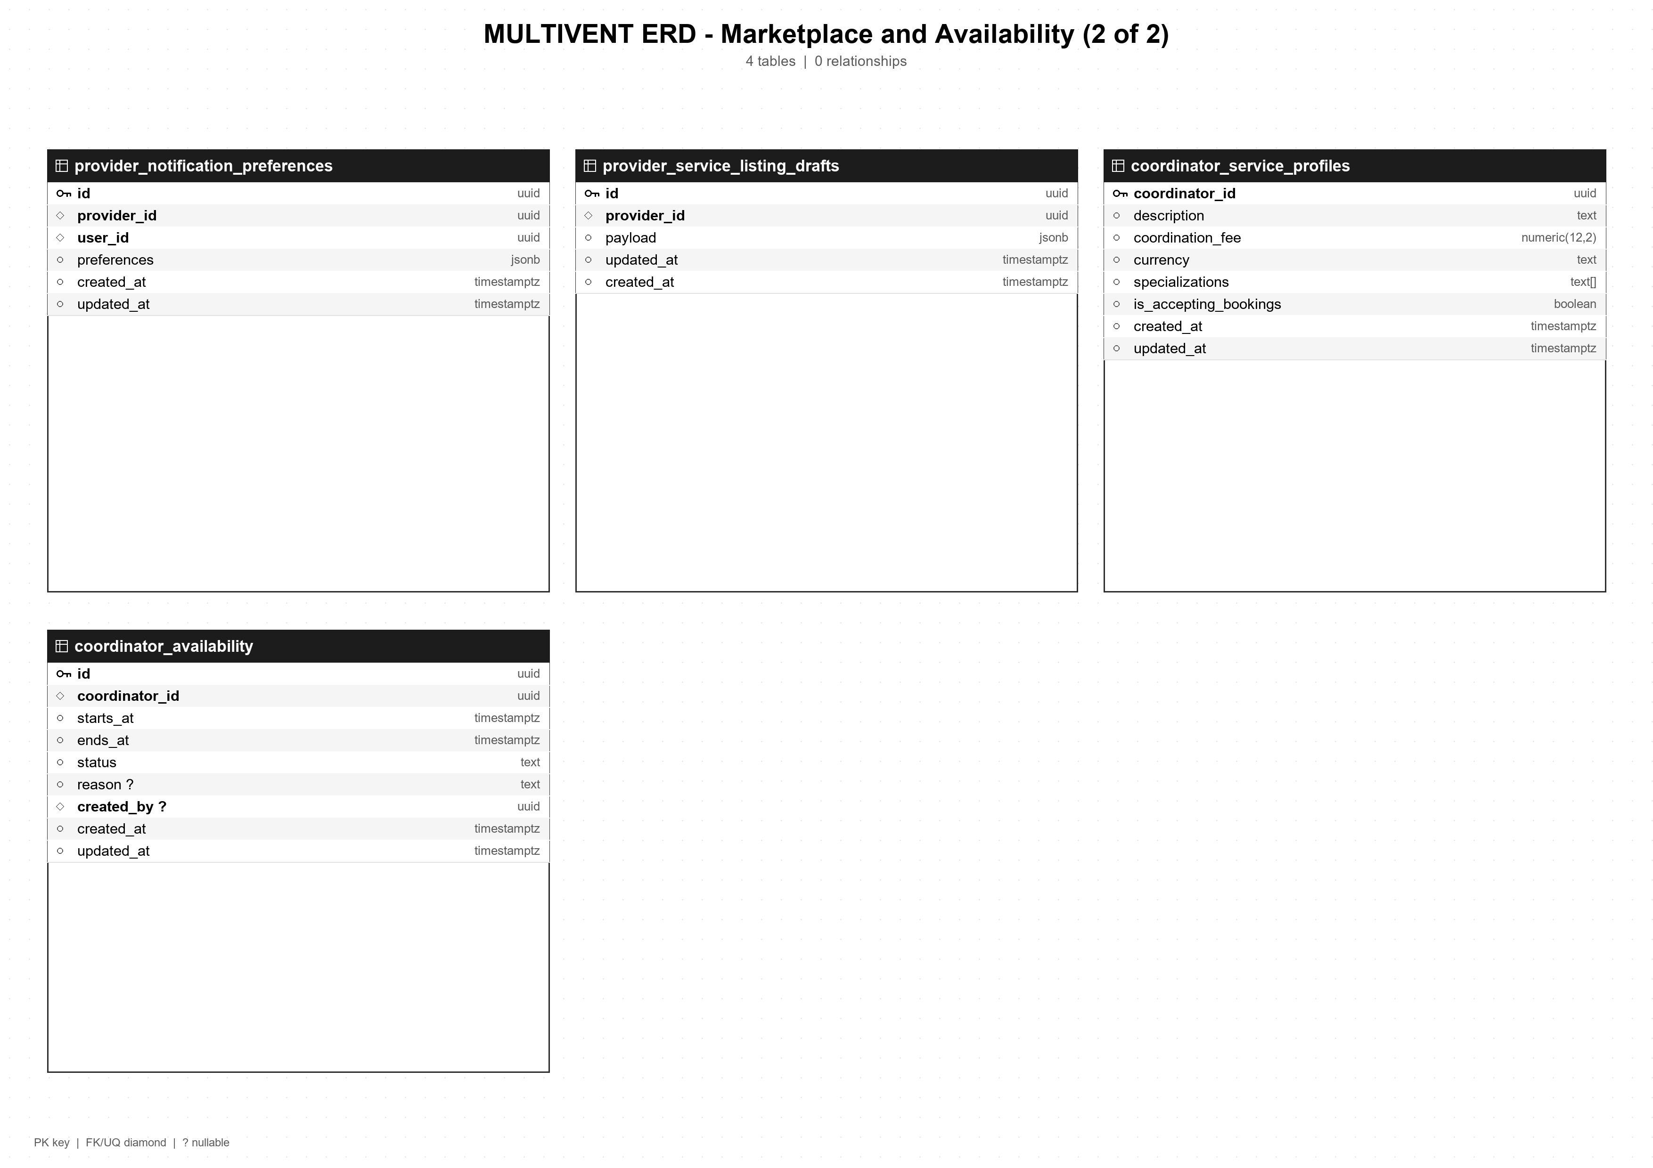

MULTIVENT ERD - Event Planning and Coordination (1 of 3)
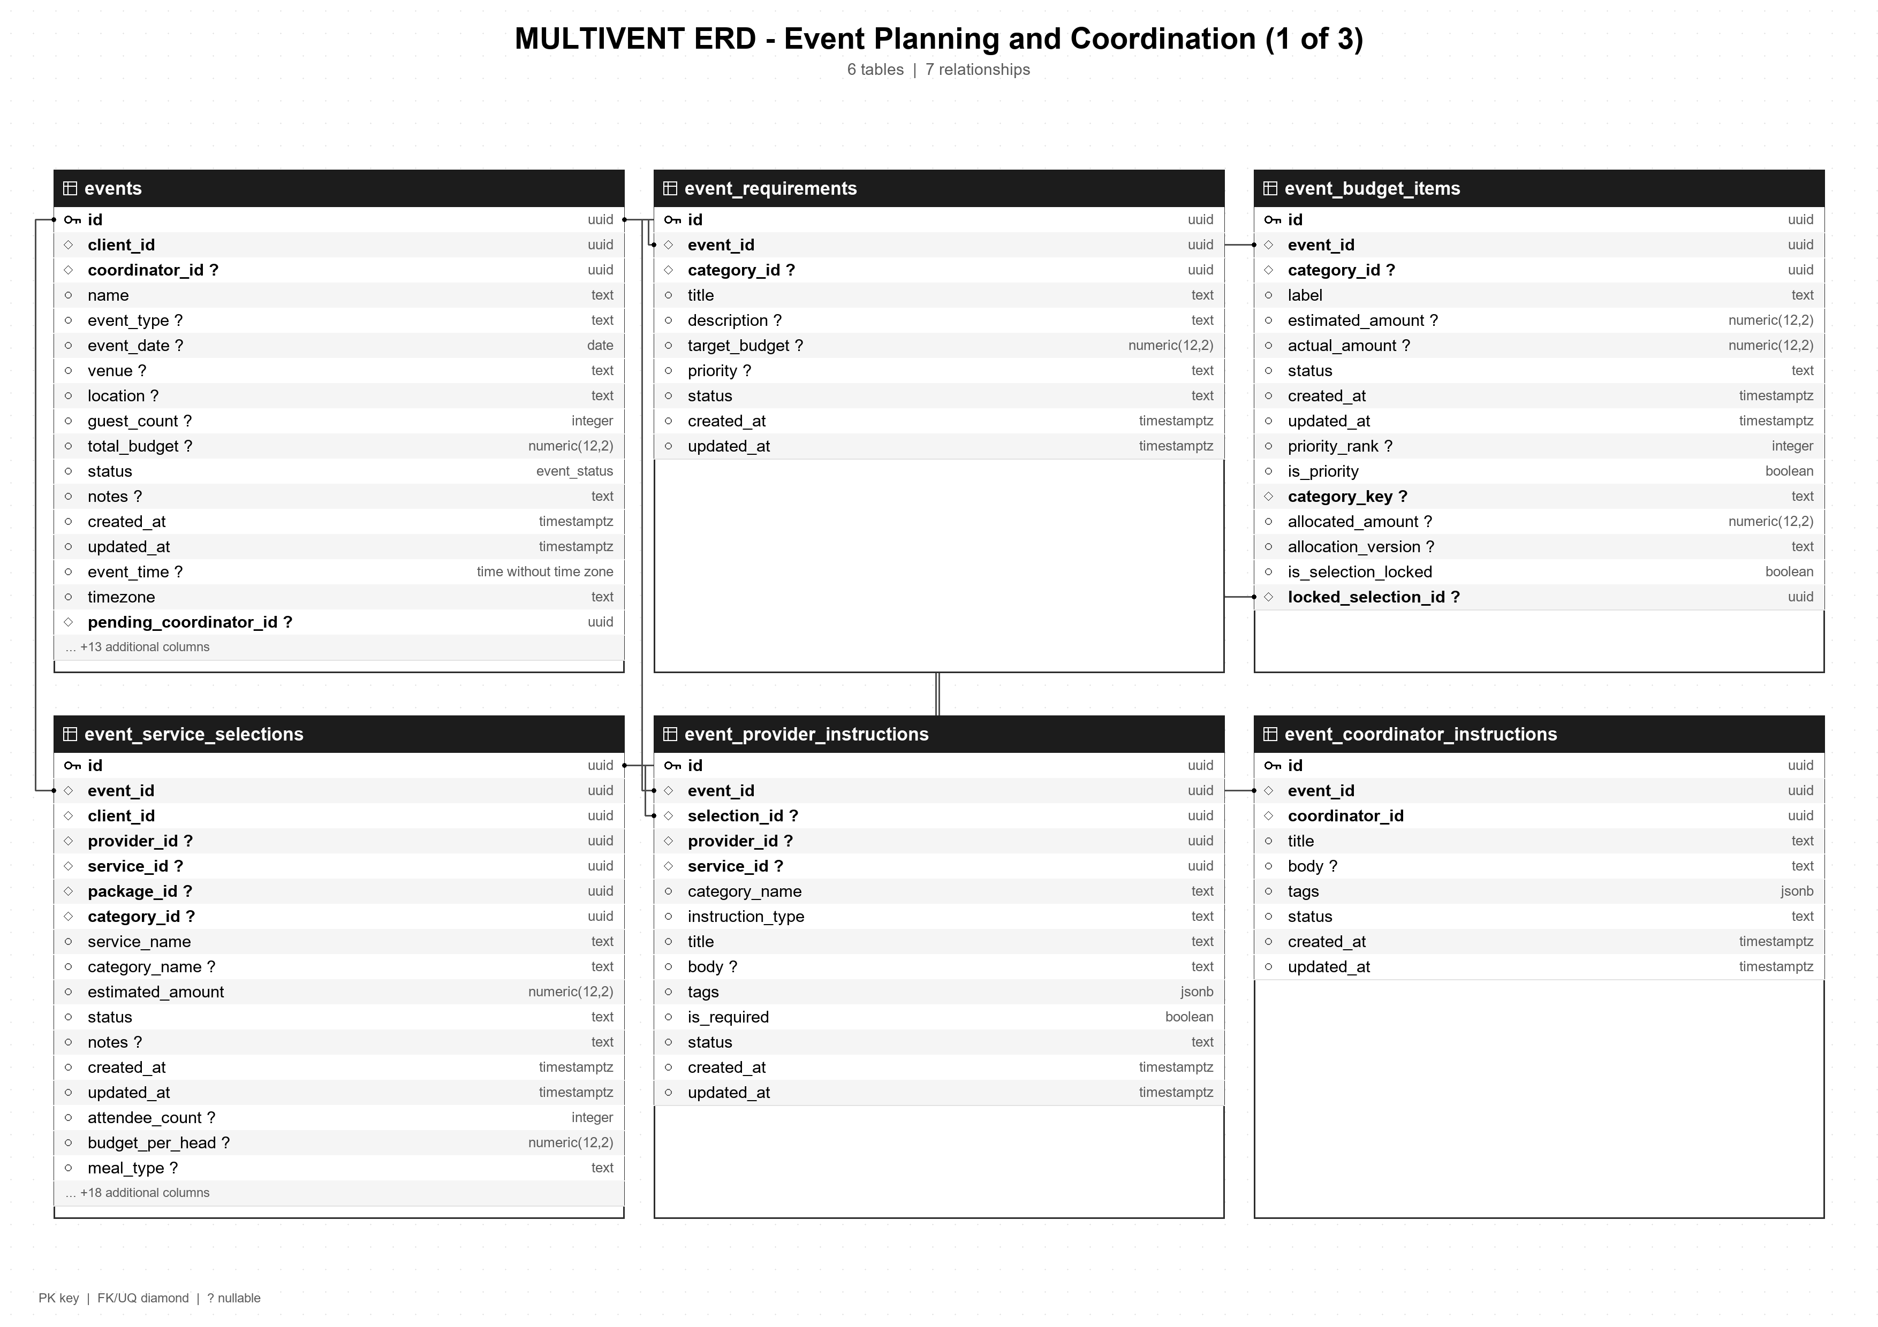

MULTIVENT ERD - Event Planning and Coordination (2 of 3)
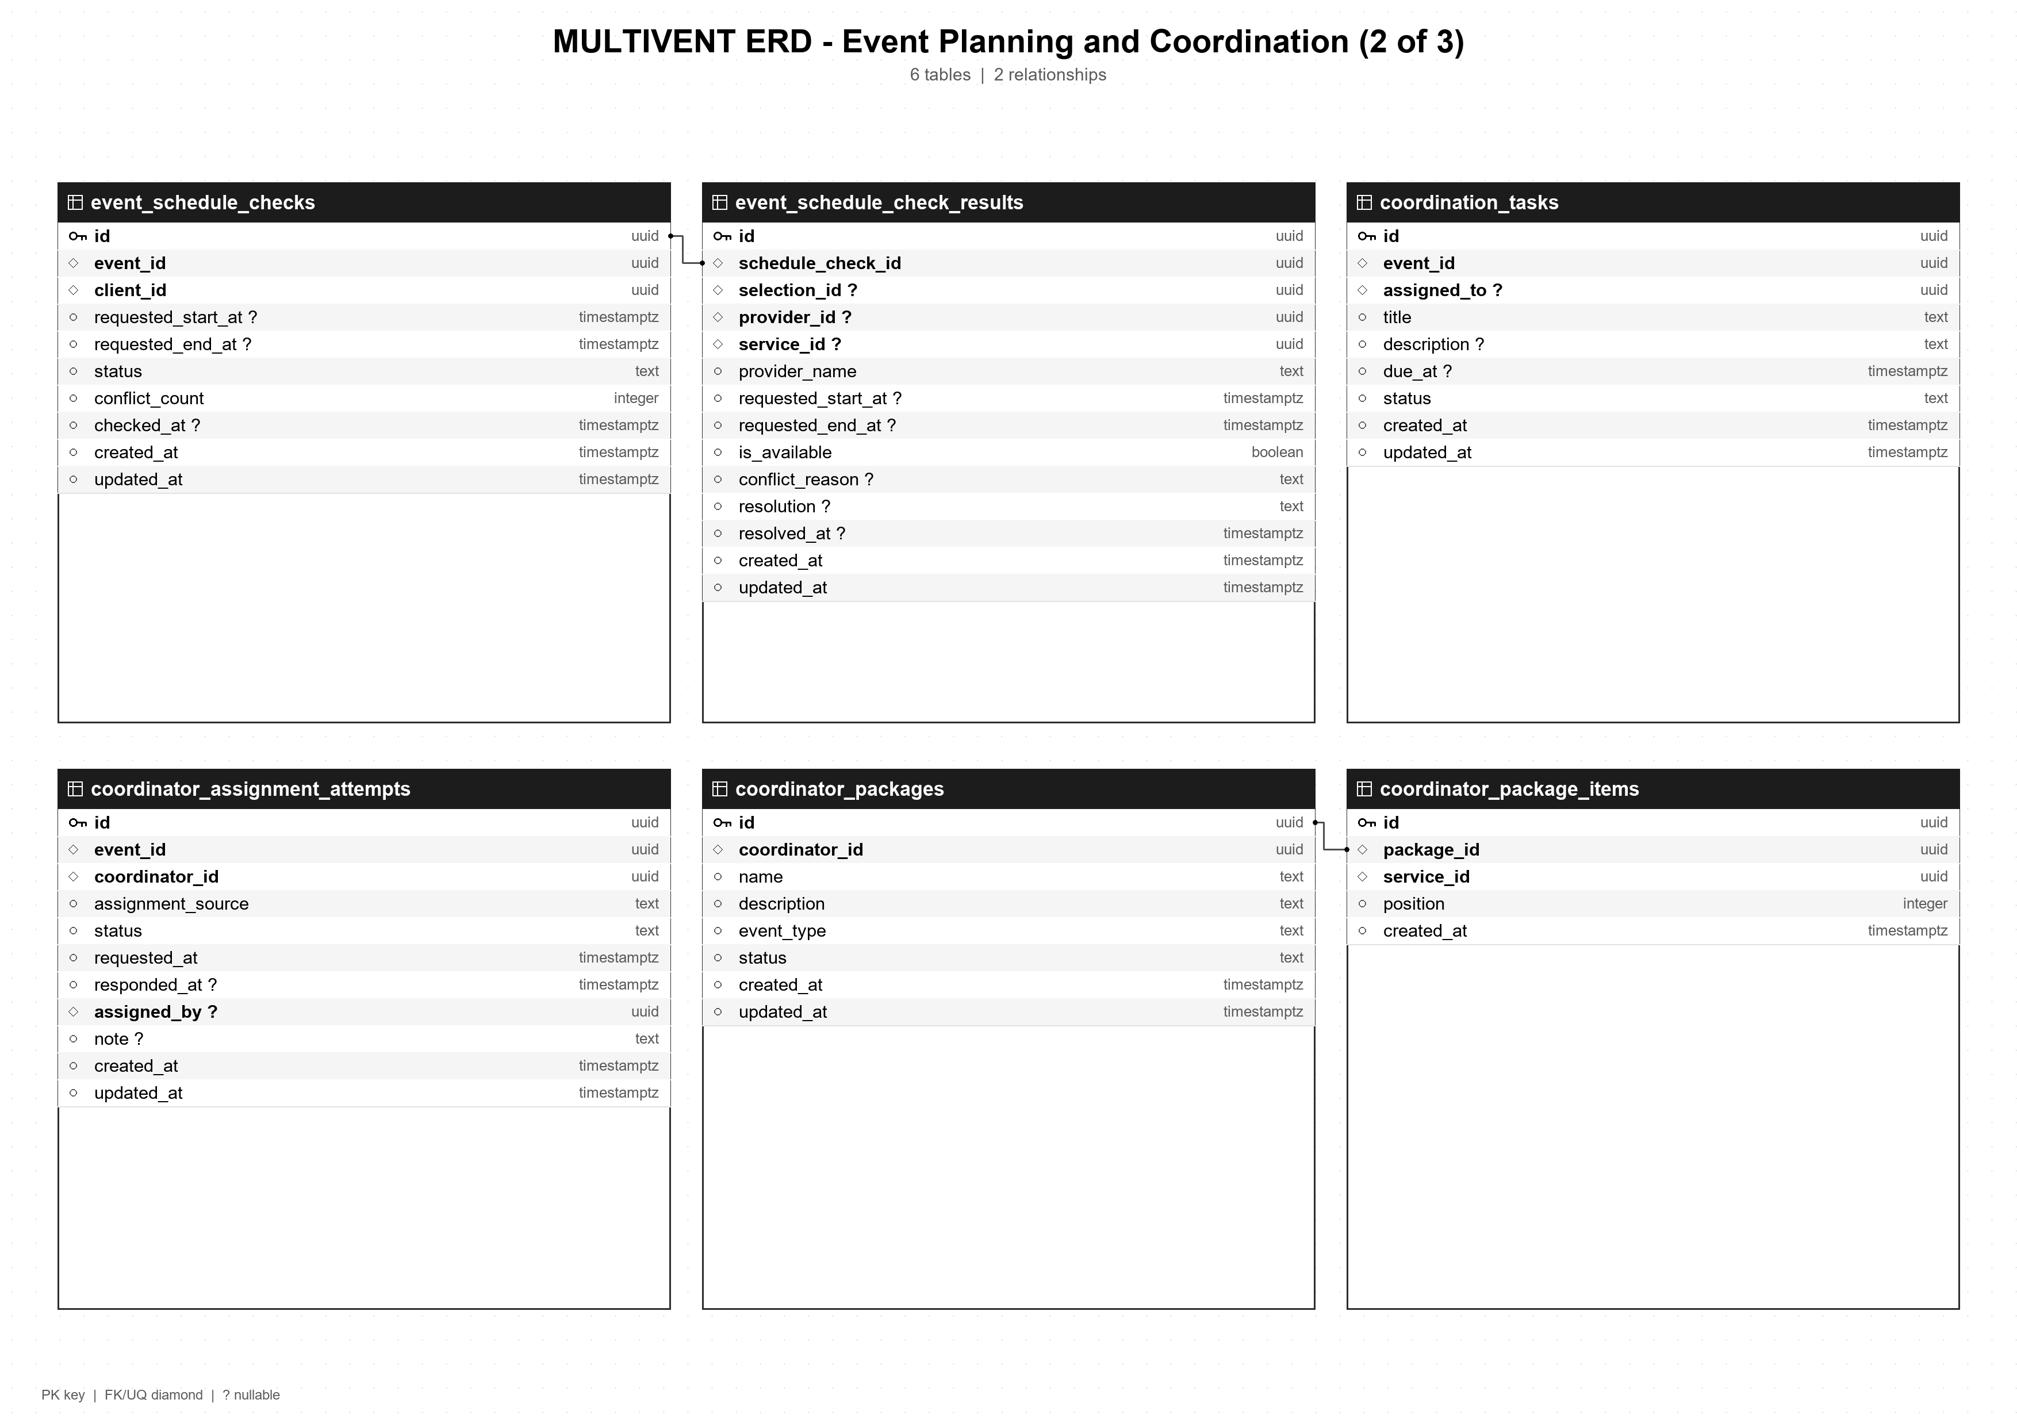

MULTIVENT ERD - Event Planning and Coordination (3 of 3)
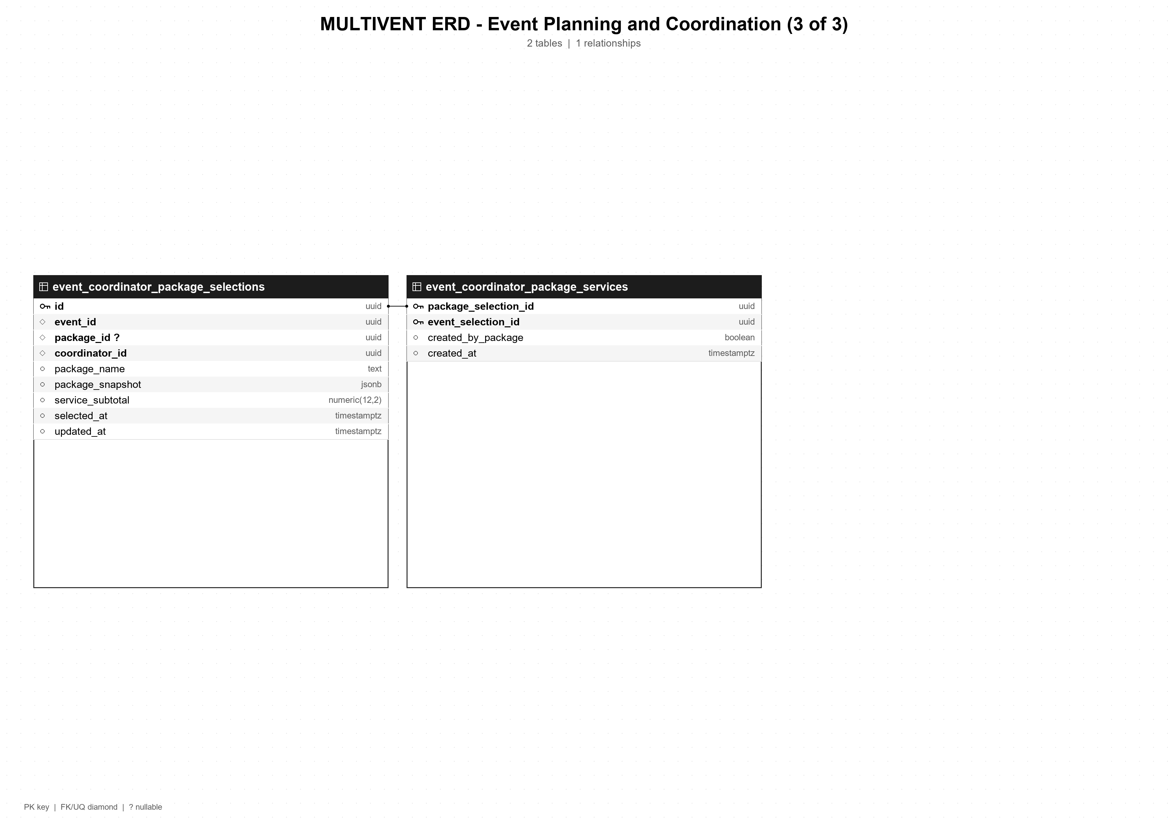

MULTIVENT ERD - Booking and Finance (1 of 2)
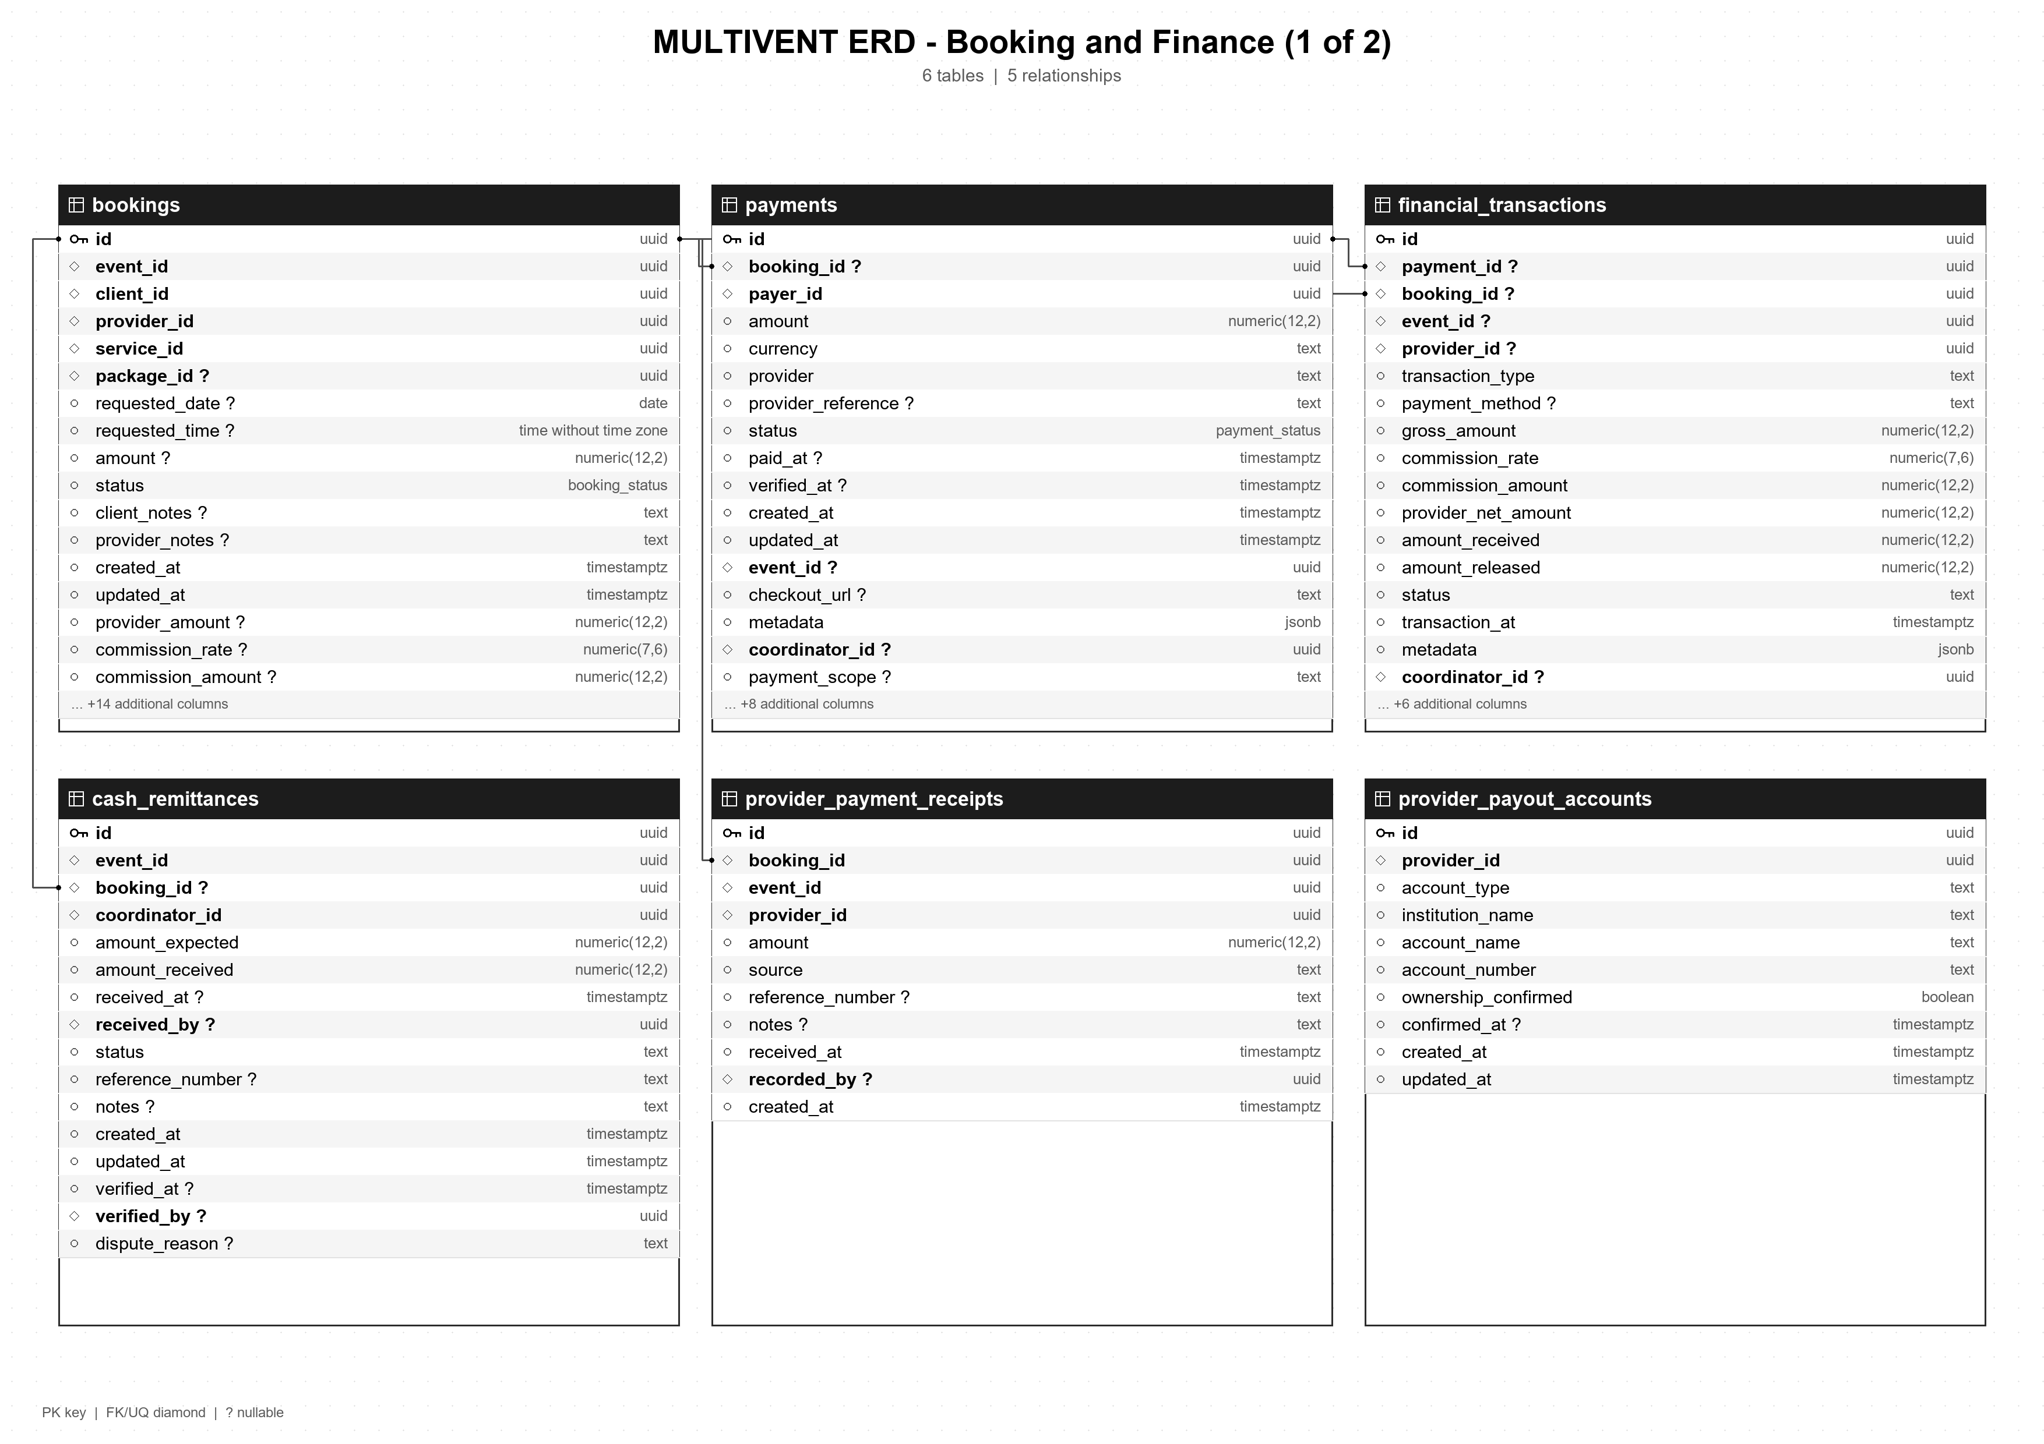

MULTIVENT ERD - Booking and Finance (2 of 2)
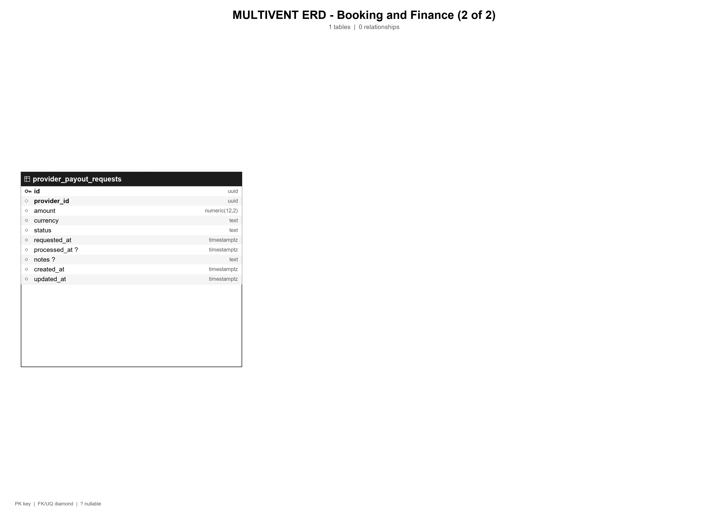

MULTIVENT ERD - Communication, Feedback, and Operations (1 of 2)
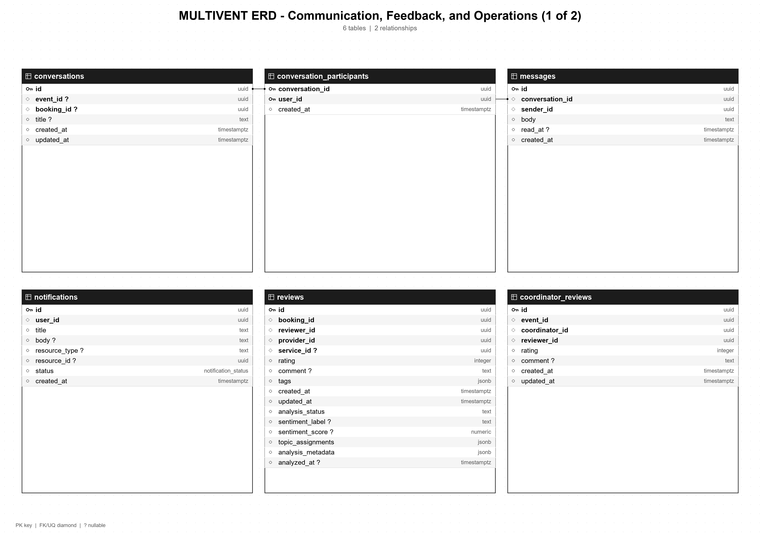

MULTIVENT ERD - Communication, Feedback, and Operations (2 of 2)
