3.2 Machine Learning Methodology
MULTIVENT applies a hybrid natural language processing pipeline to optional written comments submitted by clients after a booked service has been completed. The objective is to classify each non-empty comment as positive or negative, identify its dominant topic, retain traceable retrieval evidence, and present grouped feedback on the service page. Star ratings are stored and reported separately; they are not used to force the text sentiment label.
The term training is used carefully in this methodology. MULTIVENT fits an unsupervised Latent Dirichlet Allocation (LDA) topic model and constructs a training-only FAISS retrieval index. It does not train or fine-tune a supervised sentiment classifier. The recorded final sentiment verdict is produced by a configured pre-trained OpenAI model, augmented with LDA topic context and labeled examples retrieved from the local corpus. A weighted-neighbor classifier is implemented as a provisional local fallback.

3.2.1 Machine Learning Methodology
The methodology separates offline corpus preparation from online inference. Offline processing registers and validates four documented datasets, standardizes binary labels, removes invalid and duplicate units, assigns leakage-safe partitions, and measures event-service relevance. Only domain-relevant training rows are used to fit LDA and create the balanced retrieval index. Validation and test records are never inserted into either training artifact.
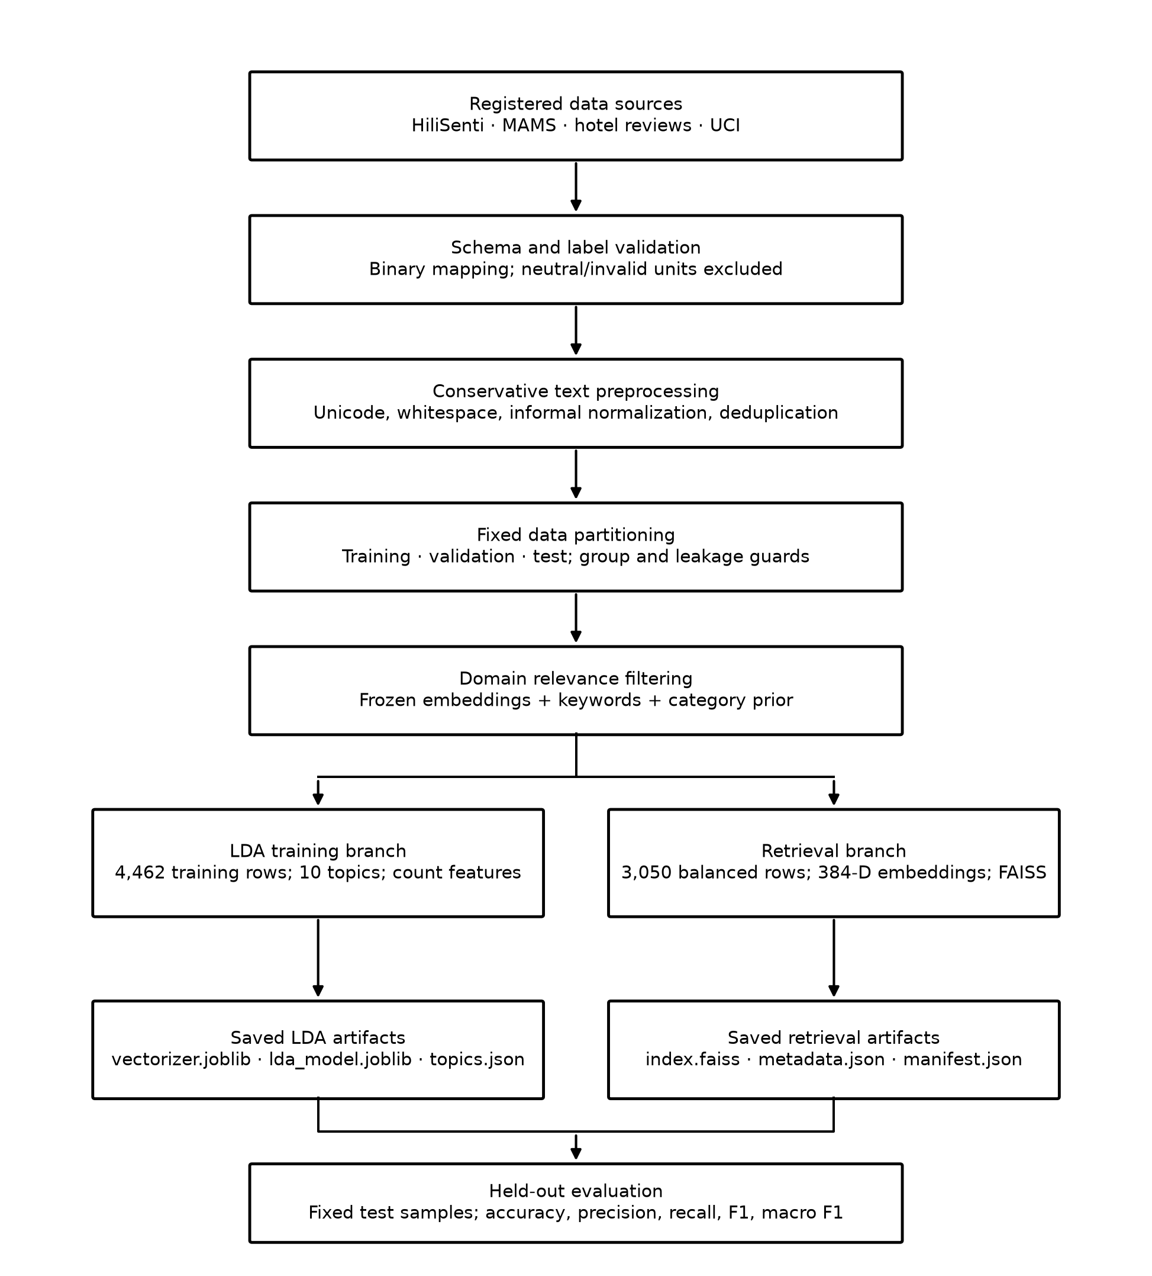
Figure 3.2-1. MULTIVENT sentiment corpus preparation, model fitting, and evaluation pipeline.
At runtime, the authenticated Supabase Edge Function verifies that the signed-in client owns the submitted review and then calls the protected Python analysis API. The API normalizes the comment, infers its LDA topic, retrieves six labeled examples, and requests a schema-constrained binary verdict. The resulting label, signed score, topic, provider, confidence, language, reason, and reference provenance are stored with the review. Retrieved training sentences themselves are not copied into the application database.
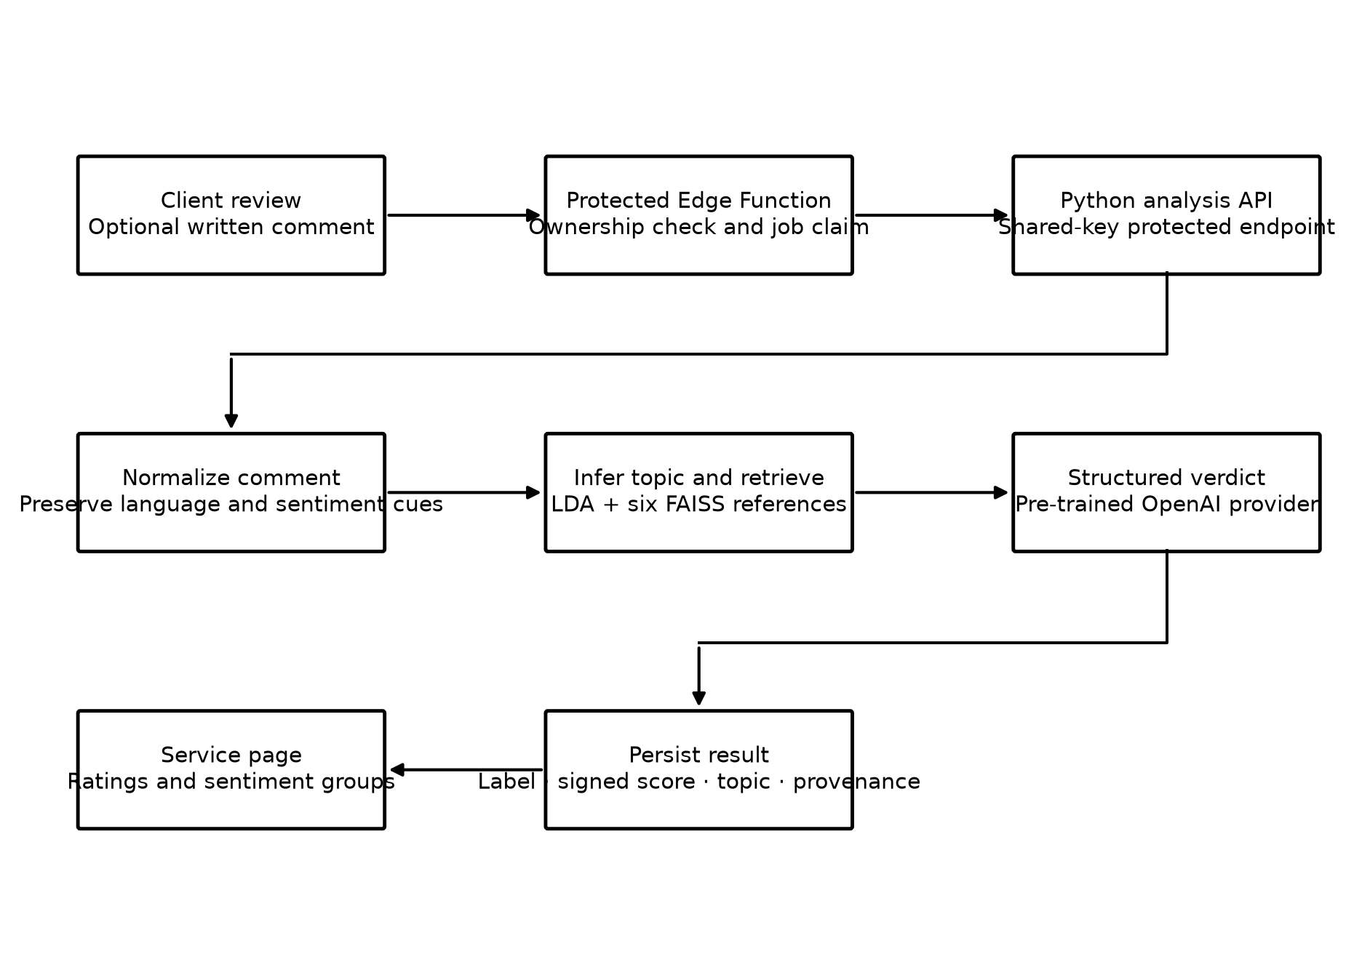
Figure 3.2-2. Runtime sentiment-analysis and application-integration flow.

3.2.2 Dataset
The corpus combines linguistic coverage from HiliSenti with service-domain coverage from restaurant and hospitality datasets. The registry pins repository revisions when available and records authorship, source URL, mapping rules, and license. No live marketplace website is scraped by the preparation pipeline.
Table 3.2-1. Registered source datasets.
Source | Records | Language/domain role | License
HiliSenti v1 | 23,337 | Hiligaynon, Filipino/Tagalog, English, and code-switched coverage | CC BY-NC-SA 4.0
MAMS ACSA | 3,000 | English restaurant and service aspects | Apache 2.0
Crawl Feeds Booking Hotel Reviews | 4,367 | English hospitality and venue/service reviews | CC BY-NC 4.0
UCI Sentiment Labelled Sentences — restaurant subset | 1,000 | English restaurant/service sentences | CC BY 4.0
Total | 31,704 | Original source records examined | —

Source-record counts are not identical to candidate-text counts. One hotel review can yield separate positive and negative units. After schema validation, label mapping, exclusions, and exact deduplication, the complete binary corpus contains 23,171 valid text units. Neutral HiliSenti records (7,154) are excluded rather than relabeled.
Table 3.2-2. Generated corpus artifacts and their roles.
Artifact | Rows | Purpose
all_binary.csv | 23,171 | All valid, deduplicated positive/negative units
domain_filtered.csv | 5,649 | Units meeting the event/service relevance threshold
lda_train.csv | 4,462 | Training-only text used to fit LDA
rag.csv | 3,050 | Balanced training-only references indexed by FAISS
validation.csv | 2,376 | Held-out validation records
evaluation_hilisenti.csv | 1,594 | Held-out HiliSenti test records
evaluation_domain.csv | 790 | Held-out hospitality/restaurant test records

The standardized CSV files contain 25 attributes: id, text_original, text_clean, sentiment, source_dataset, source_record_id, source_domain, language, split, aspect, license, source_url, text_hash, original_text_hash, source_name, language_basis, source_split, pool, label_basis, group_id, domain_relevance_score, domain_semantic_similarity, domain_keyword_score, domain_irrelevant_penalty, and domain_keyword_hits. These fields preserve the original text, target label, partition, source provenance, grouping information, and explainable domain-filtering evidence.
The main generated datasets are UTF-8 CSV files. Raw inputs include CSV, Parquet, and a ZIP archive containing the UCI restaurant text file. JSON stores manifests, checksums, parameters, and evaluation reports. LDA artifacts are serialized with joblib, while semantic references are stored in a FAISS binary index with JSON metadata.

3.2.3 Data Preprocessing
Preprocessing is conservative because the corpus contains Hiligaynon, Filipino/Tagalog, English, and code-switched feedback. The pipeline avoids transformations that could remove negators, particles, emojis, punctuation, or informal forms that carry sentiment. Every exclusion and normalization step is recorded for auditability.
- Schema and label validation. Only supported labels are mapped to positive or negative. Neutral, conflicting, malformed, empty, placeholder, and explicit no-complaint units are excluded with reasons.
- Missing values. Required standardized fields are populated; invalid source units are excluded instead of imputed. A blank domain_keyword_hits value means that no configured keyword matched and is not a missing target.
- Text normalization. Unicode normalization and whitespace cleanup are applied. Reviewed token-boundary dictionaries expand selected informal Filipino and Hiligaynon shortcuts. Excessive repeated letters, limited laughter forms, and reduplication patterns are normalized with an audit trail.
- Cleaning and preservation. The provider/embedding text retains case, punctuation, emojis, particles, and the original language. PII masking for email addresses and Philippine mobile numbers exists but was disabled for the recorded corpus. Names and locations are not automatically anonymized.
- Duplicate control. Case-insensitive exact fingerprints are generated using SHA-256. Exact duplicates are removed using test-before-validation-before-training priority, and contradictory duplicate labels are quarantined.
- Feature encoding. LDA uses CountVectorizer bag-of-words counts. Semantic retrieval uses normalized 384-dimensional sentence-transformer vectors.
- Outlier handling. Numerical z-score or interquartile-range removal is not applicable to the text labels. Instead, semantically irrelevant text is filtered by an explainable relevance score; malformed and contradictory records are quarantined rather than numerically clipped.
- Leakage protection. Whole review groups remain in one partition. Protected test fingerprints are rejected from LDA and RAG, and index construction fails if an evaluation collision remains.
For each comment vector v, L2 normalization is performed before similarity search. The small constant ε prevents division by zero.
$$\hat{v}=\frac{v}{max({\left\|v\right\|}_{2},ε)}$$ | (1)
where v is the original embedding, v̂ is the normalized embedding, and ε is a small positive constant.
Domain filtering combines the highest semantic similarity to reviewed domain descriptions, keyword evidence, a source-category prior, and an irrelevant-topic penalty.
$$K_{i}=min(1,\frac{h_{i}}{2})$$ | (2)
where hᵢ is the number of configured event/service keywords matched by text i.
$$R_{i}={clip}_{\left[0 , 1\right]}(0.55S_{i}+0.30K_{i}+0.15C_{i}−P_{i})$$ | (3)
Sᵢ is frozen-encoder semantic similarity, Kᵢ is keyword evidence, Cᵢ is the source-category prior, and Pᵢ is 0.30 when an irrelevant keyword is present. Training rows are retained when Rᵢ ≥ 0.40.

3.2.4 Machine Learning Algorithms Used

Latent Dirichlet Allocation
LDA performs unsupervised topic discovery independently of sentiment labels. CountVectorizer lowercases internally, extracts word-character unigrams, and removes only 14 conservative English function words. Filipino and Hiligaynon stop-word lists remain empty so negators and sentiment-bearing particles are retained. No stemming or lemmatization is implemented.
$$θ_{d}∼Dirichlet(α),φ_{k}∼Dirichlet(β)$$ | (4)
θ_d represents the topic distribution of document d; φ_k represents the word distribution of topic k.
$$z_{dn}∼Categorical(θ_{d}),w_{dn}∼Categorical(φ_{z_{dn}})$$ | (5)
For token n in document d, z_dn selects a topic and w_dn is generated from that topic's word distribution.
$$k^{*}=\underset{k}{arg max}P(topic=k|documentd)$$ | (6)
The runtime topic is the topic with the largest inferred posterior probability.
Table 3.2-3. Recorded LDA configuration.
Parameter | Value
Training rows | 4,462 training-only, domain-relevant units
Number of topics | 10
Maximum vocabulary | 10,000 features
Document-frequency bounds | min_df = 2; max_df = 0.95
N-gram range | Unigrams
Learning method | Batch
Maximum iterations | 20
Random state | 42

The generated topics remain labeled Unassigned Topic 0 through Unassigned Topic 9 because human validation of topic names has not yet been completed. Topic IDs and keywords are used as contextual evidence only and do not determine the sentiment label.

Multilingual Embeddings and FAISS Retrieval
The frozen sentence-transformers/paraphrase-multilingual-MiniLM-L12-v2 encoder produces 384-dimensional vectors. The resolved model revision recorded in the evaluation artifact is e8f8c211226b894fcb81acc59f3b34ba3efd5f42. Long comments are divided into token windows, embedded, mean-pooled, and normalized. The model is used for inference only and is not fine-tuned.
$$sim(q,x_{i})={\hat{q}}^{T}{\hat{x}}_{i}=cos(q,x_{i})$$ | (7)
Because query q and reference xᵢ are L2-normalized, FAISS inner product is equivalent to cosine similarity.
$$W_{i}=max(0,sim(q,x_{i}))×R_{i}×ω_{source}$$ | (8)
Wᵢ is the reranking score, Rᵢ is domain relevance, and ω_source is 1.0 for HiliSenti or 1.2 for domain sources.
The retrieval index contains 3,050 balanced training references: 1,525 positive and 1,525 negative. The default request retrieves six examples—two from the language pool and four from the domain pool—then sorts them by weighted evidence and cosine similarity.

Sentiment Decision
The recorded active provider is a pre-trained OpenAI Responses model configured as gpt-5.6-terra. It receives the original feedback, inferred topic context, and retrieved examples. A Pydantic schema restricts the response to one binary label, positive and negative scores summing to one, confidence, language, and a concise reason. The prompt explicitly treats LDA and retrieved examples as context rather than ground truth.
The local fallback computes class evidence from the same reranked references. This fallback is implemented for resilience and research comparison; its evidence shares are not calibrated probabilities.
$$E_{c}=\sum_{i:y_{i}=c}{W_{i}},p_{c}=\frac{E_{c}}{E_{positive}+E_{negative}}$$ | (9)
The fallback selects positive only when p_positive > p_negative; a tie is resolved as negative.
$$s_{sentiment}=p_{positive}−p_{negative},−1≤s_{sentiment}≤1$$ | (10)
The signed score stored by MULTIVENT is positive evidence minus negative evidence. Provider confidence is retained separately and is not presented as a calibrated probability.

3.2.5 Model Training and Testing
HiliSenti retains its publisher-provided train, validation, and test partitions. MAMS, Booking Hotel Reviews, and UCI records are assigned by deterministic SHA-256 hashing of the whole review group with seed 42. Grouping prevents the positive and negative fields from one hotel review from entering different partitions.
$$u_{g}=\frac{int({SHA256}_{\left[0 : 16\right]}(\text{“42:”}∥{group_id}_{g}),16)}{2^{64}}$$ | (11)
For non-HiliSenti sources: u_g < 0.10 gives test; 0.10 ≤ u_g < 0.20 gives validation; otherwise the group is training data.
Table 3.2-4. Realized split of the complete binary corpus.
Partition | Rows | Percentage | Use
Training | 18,411 | 79.46% | Source pool from which domain-relevant LDA/RAG subsets are drawn
Validation | 2,376 | 10.25% | Held-out development validation
Testing | 2,384 | 10.29% | Final held-out HiliSenti and domain-proxy evaluation pools
Total | 23,171 | 100.00% | Valid deduplicated binary corpus

LDA is fitted on the 4,462 domain-relevant training rows without using their sentiment labels. FAISS is built from 3,050 training-only records balanced by class within each source using seed 42. The index includes 1,525 positive and 1,525 negative references. Test and validation fingerprints are protected, and the generated manifest records that leakage checks passed.
No k-fold or stratified cross-validation is implemented. Fixed partitions were selected because the experiment preserves publisher splits, groups fields from the same review, builds retrieval artifacts from training records, and enforces strict fingerprint isolation. Therefore, the study must not claim cross-validation. Reproducibility is instead supported by deterministic hashing, seed 42, artifact checksums, and recorded evaluation samples.
The recorded evaluation used reproducible seed-42 samples of 100 held-out records from each of the two evaluation pools. Each request used six retrieved references. The full test pools remain available—1,594 HiliSenti records and 790 hospitality/restaurant records—but the recorded report did not evaluate every row.

3.2.6 Performance Evaluation Metrics
For the following equations, TP is a positive comment correctly predicted as positive, TN is a negative comment correctly predicted as negative, FP is a negative comment predicted as positive, and FN is a positive comment predicted as negative.
$$Accuracy=\frac{TP+TN}{TP+TN+FP+FN}$$ | (12)
$$Precision=\frac{TP}{TP+FP},Recall=\frac{TP}{TP+FN}$$ | (13)
$$F_{1}=2\frac{Precision×Recall}{Precision+Recall}$$ | (14)
$$F_{1}^{macro}=\frac{F_{1}^{positive}+F_{1}^{negative}}{2}$$ | (15)
Macro F1 gives equal importance to both sentiment classes even when their sample counts differ.
Table 3.2-5. Recorded binary sentiment evaluation.
Held-out set | N | Accuracy | Precision | Recall | F1 | Macro F1
HiliSenti | 100 | 0.9500 | 0.9130 | 0.9767 | 0.9438 | 0.9494
Hospitality/restaurant domain proxy | 100 | 0.9400 | 0.9583 | 0.9200 | 0.9388 | 0.9400

Table 3.2-6. Confusion matrices from the recorded evaluation.
Set | TN | FP | FN | TP | Correct / 100
HiliSenti | 53 | 4 | 1 | 42 | 95
Domain proxy | 48 | 2 | 4 | 46 | 94

For HiliSenti, precision is 42/(42+4)=0.9130 and recall is 42/(42+1)=0.9767. For the domain proxy, precision is 46/(46+2)=0.9583 and recall is 46/(46+4)=0.9200. The reported macro F1 values of 0.9494 and 0.9400 indicate similar aggregate performance across both sentiment classes within these samples.

Interpretation and Limitations
The recorded results are promising evidence that the configured hybrid pipeline can classify the sampled held-out reviews. They do not establish final performance on real MULTIVENT event feedback. Only 100 examples per pool were evaluated; the domain pool is a hospitality and restaurant proxy; some hotel labels are weak labels derived from positive/negative source fields; and the final provider was not fine-tuned on the assembled corpus.
Before sentiment is used for provider ranking, penalties, or automated business decisions, the study should collect a manually labeled and representative MULTIVENT validation set, establish annotation agreement, evaluate the complete held-out sets or justify sampling statistically, report per-language and per-service-category errors, and define acceptance thresholds before examining the final benchmark. Hiligaynon normalization and LDA topic names should also be reviewed by qualified speakers and domain experts.

Software and Implementation Tools
Table 3.2-7. Tools used by the implemented ML/NLP pipeline.
Layer | Implemented tools
Data preparation | Python, pandas, NumPy, PyYAML, Hugging Face/UCI source downloads
Topic model | scikit-learn CountVectorizer and LatentDirichletAllocation; joblib artifacts
Semantic retrieval | Sentence Transformers, PyTorch-backed encoder, FAISS CPU
Decision and API | OpenAI Responses API, Pydantic structured output, FastAPI, Uvicorn
Evaluation | scikit-learn metrics, JSON/CSV reports, pytest and httpx
System integration | Supabase PostgreSQL, RPCs, Edge Functions and secrets; React Native/Expo

Evidence Used for This Methodology
This section was prepared from the implemented training workspace and application integration. The principal evidence consisted of config/datasets.yaml; the generated corpus manifest; the dataset and binary evaluation reports; the LDA, retrieval, embedding, domain-scoring, and provider source files; and the MULTIVENT Supabase sentiment integration. The recorded evidence date for the evaluation artifacts is September 28, 2026.
- Jarder, J. J. T. HiliSenti v1. DOI: 10.57967/hf/8737.
- Jiang, Q., Chen, L., Xu, R., Ao, X., and Yang, M. (2019). A Challenge Dataset and Effective Models for Aspect-Based Sentiment Analysis.
- Kotzias, D. (2015). Sentiment Labelled Sentences. UCI Machine Learning Repository. DOI: 10.24432/C57604.
- Blei, D. M., Ng, A. Y., and Jordan, M. I. (2003). Latent Dirichlet Allocation. Journal of Machine Learning Research, 3, 993–1022.
- Reimers, N., and Gurevych, I. (2019). Sentence-BERT: Sentence Embeddings using Siamese BERT-Networks.
- Johnson, J., Douze, M., and Jégou, H. (2017). Billion-scale similarity search with GPUs.

