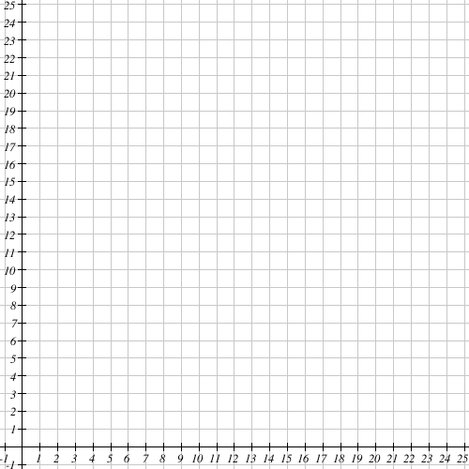

1. Plot the following Price and Quantity (P,Q) combinations: (8, 4), (2, 1), (10, 5)

2. Is your graph more likely to be a demand curve or a supply curve? Why?

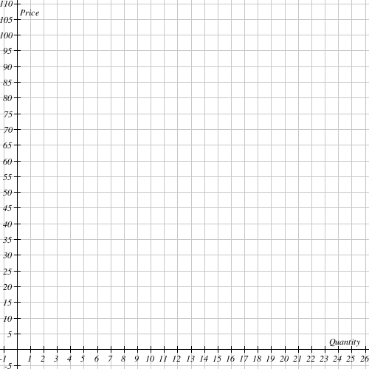
3. Plot the following Price and Quantity combinations (P,Q)
(50, 0), (40, 2), (30, 4), (20, 6), (10, 8)

4. Is this more likely to be supply or demand, how do you know?

Suppose the equation of the line changes to $P= -5×Q+70$. Compute the quantity demanded at each indicated price.
5. Price: $50, Quantity:
6. Price: $40, Quantity:
7. Price: $30, Quantity:
8. Price: $20, Quantity:
9. Price: $10, Quantity:

Use the following information to answer questions 15 and 16:
Use the following two equations for the demand and supply curves to compute the equilibrium price value.
Curve 1: $Qd=3300-2P$
Curve 2: $Qs=500+8P$
10. If the price for this good was $200, what would occur in this market?

11. If the price for this good was $300, what would occur in this market?

12. What is the value of the equilibrium price in this market?

13. What is the equilibrium quantity in this market?

Suppose Congress cuts personal income tax rates.

14. Draw a simple supply and demand graph to show how this would affect the market for refrigerators.

15. Why does this shift occur? How does that affect the equilibrium price and quantity? Explain.

Now ignore the assumption above and suppose that scooter workers accept a pay cut of 2 dollars per hour.

16. Draw a graph to show how this would affect the market for scooters.

17. Why does this shift occur? How does that affect the equilibrium price and quantity? Explain.

