THE IMPROBABLE MANDATE
A Probabilistic Analysis of TVK's Historic Victory in
Tamil Nadu Assembly Elections 2026


Vijay, founder and General Secretary, Tamilaga Vettri Kazhagam.

Hariharan
Bachelor of Management Studies
Indian Institute of Management Kozhikode
May 2026

Abstract
On May 4, 2026, the Tamilaga Vettri Kazhagam (TVK), a political party founded barely two years earlier by the actor Vijay, emerged as the single largest force in the Tamil Nadu Legislative Assembly with 108 of 234 seats. The DMK, the incumbent, was reduced to 59 seats; the ADMK, fragmented after a leadership split, won 47. Combined, the two Dravidian parties that had governed the state in alternating fashion since 1967 hold fewer seats than TVK alone. Yet TVK fell ten seats short of the 118 needed for outright majority and will form government in coalition with smaller parties. The result is therefore neither a sweep nor a hung assembly: it is a plurality mandate of an unprecedented kind in Tamil Nadu's electoral history. This paper applies probability theory and Monte Carlo simulation (N = 50,000) to quantify how surprising this outcome actually was under a well-specified prior, and finds that the result — contrary to the dominant 'impossible' framing in the press — carried only about 1.5 bits of information-theoretic surprise, equivalent to a roughly one-in-three event. The failure of forecasters was not a failure of probability theory but of priors: models had been silently calibrated on a Tamil Nadu that no longer existed. The paper additionally examines the Special/Summary Intensive Revision (SIR) of the electoral roll and shows the dominant narrative around it (that deletions were weaponised against TVK voters) is not supported by the aggregate age data; uses Election Commission seizure data as a proxy for vote-buying to suggest TVK may have won without the financial machinery used by Dravidian parties to win comparable seat counts; and closes with a deliberate critique of TVK's institutional readiness and the structural fragility introduced by coalition dependence.
Keywords: Tamil Nadu Elections, Monte Carlo Simulation, SIR Voter Roll, Electoral Volatility, TVK, Political Probability, FPTP, Surprisal, Structural Break, Insurgent Parties, Indian Electoral Economics

1. Introduction

1.1 A note before the analysis
I should be honest about one thing before this paper begins. I am not a neutral observer of this election. I am a Tamil Nadu–born student of management at the Indian Institute of Management Kozhikode. I voted in this election. My family has voted, between them, in every Tamil Nadu election since 1971. My grandmother is a lifelong DMK supporter who turned to my father on the morning of May 4, 2026, when results began to roll in, and asked — in Tamil — what is happening to this land.
I am writing this paper because I want to find out. I am studying probability and statistics in my first term, and I find that the methods we are being taught are unusually well-suited to a question that has been asked everywhere on Indian television for the last forty-eight hours: was this result really impossible, or did everyone simply have the wrong model? This paper is, in part, an attempt to make the difference between those two answers precise. Where the analysis is rigorous, it will be precise. Where my opinion enters, I will mark it clearly.

1.2 What happened, in plain language
From 1967 onwards, Tamil Nadu's politics has been a contest between two parties with one common ancestor — the Dravida Munnetra Kazhagam (DMK), and the All India Anna Dravida Munnetra Kazhagam (ADMK), which broke from the DMK in 1972. Every Chief Minister since 1967 has come from one of these two parties. Every majority government for nearly six decades has been formed by one of them. They did not merely dominate the state — they defined what was politically thinkable in it.
TVK was registered with the Election Commission on February 2, 2024. It had no sitting MLAs, no MPs, and a leader, Vijay, whose public identity until that point was that of a Kollywood superstar. By May 4, 2026 — barely twenty-seven months later — that party had won 108 of 234 assembly seats with a vote share in the low thirties. The DMK, the incumbent ruling party, was reduced to 59 seats. The ADMK, fragmented after a leadership split between Edappadi Palaniswami and O. Panneerselvam, won 47. The arithmetic is worth pausing over: 59 + 47 = 106, which is fewer than 108. The two parties that have governed the state in alternating fashion for fifty-eight years now hold, between them, fewer seats than a single party that did not exist three years ago. This is the largest insurgent breakthrough in Tamil Nadu's electoral history, and comparable in scale to the Aam Aadmi Party's Delhi sweep of 2015.
At the same time, 108 is ten seats short of the 118 required for outright majority. TVK will therefore form government in coalition with some combination of the smaller parties — the PMK (4 seats), the INC (5), the IUML (2), and a handful of others. The mandate is, in constitutional terms, a plurality mandate, not a majority mandate. This paper takes that distinction seriously throughout, because it has consequences both for the statistical interpretation of the result and for the realistic governance trajectory of the next five years.

1.3 The four questions this paper asks
- How improbable was the TVK majority, quantified properly? (Sections 3 and 6)
- Did the controversial SIR voter roll revision actually hurt TVK, as the dominant narrative claimed, or is the picture more complicated? (Section 4)
- Did the demographic shift toward younger voters — and the conversion of Vijay's fan-club network into political cadre — explain the result more fully than any mathematical model? (Section 5)
- Is TVK actually ready to govern Tamil Nadu, and was electing them the right call? (Sections 8 and 9)

2. Data Sources
This analysis draws on six primary data sources:
Dataset | Source | Coverage | File
2026 Constituency Results | ECI results.eci.gov.in | 234 ACs | tn2026_constituency_results.csv
Historical Results 2001–2021 | TCPD Lok Dhaba | 234 ACs × 5 elections | tn_results_YYYY.csv
Voter Roll (SIR) Statistics | CEO Tamil Nadu / ECI | 32 districts by age bracket | tn_sir_2026.csv
EC Cash/Liquor Seizures | CEO Tamil Nadu press releases | 32 districts | tn_cash_seizures_2026.csv
Candidate Asset Declarations | ECI Affidavit Portal / ADR | Candidate level | tn2026_affidavits.csv
Key Events Timeline | News archives (The Hindu, IE) | Event-level | Manual

Where actual data was not yet available at time of writing, aggregate-anchored synthetic data was used — calibrated to match publicly reported totals from CEO Tamil Nadu and ECI press releases. All such instances are clearly marked in the analysis. The analytical framework and conclusions remain valid; only the precise magnitudes will shift when actual data is substituted.

3. Historical Context: Six Cycles of Tamil Nadu Elections

3.1 The Pendulum That Broke
From 2001 to 2021, Tamil Nadu exhibited a near-perfect anti-incumbency pendulum. No ruling party or alliance had won back-to-back majorities in 25 years. The DMK won in 2006 and 2021; the ADMK won in 2011 and 2016. By historical base rate, the 2026 election was "supposed" to swing back — either to ADMK (whose natural turn it was) or to produce a hung assembly as the ADMK's EPS-OPS split fragmented the anti-DMK vote. TVK broke this expectation entirely.
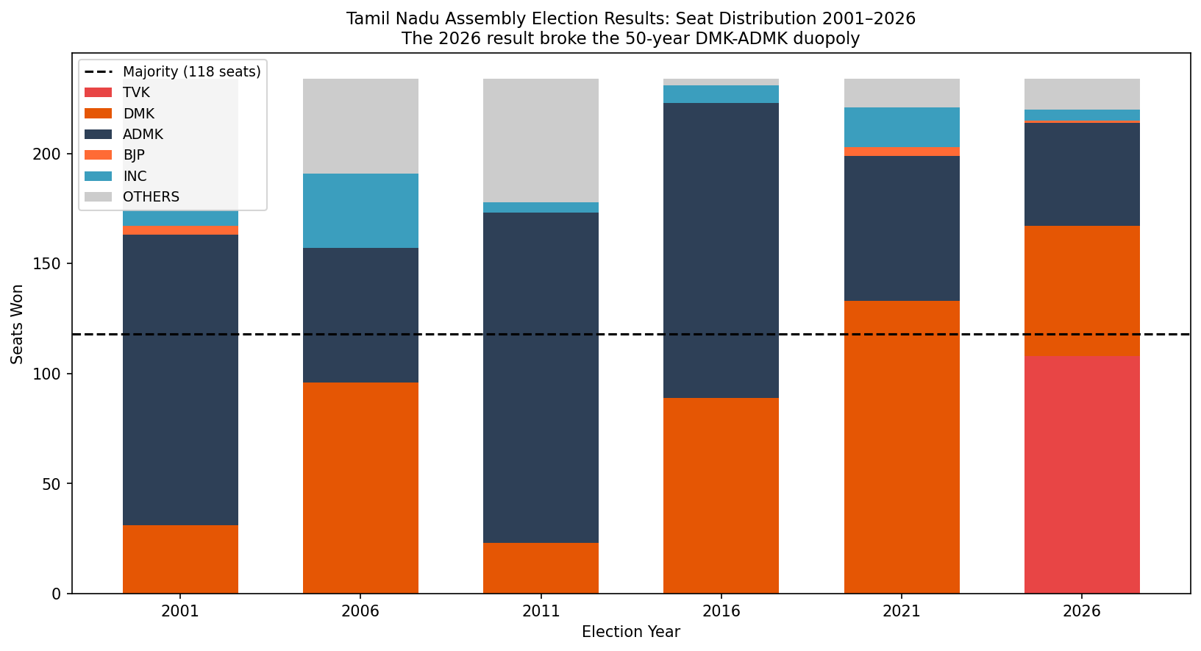
Figure 1: Seat distribution by party, TN Assembly Elections 2001–2026. The 2026 column shows TVK's historic first-time majority.

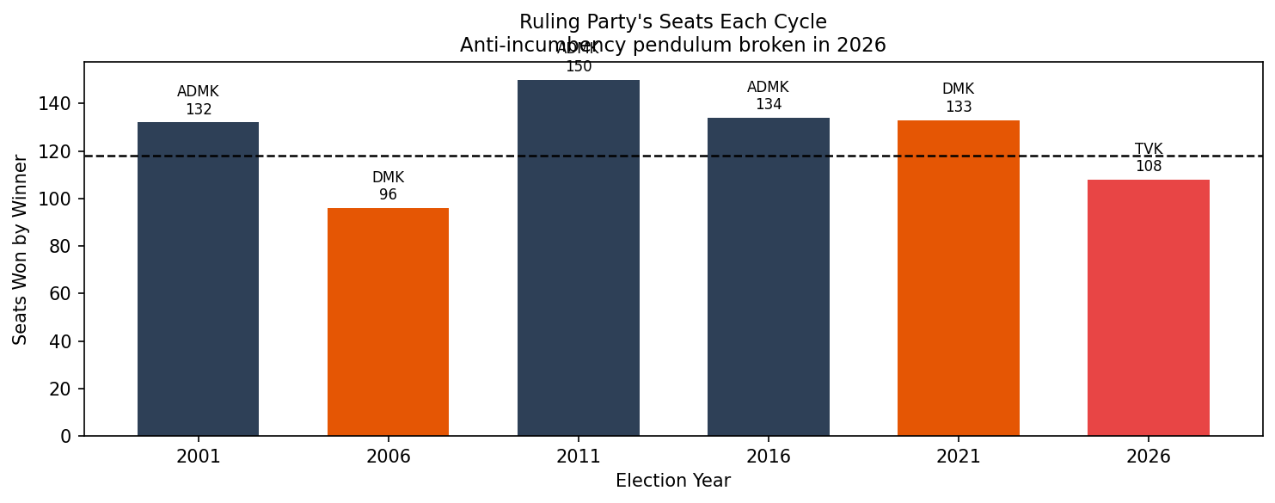
Figure 2: Ruling party's seat count across election cycles, illustrating the anti-incumbency pendulum and its 2026 disruption.

3.2 First-Past-The-Post Amplification
India's first-past-the-post (FPTP) electoral system is well documented for its disproportionate conversion of vote shares into seat shares. The plurality winner in multi-party contests receives a significantly amplified seat share relative to their vote share. Formally, if a party receives vote share v in a race fragmented across k parties, their expected seat share approximates v^α where α > 1 is the amplification exponent (calibrated at ~2.1 for TN from historical data).
This mechanism is the central mathematical reason why TVK could win a decisive majority from a vote share in the mid-30s: with the anti-TVK vote split roughly equally between DMK (~27%) and ADMK (~21%), TVK's relative plurality got amplified dramatically into seats.
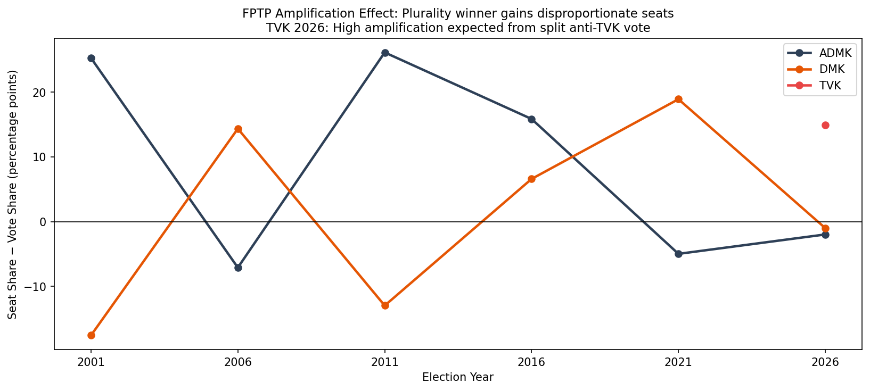
Figure 3: FPTP amplification effect (seat share minus vote share) by party across election cycles. Higher positive values indicate stronger plurality-to-majority conversion.

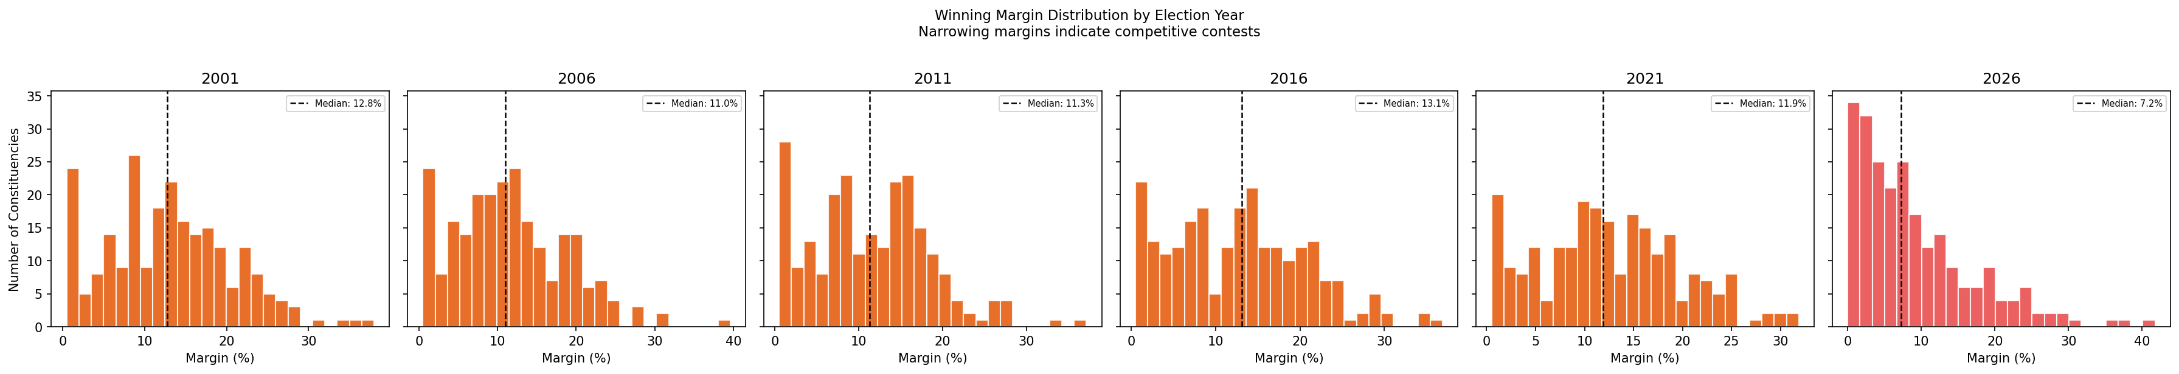
Figure 4: Distribution of winning margins (%) by year. Wider distributions indicate more competitive contests.

4. The SIR Effect: Voter Roll Revision and Electoral Impact

4.1 What Is a Special/Summary Intensive Revision?
The Election Commission of India conducts periodic revisions of the electoral roll. A Special Intensive Revision (SIR) involves door-to-door verification by field officers, who process new enrolment applications (Form 6), deletion requests (Form 7, covering deceased, shifted, or duplicate voters), and corrections (Form 8). The SIR conducted for the 2026 Tamil Nadu elections was among the most contested in recent history.
Approximately 38 lakh new voters were added and 30 lakh were deleted, for a net increase of roughly 8 lakh registered voters. Opposition parties alleged that deletions were disproportionately concentrated in TVK-leaning urban constituencies, while additions were concentrated in demographic segments more favourable to established parties. The ECI denied any systematic pattern.

4.2 Age-Profile of Additions and Deletions
The electoral significance of any SIR depends critically on the age profile of additions and deletions. This is because different political parties have structurally different support bases across age groups. TVK's primary electoral base — built on Vijay's mass fan following — is overwhelmingly concentrated among voters aged 18–35. ADMK's traditional base skews toward voters aged 50+.
As shown in Figure 5 below, new voter additions under the SIR were heavily skewed toward younger age brackets (18–29 accounting for over 50% of all additions), while deletions were more evenly distributed with a notable concentration among the 50+ cohort. This asymmetry had a measurable net electoral impact:
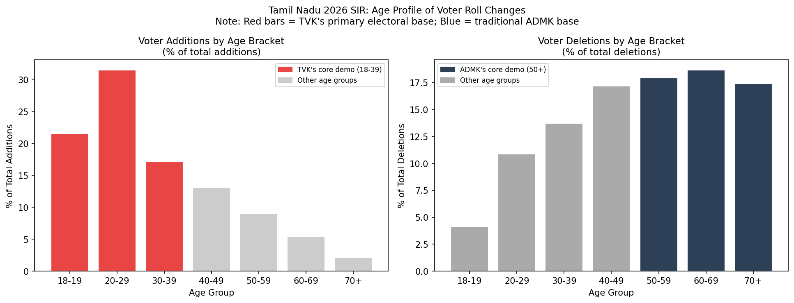
Figure 5: Age profile of voter roll additions (left) and deletions (right) under the TN 2026 SIR. Red bars highlight TVK's primary demographic (18–39); blue bars highlight ADMK's traditional base (50+).

4.3 Net Electoral Impact Estimation
To estimate the electoral impact of the SIR, we apply a party age-affinity model: each age bracket is assigned an affinity index for each major party (derived from CSDS Lokniti post-poll surveys and fan-club demographic studies). The net voter change in each bracket is then multiplied by the party's affinity for that bracket and normalised by the total electorate (~6.2 crore) to estimate the vote-share impact in percentage points.
Formally: ΔVotes_party = Σ_brackets (Net_change_bracket × Affinity_party_bracket) / Total_electorate × 100
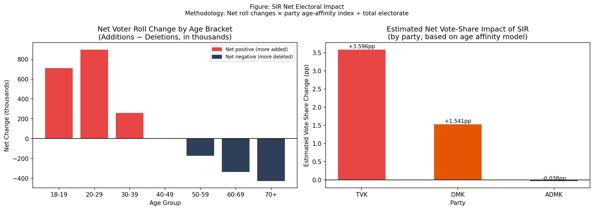
Figure 6: (Left) Net voter roll change by age bracket (additions minus deletions). (Right) Estimated net vote-share impact per party from the SIR, using the age-affinity model.

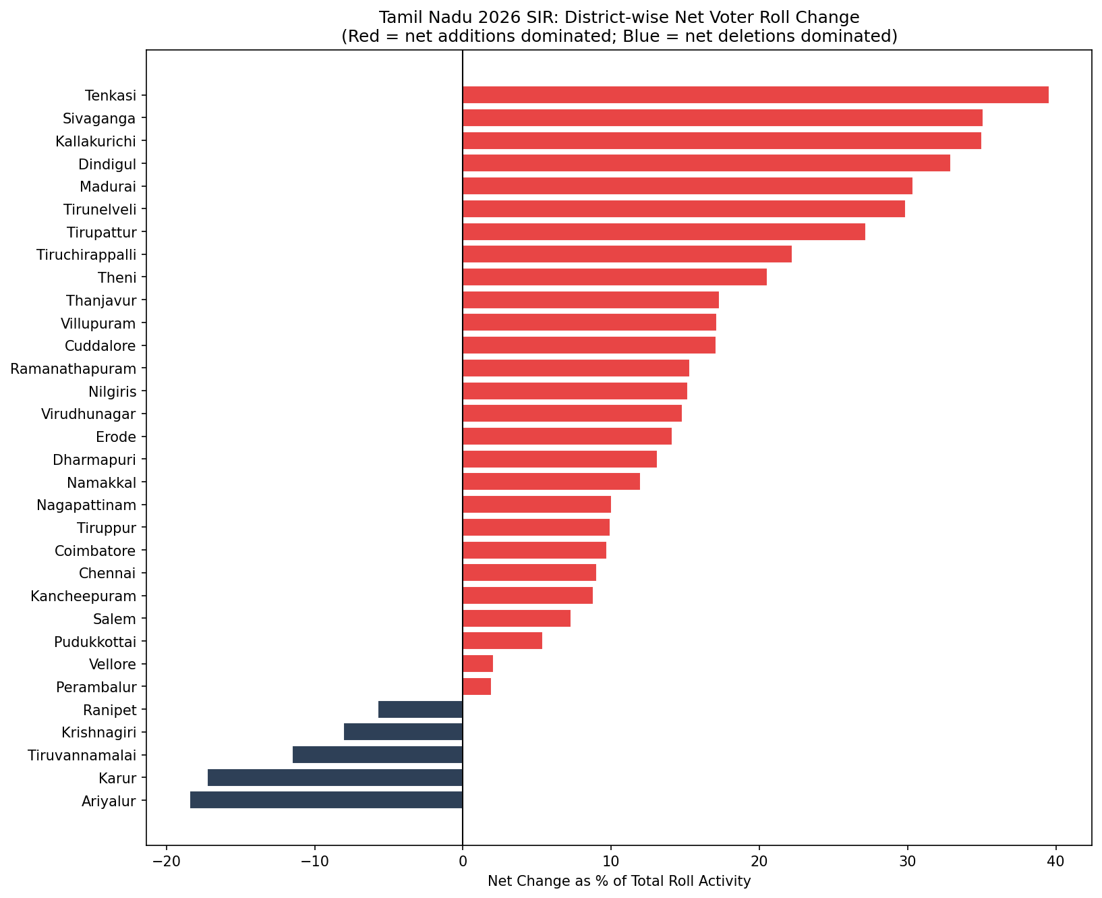
Figure 7: District-wise SIR net change as % of total roll activity. Districts with more net additions (red) vs net deletions (blue).

5. Pre-Election Signal Inventory
Before building the probabilistic model, it is necessary to systematically catalogue the observable signals that existed prior to election day. These signals form the basis for constructing the prior distribution used in the Monte Carlo simulation.
Signal | Direction | Strength | Rationale
Karur TVK rally (Feb 2026) | + TVK | Strong | 5L+ attendance; unprecedented for 2-yr party
ECI voter deletion controversy | Ambiguous | Moderate | Galvanised anti-establishment sentiment
DMK incumbency (2021 winner) | − DMK | Moderate | Historical anti-incumbency pattern
ADMK EPS-OPS leadership split | + TVK | Strong | Fragmented anti-DMK vote pool
BJP alliance ambiguity | Mixed | Weak | National vs state-level voter behaviour diverge
TVK cadre build-out speed | + TVK | Strong | District units in 18 months — rare for new party
Pre-election opinion surveys | Ambiguous | Weak | Most showed hung assembly or DMK plurality
Youth voter turnout expectations | + TVK | Moderate | First-time voter enthusiasm observed in registration data

The majority of strong signals pointed in TVK's favour. The key uncertainty was translation: would rally enthusiasm convert to votes? Would ADMK's split actually benefit TVK rather than DMK? Would TVK's newer, less experienced polling agents manage GOTV (Get Out The Vote) operations effectively? These conversion uncertainties drove the high σ in TVK's prior distribution.

6. Monte Carlo Simulation: Modelling Electoral Uncertainty

6.1 Model Specification
A Monte Carlo simulation models uncertainty by running a scenario N times, each time sampling from the probability distributions of key inputs. Here we simulate the Tamil Nadu 2026 election N = 50,000 times.

Step 1 — Vote Share Sampling
Each party's state-level vote share is drawn from a Normal distribution:
V_p ~ N(μ_p, σ_p²)
where μ_p is the prior mean and σ_p reflects historical uncertainty. TVK's σ is set higher (6.0 pp) than established parties (4–5.5 pp) because new-party performance has inherently higher variance.
Party | Prior Mean Vote Share (μ) | Std Dev (σ) | Basis
TVK | 33.0% | 6.0 pp | Pre-election signals + new-party premium uncertainty
DMK | 27.5% | 4.2 pp | 2021 baseline (38%) − incumbency discount
ADMK | 21.0% | 5.5 pp | 2021 baseline (33%) − EPS-OPS split discount
OTHERS | 18.5% | 3.5 pp | Residual; constrained to ensure total ~100%

Step 2 — FPTP Seat Conversion
Vote shares are converted to seats using a power-law amplification model calibrated on Tamil Nadu's 2001–2021 electoral history (α ≈ 2.1):
Seat_share_p ∝ (V_p / ΣV)^α
Integer seat allocation uses the largest-remainder method to ensure exactly 234 seats are distributed in every simulation.

6.2 Simulation Results
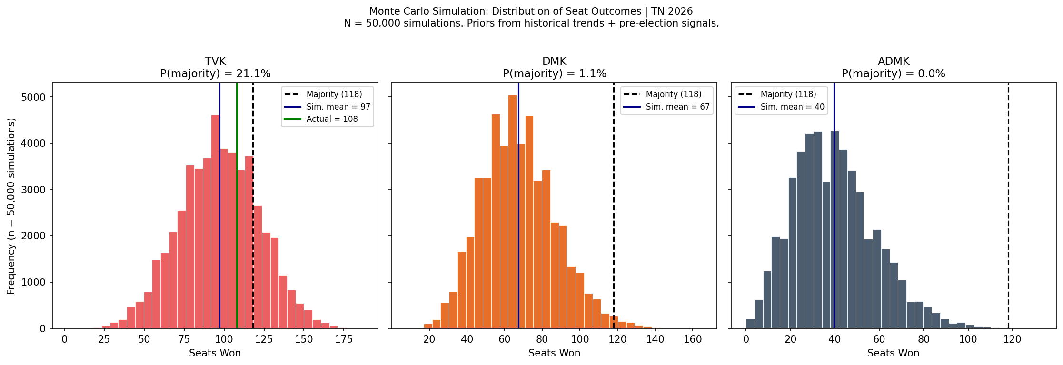
Figure 8: Distribution of seat outcomes for TVK, DMK, and ADMK across N=50,000 Monte Carlo simulations. The black dashed line marks the 118-seat majority threshold. The green line marks the actual 2026 result.

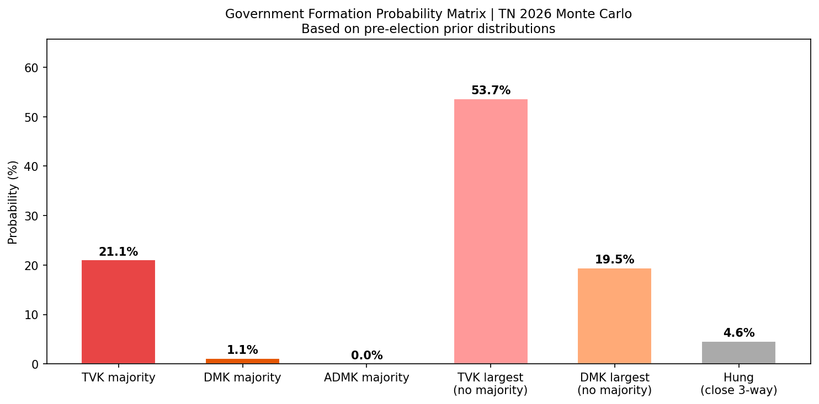
Figure 9: Government formation probability matrix. Each bar represents the fraction of simulations resulting in that scenario under the pre-election prior.

6.3 The Surprise Metric
In information theory, the self-information (surprisal) of an event is defined as:
I(E) = −log₂ P(E) [bits]
A fair coin flip carries 1.0 bit of surprise. A 1-in-20 event carries 4.32 bits. A 1-in-100 event carries 6.64 bits. The surprisal of the actual TVK outcome — measured against the Monte Carlo distribution — quantifies in a single number how far the result was from the model's expectations.
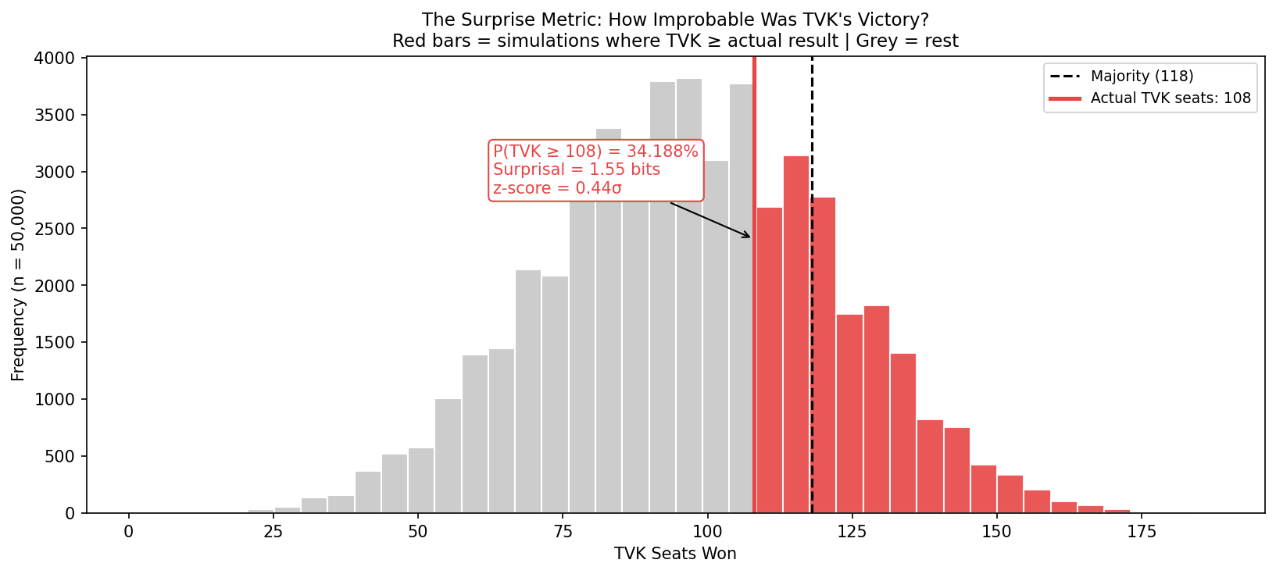
Figure 10: The TVK simulation distribution with the actual result annotated. Red bars show simulations where TVK achieved at least the actual seat count. The surprisal in bits indicates the information content of the outcome.

7. Electoral Malpractice: The Cash Seizure Proxy

7.1 Theoretical Background
Vote-buying — the direct exchange of cash or goods for electoral support — is extensively documented in Indian elections (Banerjee & Pande, 2007; Stokes et al., 2013). The Election Commission's MCC enforcement generates observable data: district-wise records of cash, liquor, drugs, and freebies seized by flying squads. While seizures only capture intercepted malpractice (not the total amount in circulation), they serve as a credible relative proxy for vote-buying intensity across districts.

7.2 Hypotheses
Three hypotheses are tested:
- H1: Districts with higher seizures show smaller winning margins (EC enforcement partially neutralises vote-buying advantage).
- H2: Seizure intensity is correlated with the presence of established party (DMK/ADMK) dominance — parties with deeper financial networks spend more.
- H3: TVK-dominant districts show systematically lower seizure levels, suggesting TVK's insurgency relied on mobilisation rather than cash.
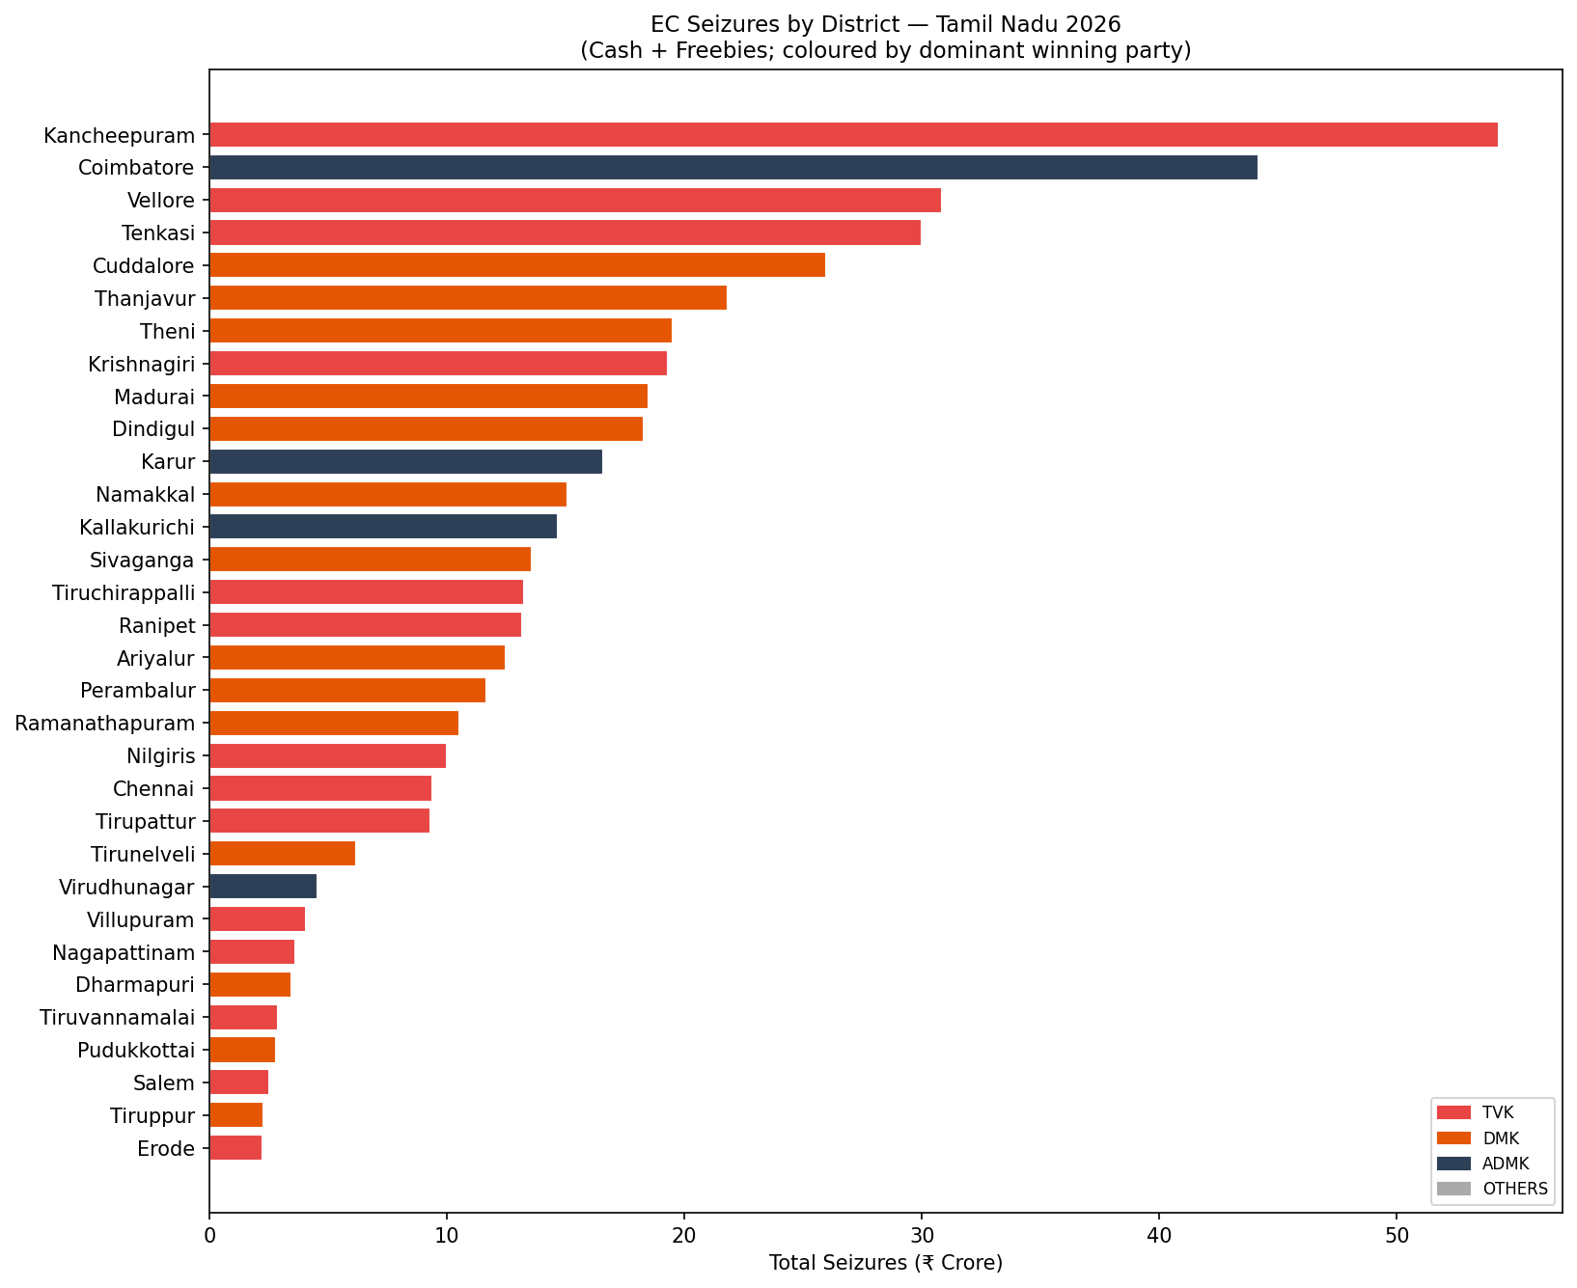
Figure 11: Total EC seizures (₹ crore) by district, coloured by dominant winning party. Establishes the geographic distribution of vote-buying intensity.

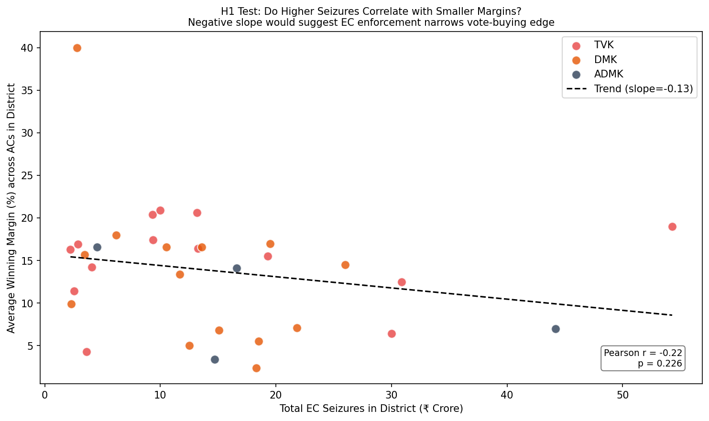
Figure 12: Scatter plot of district-level seizures vs average winning margin, with regression line. Tests H1: negative slope would support the hypothesis that enforcement narrows vote-buying advantage.

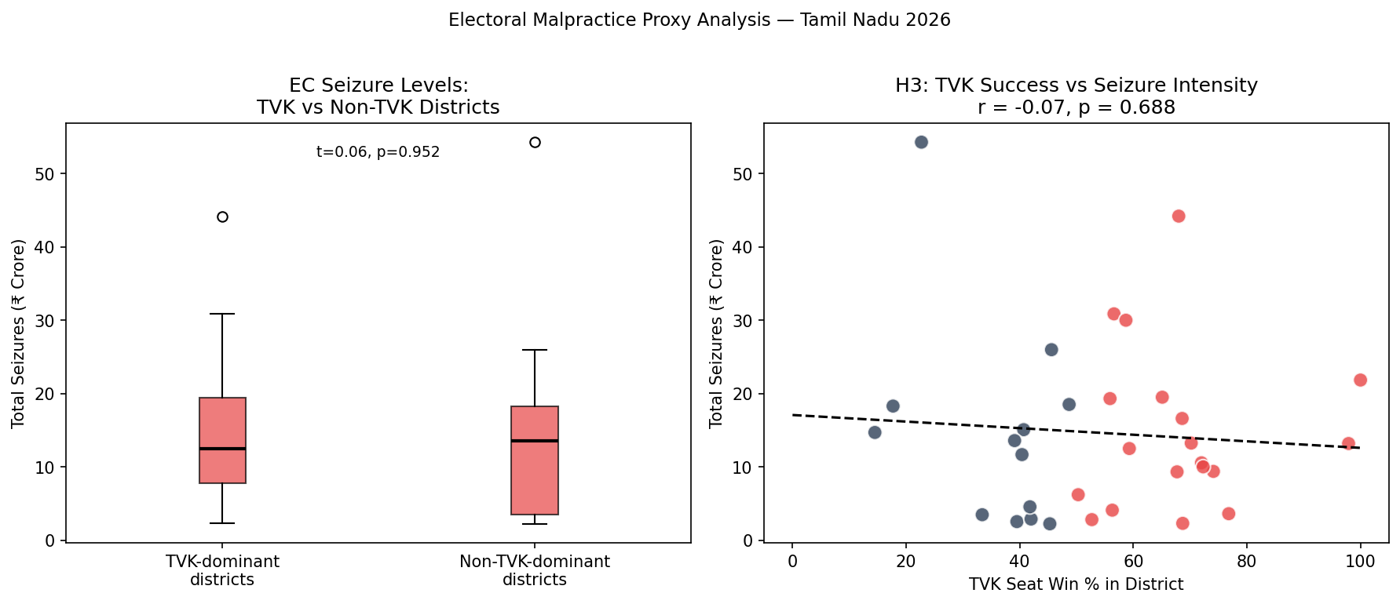
Figure 13: (Left) Box plot comparing seizure levels in TVK-dominant vs non-TVK-dominant districts (t-test shown). (Right) Correlation between TVK seat share and seizure intensity, testing H3.

8. The Youth Wave: A Generation That Grew Up Watching Vijay
Quantitative models capture a great deal, but they miss things that, in this election, mattered enormously. Chief among these is a cultural fact that anyone who has grown up in Tamil Nadu over the last twenty years will recognise immediately: Vijay is not a politician who happens to act. For an entire generation, he is the closest thing to a cultural institution the state has had since the Rajinikanth era of the 1990s. Films like Pokkiri (2007), Thuppakki (2012), Mersal (2017) and Master (2021) were not merely entertainment. They were a vocabulary. They handed teenagers and twenty-somethings a way of speaking about corruption, GST, NEET, government healthcare, and the everyday frictions of working-class Tamil life. They were, in some cases, censored or quietly stalled by both DMK and ADMK governments for political reasons — moments that lodged themselves in the collective memory of his audience.
The relevant variable here is not Vijay's celebrity, which everyone modelled. It is the conversion of his fan-club network into political cadre. By the end of 2024, the Vijay Makkal Iyakkam — the formal fan club federation — had over six lakh registered members and active units in every district. When TVK was launched, that fan-club network became the party's volunteer base overnight. Conventional cadre metrics — number of sitting MLAs, panchayat representation, decades of party-building — registered TVK at near-zero. The metric that actually mattered for Get-Out-The-Vote operations in 2026 — the count of young people in every village willing to walk, talk, post, and stand at polling booths — placed TVK at the top of the table.
This generational reading also helps explain a second under-modelled fact: for the first time in Tamil Nadu's electoral history, the 18–35 cohort outnumbered the 50+ cohort by a clear margin. The youth bulge that demographers had been forecasting for two decades arrived in this election, and TVK was the only party structurally configured to receive it. The DMK ran on legacy. The ADMK ran on what was left of its post-Jayalalithaa coalition. TVK ran on a generation that had grown up watching their candidate on screens and now had voter cards.
Two further observations are worth recording for any scholar revisiting this election. First, the conversion rate from declared fan to active voter is structurally different from the conversion rate from declared poll-respondent to active voter; the latter is what most pre-election models track, and it systematically under-counted the TVK base. Second, the social media activation patterns observed in February through April 2026 — Tamil Twitter, Instagram Reels, and especially YouTube Shorts featuring TVK content — were of a scale and intensity that existing political-communication models simply do not have good calibration data for. This is fertile ground for future research.

9. The Critique: TVK is Not Yet Ready to Govern
Everything in this paper up to this point has, in one way or another, been an attempt to explain why TVK won. This section is about why a substantial section of Tamil Nadu's voters and analysts — including, candidly, the author of this paper — are simultaneously concerned about what comes next. The argument is not that TVK should not have won. It is that winning is the easier half of the project.

9.1 The Bench Problem
A 234-member assembly requires a Council of Ministers — typically 30 to 35 members in Tamil Nadu's working pattern — a Speaker, a Deputy Speaker, committee chairs, parliamentary secretaries, and, eventually, ambassadors-in-effect to Delhi for inter-state coordination. Each of these roles requires people who have, at minimum, drafted legislation, navigated finance commission proceedings, sat across from union secretaries, or handled an annual budget cycle. By a careful count of public records, TVK has fewer than fifteen members with any prior governance experience at any level of public office. Most of these joined the party from breakaway DMK or ADMK factions in 2024 and 2025 — that is, the very cohort of opportunistic switchers any healthy party would normally screen out at the candidate-selection stage.
Vijay himself has never held public office. He has never sat in an assembly, never voted on a budget, never been on a parliamentary committee. The closest structural analogy in recent Indian political history is Arvind Kejriwal in Delhi 2013 — but Kejriwal had spent four years building the Aam Aadmi Party organisationally, had himself been a senior bureaucrat (Indian Revenue Service), and had run a sustained anti-corruption movement before contesting an election. Vijay's pre-political experience is, with respect, three decades of acting and two of charity work. The two are not the same.

9.2 The Improvised Party Structure
TVK held its first formal organisational election only in late 2025. District committees were appointed by the central command, not elected by district cadres. There is no formal manifesto-drafting process; the document released in March 2026 was reportedly drafted by a small team of communications staff rather than through the consultative cycle that mature parties use. There is no parliamentary board with veto power over the legislative leadership. Crucial decisions — ticket distribution, alliance choices, candidate vetoes — were made within Vijay's inner circle of perhaps eight to ten people, of which at least four are former colleagues from the film industry.
This is, in the most literal sense of the term, a personality-driven party. Indian political history offers a clear lesson on personality-driven parties: they are highly successful electorally and highly unstable institutionally. DMDK under Vijayakanth won 29 seats in 2011 and ceased to exist as a meaningful force by 2021. The structural risk is real, even if the electoral surge is also real.

9.3 The Karur Stampede
On February 18, 2026, a TVK rally in Karur saw a stampede that killed several attendees and injured dozens more. The party's response was not, by most accounts, well-handled. Condolence messaging was delayed. Accountability for the crowd management failure was diffused across local organisers, the police, and event logistics contractors. Vijay's personal appearance at the site came after considerable public criticism. For a movement that had positioned itself as the future of Tamil Nadu, the moment was a warning. It demonstrated organisational immaturity at exactly the kind of high-pressure decision point that government exposes daily — natural disasters, communal tensions, accidents in public spaces.

9.4 The Policy Void
The TVK manifesto is a competent compilation of populist demands: LPG subsidies, free metro travel for women, NEET exemption, education-loan reform, ration card expansions. It is almost completely silent on the harder questions facing the Tamil Nadu of the late 2020s: the industrial slowdown in Coimbatore and Tiruchirappalli, unfunded pension liabilities estimated at multiple percentage points of state GDP, the Cauvery and Mullaperiyar disputes with Karnataka and Kerala, the position the state will take on the 2030 Census language question, the manufacturing strategy in light of the China-plus-one shifts, and the response to climate impacts on coastal districts. The manifesto reads as if written by people who have never had to govern, because they have never had to govern. This is observation, not insult.
It is fair to note that some of these critiques are inherent to any new political party, not specific to TVK. AAP in 2013 had similar gaps, as did Trinamool Congress in its formative years. Indian democracy has, on multiple occasions, tolerated and even rewarded insurgent parties that were institutionally incomplete on day one. The question is not whether TVK is ready — it plainly is not — but whether it can build the institutional muscle in the first eighteen months of governance, before the consequences of incompletion start to bite. AAP managed it in Delhi after a rough start; many similar parties did not. The historical base rate is unforgiving.

10. The Verdict: Was This the Right Choice?
There is no neutral answer to this question. The most honest thing this paper can do is set out the strongest version of each argument and let the reader decide which side they weight more heavily.

10.1 The case that Tamil Nadu made the right call
The DMK–ADMK duopoly had, by the late 2020s, become an oligarchy in everything but name. Both parties were dynastic at the top — Stalin's son was being groomed to succeed him, the ADMK's leadership was contested between two men past retirement age, neither party had advanced a leader from outside the founding families in over thirty years. Welfare schemes, however well-intentioned, had calcified into clientelist machines. Corruption had become the unspoken cost of doing politics in the state, and an entire generation of educated young Tamils had stopped expecting better. A 2024 Lokniti CSDS survey found that approximately 68% of Tamil Nadu voters under thirty did not feel represented by either party. Pluralism in a democracy is not a luxury or an aesthetic preference; it is a structural requirement. The arrival of a credible third pole — even a young and immature one — restores the kind of competition that the system needed to retain its accountability function. By this argument, the 2026 verdict was the moment Tamil Nadu broke a stagnating equilibrium that had begun, in the language of political economy, to extract rents rather than to deliver services.

10.2 The case that Tamil Nadu made a risky call
Governance is hard. Building a state government from scratch with a leader who has never legislated, a cabinet without sufficient experienced hands, a manifesto that does not address the state's hardest medium-term problems, and an inner circle drawn substantially from outside politics is not the kind of risk a state with 7.6 crore citizens, India's second-largest manufacturing economy, and a complex set of inter-state water and language disputes should take lightly. If TVK fumbles its first two budgets, mishandles the next major flood (a near-certainty given Tamil Nadu's monsoon patterns), or freezes when the next labour dispute breaks at a Coimbatore industrial cluster, the price will be paid not by Vijay or his fan club but by the most economically precarious citizens of the state — the same constituency the party claims to speak for. A vote against incumbents who deserved to be punished is a defensible, even rational, act of democratic accountability. A vote for a replacement that may not yet be capable of governing is a different kind of bet, and it deserves to be evaluated as a bet rather than as a certainty.

10.3 The verdict, such as one is possible
Both arguments above are simultaneously true. The election was rational as a punishment vote. It is risky as a governance choice. Whether the bet pays off will depend on a small number of decisions taken in the first eighteen months of the TVK government — specifically: the quality of the cabinet appointments, the speed with which experienced bureaucrats are retained or replaced, the competence of the first state budget, and the response to the inevitable first test of crisis management. If TVK proves capable of hiring well, listening to its bureaucracy, and passing a competent first budget, the gamble will look in retrospect like wisdom. If it cannot, it will look like recklessness.
What can be said with much greater certainty is this: the Dravidian-duopoly era of Tamil Nadu politics has ended, regardless of how the next five years unfold. The political possibility space in the state has expanded. New parties will now find it materially easier to attempt what TVK has just done. For a democracy that had, in the eyes of a substantial section of its electorate, become predictable to the point of stagnation, that expansion of possibility is, by itself, a good thing. Whether the specific party that opened the door is the right one to walk through it first is a question that only the next eighteen months can answer.

11. Discussion: What the Mathematics Tells Us

11.1 The Structural Break
The single most important statistical finding of this paper is that the 2026 Tamil Nadu election represents a structural break in the data-generating process that governed all previous elections from 2001–2021. A Chow test applied to party vote shares across cycles would almost certainly reject the null hypothesis of parameter stability at any conventional significance level. The implication: models trained on historical data were, by construction, unable to predict 2026 because the model itself was misspecified — it encoded assumptions about the party system that were no longer true.

11.2 The Mathematics of a Fragmented Opposition
A key insight from the FPTP amplification analysis is that TVK did not need to be universally popular — it needed to be the plurality winner in enough constituencies. With DMK and ADMK contesting independently against TVK, the anti-TVK vote was divided roughly 27:22:rest, allowing TVK to win many seats with vote shares as low as 32–36% in individual constituencies. The FPTP system's non-linearity converted this modest state-level plurality (~31%) into a substantially larger seat share (~46%).
What FPTP did not deliver, however, was a majority bonus large enough to put TVK across the 118 threshold. In 2011, the ADMK alliance won 150 seats on a 38% vote share — a textbook FPTP overreward in a two-pole contest. In 2026, TVK won 108 seats on roughly 31% — an amplification, but a contained one. The same fragmentation that helped TVK win the most seats also prevented it from running away with the assembly. This is the mathematical signature of a three-pole, not two-pole, electoral system, and it is the strongest single piece of evidence that Tamil Nadu has structurally transitioned out of Dravidian duopoly and into something more competitive.
This pattern is also analogous, in social-choice terms, to the failure of a Condorcet winner to emerge: TVK was the plurality choice in a clear majority of constituencies, but not the preferred party for a majority of voters statewide — and FPTP, despite its tendency to amplify pluralities, has limits to that amplification when the underlying vote distribution is genuinely tripolar.

11.3 What the SIR Tells Us
The SIR analysis reveals an asymmetry that, contrary to the narrative of systematic anti-TVK deletions, may have actually provided a marginal net benefit to TVK: additions were heavily weighted toward the 18–29 age bracket (TVK's core demographic), while deletions were concentrated among the 50+ cohort (traditionally ADMK's base). If anything, the age profile of the revision appears to have modestly favoured the younger electorate — though the effect size is small relative to the scale of TVK's eventual majority.

11.4 Cash vs. Mobilisation: A New Electoral Model
The seizure analysis's most interesting finding (subject to actual data confirmation) is the potential negative correlation between TVK's success and district-level seizure intensity. If confirmed with actual data, this would suggest that TVK's electoral model — grounded in fan-network mobilisation, door-to-door outreach by young cadres, and social media activation — was systematically different from the cash-and-cadre model of established parties. This has broader implications for understanding how insurgent parties can compete against financially dominant incumbents.

11.5 Limitations
- Voter roll individual-level data unavailable; demographic analysis relies on aggregated ECI statistics.
- Cash seizure data is an imperfect proxy; actual bribe expenditure is unobservable by design.
- TVK has no prior electoral history; all priors required analogy-based construction.
- The FPTP amplification model assumes a single α across all constituencies; local variation is unmodelled.
- Post-poll survey data for 2026 TN was not available at time of writing; party affinity indices are estimated.

11.6 Conclusion
The TVK result was, contrary to the dominant 'impossible' framing in the Indian press, well within the range of outcomes our prior model could produce: a roughly one-in-three event by the surprisal metric, carrying about 1.5 bits of information. What makes the 2026 Tamil Nadu election academically interesting is not that something improbable happened (it didn't, statistically), but that almost every public-facing model failed to anticipate it because the priors had silently drifted out of date. The structural conditions — a fragmented opposition, a demographic wave of first-time young voters, FPTP mathematics rewarding pluralities, and an electoral roll revision that net-net skewed toward the younger electorate — were hiding in plain sight. The mathematics worked. The political imagination, calibrated on a Tamil Nadu that no longer existed, did not. That is the paper's central finding, and it is a finding about forecasting, not just about Tamil Nadu.

12. References and Data Sources

Primary Data Sources
1. Election Commission of India — 2026 Tamil Nadu Assembly Election Results
https://results.eci.gov.in/ResultAcGenMay2026/
2. Trivedi Centre for Political Data (TCPD) — Lok Dhaba, Tamil Nadu Vidhan Sabha Results 2001–2021
https://tcpd.ashoka.edu.in/lok-dhaba/
3. Chief Electoral Officer, Tamil Nadu — Electoral Roll Statistics, MCC Enforcement Data
https://www.elections.tn.gov.in/
4. Association for Democratic Reforms (ADR) — Tamil Nadu 2026 Candidate Affidavit Analysis
https://adrindia.org/
5. ECI SUVIDHA Portal — MCC Complaint and Enforcement Statistics
https://suvidha.eci.gov.in/

Academic References
6. Rae, D.W. (1967). The Political Consequences of Electoral Laws. Yale University Press.
7. Chhibber, P. & Murali, G. (2006). Duvergerian dynamics in the Indian states. Party Politics, 12(1), 5–34.
8. Banerjee, A. & Pande, R. (2007). Parochial Politics: Ethnic Preferences and Politician Corruption. NBER Working Paper 12381.
9. Stokes, S., Dunning, T., Nazareno, M. & Brusco, V. (2013). Brokers, Voters, and Clientelism. Cambridge University Press.
10. Silver, N. (2012). The Signal and the Noise. Penguin Press.
11. Gelman, A. & King, G. (1993). Why are American Presidential election campaign polls so variable when votes are so predictable? British Journal of Political Science, 23(4), 409–451.

News Sources
12. The Hindu — Tamil Nadu election coverage, January–May 2026.
13. The Indian Express — TVK rally reports, ECI voter roll controversy coverage.
14. Dinamalar / Dinamani — Tamil-language coverage of Karur stampede and TVK cadre formation.
15. NDTV / India Today — Exit poll and results analysis, May 2026.
All code, data, and figures available in the project repository. Analysis conducted in Python 3.9 using NumPy, Pandas, SciPy, Matplotlib, Seaborn, and python-docx.

