Stats 326 Assignment 1

Name: Hasnain Cheena, ID:190411106

## Question 1 - Find a Time Series that exhibits cycles

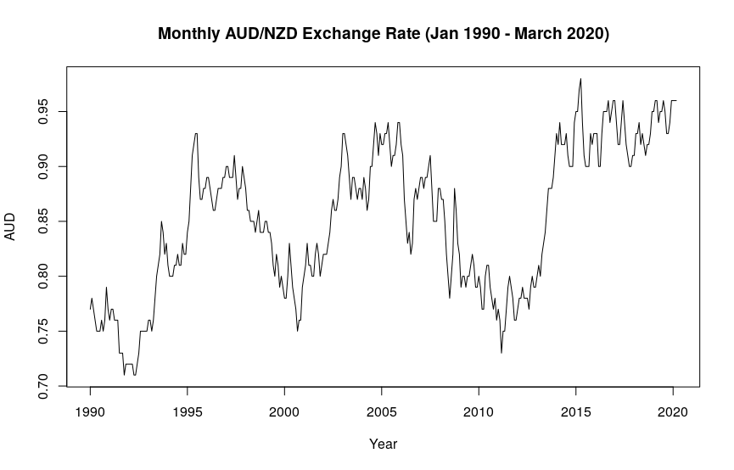The data was found from: <https://www.ofx.com/en-us/forex-news/historical-exchange-rates/monthly-average-rates/>

The series shows cyclical behaviour with reasonably large random variation. There are both major and minor cycles. There is no clear trend or seasonal behaviour.

The range of the monthly average exchange rate is between $0.71 AUD to $0.98 AUD.

## Question 2 - Find a Stationary Time Series.

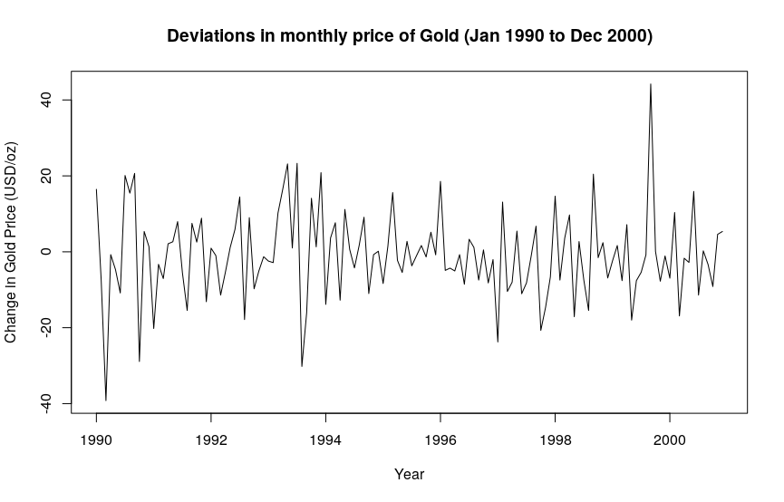Data was found from: <https://www.gold.org/goldhub/data/gold-prices>

The time series displayed above shows a reasonably constant variance and mean. Furthermore, the series has no trend, cycles or seasonality. Thus it is a stationary time series. The plot also shows a large change in the price of gold of $44.2 USD/oz in October 1999 and -$39.2 USD/oz February 1990.

The range of the change in gold price is between -$39.2/oz USD and $44.2 USD/oz.

## Question 3 - Find a Time Series that has a seasonal component but no trend or cycle.

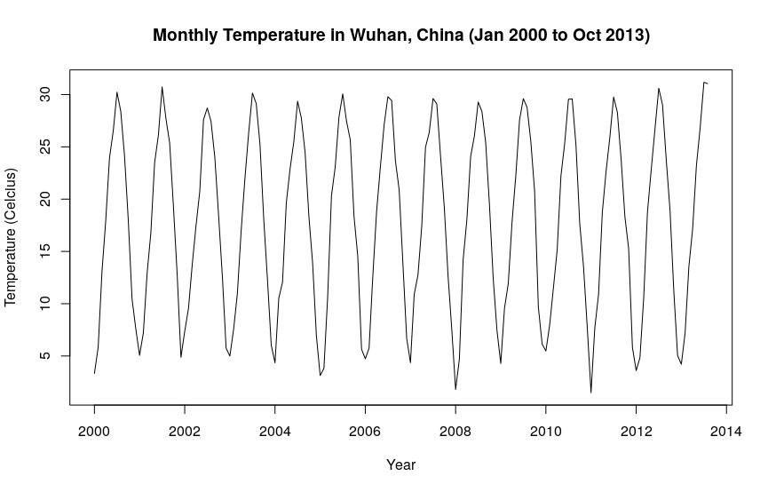

Data was found from: <https://www.kaggle.com/marvintherain/average-monthly-temp/data>

The series appears to have a strong seasonal component, although there are larger seasonal troughs in 2008 and 2011. The annual seasonal pattern starts with January having the lowest temperature and July having the highest. There does not appear to be any trend or cyclical behaviour.

The range of the Temperature (in degrees celcius) is between 1.5 degrees and 31.2 degrees.

## Question 4 - Find a Time Series that has a reasonably linear trend and has a seasonal component.

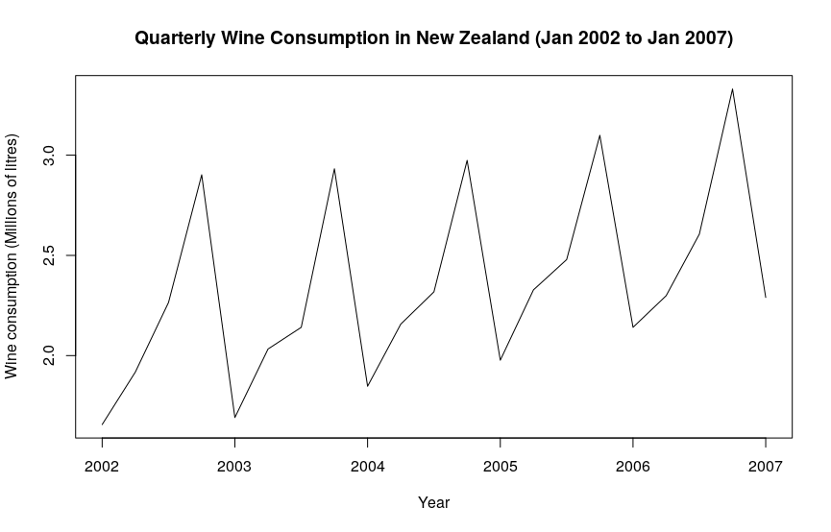Data found from: <https://new.censusatschool.org.nz/resource/time-series-data-sets-2013/>

The series shows a strong seasonal component and a reasonably positive linear trend. The seasonal pattern, once trend is considered, shows that typically quarter 1 has the lowest quarterly value while quarter 4 has the highest quarterly value. Furthermore, there is a much lower seasonal trough in 2003 that would be expected.

The range of wine consumption (in millions of litres) is between 1.6 million litres and 3.3 million litres.

## Question 5

## 

The series shows a reasonably linear increasing trend in CO2 concentration in the atmosphere at Cape Grim. Further, the series displays seasonal behaviour. The seasonal pattern shows typically quarter 1 has the lowest quarterly value and quarter 4 has the highest quarterly value, once you account for the trend.

The range of the CO2 concentration varies from 366.1 ppm and 408.6 ppm.

## 