326 Assignment 2

Hasnain Cheena

30/03/2020

## Question 1

HW.fit = HoltWinters(CO2.fit.ts)  
HW.fit

## Holt-Winters exponential smoothing with trend and additive seasonal component.  
##   
## Call:  
## HoltWinters(x = CO2.fit.ts)  
##   
## Smoothing parameters:  
## alpha: 0.9267355  
## beta : 0.0813906  
## gamma: 1  
##   
## Coefficients:  
## [,1]  
## a 405.1011655  
## b 0.5889777  
## s1 0.2311236  
## s2 -0.2791367  
## s3 -0.2150001  
## s4 0.4588345

HW.pred = predict(HW.fit,n.ahead=4)  
HW.pred

## Qtr1 Qtr2 Qtr3 Qtr4  
## 2018 405.9213  
## 2019 406.0000 406.6531 407.9159

HW.RMSEP = sqrt(1/4*sum((CO2.pred.ts-HW.pred)^2))  
HW.RMSEP

## [1] 0.2214015

plot(HW.fit, HW.pred, main="Cape Grim CO2 - Holt Winters", xlab="Year", ylab="Observed/Fitted CO2 (ppm)")

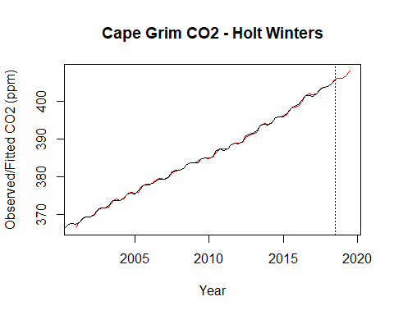 The plot of the Holt-Winters model shows the model is good fit. This is becaue the model (red line) is very close to the actual observations (black line) with very litte white space between the lines.

The RMSEP indicates that, on average, the prediction error is 0.22 ppm.

## Question 2

#calculate and extract seasonal estimates  
decomp.stl.CO2 = stl(CO2.fit.ts, s.window="periodic")  
#de-seasonalize   
stl.CO2.ts = CO2.fit.ts - decomp.stl.CO2$time.series[,1]  
plot(stl.CO2.ts, main="STL seasonally adjusted CO2 Cape Grim", xlab="Year", ylab="CO2 (ppm)")

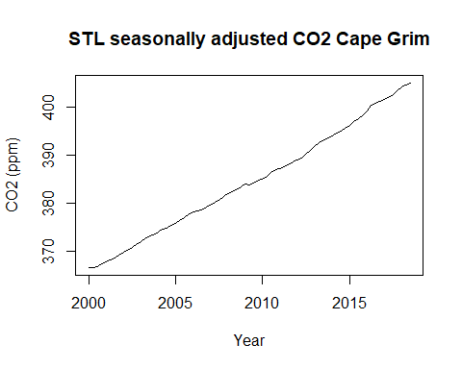 The plot of the seasonal-trend-lowess seasonally adjusted series shows a reasonably increasing linear trend.

#seasonal estimates  
decomp.stl.CO2$time.series[1:4,1]

## [1] -0.3906880 -0.3028320 0.4787971 0.2147230

The seasonal estimates for Quarter 1 & Quarter 2 are similar negative values (below the trend). In comparision Quarter 3 & Quarter 4 are positive and above the trend. Quarter 3 is the highest (0.48) while Quarter 1 is the lowest (-0.39).

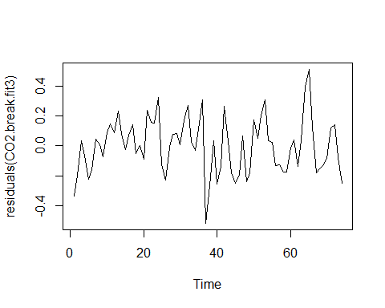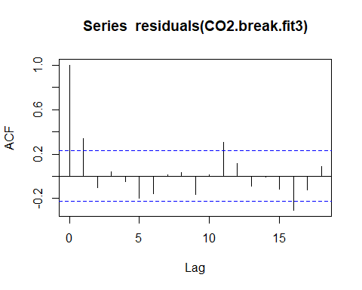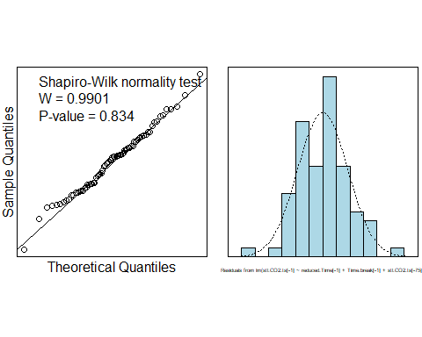

#model summary  
summary(CO2.break.fit3)

##   
## Call:  
## lm(formula = stl.CO2.ts[-1] ~ reduced.Time[-1] + Time.break[-1] +   
## stl.CO2.ts[-75])  
##   
## Residuals:  
## Min 1Q Median 3Q Max   
## -0.51687 -0.13691 0.01665 0.11813 0.51237   
##   
## Coefficients:  
## Estimate Std. Error t value Pr(>|t|)   
## (Intercept) 113.68138 29.12337 3.903 0.000216 ***  
## reduced.Time[-1] 0.15131 0.03826 3.955 0.000181 ***  
## Time.break[-1] 0.04304 0.01189 3.620 0.000554 ***  
## stl.CO2.ts[-75] 0.68994 0.07972 8.654 1.14e-12 ***  
## ---  
## Signif. codes: 0 '***' 0.001 '**' 0.01 '*' 0.05 '.' 0.1 ' ' 1  
##   
## Residual standard error: 0.189 on 70 degrees of freedom  
## Multiple R-squared: 0.9997, Adjusted R-squared: 0.9997   
## F-statistic: 8.543e+04 on 3 and 70 DF, p-value: < 2.2e-16

#forecast 2018 Q4  
t76.sa.pred = CO2.break.fit3$coefficients[1] + CO2.break.fit3$coefficients[2] * 76 + CO2.break.fit3$coefficients[3] * 26 + CO2.break.fit3$coefficients[4] * stl.CO2.ts[75]  
t76.pred = t76.sa.pred + stl.seasonal.estimates[4,1]  
  
#forecast 2019 Q1  
t77.sa.pred = CO2.break.fit3$coefficients[1] + CO2.break.fit3$coefficients[2] * 77 + CO2.break.fit3$coefficients[3] * 27 + CO2.break.fit3$coefficients[4] * t76.sa.pred  
t77.pred = t77.sa.pred + stl.seasonal.estimates[1,1]  
  
#forecast 2019 Q2  
t78.sa.pred = CO2.break.fit3$coefficients[1] + CO2.break.fit3$coefficients[2] * 78 + CO2.break.fit3$coefficients[3] * 28 + CO2.break.fit3$coefficients[4] * t77.sa.pred  
t78.pred = t78.sa.pred + stl.seasonal.estimates[2,1]  
  
#forecast 2019 Q3  
t79.sa.pred = CO2.break.fit3$coefficients[1] + CO2.break.fit3$coefficients[2] * 79 + CO2.break.fit3$coefficients[3] * 29 + CO2.break.fit3$coefficients[4] * t78.sa.pred  
t79.pred = t79.sa.pred + stl.seasonal.estimates[3,1]  
  
results.df = data.frame("Time"=c("2018 Q4", "2019 Q1", "2019 Q2", "2019 Q3"),  
 "Seasonally Adjusted"=c(t76.sa.pred,t77.sa.pred,t78.sa.pred,t79.sa.pred),   
 "Predictions"=c(t76.pred,t77.pred,t78.pred,t79.pred))  
  
results.df

## Time Seasonally.Adjusted Predictions  
## 1 2018 Q4 405.7808 405.9955  
## 2 2019 Q1 406.4578 406.0671  
## 3 2019 Q2 407.1193 406.8164  
## 4 2019 Q3 407.7700 408.2488

#calculte RMSEP  
stl.pred.ts = ts(results.df$Predictions, start=c(2018,4), frequency = 4)  
  
#RMSEP  
STL.RMSEP = sqrt(1/4*sum((CO2.pred.ts-stl.pred.ts)^2))  
STL.RMSEP

## [1] 0.1951761

## Question 3 - Technical Notes

The seasonal estimates show that the CO2 concentration is below the overall trend for Quarter 1 & Quarter 2 with Quarter 1 being the lowest (-0.39) and the CO2 concenetration is above the overall trend for Quarter 3 & Quarter 4, with Quarter 3 being the highest (0.48).

The plot of the seasonally adjusted series shows a change in the slope/break in the trend around 2012 Quarter 2 (t=50), with the trend after t=50 being slightly higher than previously.

The final model fitted to the seasonal trend lowess seasonally adjusted series included a break-in trend term and was also corrected for auto-correlation.

For the final model the residual series appears to be random scatter about 0. The plot of the autocorrelation function shows a significant autocorrelation at positive lag(1) and lag(11) and significant negative autocorrelation at lag(16). The residuals appear to be normally distributed (Shaprio-Wilk P-value = 0.83) with a Since we have autocorrelation in the Residual Series, the estimate of the error standard deviation and variance of the estimates and will be underestimated. Further, $R^{2}$ will be overestimated and the t-statistics and F-statistic will not be valid. The model $CO2.break.fit3$ does not satisfy the assumptions for a linear regression model.

We have strong evidence against the hypothesis that the coefficient associated with the time variable is 0 (P-value 0.0001). Further, we have strong against the hypothesis that the coefficient associated with the break-in trend time variable is 0 (P-value 0.0005). Additionally, we have very strong evidence against the hypothesis of no autocorrelation (P-value 0).

The F-statistic provides extremely strong evidence against the hypothesis that none of the variables are related to the seasonally adjusted CO2 concentration (P-value 0). The multiple $R^{2}$ is 0.9997 indicating that 99% of the variation in the seasonally adjusted CO2 concentration is explained by our model. Prediction wil be unreliable as the assumptions are not satisfied.

## Question 4

#best predicting model - STL model  
  
#rerun the model using all avaliable data  
CO2.break.fit4 = lm(stl.CO2.ts[-1] ~ Time[-1]+Time.break[-1] + stl.CO2.ts[-79])  
  
#model summary  
summary(CO2.break.fit4)

##   
## Call:  
## lm(formula = stl.CO2.ts[-1] ~ Time[-1] + Time.break[-1] + stl.CO2.ts[-79])  
##   
## Residuals:  
## Min 1Q Median 3Q Max   
## -0.5294 -0.1417 0.0186 0.1271 0.5095   
##   
## Coefficients:  
## Estimate Std. Error t value Pr(>|t|)   
## (Intercept) 114.64012 28.54054 4.017 0.000140 ***  
## Time[-1] 0.15269 0.03754 4.067 0.000118 ***  
## Time.break[-1] 0.04254 0.01109 3.837 0.000260 ***  
## stl.CO2.ts[-79] 0.68731 0.07813 8.797 4.02e-13 ***  
## ---  
## Signif. codes: 0 '***' 0.001 '**' 0.01 '*' 0.05 '.' 0.1 ' ' 1  
##   
## Residual standard error: 0.1896 on 74 degrees of freedom  
## Multiple R-squared: 0.9998, Adjusted R-squared: 0.9997   
## F-statistic: 1.016e+05 on 3 and 74 DF, p-value: < 2.2e-16

#forecast 2019 Q4  
t80.sa.pred = CO2.break.fit4$coefficients[1] + CO2.break.fit4$coefficients[2] * 80 + CO2.break.fit4$coefficients[3] * 30 + CO2.break.fit4$coefficients[4] * stl.CO2.ts[79]  
t80.pred = t80.sa.pred + stl.seasonal.estimates[4,1]  
  
#forecast 2020 Q1  
t81.sa.pred = CO2.break.fit4$coefficients[1] + CO2.break.fit4$coefficients[2] * 81 + CO2.break.fit4$coefficients[3] * 31 + CO2.break.fit4$coefficients[4] * t80.sa.pred  
t81.pred = t81.sa.pred + stl.seasonal.estimates[1,1]  
  
#forecast 2020 Q2  
t82.sa.pred = CO2.break.fit4$coefficients[1] + CO2.break.fit4$coefficients[2] * 82 + CO2.break.fit4$coefficients[3] * 32 + CO2.break.fit4$coefficients[4] * t81.sa.pred  
t82.pred = t82.sa.pred + stl.seasonal.estimates[2,1]  
  
#forecast 2020 Q3  
t83.sa.pred = CO2.break.fit4$coefficients[1] + CO2.break.fit4$coefficients[2] * 83 + CO2.break.fit4$coefficients[3] * 33 + CO2.break.fit4$coefficients[4] * t82.sa.pred  
t83.pred = t83.sa.pred + stl.seasonal.estimates[3,1]  
  
#convert to ts object  
stl.pred.df = data.frame(CO2=c(t80.pred,t81.pred,t82.pred,t83.pred))  
stl.pred.ts = ts(stl.pred.df, start=c(2019,4), frequency = 4)  
stl.pred.ts

## Qtr1 Qtr2 Qtr3 Qtr4  
## 2019 408.5988  
## 2020 408.6075 409.3381 410.7559

The seasonal-trend-lowess model estimates for the full timeframe model ($CO2.break.fit4$) are similar to those from the reduced timeframe model ($CO2.break.fit3$).