Stats 326: Assignment 3

Hasnain Cheena

16/04/2020

## Question 1

plot.ts(A4.df$TS1, main="TS1")

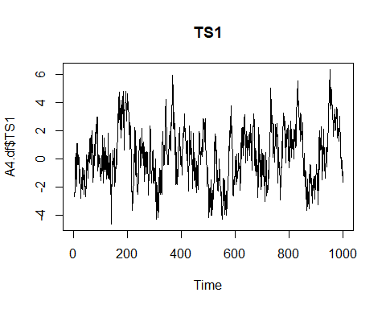

acf(A4.df$TS1, main="ACF of TS1")

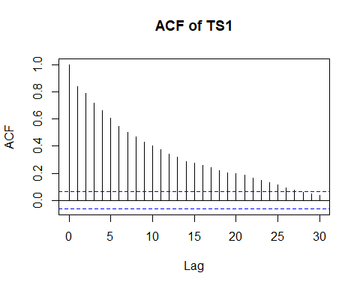

pacf(A4.df$TS1, main="PACF of TS1")

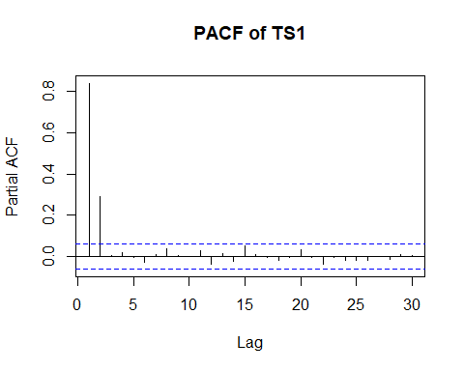

$$y_{t}=ρ_{1}y_{t−1}×ρ_{2}y_{t−2}+ε_{t}$$

The plot of the series shows clustering indcating positive autocorrelation. The acf shows decay while the pacf shows cut-off at lag 2. This suggests AR(2) is the most suitable model.

TS1.fit = arima(A4.df$TS1, order=c(2,0,0))  
TS1.fit

##   
## Call:  
## arima(x = A4.df$TS1, order = c(2, 0, 0))  
##   
## Coefficients:  
## ar1 ar2 intercept  
## 0.5958 0.2928 0.2106  
## s.e. 0.0302 0.0303 0.2821  
##   
## sigma^2 estimated as 1.008: log likelihood = -1423.72, aic = 2855.44

plot(residuals(TS1.fit), main="Residual Series")

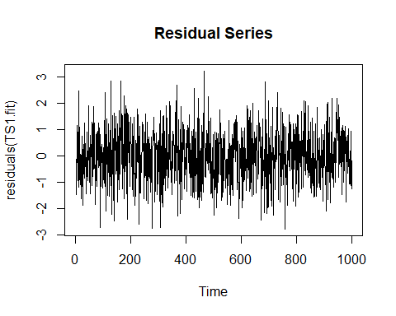

acf(residuals(TS1.fit), main="ACF")

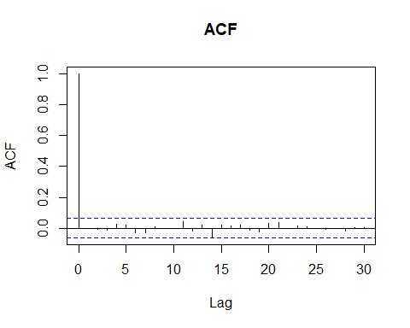

$$y_{t}=0.5958y_{t−1}×0.2928y_{t−2}+ε_{t}$$

##   
## Call:  
## arima(x = A4.df$TS1, order = c(3, 0, 0))  
##   
## Coefficients:  
## ar1 ar2 ar3 intercept  
## 0.5950 0.2911 0.0029 0.2096  
## s.e. 0.0316 0.0357 0.0317 0.2829  
##   
## sigma^2 estimated as 1.008: log likelihood = -1423.71, aic = 2857.43

##   
## Call:  
## arima(x = A4.df$TS1, order = c(2, 0, 1))  
##   
## Coefficients:  
## ar1 ar2 ma1 intercept  
## 0.6063 0.2839 -0.0115 0.2101  
## s.e. 0.1112 0.0952 0.1167 0.2831  
##   
## sigma^2 estimated as 1.008: log likelihood = -1423.71, aic = 2857.43

The Residual Series appear to be random scatter about 0. The plot of the autocorrelation function of the Residual Series shows no significant lags.

Other models tried:

AR(3) AIC = 2857.86  
ARMA(2,10) AIC = 2889.29

AR(2) is the best model. This is because all terms in the AR(2) and AR(3) were significant. However, the AIC of the AR(2) is lower than the AR(3) and the AR(2) is a simpler model.

## Question 2

plot.ts(A4.df$TS2, main="TS2")

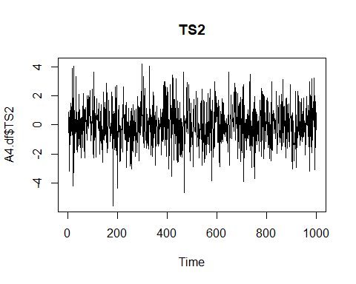

acf(A4.df$TS2, main="ACF of TS2")

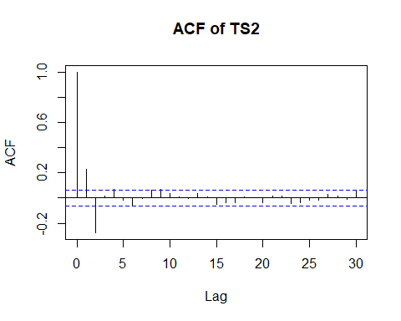

pacf(A4.df$TS2, main="PACF of TS2")

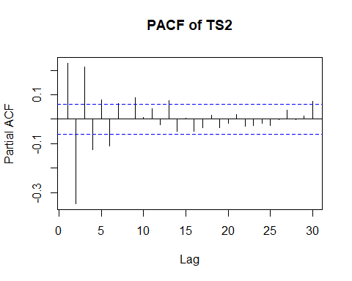 The plot of the series shows no discrenable pattern. The acf shows cut-off at lag 2 and the pacf shows decay (or persistence).

This suggests MA(2) is the most suitable model.

$$y_{t}=ε_{t}+α_{1}ε_{t−1}+α_{1}ε_{t−2}$$

TS2.fit = arima(A4.df$TS2, order=c(0,0,2))  
TS2.fit

##   
## Call:  
## arima(x = A4.df$TS2, order = c(0, 0, 2))  
##   
## Coefficients:  
## ma1 ma2 intercept  
## 0.4377 -0.311 -0.0086  
## s.e. 0.0302 0.030 0.0433  
##   
## sigma^2 estimated as 1.475: log likelihood = -1613.7, aic = 3235.4

plot(residuals(TS2.fit), main="Residual Series")

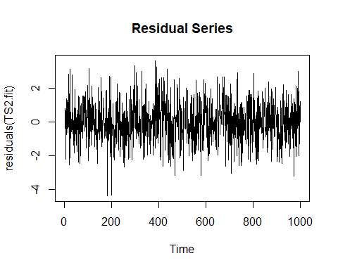

acf(residuals(TS2.fit), main="ACF")

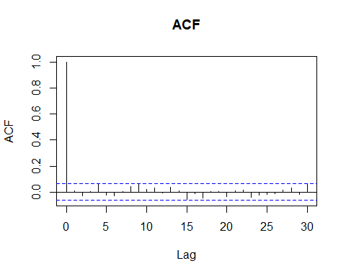 Compare with MA(3) ARMA(1,2)

## Question 3

plot.ts(A4.df$TS3, main="TS3")

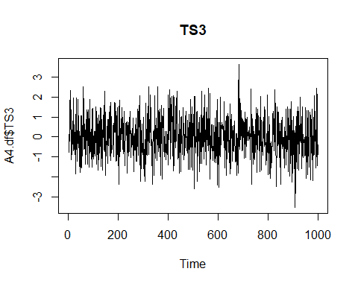

acf(A4.df$TS3, main="ACF of TS3")

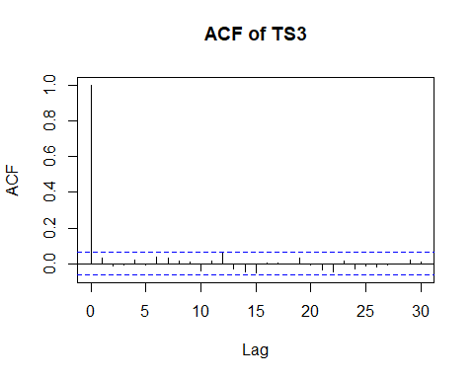

pacf(A4.df$TS3, main="PACF of TS3")

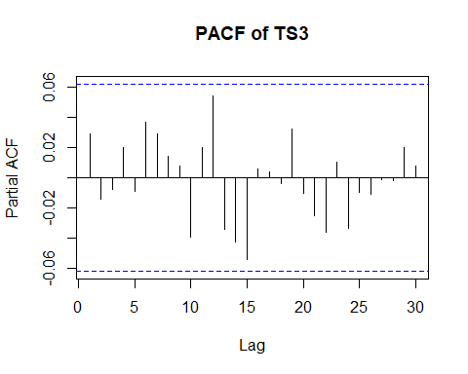

$$y_{t}=ε_{t}$$

The plot of the series shows no discrenible pattern. The acf and pacf show no significant lags. This suggests the series is White Noise.

TS3.fit = arima(A4.df$TS3, order=c(0,0,0))  
TS3.fit

##   
## Call:  
## arima(x = A4.df$TS3, order = c(0, 0, 0))  
##   
## Coefficients:  
## intercept  
## 0.0211  
## s.e. 0.0316  
##   
## sigma^2 estimated as 0.9961: log likelihood = -1417, aic = 2838

plot(residuals(TS3.fit), main="Residual Series")

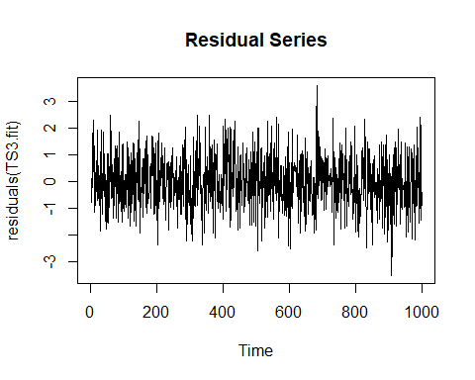

acf(residuals(TS3.fit), main="ACF")

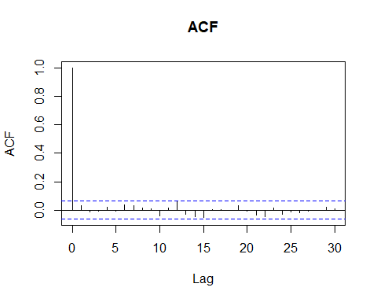

$$y_{t}=ε_{t}$$

##   
## Call:  
## arima(x = A4.df$TS3, order = c(1, 0, 0))  
##   
## Coefficients:  
## ar1 intercept  
## 0.0288 0.0211  
## s.e. 0.0316 0.0325  
##   
## sigma^2 estimated as 0.9953: log likelihood = -1416.58, aic = 2839.17

##   
## Call:  
## arima(x = A4.df$TS3, order = c(0, 0, 1))  
##   
## Coefficients:  
## ma1 intercept  
## 0.0296 0.0211  
## s.e. 0.0320 0.0325  
##   
## sigma^2 estimated as 0.9953: log likelihood = -1416.57, aic = 2839.14

The Residual Series appears to be random scatter about 0. The plot of the autocorrelation function of the Residual Series shows no significant lags.

Other models tried: AR(1) AIC: 2839.17 MA(1) AIC: 2839.14

## Question 4

plot.ts(A4.df$TS4, main="TS4")

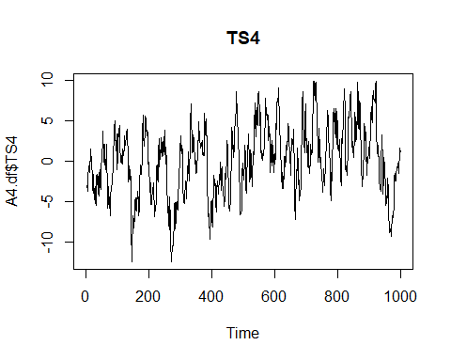

acf(A4.df$TS4, main="ACF of TS4")

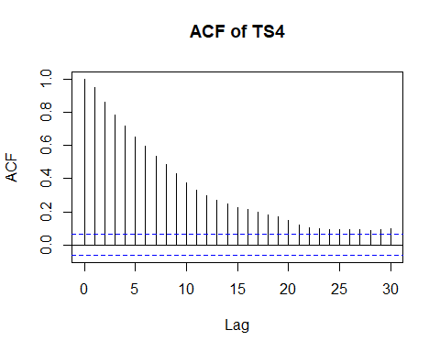

pacf(A4.df$TS4, main="PACF of TS4")

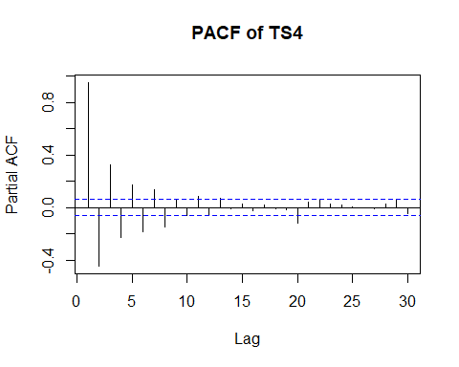

$$y_{t}=ρ_{1}y_{t−1}+α_{1}ε_{t−1}+ε_{t}$$

The plot of the series shows clustering indicating positive autocorrelation. Both the acf and pacf show decay. This suggests an ARMA(p,q) is an appropriate model. However from the plots we have no indication of what order of the ARMA model and thus I began ARMA(1,1).

TS4.fit = arima(A4.df$TS4, order=c(1,0,1))  
TS4.fit

##   
## Call:  
## arima(x = A4.df$TS4, order = c(1, 0, 1))  
##   
## Coefficients:  
## ar1 ma1 intercept  
## 0.8974 0.9121 -0.0147  
## s.e. 0.0139 0.0128 0.5786  
##   
## sigma^2 estimated as 0.9828: log likelihood = -1412.55, aic = 2833.11

plot(residuals(TS4.fit), main="Residual Series")

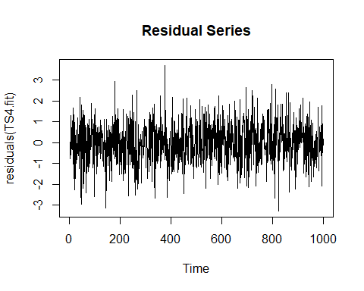

acf(residuals(TS4.fit), main="ACF")

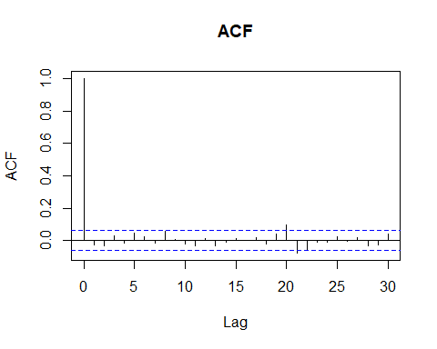

$$y_{t}=0.8974y_{t−1}+0.9121ε_{t−1}+ε_{t}$$

##   
## Call:  
## arima(x = A4.df$TS4, order = c(2, 0, 1))  
##   
## Coefficients:  
## ar1 ar2 ma1 intercept  
## 0.8623 0.0383 0.9180 -0.0139  
## s.e. 0.0344 0.0344 0.0133 0.5987  
##   
## sigma^2 estimated as 0.9815: log likelihood = -1411.93, aic = 2833.86

##   
## Call:  
## arima(x = A4.df$TS4, order = c(1, 0, 2))  
##   
## Coefficients:  
## ar1 ma1 ma2 intercept  
## 0.9058 0.8714 -0.0430 -0.0158  
## s.e. 0.0150 0.0367 0.0366 0.6019  
##   
## sigma^2 estimated as 0.9814: log likelihood = -1411.87, aic = 2833.73

The Residual Series appears to be random scatter about 0. The plot of the autocorrelation function of the Residual Series shows 2 weakly signficant lags at lags 20 and 21. As they are weakly significant, they are not a concern.

Other models tried: ARMA(2,1) AIC: 2833.86 ARMA(1,2) AIC: 2833.73

ARMA(1,1) is the best model. Even though all terms are significant in ARMA(2,1) and ARMA(1,2), ARMA(1,1) has a lower AIC score and is a simpler model.

## Question 5

plot.ts(A4.df$TS5, main="TS5")

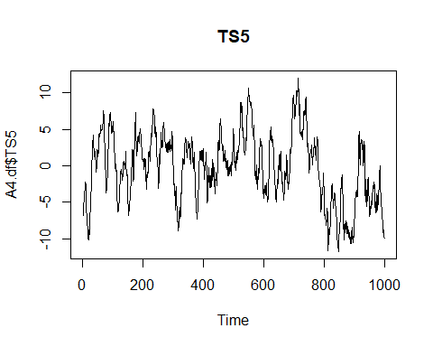

acf(A4.df$TS5, main="ACF of TS5")

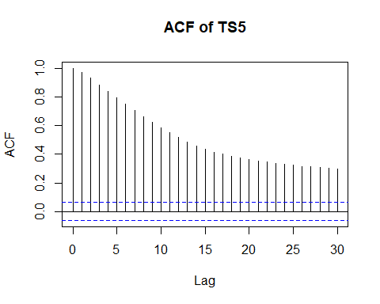

pacf(A4.df$TS5, main="PACF of TS5")

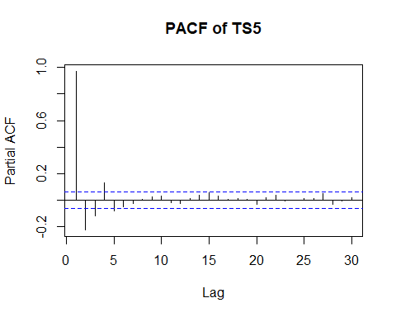

$$y_{t}=ρ_{1}y_{t−1}+α_{1}ε_{t−1}+ε_{t}$$

The plot of the series shows clustering indicating positive autocorrelation. Both the acf and pacf show decay/persistance. This suggests an ARMA(p,q) is an appropriate model. However from the plots we have no indication of what order of the ARMA model and thus I began ARMA(1,1).

TS5.fit = arima(A4.df$TS5, order=c(1,0,1))

## Warning in arima(A4.df$TS5, order = c(1, 0, 1)): possible convergence problem:  
## optim gave code = 1

TS5.fit

##   
## Call:  
## arima(x = A4.df$TS5, order = c(1, 0, 1))  
##   
## Coefficients:  
## ar1 ma1 intercept  
## 0.9674 0.1876 -0.6895  
## s.e. 0.0082 0.0260 1.1571  
##   
## sigma^2 estimated as 1.063: log likelihood = -1450.83, aic = 2909.67

plot(residuals(TS5.fit), main="Residual Series")

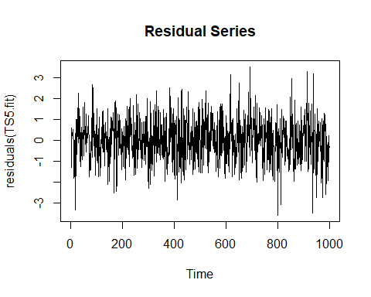

acf(residuals(TS5.fit), main="ACF")

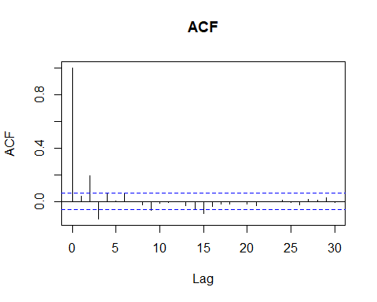

$$y_{t}=0.9674y_{t−1}+0.1876ε_{t−1}+ε_{t}$$

The Residual Series appears to be random scatter about 0. The plot of the autocorrelation function of the Residual Series shows 4 significant lags at lags 2, 3, 9 and 15.

Better Model:

TS5.AR5MA1.fit = arima(A4.df$TS5, order=c(3,0,2))

## Warning in arima(A4.df$TS5, order = c(3, 0, 2)): possible convergence problem:  
## optim gave code = 1

TS5.AR5MA1.fit

##   
## Call:  
## arima(x = A4.df$TS5, order = c(3, 0, 2))  
##   
## Coefficients:  
## ar1 ar2 ar3 ma1 ma2 intercept  
## 0.5844 0.3558 -0.0009 0.6357 0.3226 -0.5953  
## s.e. 0.1063 0.1487 0.1020 0.1016 0.0931 0.9992  
##   
## sigma^2 estimated as 0.9954: log likelihood = -1418.31, aic = 2850.63

$$y_{t}=0.5844y_{t−1}+0.3558y_{t−2}−0.0009y_{t−3}+0.6357ε_{t−1}+0.3226ε_{t−2}+ε_{t}$$

plot(residuals(TS5.AR5MA1.fit), main="Residual Series")

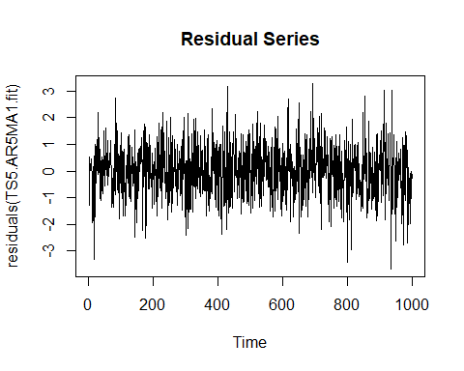

acf(residuals(TS5.AR5MA1.fit))

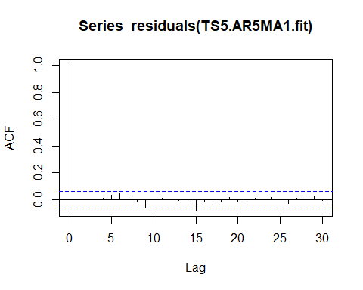 The Residual Series appears to be random scatter about 0. The plot of the autocorrelation function of the residual series shows no signficant lags.

Therefore, ARMA(5,1) was decided as the best model for this series.