Stats 330 Assignment 3

Hasnain Cheena, 190411106, hche737

18/04/2020

## Question 1

#convert degrees fahrenheit to celsius  
HighC = (nyBridges.df$High.Temp - 32) * 5/9  
LowC = (nyBridges.df$Low.Temp - 32) * 5/9  
  
#convert rain in inches to mm  
#as a result of this conversion trace amounts (denoted with a T) are converted to NaN  
Rainmm = as.numeric(as.character(nyBridges.df$Precipitation)) * 25.4

## Warning: NAs introduced by coercion

#relevel day variable  
day.relevel = relevel(nyBridges.df$Day, "Monday")

*Day Factor Relevel*  
Monday was selected to be the baseline level as in New Zealand we consider Monday to be the first day of the week. Further by using Monday we can easily assess if there is a difference in bicycle travel between the first day of week and the rest of the week.

*Trace Characteristics*  
Trace characterises an amount of percipitation that is greater than 0 but too small to be measured reliably. The “T” used in the dataset denotes trace amounts of percipitation. As I am not a meterologist and therefore cannot confirm whether trace amounts of perciptation are equivalent to 0 and so I have chosen to recode trace amounts as NaN.

Reference for definition of trace: <https://www.wmo.int/pages/prog/www/IMOP/publications/CIMO-Guide/Prelim_2018_ed/8_I_6_en_MR_clean.pdf>

## Question 2

pairs20x(nyBridges.Q2.df, main="Pairs Plot")

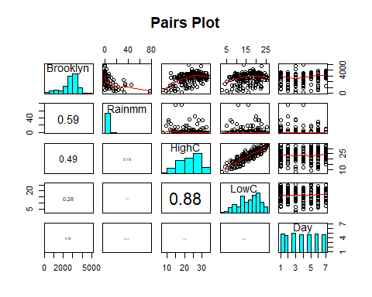 (a) The statistician did not include both high temperature ($HighC$) and low temperature ($LowC$). This is because as you can see from the pairs plot that the high temperature variable and low temperature variable are highly correlated. Thus, both HighC and LowC explain the same pattern in the response variable and therefore the statistician only included one of them. HighC in specific was choosen HighC was choosen as HighC has a stronger correlation to the response than LowC.

1. Firstly, the log transformation was used on Rainmm as the variable is very right skewed (shown on pairs plot histogram). However using the natural log transformation will not work as Rainmm contains the value 0. Therefore log1p was used as it log1p computes the computes the natural logarithm of the given value plus 1 accounting for Rainmm values of 0.
2. A quadratic effect for temperature was included in the models because the relatioship between temperature ($HighC$) and the response showed curvature indicating a non-linear relationship. Therefore a quadratic term for temperature was added to account for the non-linearity aspect of the relationship.

## Question 3

### Model A Exploration

model.lin.a<-lm(Brooklyn~log1p(Rainmm)+Day+HighC+I(HighC^2),data=NYBridges.df)  
  
layout(matrix(c(1,1,1,1,1,1,2,2,2,2,2,2), nrow = 4, ncol = 3, byrow = TRUE))  
#raw residual  
plot(predict(model.lin.a),residuals(model.lin.a), ylab="Raw Residuals",xlab="Fitted values")  
abline(h=0, lty='dashed')  
#pearson residual   
plot(predict(model.lin.a),residuals(model.lin.a, type="pearson"), ylab="Pearson Residuals", xlab="Fitted values")  
abline(h=0, lty='dashed')

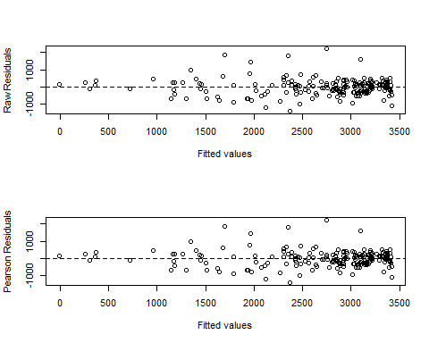

normcheck(model.lin.a, shapiro.wilk = TRUE)

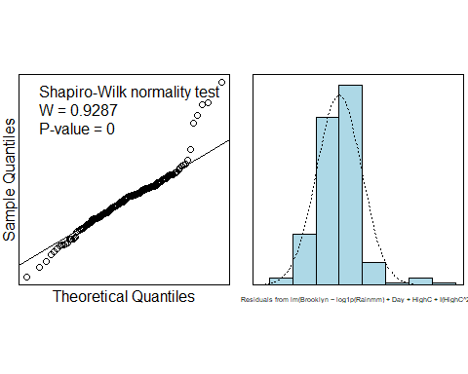

#assess goodness of fit  
deviance(model.lin.a)

## [1] 46551228

The raw residuals and pearson residuals do not show a patternless band around 0. The pearson residuals clearly display non-constant variance and the majority of the residuals are not between -2 and 2. Furthermore, the histogram of residuals shows the residuals are very right skewed. The residual sum of squares is 46551228. This value was not useful in making a decision on the model as we had no scale to compare to inorder to make the decision that the model was appropriate.

All the evidence above coupled with the fact that the response variable is a count lead to the conclusion that the linear model is not appropriate to capture the relationship correctly between the bicycle activity on the Brooklyn bridge and explanatory variables.

### Model B Exploration

model.pois.b<-glm(Brooklyn~log1p(Rainmm)+Day+HighC+I(HighC^2),family=poisson,data=NYBridges.df)  
  
layout(matrix(c(1,1,1,1,1,1,2,2,2,2,2,2), nrow = 4, ncol = 3, byrow = TRUE))  
#pearson residual   
plot(predict(model.pois.b),residuals(model.pois.b, type="pearson"),ylab="Pearson Residuals", xlab="Fitted values")  
abline(h=0, lty='dashed')  
#deviance   
plot(predict(model.pois.b),residuals(model.pois.b, type="deviance"),ylab="Deviance Residuals", xlab="Fitted values")  
abline(h=0, lty='dashed')

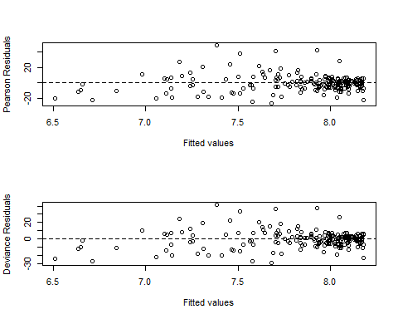

#assess goodness of fit  
1-pchisq(model.pois.b$deviance, model.pois.b$df.residual)

## [1] 0

The pearson and deviance residual plots do not have a patternless band around 0. Therefore, the residual plots show non-constant variance. Furthermore, a majority of the residuals are not within -2 and 2 indcating the model is not appropriate. Moreover, we have very strong evidence (p-value = 0) that the model is not a good fit. Taking the above facts into consideration this model is also not appropriate to capture the relationship correctly between the bicycle activity on the Brooklyn bridge and explanatory variables.

### Model C Exploration

model.qpois.c<-glm(Brooklyn~log1p(Rainmm)+Day+HighC+I(HighC^2),family=quasipoisson,data=NYBridges.df)  
  
layout(matrix(c(1,1,1,1,1,1,2,2,2,2,2,2), nrow = 4, ncol = 3, byrow = TRUE))  
#pearson residual   
plot(predict(model.qpois.c),residuals(model.qpois.c, type="pearson"),ylab="Pearson Residuals", xlab="Fitted values")  
abline(h=0, lty='dashed')  
#deviance   
plot(predict(model.qpois.c),residuals(model.qpois.c, type="deviance"),ylab="Deviance Residuals", xlab="Fitted values")  
abline(h=0, lty='dashed')

 The Pearson and deviance residual plots are still showing non-constant variance as they are not a patternless band around 0. This suggests that the quasi-Poisson model is not suitable to model the relationship between the bicycle activity on the Brooklyn bridge and explanatory variables.

### Model D Exploration

model.nb.d<-glm.nb(Brooklyn~log1p(Rainmm)+Day+HighC+I(HighC^2),data=NYBridges.df)  
  
layout(matrix(c(1,1,1,1,1,1,2,2,2,2,2,2), nrow = 4, ncol = 3, byrow = TRUE))  
#pearson residual   
plot(predict(model.nb.d),residuals(model.nb.d, type="pearson"),ylab="Pearson Residuals", xlab="Fitted values")  
abline(h=0, lty='dashed')  
#deviance   
plot(predict(model.nb.d),residuals(model.nb.d, type="deviance"),ylab="Deviance Residuals", xlab="Fitted values")  
abline(h=0, lty='dashed')

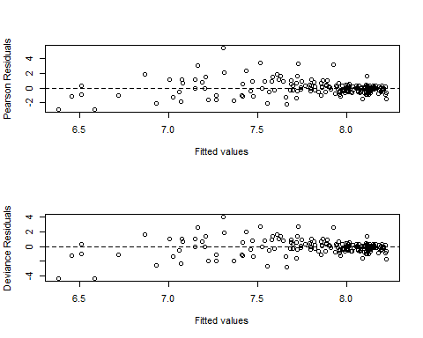

#summary  
summary(model.nb.d)

##   
## Call:  
## glm.nb(formula = Brooklyn ~ log1p(Rainmm) + Day + HighC + I(HighC^2),   
## data = NYBridges.df, init.theta = 15.71142767, link = log)  
##   
## Deviance Residuals:   
## Min 1Q Median 3Q Max   
## -4.3575 -0.4805 -0.0738 0.2983 3.9887   
##   
## Coefficients:  
## Estimate Std. Error z value Pr(>|z|)   
## (Intercept) 6.1101329 0.2556884 23.897 < 2e-16 ***  
## log1p(Rainmm) -0.2715243 0.0176485 -15.385 < 2e-16 ***  
## DayFriday -0.0125467 0.0677290 -0.185 0.8530   
## DaySaturday -0.0177899 0.0654899 -0.272 0.7859   
## DaySunday -0.1311051 0.0673415 -1.947 0.0516 .   
## DayThursday 0.0148485 0.0675741 0.220 0.8261   
## DayTuesday 0.0831982 0.0666101 1.249 0.2117   
## DayWednesday 0.0572638 0.0673593 0.850 0.3953   
## HighC 0.1455586 0.0227150 6.408 1.47e-10 ***  
## I(HighC^2) -0.0026132 0.0005004 -5.222 1.77e-07 ***  
## ---  
## Signif. codes: 0 '***' 0.001 '**' 0.01 '*' 0.05 '.' 0.1 ' ' 1  
##   
## (Dispersion parameter for Negative Binomial(15.7114) family taken to be 1)  
##   
## Null deviance: 560.21 on 199 degrees of freedom  
## Residual deviance: 203.62 on 190 degrees of freedom  
## (14 observations deleted due to missingness)  
## AIC: 3167.4  
##   
## Number of Fisher Scoring iterations: 1  
##   
##   
## Theta: 15.71   
## Std. Err.: 1.58   
##   
## 2 x log-likelihood: -3145.446

#assess goodness of fit  
1-pchisq(model.nb.d$deviance, model.nb.d$df.residual)

## [1] 0.2367973

The Pearson and deviance residuals are scattered in a reasonably patternless band around 0. Further, a majority of the residuals are between -2 and 2. Therefore, the residuals do not show a pattern in the mean and variance. Further, the deviance does not provide evidence (p-value 0.24) for a lack of fit. The negative binomial model is appropriate to model the relationship between the bicycle activity on the Brooklyn bridge and explanatory variables.

## Question 4

#weekend vs weekday  
#relevel with baseline as sunday  
NYBridges.df$Day <- relevel(NYBridges.df$Day, "Saturday")  
model.nb.d<-glm.nb(Brooklyn~log1p(Rainmm)+Day+HighC+I(HighC^2),data=NYBridges.df)  
summary(model.nb.d)

##   
## Call:  
## glm.nb(formula = Brooklyn ~ log1p(Rainmm) + Day + HighC + I(HighC^2),   
## data = NYBridges.df, init.theta = 15.71142767, link = log)  
##   
## Deviance Residuals:   
## Min 1Q Median 3Q Max   
## -4.3575 -0.4805 -0.0738 0.2983 3.9887   
##   
## Coefficients:  
## Estimate Std. Error z value Pr(>|z|)   
## (Intercept) 6.0923430 0.2534232 24.040 < 2e-16 ***  
## log1p(Rainmm) -0.2715243 0.0176485 -15.385 < 2e-16 ***  
## DayMonday 0.0177899 0.0654899 0.272 0.7859   
## DayFriday 0.0052432 0.0668158 0.078 0.9375   
## DaySunday -0.1133152 0.0665772 -1.702 0.0888 .   
## DayThursday 0.0326384 0.0666821 0.489 0.6245   
## DayTuesday 0.1009881 0.0655065 1.542 0.1232   
## DayWednesday 0.0750537 0.0666616 1.126 0.2602   
## HighC 0.1455586 0.0227150 6.408 1.47e-10 ***  
## I(HighC^2) -0.0026132 0.0005004 -5.222 1.77e-07 ***  
## ---  
## Signif. codes: 0 '***' 0.001 '**' 0.01 '*' 0.05 '.' 0.1 ' ' 1  
##   
## (Dispersion parameter for Negative Binomial(15.7114) family taken to be 1)  
##   
## Null deviance: 560.21 on 199 degrees of freedom  
## Residual deviance: 203.62 on 190 degrees of freedom  
## (14 observations deleted due to missingness)  
## AIC: 3167.4  
##   
## Number of Fisher Scoring iterations: 1  
##   
##   
## Theta: 15.71   
## Std. Err.: 1.58   
##   
## 2 x log-likelihood: -3145.446

#relevel with baseline as saturday  
NYBridges.df$Day <- relevel(NYBridges.df$Day, "Sunday")  
model.nb.d<-glm.nb(Brooklyn~log1p(Rainmm)+Day+HighC+I(HighC^2),data=NYBridges.df)  
summary(model.nb.d)

##   
## Call:  
## glm.nb(formula = Brooklyn ~ log1p(Rainmm) + Day + HighC + I(HighC^2),   
## data = NYBridges.df, init.theta = 15.71142767, link = log)  
##   
## Deviance Residuals:   
## Min 1Q Median 3Q Max   
## -4.3575 -0.4805 -0.0738 0.2983 3.9887   
##   
## Coefficients:  
## Estimate Std. Error z value Pr(>|z|)   
## (Intercept) 5.9790278 0.2574954 23.220 < 2e-16 ***  
## log1p(Rainmm) -0.2715243 0.0176485 -15.385 < 2e-16 ***  
## DaySaturday 0.1133152 0.0665772 1.702 0.08875 .   
## DayMonday 0.1311051 0.0673415 1.947 0.05155 .   
## DayFriday 0.1185584 0.0684876 1.731 0.08344 .   
## DayThursday 0.1459536 0.0679912 2.147 0.03182 *   
## DayTuesday 0.2143033 0.0674407 3.178 0.00148 **   
## DayWednesday 0.1883689 0.0677742 2.779 0.00545 **   
## HighC 0.1455586 0.0227150 6.408 1.47e-10 ***  
## I(HighC^2) -0.0026132 0.0005004 -5.222 1.77e-07 ***  
## ---  
## Signif. codes: 0 '***' 0.001 '**' 0.01 '*' 0.05 '.' 0.1 ' ' 1  
##   
## (Dispersion parameter for Negative Binomial(15.7114) family taken to be 1)  
##   
## Null deviance: 560.21 on 199 degrees of freedom  
## Residual deviance: 203.62 on 190 degrees of freedom  
## (14 observations deleted due to missingness)  
## AIC: 3167.4  
##   
## Number of Fisher Scoring iterations: 1  
##   
##   
## Theta: 15.71   
## Std. Err.: 1.58   
##   
## 2 x log-likelihood: -3145.446

100*(exp(confint(model.nb.d))-1)

## Waiting for profiling to be done...

## 2.5 % 97.5 %  
## (Intercept) 23655.2192952 66322.1334187  
## log1p(Rainmm) -26.4002232 -21.0172861  
## DaySaturday -1.9179299 27.8613408  
## DayMonday -0.1535242 30.1692216  
## DayFriday -1.5960193 28.8301055  
## DayThursday 1.3179836 32.1561966  
## DayTuesday 8.5174119 41.4508963  
## DayWednesday 5.6734862 37.9264816  
## HighC 10.4271304 21.0577286  
## I(HighC^2) -0.3610522 -0.1591307

*Brief Model Interpretation* There is no evidence of a difference between the number of cyclists in Brooklyn on Saturday compared to all the weekdays.

There is evidence of the a difference between the number of cyclists in Brooklyn on Sunday compared to Tuesday, Wednesday and Thursday. However there is no evidence of a difference between the number of cyclists in Brooklyn on Sunday compared to Monday and Friday. We estimate that, for the same percipitation amount and temperature, the expected number of cyclists in Brooklyn on Tuesday is 8.5% to 41.5% higher than Sunday. We estimate that, for the same percipitation amount and temperature, the expected number of cyclists in Brooklyn on Wednesday is 5.7% to 37.9% higher than Sunday. We estimate that, for the same percipitation amount and temperature, the expected number of cyclists in Brooklyn on Thursday is 1.3% to 32.2% higher than Sunday.

*Which of the four models do you think is best?* From the evidence presented above the negative binomial model ($model.nb.d$) is the best. Relative to the other models the Pearson and deviance residual plots of the negative binomial model show reasonably constant variance and no pattern in the mean. Further most of the residuals are within -2 and 2. Thus the modelling assumptions are met unlike the other models. Further, for the negative binomial model the deviance does not provide evidence (p-value 0.24) for a lack of fit. In constrast all the other models specified provide evidence against the hypothesis that the model is a good fit.

AIC(model.lin.a,model.pois.b,model.nb.d)

## df AIC  
## model.lin.a 11 3061.125  
## model.pois.b 10 23972.325  
## model.nb.d 11 3167.446

AICc(model.lin.a,model.pois.b,model.nb.d)

## df AICc  
## model.lin.a 11 3062.529  
## model.pois.b 10 23973.489  
## model.nb.d 11 3168.851

BIC(model.lin.a,model.pois.b,model.nb.d)

## df BIC  
## model.lin.a 11 3097.406  
## model.pois.b 10 24005.308  
## model.nb.d 11 3203.728

*Do you think the model fits well?* I believe the negative binomial model ($model.nb.d$) is a good fit but it does not fit the data well. This is because of the AIC, AICc and BIC scores. The AICc, AIC and BIC scores show that the linear model ($model.lin.a$) is considerably better supported than by the data than the the negative binomial model ($model.nb.d$). However, we know the linear model is not appropriate and does not fit the data well. Thus since it is least-worst out of the candidate models, all the candidate models must not fit the data well.

*Other variables* Additional meterological variables I believe this dataset could benefit from are: * Cloud cover: Days with high cloud cover may indicate chance of rain and thus de-incentize cyclists. * Average Wind speed - Days with higher wind speed makes bicycle riding harder increasing the possibilty of less cyclists on the Brooklyn bridge. * Hours of sunshine - Hours of daily sunshine could give an indication on the season. Less daily sunshine could mean winter and thus less cyclists on the Brooklyn bridge due to the cold conditions. * Relative Humidity - Quite humid days are uncomfortable may deter cyclists.