Stats 330 Assignment 4

Hasnain Cheena

04/06/2020

## Question 1

### 1a)

feuro.df = read.csv('feuro.csv', header = TRUE)  
  
#create BMI  
feuro.df <- transform(feuro.df, BMI = weight / height^2)  
  
# Sort by age  
sort.order <- with(feuro.df, order(age))  
feuro.df <- feuro.df[sort.order, ]  
  
#fit linear model with quadratic in age  
quadbmi.fit = lm(BMI ~ poly(age, 2, raw=TRUE), feuro.df)

The model equation is shown below:

$$BMI_{i}=β_{2}age_{i}^{2}+β_{1}age_{i}+β_{0}$$

Where $BMI_{i}$ is the ith European woman’s body mass index and $age_{i}$ is the ith European woman’s age in years. To find the age at which a European woman’s BMI is maximised the derivative of the equation is found and equated to 0 as shown below:

$$\frac{d}{dx}(β_{2}age_{i}^{2}+β_{1}age_{i}+β_{0})=0$$

$$2β_{2}age_{i}+β_{1}=0$$

$$age_{i}=\frac{−β_{1}}{2β_{2}}$$

#obtain age where bmi is maximised  
theta.hat = (-1*quadbmi.fit$coefficients[2])/(2*quadbmi.fit$coefficients[3])  
names(theta.hat) = "Age at which bmi is maximised"  
theta.hat

## Age at which bmi is maximised   
## 61.92375

Therefore the estimated age at which BMI is maximised for European women is 61.9 years old.

azure <- "#007FFF"  
plot(BMI ~ jitter(age), data = feuro.df, col = azure, cex = 0.5,las = 1, main = "BMI vs age for European women", ylab = "BMI (kg/m^2)")  
lines(with(feuro.df, age), fitted(quadbmi.fit), col = "red", lwd=1)  
abline(v=c(theta.hat), lty="dashed", col="gray50")  
legend("topleft",legend=c("Quadratic"),col=c("red"),lty=rep(1))

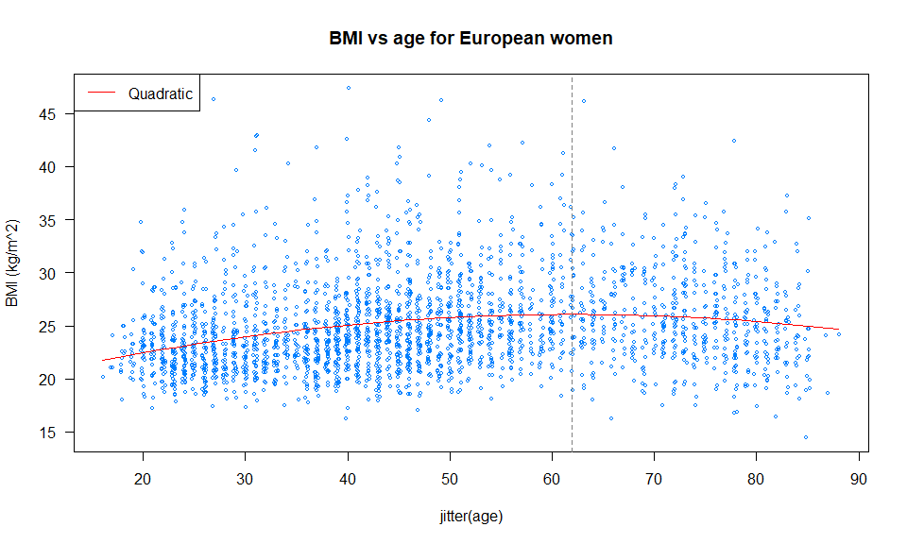 To produce a high quality scatter plot jitter was used. The vertical dashed line in the scatterplot shows the age at which BMI is maximised ($\hat{θ}$).

### 1b)

#reproducible  
set.seed(106)  
  
n.sims = 10000  
#create vectors to store estimates  
est.theta = numeric(n.sims)  
#number of observations  
n = nrow(feuro.df)  
#calculate expected values  
feuro.df$expected.values = quadbmi.fit$coefficients[1] + quadbmi.fit$coefficients[2]*feuro.df$age + quadbmi.fit$coefficients[3]*(feuro.df$age)^2  
  
sigma.hat = summary(quadbmi.fit)$sigma  
  
#simulate  
for (i in 1:n.sims){  
 #simulate responses  
 bmi.simulated = rnorm(n, feuro.df$expected.values, sigma.hat)  
   
 #refit  
 sim.fit = lm(bmi.simulated ~ poly(feuro.df$age, 2, raw=TRUE))  
   
 #calculate theta and save  
 est.theta[i] = (-1*sim.fit$coefficients[2])/(2*sim.fit$coefficients[3])  
}  
  
#quantiles to obtain 95% interval  
a = theta.hat - quantile(est.theta, prob=0.025)  
b = quantile(est.theta, prob=0.975) - theta.hat  
ci = c(theta.hat-b, theta.hat+a)  
names(ci) = c("2.5%", "97.5%")  
ci

## 2.5% 97.5%   
## 57.52950 64.94484

Therefore, using parametric boostrapping we estimate that the expected age at which bmi is maximised is between 57.5 years old and 64.9 years old.

### 1c)

#reproducible  
set.seed(106)  
  
n.sims = 10000  
#create vectors to store estimates  
est.theta = numeric(n.sims)  
#number of observations  
n = nrow(feuro.df)  
  
#simulate  
for (i in 1:n.sims){  
 #resample dataframe  
 samp = sample(1:n, replace=TRUE)  
 boot.df = feuro.df[samp,]  
   
 #fit the model  
 sim.fit = lm(BMI ~ poly(age, 2, raw=TRUE), boot.df)  
   
 #calculate theta and save  
 est.theta[i] = (-1*sim.fit$coefficients[2])/(2*sim.fit$coefficients[3])  
}  
  
#quantiles to obtain 95% interval  
a = theta.hat - quantile(est.theta, prob=0.025)  
b = quantile(est.theta, prob=0.975) - theta.hat  
ci = c(theta.hat-b, theta.hat+a)  
names(ci) = c("2.5%", "97.5%")  
ci

## 2.5% 97.5%   
## 57.44098 64.95676

Therefore, using non-parametric boostrapping we estimate that the expected age at which bmi is maximised is between 57.4 years old and 64.9 years old.

Therefore, the confidence intervals created by parametric and non-parametric bootstrapping are very similar.

### 1d)

library(msm)  
  
#using original model fit from above  
quadbmi.fit = lm(BMI ~ poly(age, 2, raw=TRUE), feuro.df)  
  
#delta method  
dm.sd = deltamethod(~x1/(2*x2), coef(quadbmi.fit), vcov(quadbmi.fit))  
dm.CI = -coef(quadbmi.fit)[2]/(2*coef(quadbmi.fit)[3]) + 1.96 * c(-1,1) * dm.sd  
names(dm.CI) = c("2.5%", "97.5%")  
dm.CI

## 2.5% 97.5%   
## 52.22546 71.62204

Therefore, using the delta-method we estimate that the expected age at which bmi is maximised is between 52.2 years old and 71.6 years old.

Therefore, it can be seen that the confidence interval created by the delta-method is relatively wider than the intervals created by parametric/non-parametric bootstrapping.

### Q1e

The results obtained above will not be able to generalise well to the population here and now. This is because: 1. The original study has conducted in the mid-1990’s which is around 25 years ago. Factors that affect BMI such as the food we eat has evolved over time and therefore the population in the original study is different from the population today.

2.The original study contained both male and female participants. However, our results were based on female participants only.Thus, the results will not generalise over both genders.

3.The original study contained 4 major ethnic groups: “Europeans”, “Maori”, “Polynesian” and “Others”. Our results were only based on the “European” group and as such will not generalise well over all ethnicities.

## Question 2

library(datasets)  
library(MuMIn)  
  
fm1 <- lm(sr ~ pop15 + pop75 + dpi + ddpi, data = LifeCycleSavings)  
  
#use dredge to get a model selected from a table of models  
#only keep models that include models with ddpi and use BIC to rank models  
options(na.action="na.fail", width=120)  
dredge(fm1,rank="BIC", subset=with(ddpi))

## Fixed term is "(Intercept)"

## Global model call: lm(formula = sr ~ pop15 + pop75 + dpi + ddpi, data = LifeCycleSavings)  
## ---  
## Model selection table   
## (Intrc) ddpi dpi pop15 pop75 df logLik BIC delta weight  
## 6 15.600 0.4428 -0.2164 4 -136.943 289.5 0.00 0.439  
## 14 28.120 0.4278 -0.4518 -1.8350 5 -135.171 289.9 0.37 0.366  
## 8 19.280 0.3929 -0.0008704 -0.2884 5 -136.416 292.4 2.86 0.105  
## 16 28.570 0.4097 -0.0003369 -0.4612 -1.6910 6 -135.098 293.7 4.13 0.056  
## 10 5.470 0.4636 1.0730 4 -140.211 296.1 6.54 0.017  
## 4 6.360 0.5292 0.0011950 4 -141.022 297.7 8.16 0.007  
## 2 7.883 0.4758 3 -142.990 297.7 8.18 0.007  
## 12 5.487 0.4738 0.0001972 0.9529 5 -140.190 299.9 10.41 0.002  
## Models ranked by BIC(x)

The table above shows a selection of models ranked by BIC and that contain the variable $ddpi$.

## Question 3

### 3a)

# Generate the 'original' data  
#ID: 190411106  
set.seed(106)  
  
n <- 100  
X <- scale(3 * (1:n)/n, scale = FALSE)  
myfun <- function(x)  
 2 - x + 3*x*x  
Y <- myfun(X) + rnorm(n)  
  
plot(X, Y, col = "blue", main="Simulated Data fit with smooth splines")  
fit <- smooth.spline(X, Y, df = 3 , all = TRUE)  
lines(fit, lty = 1, col = "black", lwd = 1)  
legend("topright",legend=c("Smooth Spline df=3"),col=c("darkgreen"),lty=rep(1))

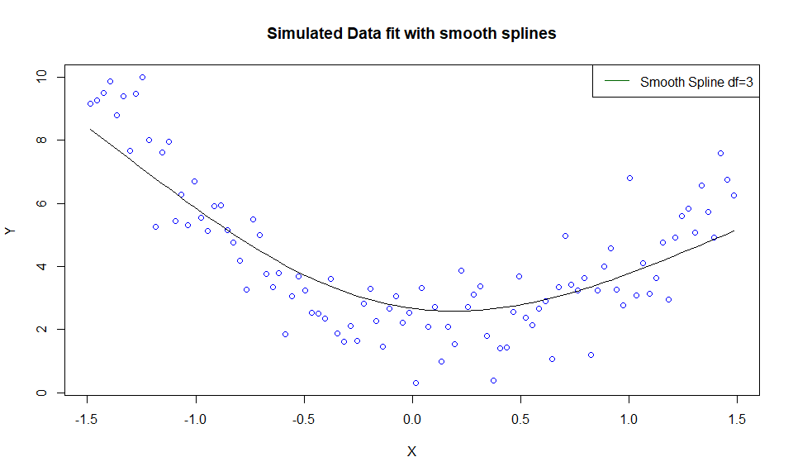 The scatterplot above overlaid with the spline of equivalent number of degrees of freedom of 3 shows that the spline is underfitting the data.

### 3b)

#smooth spline with df=2  
spline.df2 <- smooth.spline(X, Y, df = 2 , all = TRUE)  
  
#smooth spline with df=20  
spline.df20 <- smooth.spline(X, Y, df = 20 , all = TRUE)  
  
plot(X, Y, col = "blue", main="Simulated Data fit with smooth splines")  
lines(fit, lty = 1, col = "black", lwd = 1)  
lines(spline.df2, lty = 1, col = "red", lwd = 1)  
lines(spline.df20, lty = 1, col = "orange", lwd = 1)  
legend("topright",legend=c("Smooth Spline df=3", "Smooth Spline df=2", "Smooth Spline df=20"),col=c("darkgreen", "red", "orange"),lty=rep(1,3))

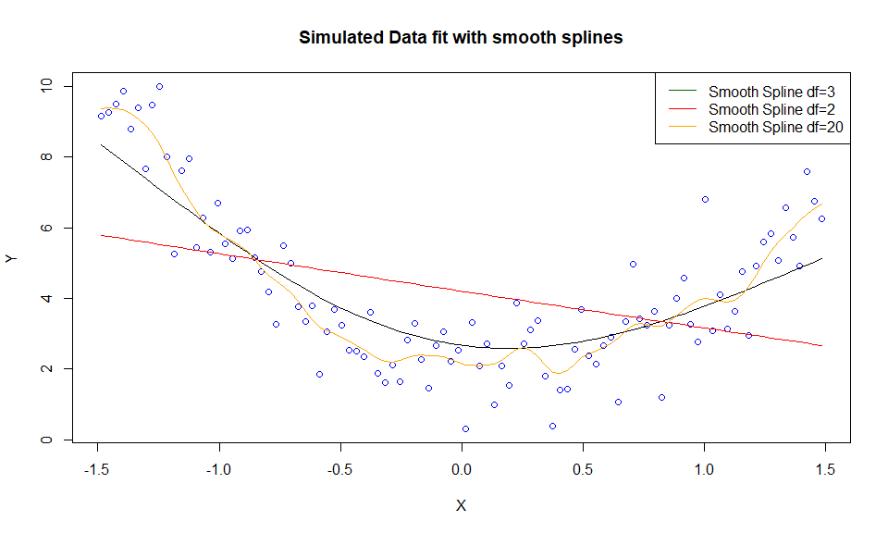

From the scatterplot above overlaid with the smooth splines it is clear that the spline with equivalent degrees of freedom of 2 is underfitting while the spline with equivalent number of degrees of freedom of 20 is overfitting.

### 3c)

dfvec = 2:n  
results.df = data.frame(df=dfvec, MSE= matrix(0, nrow=n-1))  
  
  
for (i in dfvec){  
 #fit spline  
 smooth.fit = smooth.spline(X, Y, df = i , all = TRUE)  
 #calculate MSE and add to df  
 results.df$MSE[i-1] = (sum((Y - smooth.fit$y)^2))/n  
  
}  
  
#plot using line  
plot(MSE~df, results.df, type="n", main="Mean Residual Sum of Squares vs Equivalent degrees of freedom", xlab="Equivalent degrees of freedom", ylab="Mean Residual Sum of Squares")   
lines(MSE~df, results.df, lty = 1, col = "red", lwd = 1)  
legend("topright",legend=c("Training Error"),col=c("red"),lty=rep(1))

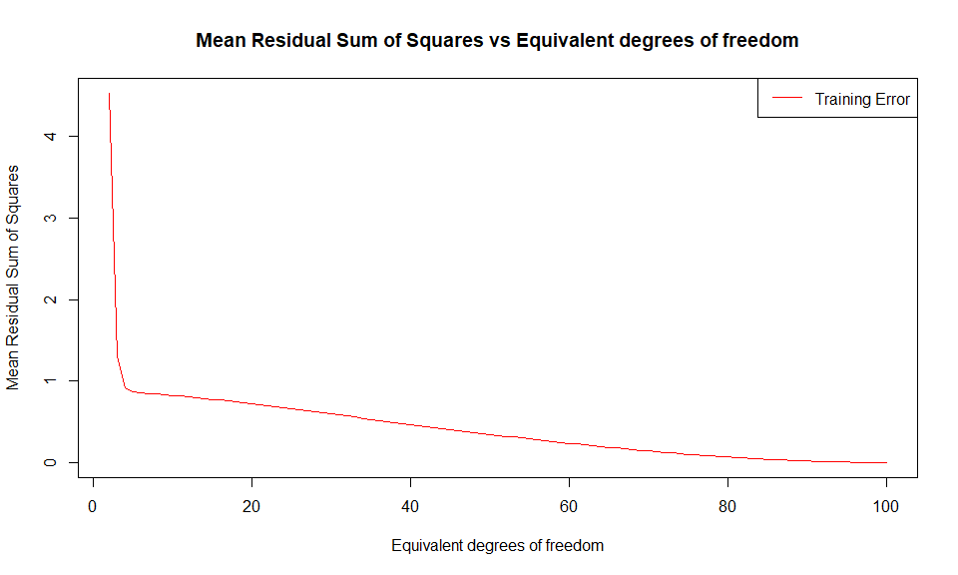 From the plot above it can be seen that as the equivalent degrees of freedom increases the mean residuals sum of squares computed on the training set decreases. This is because as the equivalent degrees of freedom increases the model becomes more complex begins to overfit the data.

### 3d)

#model complexity vs prediction error  
#generate new test data  
n <- 100  
X.test <- scale(3 * (1:n)/n, scale = FALSE)  
myfun <- function(x)  
 2 - x + 3*x*x  
Y.test <- myfun(X.test) + rnorm(n)  
  
dfvec = 2:n  
results.train.df = data.frame(df=dfvec, MSE= matrix(0, nrow=n-1))  
results.test.df = data.frame(df=dfvec, MSE= matrix(0, nrow=n-1))  
  
#fit splines with training data and fit on test data  
for (i in dfvec){  
 #fit spline  
 smooth.fit = smooth.spline(X, Y, df = i , all = TRUE)  
 #calculate MSE and add to training df  
 results.train.df$MSE[i-1] = (sum((Y - smooth.fit$y)^2))/n  
   
 #predict test   
 Y.pred = predict(smooth.fit, data=X.test, type="response")  
 #calculate MSE  
 results.test.df$MSE[i-1] = (sum((Y.test - Y.pred$y)^2))/n  
}  
  
#plot using line  
plot(MSE~df, results.train.df, type="n", main="Mean Residual Sum of Squares vs Equivalent degrees of freedom", xlab="Equivalent degrees of freedom", ylab="Mean Residual Sum of Squares")  
lines(MSE~df, lty = 1, col = "red", lwd = 1, results.train.df)  
lines(MSE~df, lty = 1, col = "blue", lwd = 1, results.test.df)  
legend("topright",legend=c("Training Error", "Test Error"),col=c("red", "blue"),lty=rep(1,2))

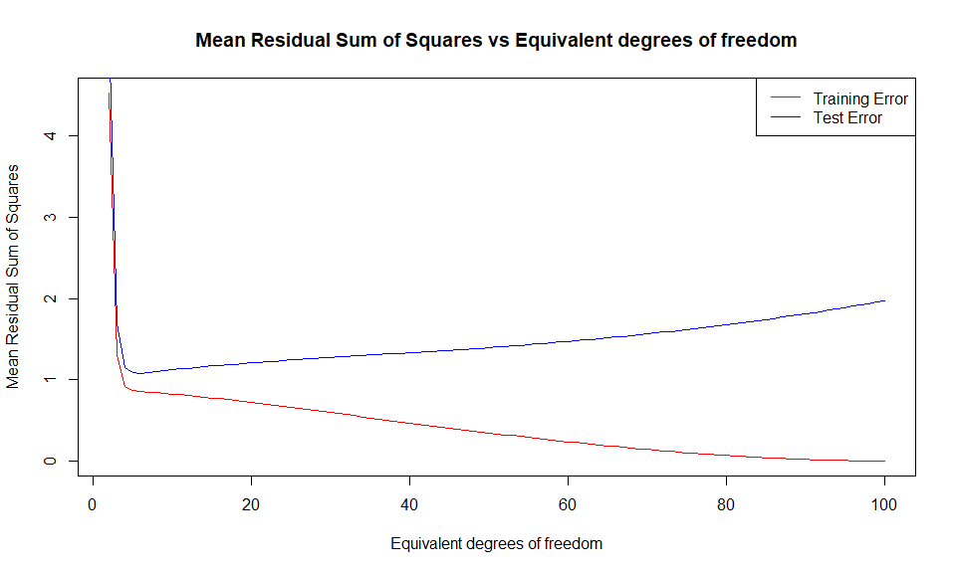 From the plot above it can be seen that as the equivalent degrees of freedom increases the mean residuals sum of squares computed on the training dataset decreases. In comparision, mean residuals sum of squares computed on the test dataset initially decrease upto an optimal equivalent degrees of freedom value and then begin to increase. This is because as the equivalent degrees of freedom increases the model becomes more complex and begins to overfit to the training set and therefore clearly doesn’t generalise well on the test set. From the plot it is clear the optimal equivalent degrees of freedom is between 4 and 5.

### 3e)

smooth.autogcv.fit = smooth.spline(X, Y, all = TRUE)  
smooth.autogcv.fit

## Call:  
## smooth.spline(x = X, y = Y, all.knots = TRUE)  
##   
## Smoothing Parameter spar= 0.9508283 lambda= 0.005551461 (14 iterations)  
## Equivalent Degrees of Freedom (Df): 5.125804  
## Penalized Criterion (RSS): 86.49381  
## GCV: 0.9609235

#plot a scatter plot with the smoother  
plot(X, Y, col = "blue", main="Simulated Data fit with smooth splines")  
lines(smooth.autogcv.fit, lty = 1, col = "orange", lwd = 1)

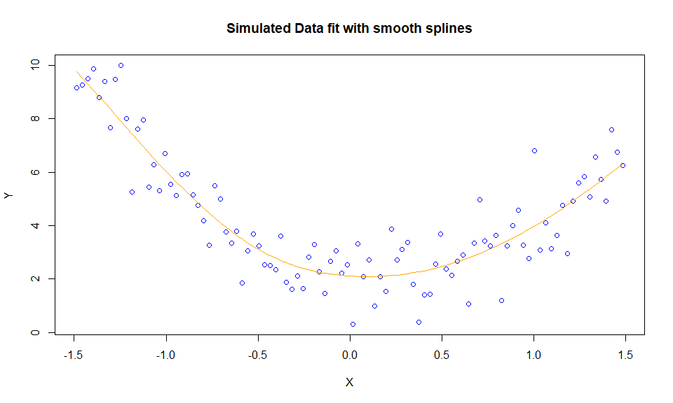 The optimal equivalent degrees of freedom set by GCV is approximately 5.1. This spline is a good fit and relatively better than the splines above as it seems to captures the underlying pattern in the data.

### 3f)

This section highlights the differences between good fitting, underfitting and overfitting models.

Quetions 3b and 3e show the visual differences between a good fitting, underfitting and overfitting model. These questions show that overfitting models fit to the random variation in the data (low bias and high variance) while underfitting models are not able to capture the underlying pattern in the data (high bias and low variance).

Furthermore, Questions 3c and 3d show how overfitting tends to occur when the complexity (equivalent degrees of freedom) of a model increases leading to a failure to generalise well. Moreover, these questions also show that characteristicly underfitting models have both high training and test error while overfitting models have low training error but high test error.