Homework 2

Haden Stuart – has0027

1. (10) Given the grammar below, identify which sentences are in the language (which are valid sentence).
   1. baab
   2. bbbab
   3. bbaaaaaa
   4. bbaab

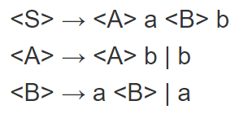

From the first line, <S> -> <A> a <B> b, we know that the ending to any sentence must have the letter b, meaning c is invalid. Continuing through the grammar we have <A> -> <A> b | b, which means that the first letter must be the letter b. Plugging these values in we get two possible strings:

ba<B>b or bba<B>b 🡺 baab or bbaab 🡺 Meaning only **a** and **d** are valid

1. (10) Identify all of the tokens (categories of lexemes) in the grammar below, and which lexemes they categorize. Put them in a table.

|  |  |
| --- | --- |
| **Tokens** | **Lexemes** |
| Variable | A,B,C |
| Add_op | + |
| Mult_op | * |
| Assign_op | = |
| Parenthesis | (,) |

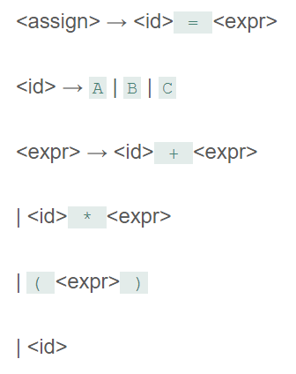

1. (10) Given the grammar from question 2, show a left-most derivation and draw the parse tree for the following statement.
   1. B = B + (C + (A * A))

<assign> -> <id> = <expr>

<expr>

=

<id>

<B>

<assign>

-> B = <expr>

-> B = <id> + <expr>

<expr>

+

<id>

<B>

-> B = B + <expr>

)

<expr>

(

*

-> B = B + (<expr>)

-> B = B + (<id> + <expr>)

-> B = B + (C + <expr>)

<expr>

<id>

-> B = B + (C + (<expr>))

<id>

A

-> B = B + (C + (<id> * <expr>))

A

-> B = B + (C + (A * <expr>))

-> B = B + (C + (A * <id>))

-> B = B + (C + (A * A))

1. (10) Remove all of the recursion from the following grammar:

S -> Aa | Bb S -> Aa | Bb

A -> Aa | AbC | C A -> AA’

B -> S | bb A -> C

C -> c A’ -> a | bC

B -> S | bb

C -> c

1. (10) Use left factoring to resolve the pairwise disjointness problems in the following grammar:

A -> aBc | ac | a A -> aA’

B -> b | aB A’ -> Bc | c

B -> b | aB

1. (20 pts) Create an LR(0) parse table for the following grammar. Show all steps (creating closures, the DFA, the transition table, and finally the parse table):

E -> E + T | E * T | T

S6

*

E -> E * .T

+

S5

E -> E + .T

S0

E’ -> .E

E -> .E + T

E -> .E * T

E -> .T

T -> .(E)

T -> .id

S1

E

E’ -> E.

E -> E. + T

E -> E. * T

S2

E -> T.

T

id

S4

T -> id.

S5

E -> E +. T

T -> .(E)

T -> .id

+

S6

E -> E *. T

T -> .(E)

T -> .id

*

(

S3

T -> (.E)

E’ -> .E

E -> .E + T

E -> .E * T

E -> .T

T -> .(E)

T -> .id

S3

T -> (.E)

(

S4

T -> id.

id

S2

E -> T.

T

S7

E

T -> (E.)

E -> E. + T

E -> E. * T

S3

T -> (.E)

(

S8

E -> E + T.

T

S3

T -> (.E)

(

S8

E -> E * T.

T

id

S4

T -> id.

)

S9

T -> (E).

id

S4

T -> id.

T -> (E) | id

**Closures:**

|  |  |  |  |  |  |  |  |  |
| --- | --- | --- | --- | --- | --- | --- | --- | --- |
| **State** | **Action** | | | | | | **Goto** | |
| **+** | **\*** | **(** | **)** | **Id** | **$** | **E** | **T** |
| **0** |  |  | S3 |  | S4 | acc | 1 | 2 |
| **1** | S5 | S6 |  |  |  |  |  |  |
| **2** | R3 | R3 |  | R3 |  |  |  |  |
| **3** |  |  | S3 |  | S4 |  | 7 | 2 |
| **4** | R5 | R5 |  | R5 |  |  |  |  |
| **5** |  |  | S3 |  | S4 |  |  | 8 |
| **6** |  |  | S3 |  | S4 |  |  | 8 |
| **7** | S5 | S6 |  | S9 |  |  |  |  |
| **8** | R2 | R2 |  | R2 |  |  |  |  |
| **9** | R4 | R4 |  | R4 |  |  |  |  |

1. (20 pts) Show a complete bottom-up parse, including the parse stack contents, input string, and action for the string below using the parse table you created in step 6. Think about how I went through this in class.

**Parse stack:**

**Input String:**

(id + id) * id

1. (10 pts) Show a rightmost derivation for the string above, and show how the bottom-up parse you completed in step 7 correctly finds all of the handles for the input string above.

(id + id) * id