Comp 5350/6350/6356 Project 1

Lucia Bajo, Rachel Sowada, and Haden Stuart

10/8/2020

# Executive Summary

This section should begin on a new page. The executive summary should include a table that answers all of the questions in project along with your findings. The line spacing default is double-spacing for academic reports.

# Table of Contents

This section should begin on a new page. The table of contents below is generated using the "References" menu.

Table of Contents

**Executive Summary** **2**

Table of Contents **3**

**List of Figures** **4**

List of Tables **5**

1 Problem Description **6**

2 Analysis Techniques **6**

2.1 First Subheading 6

2.2 Second Subheading 6

**2.2.1 First Sub-subheading** **6**

**2.2.2 Second Sub-subheading** **7**

3 Technical Findings (Tables and Screenshots) **7**

5 Conclusions and Recommendations **8**

6 Acknowledgements **9**

7 References **9**

Appendix A: Place the title of appendix here **10**

# List of Figures

This section should begin on a new page. This should be one of the last pages to be completed.

# List of Tables

This section should begin on a new page. All tables must have a caption.

# 1 Problem Description

This section should begin on a new page. This should use "Heading 1" style font settings for the heading, then “Normal” style for the content.

# 2 Analysis Techniques

This section does not begin on a new page and should use "Heading 1" style font settings for the heading, then “Normal” style for the content.

## 2.1 First Subheading

Subheadings are sections beneath headings. These sections should use "Heading 2" style font settings.

Subheadings and sub-subheadings are not mandatory. However, if there is one subheading, there must be at least a second subheading. Otherwise, there is no reason for the subdivisions under the primary headings.

## 2.2 Second Subheading

This paragraph is repeated. Subheadings are sections beneath headings. These sections should use "Heading 2" style font settings.

Subheadings and sub-subheadings are not mandatory. However, if there is one subheading, there must be at least a second subheading. Otherwise, there is no reason for the subdivisions under the primary headings.

### 2.2.1 First Sub-subheading

This paragraph is repeated. Subheadings are sections beneath headings. These sections should use "Heading 3" style font settings.

Subheadings and sub-subheadings are not mandatory. However, if there is one subheading, there must be at least a second subheading. Otherwise, there is no reason for the subdivisions under the primary headings.

### 2.2.2 Second Sub-subheading

Avoid any further divisions under the sub-subheading. Otherwise, the number of divisions becomes distracting and difficult to follow.

# 3 Technical Findings (Tables and Screenshots)

This section does not begin on a new page and should use "Heading 1" style font settings for the heading, then “Normal” style for the content.

The first part of this project focuses on the technical analysis of the disk image where you will answer the following questions.

1) Specify the number and type of partitions on the disk image.

2) Specify the number of files, file names, and file size of each file on each partition.

3) Specify the starting and ending byte offset location of each file on each partition.

4) For each FAT partition explain the contents of the File Allocation Table and Root Directory.

5) For each NTFS partition specify which file attributes are associated with each file

6) Manually recover all files from each disk image. Note: You must show the step-by-step process for file recovery. Automated file recovery tools may not be used during this project!

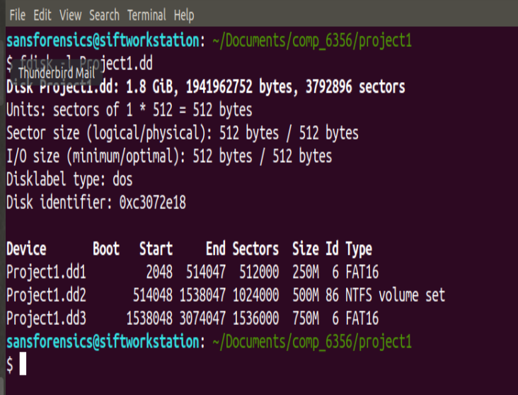

# 5 Conclusions and Recommendations

This section does not begin on a new page and should use "Heading 1" style font settings for the heading, then “Normal” style for the content.

The second part of this project is to “paint a picture” from the digital artifacts collected and analyzed. During this part of the project your team will answer the following questions:

1) What data hiding methods were used on this disk image?

2) What tools and / or applications were used to hide data?

3) Lastly, what was the ultimate objective of users of the laptop?

# 6 Acknowledgements

This section allows authors to acknowledge contributors and other sources that are not appropriate to list in the references section.

# 7 References

This is the last section of the report, prior to any appendices. The references should not be double-spaced, but single-spaced. For a technical report, use the CSE style.

[1] Reference 1 information.

[2] Reference 2 information.

[3] Reference 3 information.

# Appendix A: Place the title of appendix here

Provide appropriate appendices as necessary. Each appendix should begin on a new page.