TECHNICAL
PROJECT REPORT
VMware-Based
Cybersecurity Testing Lab
Kali Linux network configuration, host integration and recovery point

PREPARED BY | Hasnain Awan
PLATFORM | VMware Workstation • Kali Linux
DATE | 30 October 2026

A reproducible, isolated virtual environment for authorised cybersecurity learning and testing.

Executive Summary
This report documents the setup of a Kali Linux cybersecurity testing environment using VMware Workstation. The supplied WK1-PM1 brief specifies a private 10.0.0.0/24 network, Kali address 10.0.0.2/24, internet access, a host Downloads share, clipboard and drag-and-drop integration, and a virtual-machine snapshot. The brief names VirtualBox as its reference hypervisor; this implementation uses VMware Workstation instead. The requested lab outcomes were retained and implemented through VMware's VMnet8 NAT network.
The completed configuration assigns Kali Linux the static address 10.0.0.2/24, uses 10.0.0.1 as the NAT gateway, and reserves 10.0.0.128–10.0.0.254 for DHCP clients. Gateway and DNS connectivity were demonstrated after the static configuration. The Windows Downloads directory is exposed to Kali through VMware shared folders and mounted at /mnt/hgfs. VMware copy/paste and drag-and-drop options are enabled. A snapshot named Kali-Linux-Lab-Configured was created and confirmed in Snapshot Manager.
1. Project Objectives
- Create a private virtual network using the 10.0.0.0/24 address range.
- Connect Kali Linux to the virtual network with static address 10.0.0.2/24.
- Provide outbound internet access through NAT and verify gateway/DNS connectivity.
- Share the Windows host Downloads directory with the Kali guest.
- Enable clipboard copy/paste and file drag-and-drop integration.
- Create a recoverable VMware snapshot after configuration.
2. Implementation Scope and Platform Deviation
The source brief specifies VirtualBox and a NAT Network. The implementation documented here uses VMware Workstation because the Kali Linux virtual machine was already installed and operational in VMware. This is a platform substitution, not a change to the required network addressing or lab outcomes. VMware VMnet8 provides the equivalent NAT-backed private virtual network for this single-VM setup.
The optional future phase in the source brief (adding Windows or Android virtual machines and testing inter-VM traffic) was outside the scope of this completed setup.
3. Network Design
Component | Configured value | Purpose
Hypervisor network | VMware VMnet8 — NAT | Private guest network with host NAT access
Subnet | 10.0.0.0/24 | Lab address range
Kali interface | eth0 | Guest network interface
Kali IPv4 | 10.0.0.2/24 (static) | Required guest address
NAT gateway | 10.0.0.1 | Default route to external networks
DHCP pool | 10.0.0.128–10.0.0.254 | Dynamic range kept separate from Kali static IP
Broadcast | 10.0.0.255 | Subnet broadcast address
DNS servers | 1.1.1.1, 8.8.8.8 | Configured resolvers

Address allocation avoids overlap: Kali uses 10.0.0.2, the NAT gateway uses 10.0.0.1, and the DHCP pool begins at 10.0.0.128. This keeps the static guest address outside the dynamic lease range.
4. Configuration Procedure
4.1 VMware network adapter
The Kali VM network adapter was configured to connect to the NAT network. The VM was then attached to the custom VMnet8 network in VMware Workstation.
4.2 VMnet8 NAT network
VMnet8 was configured as NAT with subnet 10.0.0.0 and mask 255.255.255.0. The NAT gateway was changed to 10.0.0.1. The DHCP range was updated to 10.0.0.128–10.0.0.254 to match the subnet and avoid the Kali static address.
4.3 Kali static IPv4 configuration
NetworkManager was used to configure the active profile Wired connection 1. The final interface output showed 10.0.0.2/24 on eth0 and the routing table showed the default route via 10.0.0.1.
sudo nmcli connection modify "Wired connection 1" ipv4.addresses 10.0.0.2/24
sudo nmcli connection modify "Wired connection 1" ipv4.gateway 10.0.0.1
sudo nmcli connection modify "Wired connection 1" ipv4.dns "1.1.1.1 8.8.8.8"
sudo nmcli connection modify "Wired connection 1" ipv4.method manual
sudo nmcli connection down "Wired connection 1" && sudo nmcli connection up "Wired connection 1"
4.4 Shared folder
VMware Shared Folders was set to Always enabled. The Windows host path C:\Users\user\Downloads was shared with the guest using the share name Downloads. In Kali, vmware-hgfsclient listed the share. The directory /mnt/hgfs was created and the share was mounted using:
sudo vmhgfs-fuse .host:/ /mnt/hgfs -o allow_other
The guest then listed /mnt/hgfs/Downloads and displayed files from the host directory. The mount command emitted a FUSE library compatibility warning, but the share mounted and its contents were accessible in the captured test.
4.5 Guest isolation integration
In VMware Options → Guest Isolation, both Enable drag and drop and Enable copy and paste were checked. The settings are configured; a separate end-to-end transfer test was not captured in the supplied evidence.
4.6 Snapshot
A snapshot named Kali-Linux-Lab-Configured was created. Snapshot Manager displayed the saved snapshot and its creation timestamp (30 October 2026, 8:42:43 PM), confirming that the restore point exists.
5. Verification and Results
Verification item | Evidence / observed result | Assessment
VMnet8 subnet | 10.0.0.0/24; NAT enabled; DHCP enabled | Configured
NAT gateway | 10.0.0.1 | Configured
Kali interface | eth0 = 10.0.0.2/24 | Verified
Default route | default via 10.0.0.1 | Verified
Gateway reachability | 4 packets received; 0% loss | Passed
DNS resolution | google.com resolved and 4 packets received; 0% loss | Passed
Shared folder discovery | vmware-hgfsclient listed Downloads | Verified
Shared folder access | /mnt/hgfs/Downloads contents listed | Verified
Clipboard / drag-and-drop | Both VMware Guest Isolation options checked | Enabled; transfer not separately tested
Snapshot | Kali-Linux-Lab-Configured shown in Snapshot Manager | Created and verified

Note: the post-static-IP screenshot shows a successful gateway ping and a successful google.com ping. A separate 1.1.1.1 ping was performed before the static-IP change and showed one lost packet; it was not repeated in the final post-change evidence. Therefore, this report does not claim a post-change 1.1.1.1 test.
6. Conclusion
The VMware-based Kali Linux lab was configured to meet the core WK1-PM1 outcomes: private 10.0.0.0/24 networking, Kali static address 10.0.0.2/24, NAT gateway access, DNS resolution, host Downloads sharing, guest integration settings, and a verified snapshot. The only implementation deviation is the use of VMware Workstation instead of the VirtualBox hypervisor named in the source brief. The environment is ready for authorised cybersecurity practice within the isolated lab network.
7. Operational Notes
- The shared folder is mounted at /mnt/hgfs. If it is not mounted after a reboot, run: sudo vmhgfs-fuse .host:/ /mnt/hgfs -o allow_other
- Keep the Kali-Linux-Lab-Configured snapshot as the clean baseline. Create additional snapshots before major tool installations or configuration changes.
- A VMware snapshot is a restore point, not a standalone backup. For disaster recovery, copy the complete VM directory while the VM is shut down.
- Use the lab only for systems and networks for which testing is authorised.

Appendix A — VMware and Kali Evidence
The following appendix contains the actual screenshots supplied during the configuration session. No VirtualBox screenshots or generated illustrative screenshots are used.
Figure 01. VMware VM network adapter configured for NAT
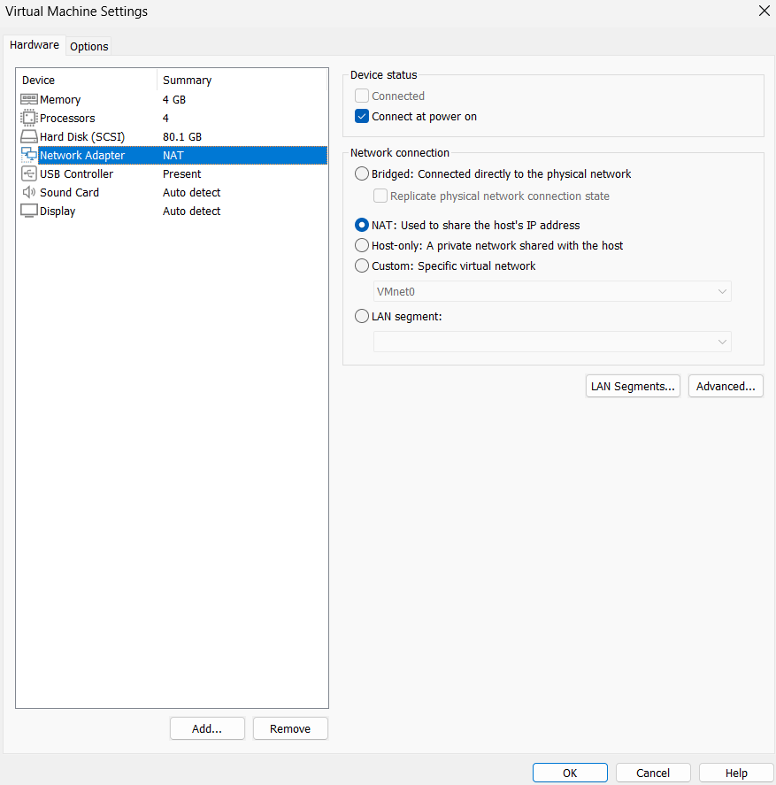
Figure 02. VMware VMnet8 configured as NAT on 10.0.0.0/24
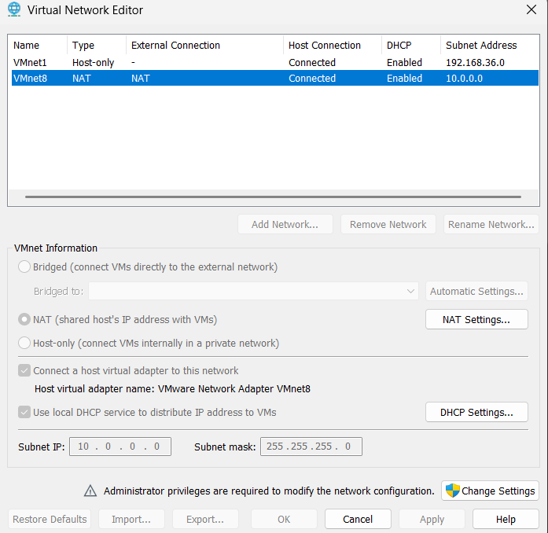

Figure 03. DHCP pool reserved from 10.0.0.128 to 10.0.0.254
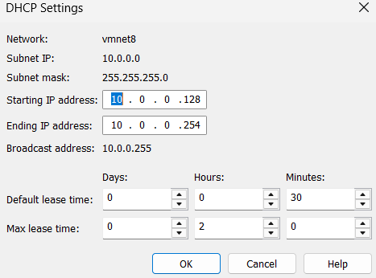
Figure 04. Initial Kali interface and route before static addressing
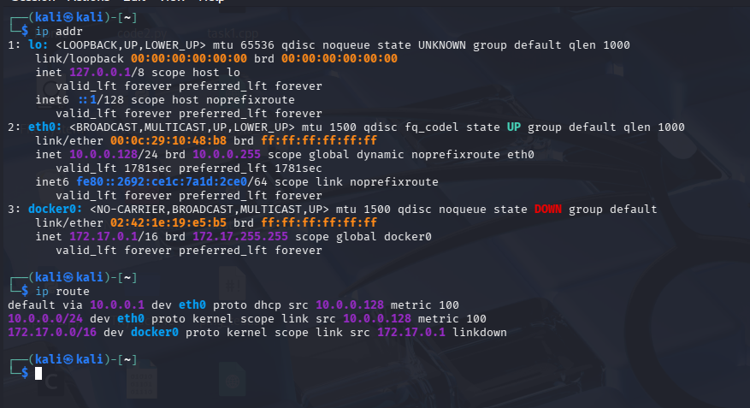

Figure 05. Kali static address 10.0.0.2/24 and default route via 10.0.0.1
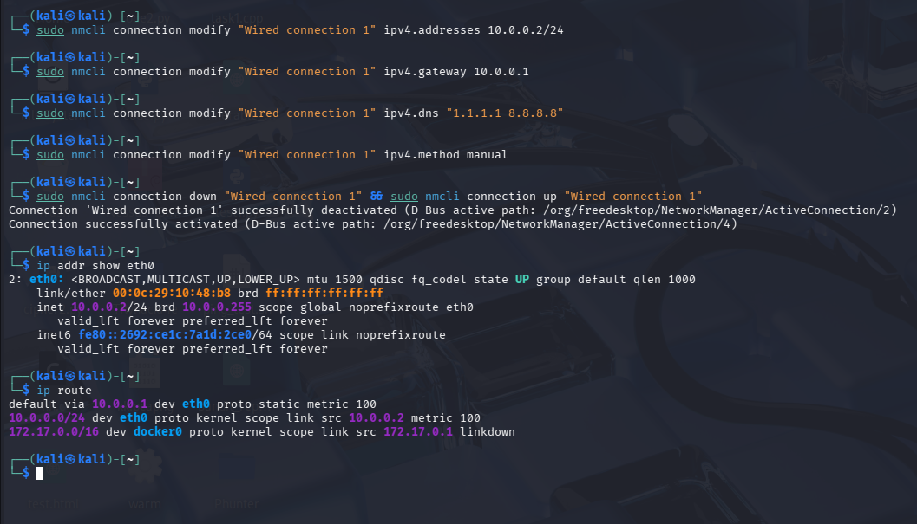
Figure 06. Connectivity verification after static addressing
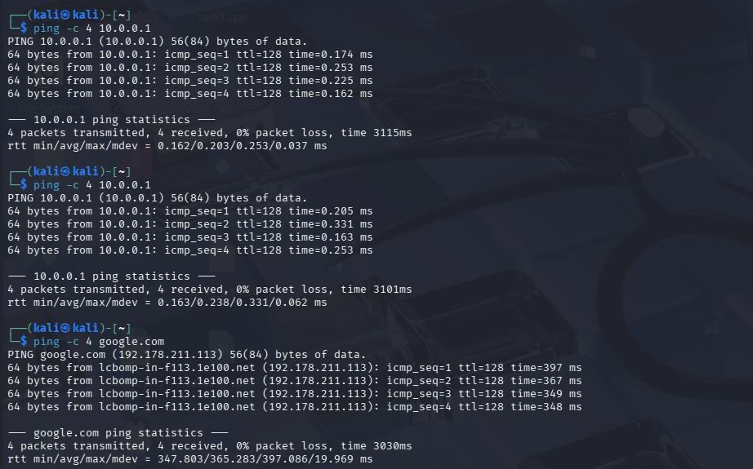

Figure 07. VMware shared folder configured for the Windows Downloads directory
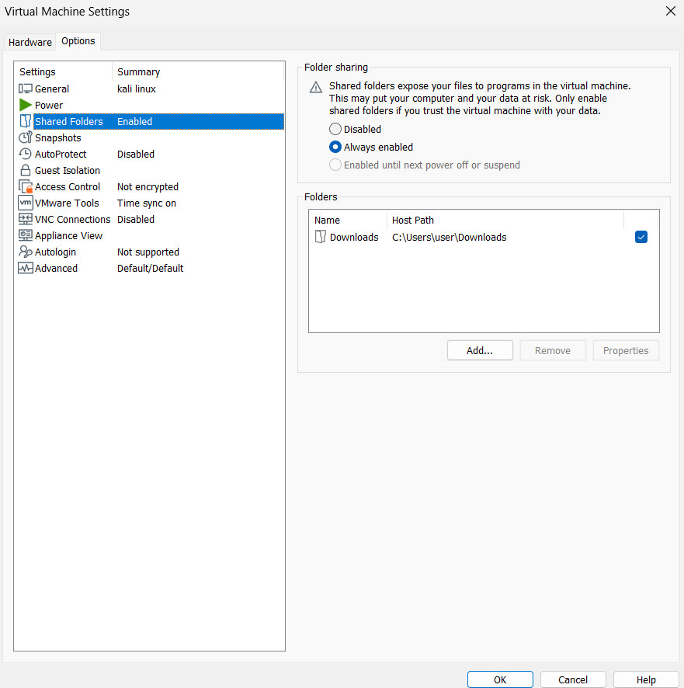
Figure 08. Shared Downloads folder mounted and its contents visible in Kali
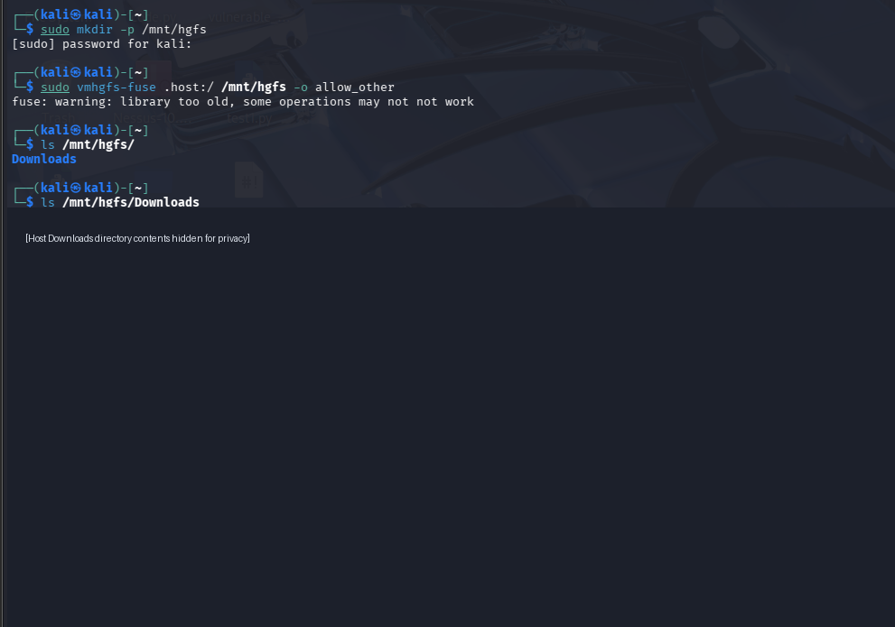

Figure 09. VMware copy/paste and drag-and-drop options enabled
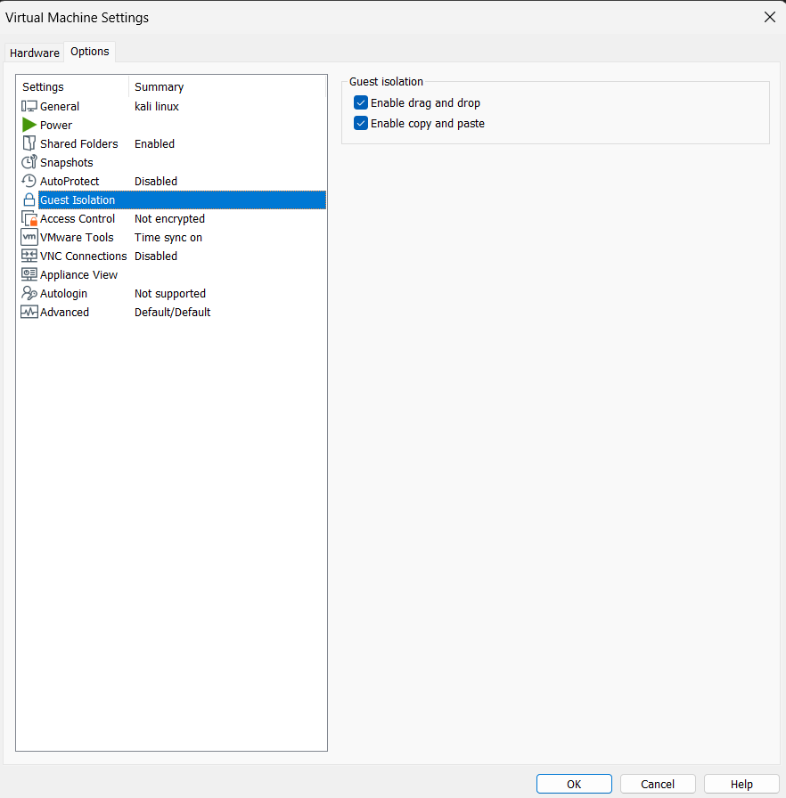
Figure 10. Snapshot creation details
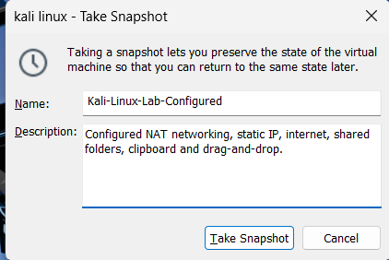

Figure 11. Snapshot Manager confirming the saved lab snapshot


