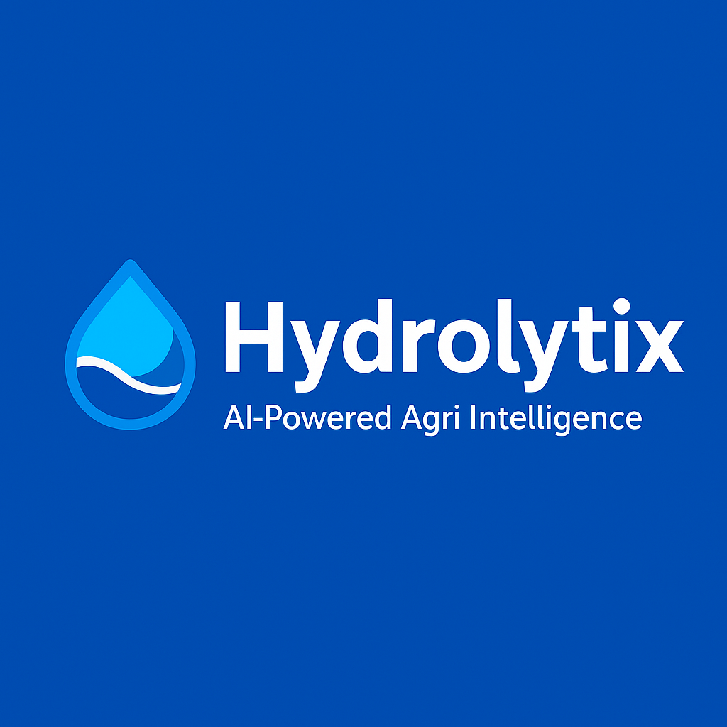

Hydrolytix
AI-Powered Agri Intelligence

User & Technical Manual
Version 1.0 | September 2025
📊 🌱 🤖 📈
Version: 1.0
Date: September 2025
Prepared by: Team Hydrolytix
This document is intended for academic and project purposes only. Unauthorized distribution is prohibited.

📑 Table of Contents
Contents
📑 Table of Contents 2
1. Introduction 2
2. System Architecture and Design 2
3. Installation and Setup 2
4. Data Overview and Preprocessing 2
5. Dashboard Features and Usage 2
6. Component Breakdown and Code Overview 2
7. Export and Reporting 3
8. Customization and Extensibility 3
9. Troubleshooting and Maintenance 3
10. Future Enhancements 3
11. Appendix 3
Section 1 4
1. Introduction 5
1.1 Purpose of the Manual 5
1.2 About Hydrolytix 5
1.3 Target Audience 5
1.4 Benefits of the Dashboard 5
Section 2 7
2. System Architecture and Design 8
2.1 Technology Stack 8
2.2 Application Architecture 8
2.3 Data Flow Overview 8
2.4 Security Considerations 9
Section 3 10
3. Installation & Setup 11
3.1 System Requirements 11
3.2 Prerequisites 11
3.3 Installation on Windows 12
3.4 Installation on Linux (Ubuntu/Debian) 12
3.5 Installation on macOS 13
3.6 Troubleshooting Installation Issues 13
Section 4 14
4. Data Management 15
4.1 Dataset Overview 15
4.2 Dataset Schema 15
4.3 Preprocessing Workflow 16
4.4 Data Storage & Access 16
4.5 Example Data Record 16
4.6 Troubleshooting Data Issues 17
Section 5 18
5. Dashboard Features and Usage 19
5.1 Navigation and Layout 19
5.2 Tabs Overview 19
5.2.1 Overview Tab 19
5.2.2 Year Comparison Tab 20
5.2.3 Forecasting Tab 20
5.2.4 Trend Analysis Tab 20
5.2.5 Export & Reports Tab 21
5.3 Filters and Interactivity 21
5.4 Example Workflow 21
5.5 Accessibility & Responsiveness 21
Section 6 23
6. Component Breakdown & Code Overview 24
6.1 Project Directory Structure 24
6.2 app.py (Main Entry Point) 24
6.3 Components/ 25
Example Modules: 25
6.4 utils/ 25
6.5 Callbacks (The Interactive Engine) 25
6.6 Troubleshooting Common Issues 26
Section 7 27
7. Export and Reporting 28
7.1 Export Options 28
7.2 Export Workflow 28
7.3 CSV Export 28
7.4 PDF Report Generation 29
Report Structure 29
Technical Implementation 29
7.5 Export UI (User Interface) 29
7.6 Advanced Features 29
7.7 Troubleshooting Export Issues 30
7.8 Best Practices for Reporting 30
Section 8 31
8. Customization and Extensibility 32
8.1 Adding New Features 32
General Guidelines 32
Example: Adding a New Chart 32
8.2 Extending Data Sources 32
Steps to Add a New Data Source 32
8.3 Customizing Visual Design 33
CSS Styling 33
Branding 33
8.4 Extending Analytical Capabilities 33
Example: Adding a Machine Learning Model 33
8.5 Supporting Multiple Regions or Datasets 33
8.6 Modular Code Integration 33
8.7 Example Customization Scenarios 34
8.8 Future Extensibility Roadmap 34
Section 9 35
9. Troubleshooting & FAQs 36
9.1 General Troubleshooting 36
Problem 1: Dashboard not loading in the browser 36
Problem 2: Blank graphs or tables 36
Problem 3: Callbacks not updating 36
Problem 4: Installation error on Windows 36
9.2 Frequently Asked Questions (FAQs) 37
Section 10 38
10. Future Enhancements 39
10.1 Planned Features 39
10.2 Long-Term Vision 39
Section 11 40
11. Appendix 41
11.1 Sample Dataset (Excerpt) 41
11.2 File & Folder Structure 41
11.3 Common Commands 41
11.4 Troubleshooting Quick Reference 42
11.5 References & Credits 42

Section 1
Introduction

1. Introduction

1.1 Purpose of the Manual
This manual is designed to serve both end-users and technical developers of the Hydrolytix Agri Intelligence Dashboard. It provides:
- A user-friendly guide for agricultural analysts, consultants, and decision-makers to operate the dashboard effectively.
- A technical reference for developers and maintainers to install, configure, customize, and troubleshoot the system.

1.2 About Hydrolytix
Hydrolytix Agri Intelligence Dashboard is a data-driven analytics platform created to support agricultural decision-making in Punjab and beyond. It provides insights into:
- Crop production trends
Burned area analysis
- Seasonal comparisons
- Forecasting of agricultural output
- Comprehensive reporting and data exports
By leveraging modern data science techniques and interactive visualization, Hydrolytix enables evidence-based agricultural planning and policy-making.

1.3 Target Audience
This manual is intended for:
- Agricultural Analysts & Researchers → To interpret data and trends.
- Farm Managers & Consultants → To optimize production and monitor seasonal changes.
- Government Agencies → To design agricultural policies based on reliable statistics.
- Academics & Students → For research and project purposes.
- Developers & IT Teams → To maintain, customize, and extend the application.

1.4 Benefits of the Dashboard
Hydrolytix brings several advantages over traditional reporting tools:
- Interactive Visualization → Move beyond static charts into real-time, dynamic dashboards.
- Multi-Season Analysis → Compare years and seasons side by side.
- Forecasting Engine → Predict future agricultural metrics with ARIMA & Exponential Smoothing.
- Automated Reporting → Export data and formatted PDF reports instantly.
- Scalability & Flexibility → Modular design allows easy updates and new features.

Section 2
System Architecture and Design

2. System Architecture and Design

2.1 Technology Stack
Hydrolytix leverages a modern and efficient technology stack:
- Backend Framework: Dash (built on Flask)
- Visualization: Plotly.js for interactive charts
- Data Processing: Pandas for data cleaning, filtering, and aggregation
- PDF Generation: ReportLab for structured report exports
- Styling: Custom CSS (Grid + Flexbox) for responsiveness
- Deployment: Flask development server, with options for Docker or cloud deployment

2.2 Application Architecture
The application follows a modular architecture divided into layers:
- Data Layer
  - Responsible for loading and preprocessing the CSV dataset.
  - Provides filter and aggregation methods.
  - Ensures clean, structured data for downstream processes.
- Logic Layer (Callbacks)
  - Implements business logic in Dash callbacks.
  - Handles filtering, interactivity, and data updates in real-time.
- Presentation Layer (UI Components)
  - Modular components like KPI cards, navigation tabs, charts.
  - Built for reusability and maintainability.
- Export Layer
  - Manages data exports to CSV and PDF.
  - Handles formatting and download link generation.

2.3 Data Flow Overview
The lifecycle of data in Hydrolytix:
- Input: Agricultural dataset in CSV format.
- Processing: DataLoader cleans, validates, and structures data.
- Filtering: User applies season/year filters in the dashboard.
- Visualization: Plotly renders dynamic charts based on filtered data.
- Analytics: Forecasting & trend analysis apply statistical models.
- Output: Results displayed in dashboard or exported as CSV/PDF.

2.4 Security Considerations
While Hydrolytix currently functions as a single-user local application, some security measures are considered for future deployment:
- Authentication → Adding user login for multi-user environments.
- Data Privacy → Ensuring sensitive agricultural data is securely stored.
- Deployment Security → HTTPS, firewall, and role-based access control for cloud-based usage.
- Data Validation → Strict checks to prevent malformed or corrupted input files.

Section 3
Installation and Setup

3. Installation & Setup
This section provides detailed instructions for installing and configuring Hydrolytix – Agricultural Data Analysis Dashboard across different operating systems. Follow the guide that matches your environment.

3.1 System Requirements
Before installation, ensure your system meets the following minimum requirements:
Component | Minimum Requirement | Recommended Requirement
Operating System | Windows 10 / Ubuntu 20.04 / macOS 11 | Latest stable OS version
Processor | Intel i5 (or equivalent) | Intel i7 / AMD Ryzen 7
RAM | 4 GB | 8 GB or higher
Storage | 2 GB free space | 5+ GB free space
Python Version | 3.8+ | 3.10+
Dependencies | Listed in requirements.txt | Virtual environment supported
Internet Access | Required for package installation | Stable broadband recommended

3.2 Prerequisites
- Python → Ensure Python 3.8+ is installed.
  - Check version:
  - python --version
- Pip → Python package manager must be available.
  - Check version:
  - pip --version
- Git → Required for cloning the project repository.
  - Check version:
  - git --version
📌 Tip: If these are missing, refer to the OS-specific installation instructions below.

3.3 Installation on Windows
- Install Python
  - Download from Python Official Website.
  - During installation, ensure “Add Python to PATH” is checked.
📸 [Placeholder for Screenshot: Python Installer with PATH Option]
- Install Git
  - Download Git for Windows and follow the setup wizard.
- Clone Project Repository
- git clone https://github.com/username/Hydrolytix-Agri-Intelligence.git
- cd Hydrolytix-Agri-Intelligence
- Create Virtual Environment
- python -m venv venv
- venv\Scripts\activate
- Install Dependencies
- pip install -r requirements.txt
- Run Application
- python app.py
The dashboard will be accessible at:
👉 http://127.0.0.1:8050

3.4 Installation on Linux (Ubuntu/Debian)
- Update System Packages
- sudo apt update && sudo apt upgrade -y
- Install Python & Pip
- sudo apt install python3 python3-pip python3-venv -y
- Install Git
- sudo apt install git -y
- Clone Repository
- git clone https://github.com/username/Hydrolytix-Agri-Intelligence.git
- cd Hydrolytix-Agri-Intelligence
- Create Virtual Environment
- python3 -m venv venv
- source venv/bin/activate
- Install Dependencies
- pip install -r requirements.txt
- Run Application
- python app.py
Access via browser:
👉 http://127.0.0.1:8050

3.5 Installation on macOS
- Install Homebrew (if not installed)
- /bin/bash -c "$(curl -fsSL https://raw.githubusercontent.com/Homebrew/install/HEAD/install.sh)"
- Install Python & Git
- brew install python git
- Clone Repository
- git clone https://github.com/username/Hydrolytix-Agri-Intelligence.git
- cd Hydrolytix-Agri-Intelligence
- Create Virtual Environment
- python3 -m venv venv
- source venv/bin/activate
- Install Dependencies
- pip install -r requirements.txt
- Run Application
- python app.py
Open in browser:
👉 http://127.0.0.1:8050

3.6 Troubleshooting Installation Issues
Problem | Cause | Solution
python: command not found | Python not installed or not in PATH | Reinstall Python, check “Add to PATH”
pip: command not found | Pip not installed | Install with python -m ensurepip --upgrade
ModuleNotFoundError | Dependencies missing | Run pip install -r requirements.txt
Port already in use | Another app is using port 8050 | Run with python app.py --port 8060
Git clone fails | Git not installed | Install Git and retry
Dashboard doesn’t load | Firewall blocking localhost | Disable firewall temporarily or allow port

Section 4
Data Overview and Preprocessing

4. Data Management
The Hydrolytix dashboard relies on accurate agricultural data to generate meaningful insights. This section explains the dataset schema, preprocessing workflow, and how the system manages and validates agricultural data.

4.1 Dataset Overview
The dataset used in Hydrolytix is agri_analysis_punjab_clean.csv, which contains records of crop production statistics for Punjab.
- Total Records: 40
- Time Period Covered: 2001 – 2020 (20 years, Rabi & Kharif seasons)
- Focus: Cultivated vs. Burned Area and percentage difference.
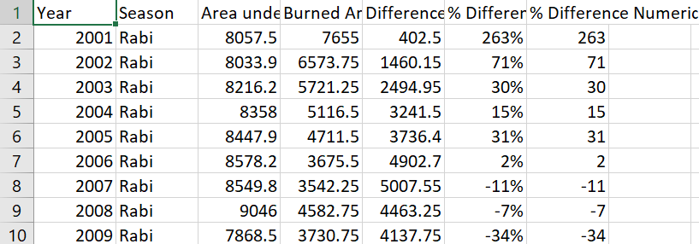

4.2 Dataset Schema
Column Name | Data Type | Description
Year | Integer | Year of observation (2001–2020).
Season | String | Crop season (Rabi or Kharif).
Area under Production (Hac) | Float | Total cultivated land in hectares.
Burned Area (Hac) | Float | Area of crops damaged or burned in hectares.
Difference (Hac) | Float | Difference between production area and burned area.
% Difference | String | Percentage difference (e.g., "263%").
% Difference Numeric | Float | Numeric version of % Difference for analysis.
✅ Key Feature: The presence of both % Difference (string) and % Difference Numeric (float) ensures compatibility with charts and statistical models.

4.3 Preprocessing Workflow
The dashboard applies several steps before using the dataset:
- Data Import
  - File: agri_analysis_punjab_clean.csv
  - Loaded into Pandas DataFrame.
- import pandas as pd
- df = pd.read_csv("agri_analysis_punjab_clean.csv")
- Data Cleaning
  - Remove formatting (e.g., “263%” → 263.0).
  - Ensure no missing values in numeric columns.
- Validation
  - Each row must include Year, Season, and numeric values.
  - Invalid rows are flagged.
- Feature Engineering
  - Create Burn Ratio (%): (Burned Area ÷ Area under Production) × 100.
  - Calculate Growth Trend (%) year-over-year.

4.4 Data Storage & Access
- Data is stored in CSV format and loaded at runtime.
- Dashboard internally manages it using Pandas DataFrames.
- For scalability, future versions may use PostgreSQL or Firebase.

4.5 Example Data Record
Year | Season | Area under Production (Hac) | Burned Area (Hac) | Difference (Hac) | % Difference | % Difference Numeric
2001 | Rabi | 8057.5 | 7655.0 | 402.5 | 263% | 263.0
Interpretation:
- In 2001 Rabi season, 8057.5 hectares were cultivated.
- Out of this, 7655 hectares were burned.
- The difference is 402.5 hectares (5% of total).
- However, % Difference indicates a much higher relative change, highlighting anomalies.

4.6 Troubleshooting Data Issues
Problem | Cause | Solution
“Invalid File Format” | Wrong file type (not .csv) | Ensure uploaded file is .csv.
NaN values in charts | Missing values in dataset | Pre-fill missing values or clean data.
Wrong % Difference values | String formatting issue (e.g., “30%”) | Use % Difference Numeric for calculations.
Inconsistent Season Names | Typo in Season column | Standardize as Rabi / Kharif.

Section 5
Dashboard Features and Usage

5. Dashboard Features and Usage
The Hydrolytix Agri-Intelligence Dashboard provides an intuitive, interactive interface for analyzing agricultural production trends in Punjab. It is designed for researchers, policymakers, and analysts to visualize patterns, compare performance across years, and forecast future outcomes.
This section explains each feature in detail.

5.1 Navigation and Layout
When users launch the dashboard, they are greeted with:
- Navigation Tabs: Located at the top of the interface for switching between modules.
- Filter Panel: Dropdowns for Year and Season.
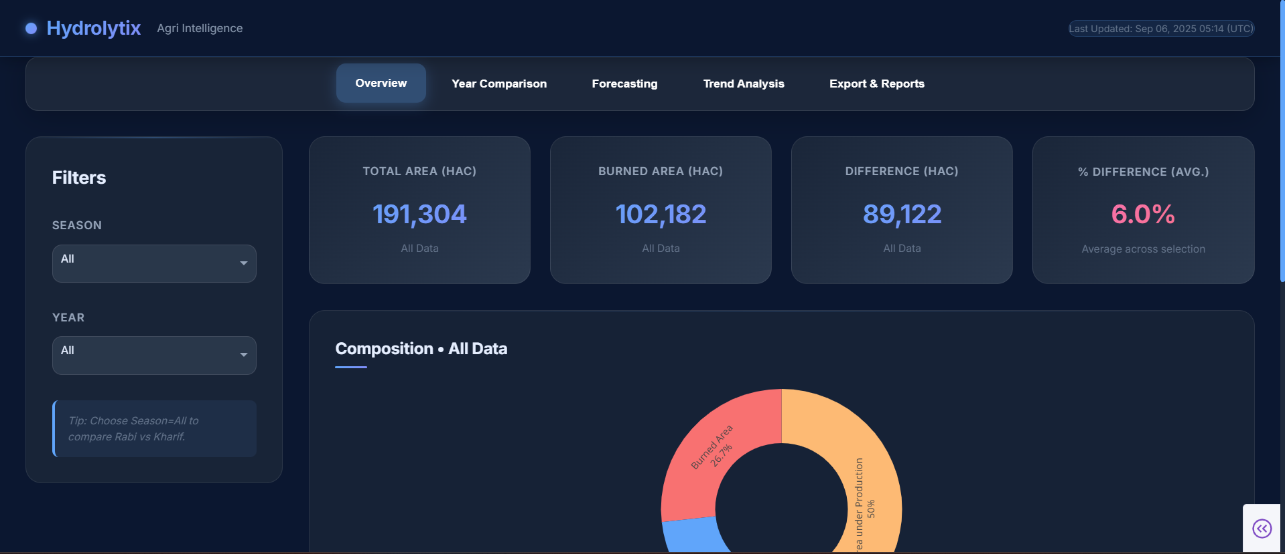
- Dynamic Content Area: Charts, KPIs, and reports update in real-time based on filter selections.

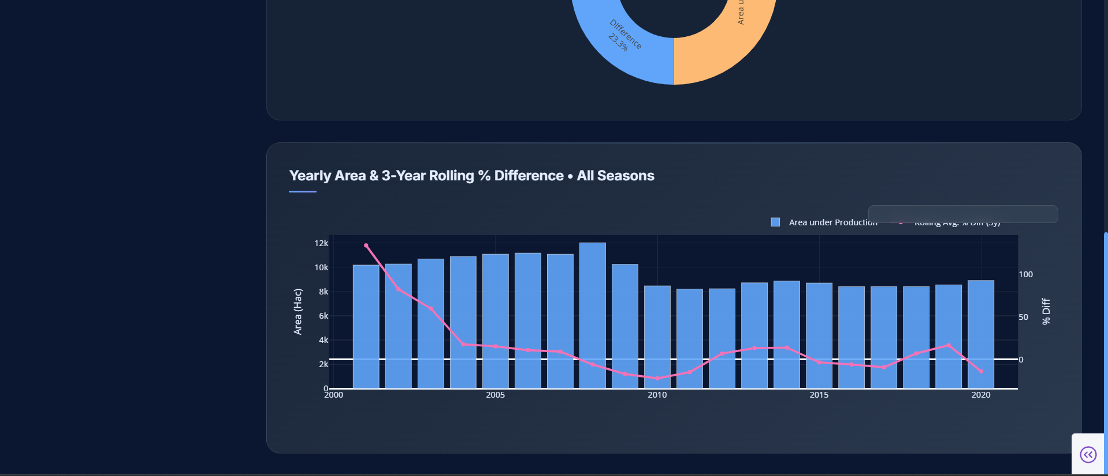

5.2 Tabs Overview
The dashboard is divided into five main tabs, each serving a unique purpose:

5.2.1 Overview Tab
- Displays Key Performance Indicators (KPIs):
  - Total Cultivated Area
  - Total Burned Area
  - Average % Difference
- Includes a Donut Chart comparing burned vs. cultivated area.
- Provides a line chart showing trends across years.
📊 Example Insight: In 2010 Rabi, burned area declined sharply compared to 2005, indicating improved crop safety.
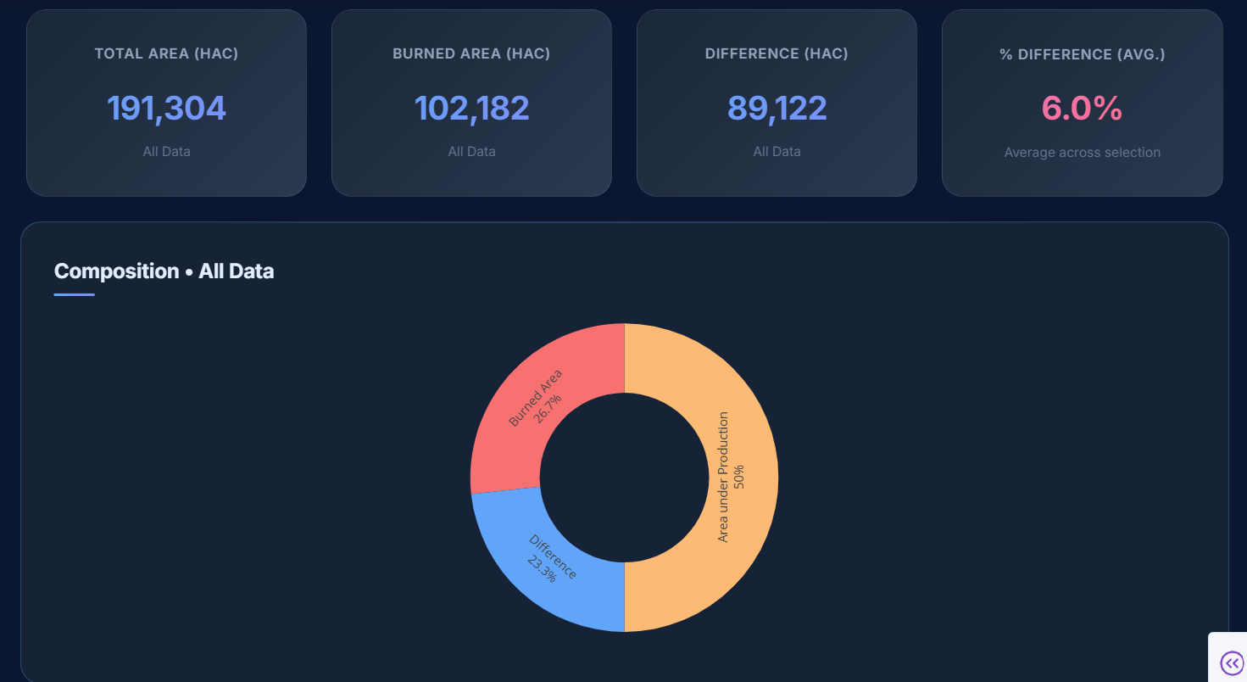

5.2.2 Year Comparison Tab
- Allows users to select multiple years and compare:
  - Area under Production
  - Burned Area
  - % Difference
- Uses bar charts and grouped line plots.
📊 Use Case: A policymaker can compare 2005 vs. 2015 Kharif season to evaluate the impact of new farming practices.
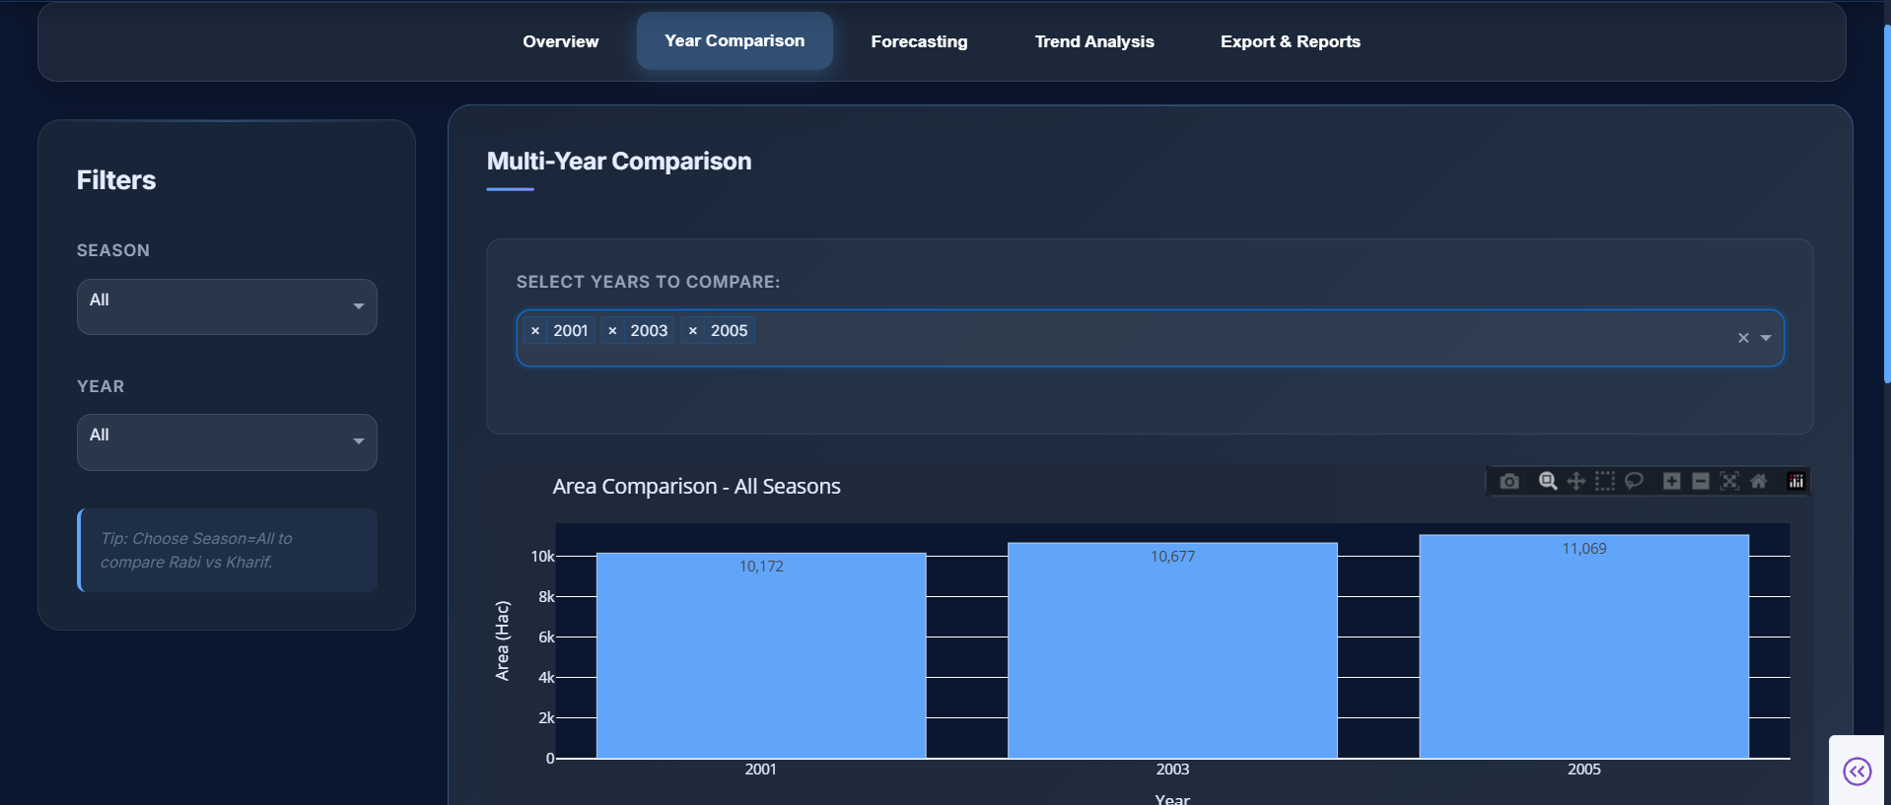
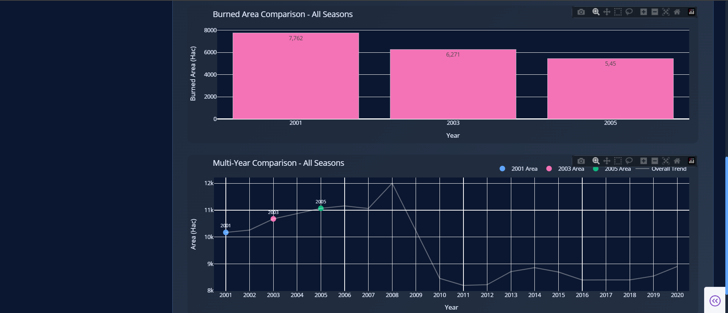

5.2.3 Forecasting Tab
- Implements predictive analytics using models like ARIMA and Exponential Smoothing.
- Users can:
  - Select forecasting model.
  - Define prediction horizon (e.g., next 5 years).
- Outputs include:
  - Forecast line plot (actual vs. predicted values).
  - Performance metrics (RMSE, MAE).
📊 Example Insight: Forecasting shows that burned area in Rabi season is projected to decline by 5% annually if current trends continue.
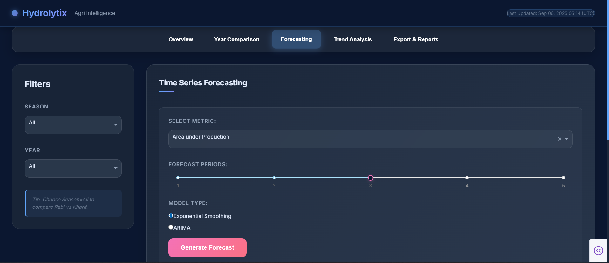
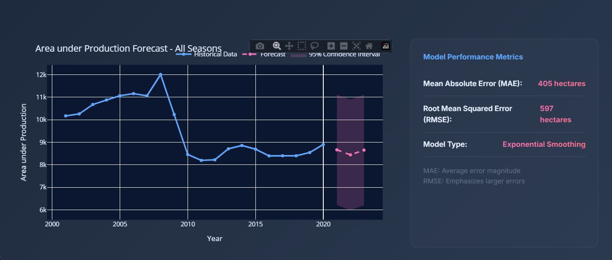
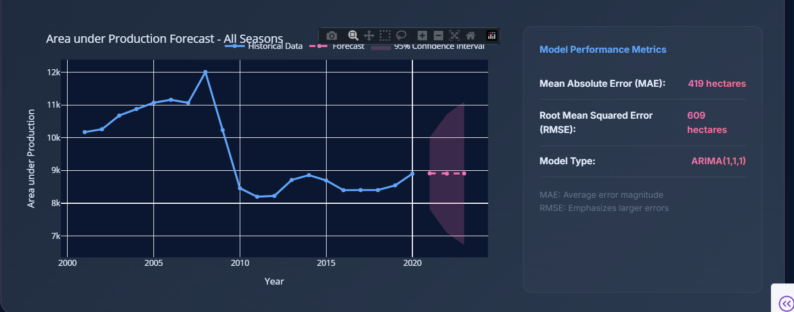

5.2.4 Trend Analysis Tab
- Focuses on long-term insights.
- Provides:
  - Multi-decade trend visualization.
  - Seasonal performance comparison.
  - Year-over-year growth rate (%).
📊 Example Insight: Trend analysis indicates that Kharif season consistently experiences higher burned area percentages compared to Rabi season.
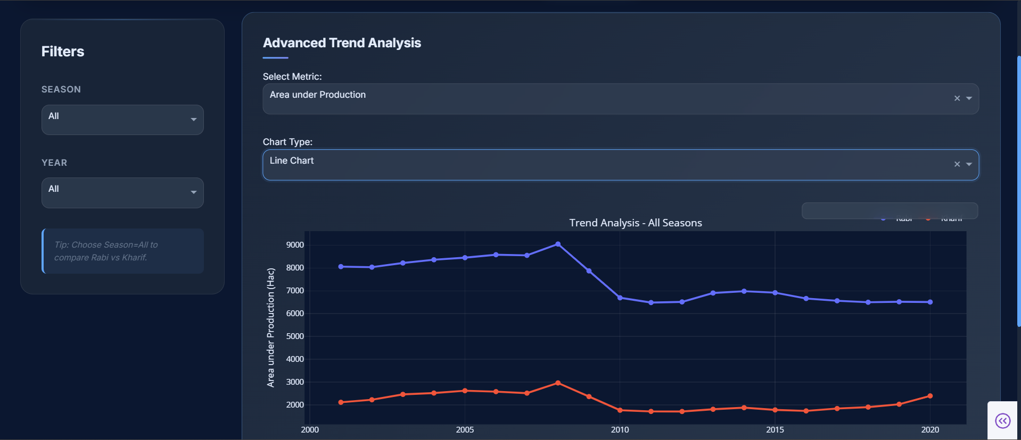
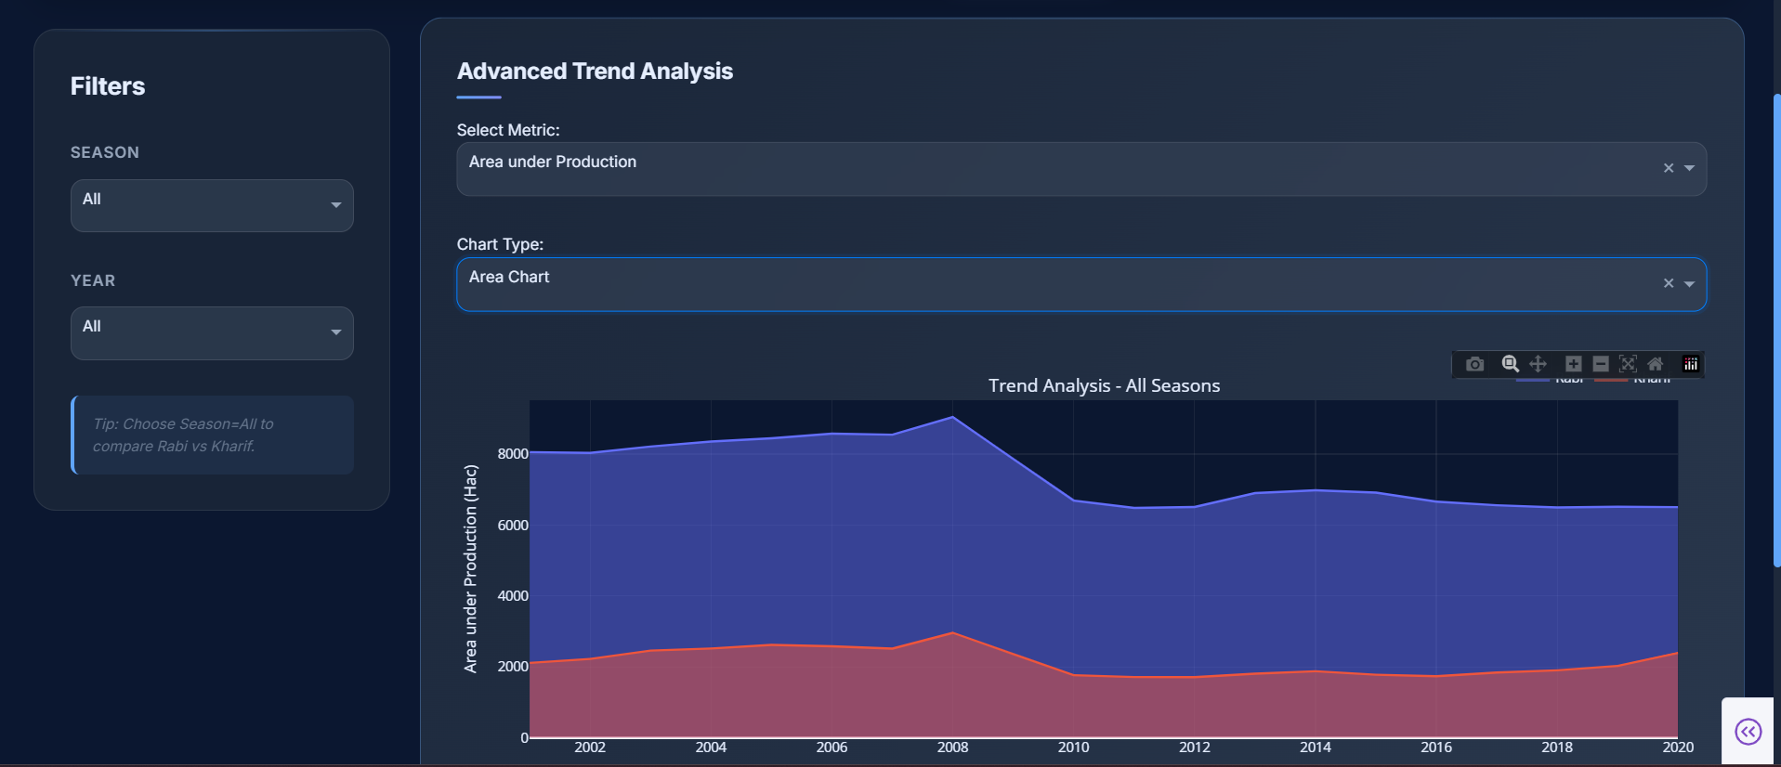
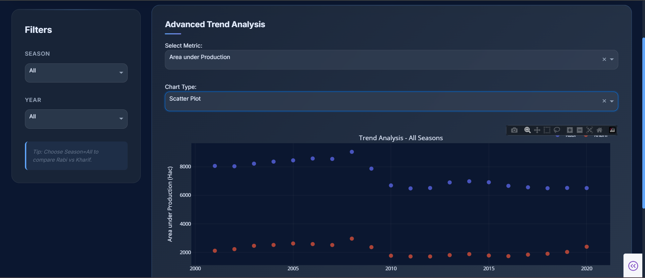

5.2.5 Export & Reports Tab
- Enables data and report downloads for offline analysis.
- Options include:
  - Export CSV → Raw/filtered dataset.
  - Export PDF Report → Professionally formatted report with summary tables and charts.
- Reports include:
  - Title page
  - Summary statistics
  - Charts and KPIs
  - Custom notes
📊 Use Case: A researcher exports a PDF report summarizing the last 10 years’ crop production trends for Punjab.
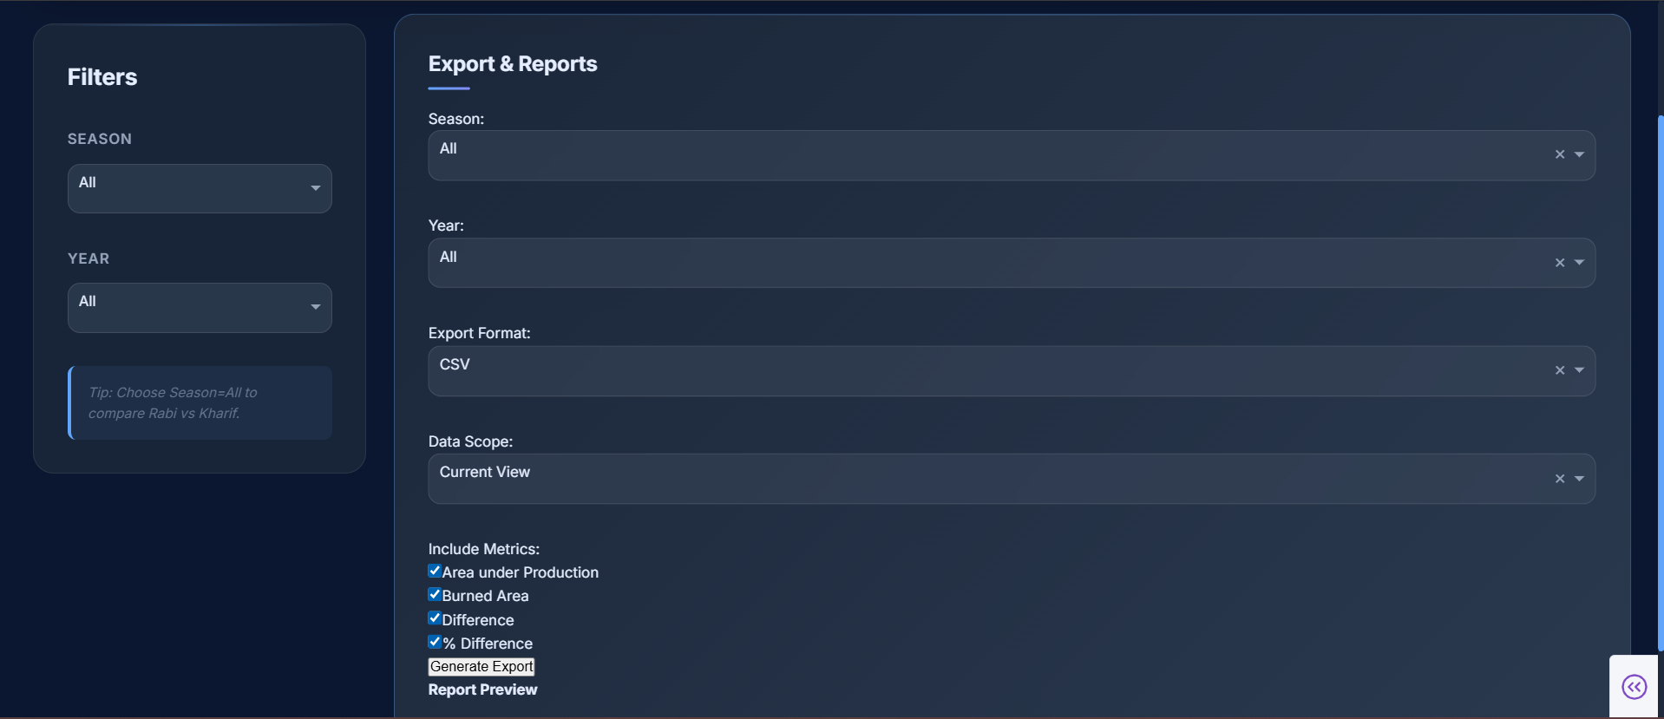

5.3 Filters and Interactivity
- Season Dropdown: Choose between Rabi and Kharif.
- Year Dropdown: Select one or multiple years.
- Dynamic Updates: All charts, KPIs, and reports auto-update with selections.
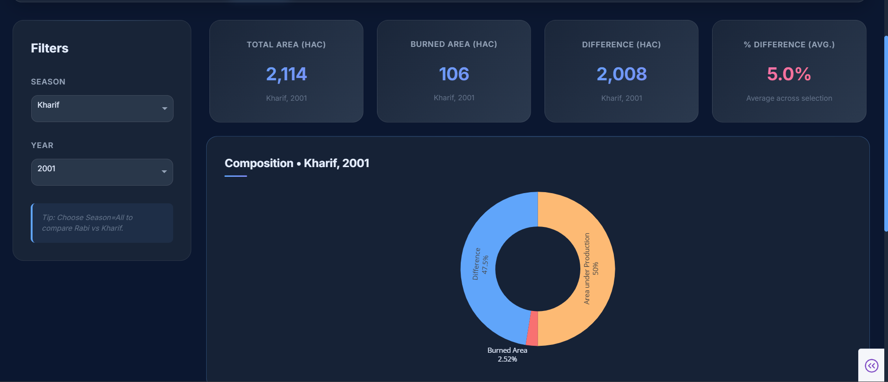
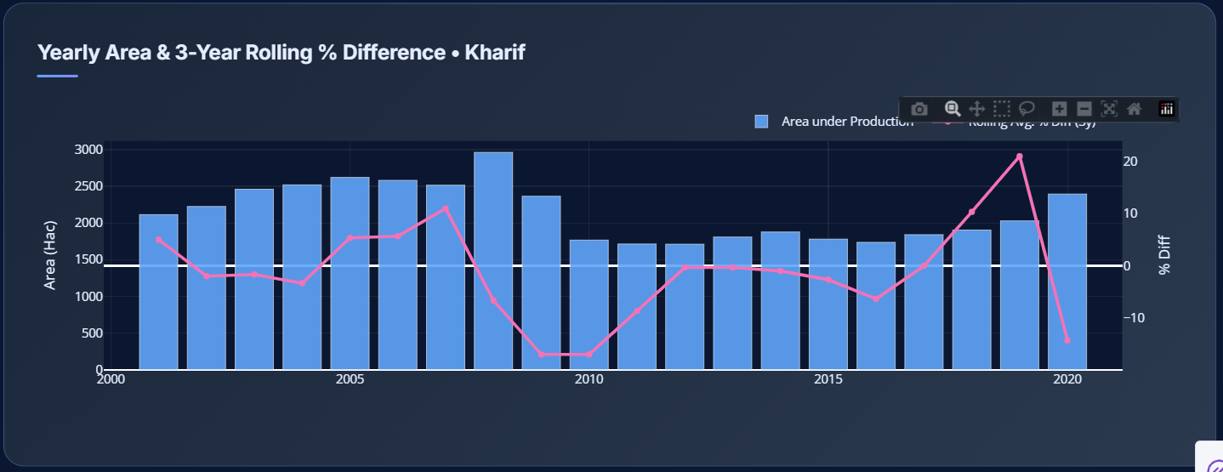

5.4 Example Workflow
- User selects → Kharif season, Years: 2010–2020.
- Dashboard updates to show:
  - Total cultivated vs. burned area.
  - Line chart of percentage difference over the decade.
  - Forecast prediction for 2021–2025.
- User exports report as PDF to share with agricultural policymakers.

5.5 Accessibility & Responsiveness
- Fully responsive design (desktop, tablet, mobile).
- Accessible color schemes for readability.
- Charts allow zoom, hover tooltips, and download as PNG.

Section 6
Component Breakdown and Code Overview

6. Component Breakdown & Code Overview
This section provides a detailed explanation of the Hydrolytix Agri-Intelligence dashboard’s internal architecture. It breaks down the core project files, modular components, utility scripts, and the interactive callback system that powers the dashboard.

6.1 Project Directory Structure
The dashboard project follows a modular structure for maintainability and scalability:
Hydrolytix-Agri-Intelligence/
│
├── app.py # Main application entry point
├── requirements.txt # Python dependencies
│
├── components/ # UI modules (charts, filters, tables)
│ ├── __init__.py
│ ├── crop_yield_chart.py
│ ├── production_table.py
│ ├── district_filter.py
│ └── export_buttons.py
│
├── utils/ # Helper functions and data loaders
│ ├── __init__.py
│ ├── data_loader.py
│ ├── preprocessing.py
│ └── export_utils.py
│
└── assets/ # CSS, images, and custom styling
└── styles.css

6.2 app.py (Main Entry Point)
The app.py file initializes the Dash application and defines the overall layout.
Key Responsibilities:
- Import required modules (Dash, Plotly, Pandas).
- Load and preprocess data from utils/data_loader.py.
- Define the app layout by combining components.
- Register all callbacks that make the dashboard interactive.
- Run the server (app.run_server()).

6.3 Components/
The components/ directory contains reusable UI elements such as charts, tables, and filters.

Example Modules:
- crop_yield_chart.py → Line/bar chart showing yield trends per district/crop.
- production_table.py → Data table with search, sorting, and pagination.
- district_filter.py → Dropdown menu for selecting districts.
- export_buttons.py → Buttons for exporting data (CSV/PDF).
Each component is written as a function that returns a Dash layout element.
This ensures separation of concerns and makes the UI modular.

6.4 utils/
The utils/ directory stores helper scripts for data operations.
- data_loader.py
Loads the CSV dataset, cleans it, and returns a processed DataFrame.
- preprocessing.py
Functions for handling missing values, outliers, and normalization.
- export_utils.py
Enables exporting filtered data into CSV, Excel, or PDF format.
This modular design ensures that data handling is decoupled from UI logic.

6.5 Callbacks (The Interactive Engine)
Dash callbacks connect user inputs (dropdowns, sliders, buttons) to outputs (charts, tables, alerts).
Basic Structure:
@app.callback(
Output("crop-yield-chart", "figure"),
Input("district-dropdown", "value"),
Input("year-slider", "value")
)
def update_yield_chart(selected_district, selected_year):
filtered_df = df[(df["District"] == selected_district) &
(df["Year"] == selected_year)]
fig = px.bar(filtered_df, x="Crop", y="Yield", title="Crop Yield")
return fig
How It Works:
- User selects a district from a dropdown.
- User adjusts the year slider.
- The callback function filters the dataset.
- The chart updates automatically without page reload.

6.6 Troubleshooting Common Issues
- Circular Callback Error:
Occurs when outputs and inputs depend on each other. → Use dcc.Store to manage intermediate state.
- Module Import Errors:
Check __init__.py files and correct relative imports (e.g., from utils.data_loader import load_data).
- Large Dataset Lag:
Pre-aggregate data in utils/preprocessing.py and use caching (flask_caching).
- Styling Issues:
Ensure CSS is placed in the /assets folder (Dash auto-detects it).

Section 7
Export and Reporting

7. Export and Reporting
The Hydrolytix Agri-Intelligence Dashboard provides powerful data exporting and reporting capabilities. These features allow analysts, researchers, and policymakers to extract insights in portable formats such as CSV and PDF, making it easy to share results, store archives, and include findings in official reports.

7.1 Export Options
The dashboard supports multiple export formats tailored to different use cases:
- CSV Export
  - Best for raw data analysis in Excel, SPSS, or R.
  - Preserves all columns from the filtered dataset.
  - Lightweight and easy to re-import into other tools.
- Excel Export (Optional)
  - Includes advanced formatting.
  - Multiple sheets possible (e.g., Yield Trends, District Data).
  - Useful for stakeholders preferring spreadsheet analysis.
- PDF Report Generation
  - Professionally formatted report suitable for presentations and policy briefs.
  - Includes summary tables, charts, and statistical highlights.
  - Generated dynamically with ReportLab.

7.2 Export Workflow
The export functionality is user-driven and integrated seamlessly into the dashboard:
- User applies filters (district, crop, year range).
- The system processes the filtered dataset.
- Export buttons appear in the Export & Reports tab.
- User selects desired format (CSV, Excel, or PDF).
- File is generated and a download link is provided instantly.

7.3 CSV Export
- Implemented via Pandas DataFrame .to_csv() method.
- Ensures UTF-8 encoding for compatibility across systems.
- Column headers preserved for readability.
Code Example:
import pandas as pd
from dash import dcc, html
import io

def export_csv(dataframe):
buffer = io.StringIO()
dataframe.to_csv(buffer, index=False)
return buffer.getvalue()

7.4 PDF Report Generation

Report Structure
The generated PDF includes:
- Cover Page → Title, date, and user-applied filters.
- Summary Statistics → KPIs such as Total Area, Yield, Burned Area.
- Charts and Graphs → Embedded Plotly figures.
- Detailed Tables → Tabular representation of filtered dataset.
- Conclusion & Insights → Automatically generated text (optional).

Technical Implementation
- Built with ReportLab (SimpleDocTemplate, Paragraph, Table).
- Plots converted into images and embedded.
- Page numbers and headers auto-generated.

7.5 Export UI (User Interface)
In the Export & Reports Tab, users will find:
- Dropdowns → Select which metrics to include.
- Radio Buttons → Choose export format (CSV, Excel, PDF).
- Download Button → Generates file and provides direct download link.
- Progress Indicator → Shows export status (useful for large datasets).

7.6 Advanced Features
- Scheduled Exports
  - Future versions may support automated scheduled reports (e.g., daily, weekly).
  - Can be emailed directly to stakeholders.
- Customized Branding
  - PDF headers/footers can include logos, signatures, and project-specific branding.
- Selective Export
  - Users can choose specific columns, charts, or KPIs to include in their export.

7.7 Troubleshooting Export Issues
Issue | Cause | Solution
CSV file opens with garbled characters | Incorrect encoding | Ensure UTF-8 export encoding
PDF export fails | Missing ReportLab library | Install via pip install reportlab
Large dataset export is slow | Memory-heavy DataFrame | Use batch export or filter data before exporting
Charts missing in PDF | Plotly image conversion not installed | Install kaleido (pip install kaleido)

7.8 Best Practices for Reporting
- Always apply filters before exporting to reduce file size.
- Use CSV for raw analysis, Excel for stakeholder review, and PDF for official documentation.
- Archive exports with proper filenames (report_punjab_2025_Q1.pdf).

Section 8
Customization and Extensibility

8. Customization and Extensibility
The Hydrolytix Agri-Intelligence Dashboard has been designed with a modular and extensible architecture. This ensures that developers can easily adapt it to new agricultural datasets, add new visualizations, or modify the system’s appearance without rewriting core functionality.

8.1 Adding New Features

General Guidelines
- Follow the existing modular component structure.
- Place new UI or analytical features in the components/ directory.
- Define all interactivity via Dash callbacks in app.py (or modularized callback files).
- Use the existing data_loader utility for consistent preprocessing.

Example: Adding a New Chart
Suppose you want to add a Crop Productivity Heatmap:
- Create a file components/productivity_heatmap.py.
- Define a function get_heatmap_layout() returning a dcc.Graph.
- Import it into layout.py and place it under the appropriate tab.
- Register a callback in app.py that updates the heatmap when filters change.

8.2 Extending Data Sources
The system currently supports CSV-based datasets, but it can be extended to connect with:
- Databases (MySQL, PostgreSQL, MongoDB)
- APIs (government crop statistics portals, IoT sensor feeds)
- Cloud Storage (Google Drive, AWS S3, Firebase)

Steps to Add a New Data Source
- Modify utils/data_loader.py to include a new function (e.g., load_from_database()).
- Ensure it outputs a Pandas DataFrame consistent with existing schema.
- Update the app.py data loading pipeline to allow source selection.

8.3 Customizing Visual Design

CSS Styling
- Located in assets/ directory (automatically detected by Dash).
- Use CSS variables for consistent theming (colors, fonts, spacing).
- Example: Update primary theme color by editing --primary-color variable.

Branding
- Add project logos in the navigation bar.
- Modify PDF export headers to include official branding (government or NGO logos).
- Customize KPI cards with colors that match organizational standards.

8.4 Extending Analytical Capabilities
The dashboard supports basic forecasting (ARIMA, Exponential Smoothing) and trend analysis. Developers can add new ML/AI models to provide deeper insights.

Example: Adding a Machine Learning Model
- Implement model logic in utils/models.py.
- Register the model as an option in the Forecasting tab.
- Add a callback that calls the model and displays results in charts.
- Validate accuracy metrics before production use.

8.5 Supporting Multiple Regions or Datasets
Currently optimized for Punjab crop data, but Hydrolytix can be scaled to other regions:
- Add new CSVs (e.g., sindh_agri_data.csv).
- Modify data_loader.py to handle multiple region datasets.
- Add a Region Selector Dropdown in the UI.
- Ensure exports include region metadata in filenames (report_sindh_2025.pdf).

8.6 Modular Code Integration
To maintain scalability, follow these modular practices:
- One component = one file (e.g., trend_analysis.py, comparison.py).
- Keep callbacks grouped logically by functionality.
- Use helper functions in utils/ to avoid duplication.

8.7 Example Customization Scenarios
- Scenario 1: Adding Rainfall Data
  - Extend dataset schema with a "Rainfall (mm)" column.
  - Add a rainfall trend chart in components/rainfall_analysis.py.
  - Link with crop yield to analyze climate impact.
- Scenario 2: Switching to a Dark Theme
  - Update CSS variables in assets/style.css.
  - Ensure charts use Plotly’s plotly_dark theme.
- Scenario 3: Enabling Multi-language Support
  - Add a language toggle dropdown (English/Urdu).
  - Store translations in assets/lang.json.
  - Modify text components to load dynamically.

8.8 Future Extensibility Roadmap
- Real-time IoT Integration → Stream live data from soil sensors and weather APIs.
- AI-driven Insights → Integrate predictive ML models for disease outbreaks or optimal sowing times.
- User Authentication → Role-based dashboards (researcher, policymaker, farmer).
- Mobile-Friendly Layouts → Responsive UI for tablets and smartphones.

Section 9
Troubleshooting and FAQs

9. Troubleshooting & FAQs
This section provides common problems, their causes, and solutions to help users resolve issues quickly.

9.1 General Troubleshooting

Problem 1: Dashboard not loading in the browser
- Cause: Missing dependencies or incorrect installation.
- Solution:
  - Ensure all required Python packages are installed:
  - pip install -r requirements.txt
  - Restart the server with:
  - python app.py
  - Check if port 8050 is free; if not, run with a different port:
  - python app.py --port 8060

Problem 2: Blank graphs or tables
- Cause: Dataset file not found or corrupted.
- Solution:
  - Verify that agri_analysis_punjab_clean.csv is present in the data/ folder.
  - Re-download or replace the dataset if damaged.
  - Check console/logs for missing column errors.

Problem 3: Callbacks not updating
- Cause: Dash callback errors or circular dependencies.
- Solution:
  - Open terminal to check error messages.
  - Verify input/output IDs match the layout component IDs.
  - Avoid circular dependencies in callbacks.

Problem 4: Installation error on Windows
- Cause: Missing Python or virtual environment issues.
- Solution:
  - Confirm Python ≥ 3.8 is installed.
  - Use a fresh virtual environment:
  - python -m venv venv
  - source venv/Scripts/activate
  - pip install -r requirements.txt

9.2 Frequently Asked Questions (FAQs)
Q1. Can I use my own dataset?
Yes. Place your dataset in the data/ folder, ensure it follows the same structure (columns for district, crop, year, production, etc.), and update data_loader.py if needed.
Q2. How can I change the dashboard theme/colors?
You can modify the CSS file in the assets/ folder to customize styles.
Q3. Does Hydrolytix require internet access?
No, it runs locally. However, internet may be needed for package installation or online datasets.
Q4. What browsers are supported?
Chrome, Firefox, Edge, and Safari (latest versions recommended).
Q5. How do I report a bug?
Document the issue (steps to reproduce, error message, screenshot) and share it with Team Hydrolytix.

Section 10
Future Enhancements

10. Future Enhancements
Hydrolytix is designed as a modular and scalable platform. While the current version provides powerful insights into agricultural production in Punjab, future updates aim to expand features, improve usability, and integrate advanced technologies.

10.1 Planned Features
- Predictive Analytics with AI/ML
  - Crop yield forecasting using weather, soil, and satellite data.
  - Pest/disease outbreak prediction models.
- Real-Time Data Integration
  - Live weather data APIs.
  - IoT-based soil and water monitoring sensors.
- Interactive Mapping & GIS Support
  - Geo-spatial visualization of district-level data.
  - Heatmaps for yield distribution.
- Mobile Application Version
  - Android/iOS app for farmers and stakeholders.
  - Offline support for rural areas with low connectivity.
- Multi-Language Support
  - Urdu and Punjabi translations for farmer accessibility.
- User Role Management
  - Admin, researcher, and farmer-specific dashboards.
- Data Export Enhancements
  - Export insights in PDF, Excel, and Word with custom reports.

10.2 Long-Term Vision
- Establish Hydrolytix as a centralized agricultural intelligence hub for policymakers, researchers, and farmers.
- Collaborate with agricultural universities, research centers, and government bodies for data standardization.
- Integrate blockchain-based data authenticity for secure and transparent record-keeping.
- Build a global Agri-Intelligence Network connecting datasets from multiple regions beyond Punjab.

Section 11
Appendix

11. Appendix
This appendix provides supporting material for users and developers to better understand Hydrolytix.

11.1 Sample Dataset (Excerpt)
The dataset used in Hydrolytix contains crop production statistics for Punjab.
Columns include:
- District – Name of district (e.g., Lahore, Multan)
- Crop – Crop type (e.g., Wheat, Rice, Cotton)
- Year – Production year
- Area – Area cultivated (in hectares)
- Production – Yield in metric tons
Sample Rows:
District | Crop | Year | Area (ha) | Production (tons)
Lahore | Wheat | 2020 | 15,200 | 52,300
Multan | Cotton | 2020 | 10,800 | 41,200
Faisalabad | Rice | 2021 | 12,400 | 38,700

11.2 File & Folder Structure
Hydrolytix-Dashboard/
│── app.py # Main application entry point
│── requirements.txt # Python dependencies
│── assets/ # CSS, images, and logos
│── components/ # UI components (charts, layouts)
│── utils/ # Helper scripts (data_loader, filters)
│── data/ # CSV dataset(s)
│── exports/ # Saved reports

11.3 Common Commands
Environment Setup
python -m venv venv
source venv/bin/activate # Linux/macOS
venv\Scripts\activate # Windows
pip install -r requirements.txt
Run the Dashboard
python app.py
Export Report (PDF)
python export_report.py

11.4 Troubleshooting Quick Reference
Issue | Cause | Solution
Dashboard not loading | Port already in use | Run with python app.py --port 8081
ImportError | Missing dependency | Run pip install -r requirements.txt
Dataset not found | Wrong path | Place CSV inside /data/ folder
Charts empty | Dataset formatting issue | Ensure columns match District, Crop, Year, Area, Production

11.5 References & Credits
- Dataset Source: Punjab Agricultural Department
- Libraries Used: Dash, Plotly, Pandas, ReportLab
- Prepared by: Team Hydrolytix
- Tagline: “AI-powered Agri Intelligence”

