1. **If two points x1x_1x1​ and x2x_2x2​ are the same, what happens to the line equation?**

* Mathematically, the cross product of a vector with itself is **zero**, meaning: l = x1 × x1 = 0.
* This tells us **no unique line exists** because there’s no direction defined by two distinct points.

1. **What happens if x1x_1x1​ and x2x_2x2​ are infinitely far apart?**

• If two points are infinitely far apart, they still define a line.

• However, one of the points is an **ideal point at infinity**, meaning the line has a **fixed direction** but no finite endpoint.

* In projective geometry, these lines will meet at the **line at infinity**, which collects all these "infinite" points.

**Duality Theorem**

"For every theorem in 2D projective geometry, there is a corresponding dual theorem where points and lines are swapped."

Example:

* **Intersection of two lines gives a point**: x = l1 × l2
* **Joining two points gives a line**: l = x1 × x2

**How can we ensure that ccc directly gives us the distance from the origin?**

* By **normalizing** the equation so that the normal vector has a unit length:
  + Sqrt {a^2 + b^2} = 1
* This ensures that: c normalized = c / {\sqrt{a^2 + b^2}}
* Now, c normalized ​ gives the **true Euclidean distance** from the origin.

All points at infinity lie on the line at infinity 𝐥∞= (0, 0,1)

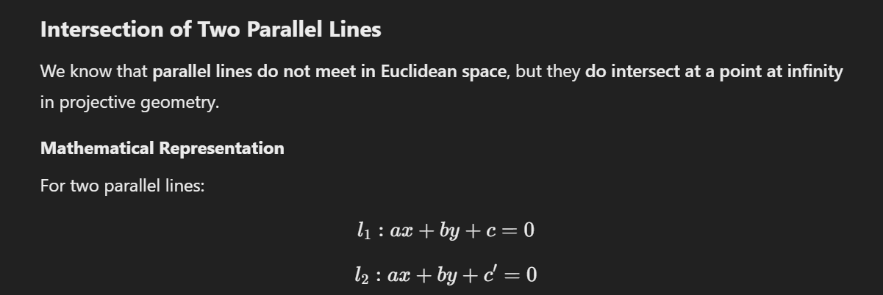

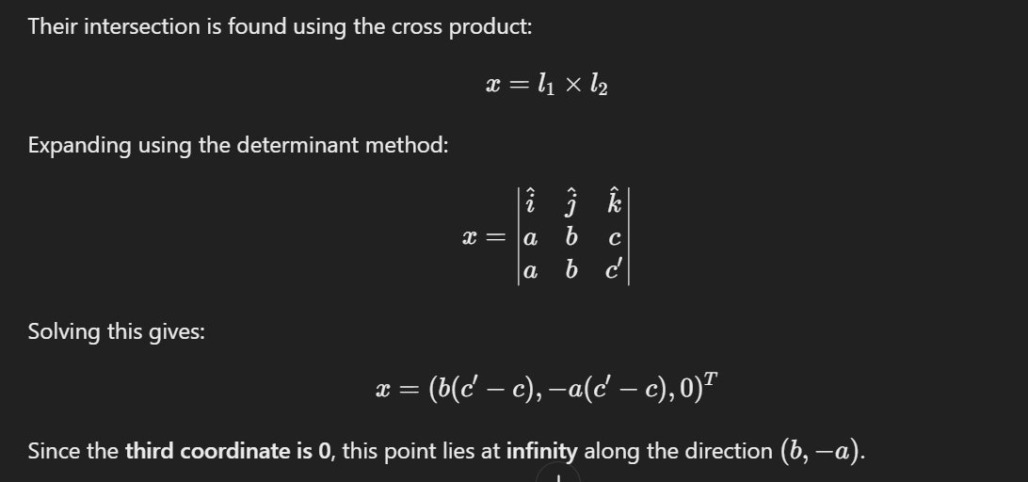

### 

### **Line at Infinity & Its Importance:**

* The **line at infinity** is given by: l∞ = (0,0,1) T
* It collects all **ideal points** (points at infinity).
* In projective space P2, **all parallel lines meet on this line**.
* In Euclidean space R2, this concept does **not exist**, but in projective geometry, it is fundamental.

**Key Property:**

* Any line l intersects l∞ at: (b,−a,0)T
* which gives the **direction of the line** at infinity.