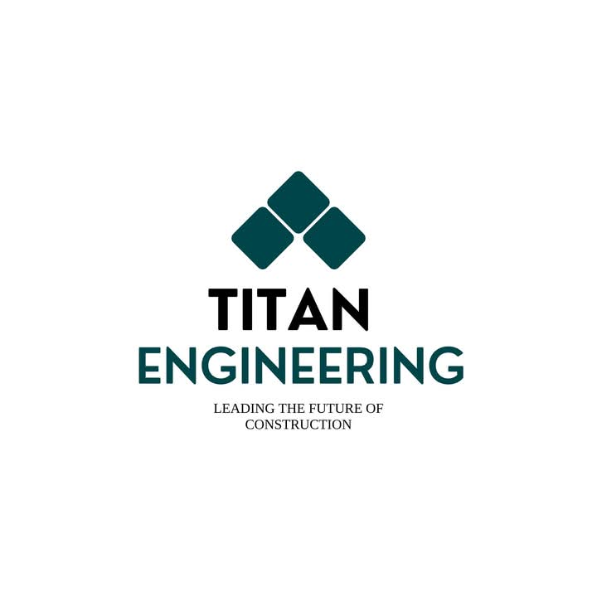
COMPANY PROFILE
1. ABOUT US
Titan Engineering is a professional engineering and construction consultancy dedicated to providing reliable, innovative, and practical solutions for modern residential and construction projects.
We focus on transforming our clients' ideas into well-planned, functional, and aesthetically pleasing spaces. From the initial site consultation and concept development to detailed drawings and technical documentation, our team provides a complete range of services to support the successful planning and development of construction projects.
At Titan Engineering, we understand that every client has different requirements, preferences, land conditions, and budgets. Therefore, we provide customized solutions that balance modern design, functionality, construction requirements, and cost considerations.
Our goal is to make the construction planning process simple, clear, and convenient for our clients while maintaining professional standards throughout every stage of the project.

2. OUR VISION
To be a trusted and innovative engineering partner in the future of construction.
We aim to become a recognized engineering and design service provider by delivering modern, practical, sustainable, and cost-effective solutions while continuously improving our technical knowledge and professional capabilities.

3. OUR MISSION
Our mission is to provide clients with professional engineering, architectural planning, design, and construction-related solutions that meet their individual requirements.
We are committed to:
- Understanding the client's vision and requirements.
- Providing practical and innovative design solutions.
- Maintaining professional quality in every project.
- Delivering accurate technical documentation.
- Offering cost-conscious solutions.
- Supporting clients throughout the planning process.
- Using modern design and engineering technologies.
- Building long-term relationships based on trust and reliability.

4. OUR SERVICES
Architectural House Plans
We prepare customized architectural house plans according to the client's requirements, land conditions, lifestyle, and budget.
Our designs focus on creating comfortable and functional spaces while maintaining a modern architectural appearance.
We can develop house plans for different requirements, including:
- Single-storey houses
- Two-storey houses
- Modern luxury houses
- Compact residential houses
- Customized family homes
- Investment properties
Our planning process considers space utilization, room arrangement, natural lighting, ventilation, accessibility, and overall functionality.

3D Exterior & Interior Design
Our 3D design services help clients visualize their future property before construction begins.
Exterior Design
We create modern exterior concepts that consider:
- Building appearance
- Facade design
- Roof design
- Windows and doors
- Exterior finishes
- Landscaping concepts
- Lighting concepts
- Outdoor living areas
Interior Design
We also provide interior design concepts for living rooms, bedrooms, kitchens, bathrooms, dining areas, and other spaces.
3D visualization allows clients to understand the proposed design, colours, materials, furniture arrangements, and overall appearance before implementation.

5. ENGINEERING DRAWINGS & TECHNICAL DOCUMENTATION
A successful construction project requires accurate and properly organized technical drawings.
Titan Engineering provides technical drawing services covering the major requirements of residential and construction projects.
Our services include:
- Architectural drawings
- Floor plans
- Elevation drawings
- Section drawings
- Detailed working drawings
- Electrical layout plans
- Plumbing layout plans
- Structural drawings
- Construction details
- Door and window schedules
- Finishing details
These drawings are prepared to provide clear information required for construction and coordination between different professionals involved in the project.

6. ELECTRICAL & PLUMBING LAYOUTS
We provide coordinated electrical and plumbing layout plans as part of our building design services.
Electrical Layouts
Electrical planning may include:
- Lighting points
- Switch locations
- Power outlets
- Distribution board locations
- Electrical circuit planning
- Air-conditioning points
- External lighting points
Plumbing Layouts
Plumbing plans may include:
- Water supply arrangements
- Bathroom plumbing
- Kitchen plumbing
- Drainage arrangements
- Sanitary fixture locations
- Water tank and related services
Proper planning helps minimize unnecessary modifications and improves coordination during construction.

7. STRUCTURAL DRAWINGS
Structural planning is an important component of safe and efficient construction.
Our structural drawing services provide technical documentation to support the construction of structural elements such as:
- Foundations
- Columns
- Beams
- Slabs
- Staircases
- Roof structures
- Other structural details
Structural requirements are considered together with the architectural design to achieve a practical and coordinated building solution.

8. BOQ & DETAILED ESTIMATES
Understanding the expected construction cost is an important part of planning a project.
We provide BOQ (Bill of Quantities) and detailed estimation services to help clients understand the approximate quantities and costs associated with their proposed construction work.
Our estimation services can assist clients with:
- Material quantity planning
- Construction cost estimation
- Labour cost considerations
- Work item breakdown
- Budget planning
- Cost control
This enables clients to make better financial decisions before starting construction.

9. BANK LOAN DOCUMENTATION
We assist clients in preparing the necessary technical documentation required for construction-related bank loan processes.
Depending on the project requirements, documentation can include relevant:
- House plans
- Building estimates
- BOQ
- Project details
- Supporting technical documents
Our objective is to make the documentation process more organized and convenient for the client.

10. LOCAL AUTHORITY APPROVAL DRAWINGS
Obtaining the necessary approvals is an important stage of any construction project.
Titan Engineering provides assistance with preparation of drawings and relevant documentation required for submission to the appropriate local authorities.
We focus on preparing clear and properly organized documentation according to the requirements applicable to the project.

11. DETAILED WORKING DRAWINGS
Detailed working drawings provide construction teams with the information required to properly execute the proposed design.
Our working drawings can include detailed information relating to:
- Floor layouts
- Elevations
- Sections
- Construction details
- Staircases
- Doors and windows
- Finishes
- Electrical arrangements
- Plumbing arrangements
- Structural components
These drawings help reduce uncertainty during construction and improve communication between the client, designer, engineer, and construction team.

12. 3D WALKTHROUGH & VISUALIZATION
Our 3D visualization services allow clients to experience their proposed property before construction.
A 3D walkthrough can provide a realistic understanding of:
- Exterior appearance
- Interior spaces
- Room arrangements
- Materials and finishes
- Lighting concepts
- Furniture arrangements
- Overall building atmosphere
This is particularly useful for clients who want to clearly understand their proposed design before making construction decisions.

13. SUSTAINABLE DESIGN CONSULTING
We promote practical and environmentally conscious design approaches where appropriate to the project.
Our design considerations may include:
- Natural lighting
- Natural ventilation
- Efficient space planning
- Energy-conscious solutions
- Practical material selection
- Landscape integration
- Reduced unnecessary construction costs
Our objective is to create buildings that are not only attractive but also comfortable, practical, and efficient.

14. OUR DESIGN PACKAGES
BASIC PACKAGE
Architectural Planning Solution
Suitable for clients who primarily require a professional architectural house plan.
Includes:
- Architectural house plan
- Initial site consultation
- Basic planning consultation
- Customized floor arrangement

STANDARD PACKAGE
Complete House Design Solution
A more comprehensive package for clients who require architectural and basic technical planning.
Includes:
- Architectural house plan
- 3D design
- Electrical layout plan
- Plumbing layout plan
- BOQ / detailed estimate
- Bank loan documentation
- Local authority approval documentation

PREMIUM PACKAGE
Complete Professional Design Solution
Our premium package is designed for clients who require a complete design and technical documentation package.
Includes:
- Architectural house plan
- High-quality 3D designs
- Electrical layout plan
- Plumbing layout plan
- Detailed structural drawings
- Detailed working drawings
- 3D walkthrough video
- Complete detailed drawing book
- Technical consultation and coordination

15. OUR PROFESSIONAL TEAM
LASANTHA
Head – Surveyor
Lasantha leads the professional team and contributes to the technical planning and coordination of projects. His role includes understanding site requirements, coordinating project information, and supporting clients throughout the planning and development process.
His practical approach helps ensure that project requirements are properly understood and incorporated into the design and technical planning process.

PRADEEP LAKMAL
Civil Engineer
Pradeep Lakmal provides civil engineering expertise for construction and building-related projects.
His responsibilities include supporting structural and engineering requirements, reviewing construction-related technical aspects, and contributing to practical engineering solutions.
His involvement helps ensure that architectural concepts are developed with appropriate engineering considerations and construction practicality.

HASAL
Technical Support
H.N.D. contributes to the technical and digital aspects of project planning and supports the preparation and management of project-related spatial and technical information.
The role supports the team in organizing project information and assisting with technology-based planning requirements.

16. OUR PROJECT APPROACH
At Titan Engineering, we follow a structured approach to help clients move from an initial idea to a practical construction solution.
STEP 01 — CLIENT CONSULTATION
We first understand the client's requirements, preferences, lifestyle, budget, and expectations.
STEP 02 — SITE & REQUIREMENT ASSESSMENT
We review the available site information and identify important planning considerations.
STEP 03 — CONCEPT DEVELOPMENT
Our team develops an initial concept based on the client's requirements and available site conditions.
STEP 04 — ARCHITECTURAL DESIGN
The selected concept is developed into a detailed architectural plan.
STEP 05 — 3D VISUALIZATION
Where required, 3D exterior and interior designs are developed to help the client visualize the final outcome.
STEP 06 — TECHNICAL DRAWINGS
Electrical, plumbing, structural, and detailed working drawings are prepared according to the project requirements.
STEP 07 — ESTIMATION & DOCUMENTATION
BOQ, estimates, and relevant supporting documentation are prepared.
STEP 08 — FINAL DELIVERY
The completed drawings and documents are organized and delivered to the client for the next stage of the project.

17. WHY CHOOSE TITAN ENGINEERING?
Professional Approach
We handle each project with attention to detail and a commitment to professional service.
Customized Designs
We do not believe in one design for everyone. We develop solutions according to individual client requirements.
Modern & Elegant Concepts
Our designs combine contemporary architectural styles with practical functionality.
Budget-Conscious Solutions
We consider the client's budget while developing practical design solutions.
Complete Service
From initial consultation to drawings, estimates, and visualization, we provide a comprehensive range of services.
Technical Expertise
Our team combines engineering and technical knowledge to provide practical project solutions.
Client-Focused Service
We maintain close communication with clients throughout the planning process to ensure that their requirements are properly understood.

18. OUR COMMITMENT
At Titan Engineering, we believe that a successful building begins with a well-planned design.
We are committed to providing our clients with solutions that combine quality, creativity, functionality, technical accuracy, and affordability.
Whether it is a modern family home, a customized residential project, or a construction-related development, our team is ready to support the client from the initial concept through the planning and documentation stages.
Your Vision. Our Expertise. A Better Future.

CONTACT US
TITAN ENGINEERING
Leading the Future of Construction
📞 +94 71 730 0011
For Consultations & Bookings
Modern Designs | Professional Engineering | Customized Solutions | Quality Service

