# Performance Analysis

## Doubling Hypothesis (With Visualization) – Methodology based on Empirical Study

|  |  |
| --- | --- |
| Number of Nodes (Vertices) | Elapsed Time (Seconds) |
| 6 | 0.522 |
| 12 | 1.635 |
| 24 | 3.236 |
| 48 | 10.494 |
| 96 | 47.509 |

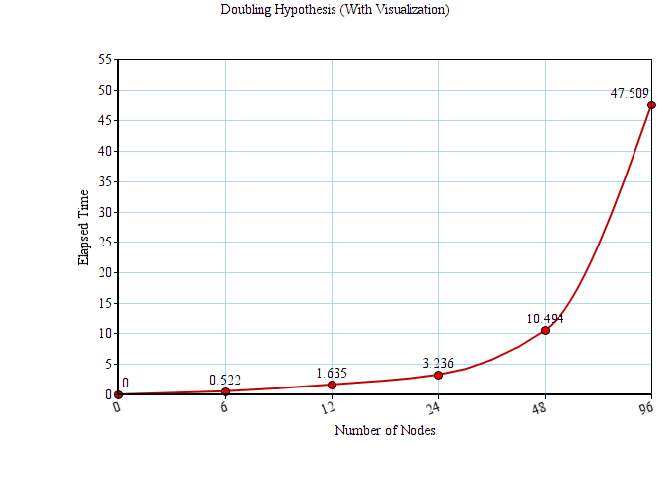

Figure - Doubling Hypothesis visualized on a graph

Ford Fulkerson algorithm is used to calculate the maximum flow of a flow network. In the program, maximum flow of the user generated/auto generated flow network is calculated using Edmonds Karp algorithm which is refining the Ford-Fulkerson algorithm by choosing the augmenting path with the smallest number of edges, in its every iteration.

It is clearly visible that the graph justifies the O(VE^2) of the algorithm. It is O(VE^2) because in the worst-case scenario, bfs takes O(E) and to get the augmented path, it is O(VE). The program ran for 5 times, the input being doubled from 6 to 96. The above spline graph is drawn by getting the outputs of those executions with the visualization on JFrame and considering the elapsed process time to get the maximum flow (These values were taken to test the doubling hypothesis of the algorithm but in the actual implementation, a delay is added between flows to make it easy on the eye for the viewer). It is visible that the elapsed time increases with every doubled number of nodes. From 6 nodes to 48 nodes it shows a normal increase, but from 48 nodes to 96 nodes, it is a drastic increase. Overall, the behavior of the graph can be called polynomial in the number of vertices of the flow network.

Order of Growth of the algorithm is: VE^2

# Appendix

