6SENG002W Concurrent Programming

FSP Process Analysis & Design Form

Name | Hasal Fernando
Student ID | w1697758
Date | 20/12/2020

1. FSP Process Attributes

Attribute | Value
Name | PRINTER
Description | A machine which prints documents and is shared among Students and a technician. Students use the printer to print documents and technician keeps checking if the printer papers are empty. Technician refills it when he/she is alerted that printer has run out of paper. It can print on three sheets before it is refilled.
Alphabet | { acquire, emptyAlert, notEmpty, print[1], print[2], print[3], printerCheck.acquire, printerCheck.release, refill, release, t.acquire }
Number of States | 19
Deadlocks (yes/no) | No Deadlocks.
Deadlock Trace(s)  (if applicable) | None.

2. FSP Process Code

FSP Process:
const MIN_PAPERS = 0
const MAX_PAPERS = 3
range PAPER_RANGE = MIN_PAPERS..MAX_PAPERS

//PRINTER
PRINTER(SHEETS = MAX_PAPERS) = PRINTER_READY[SHEETS],
PRINTER_READY[ paper : PAPER_RANGE ] = ( when( paper > 0 ) acquire -> print[paper] -> release -> PRINTER_READY[ paper - 1 ]
| when( paper == 0 ) emptyAlert -> t.acquire -> refill -> release -> PRINTER_READY[MAX_PAPERS]
| when( paper > 0 ) printerCheck.acquire -> notEmpty -> printerCheck.release -> PRINTER_READY[ paper ] ) .

3. Actions Description
A description of what each of the FSP process' actions represents, i.e. is modelling. In addition, indicate if the action is intended to be synchronised (shared) with another process or asynchronous (not shared). (Add rows as necessary.)

Actions | Represents | Synchronous or Asynchronous
acquire | Students acquire printer to print documents. | Asynchronous
emptyAlert | Alerting technician that printer has run out of papers. | Asynchronous
notEmpty | Technician confirms the papers are not empty in the printer. | Asynchronous
print[1] | Student printing their document with id “1”. | Asynchronous
print[2] | Student printing their document with id “2”. | Asynchronous
print[3] | Student printing their document with id “3”. | Asynchronous
printerCheck.acquire | Technician acquires printer to check the status of papers. | Asynchronous
printerCheck.acquire | Technician releases printer after checking the status of papers. | Asynchronous
refill | Technician refills papers in the printer. | Asynchronous
release | Printer is released by both students and technician after printing documents and refilling printer resources, respectively. | Asynchronous
t.acquire | Technician acquires printer to refill papers. | Asynchronous

4. FSM/LTS Diagrams of FSP Process
Note that if there are too many states, more than 64, then the LTSA tool will not be able to draw the diagram. In this case draw small diagrams of the most important parts of the complete diagram.

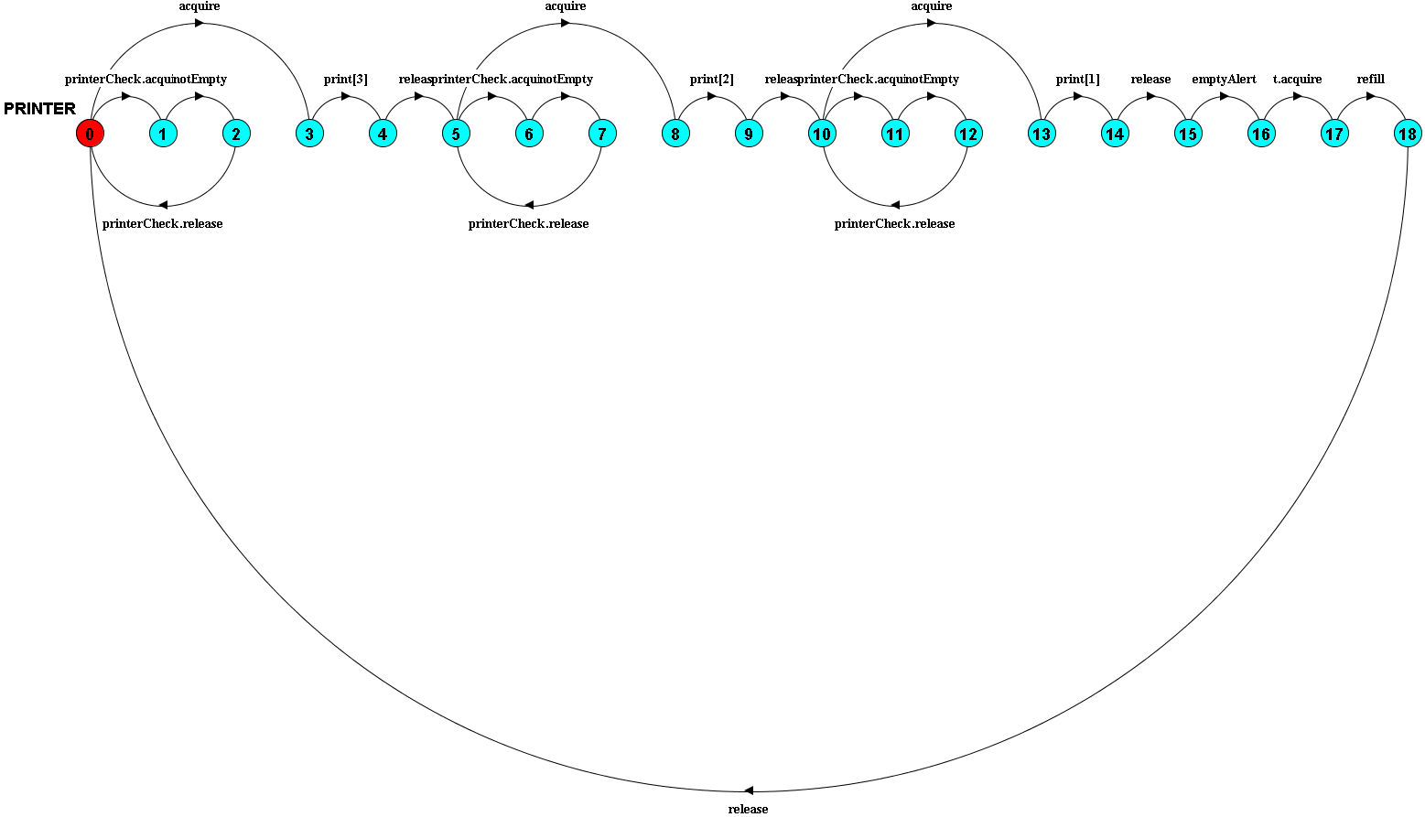

5. LTS States
A description of what each of the FSP process' states represents, i.e. is modelling. If there are a large number of states then you can group similar states together &/or only include the most important ones. For example, identify any states related to mutual exclusion (ME) & the associated critical section (CS), e.g. waiting to enter the CS state, in the CS state(s), left the CS state. (Add rows as necessary.)

State | Represents
0 | Printer is available with resources and can be acquired by any of the two students to print a document or the technician can check printer’s paper status.
1, 6, 11 | Technician acquires printer to check the status of papers in the printer.
2, 7, 12 | Technician gets to know that papers in printer are not empty.
3, 8, 13 | Printer is acquired by a student.
4 | A student has printed a document using the 3rd paper that is left in the printer, and the print job is complete. Printer is ready to be released.
5, 10 | Printer is released and available with resources. Printer can be acquired by any of the two students to print a document or the technician can check printer status.
9 | A student has printed a document using the 2nd paper that is left in the printer, and the print job is complete. Printer is ready to be released.
14 | A student has printed a document using the last paper that is left in the printer, and the print job is complete. Printer is ready to be released.
15 | Printer is released but the papers are empty in the printer. Technician can be alerted that papers are empty.
16 | Technician is alerted that papers are empty in the printer.
17 | Technician has acquired the printer to refill printer’s papers.
18 | Technician has refilled printer’s papers.

6. Trace Tree for FSP Process
The trace tree for the process. Use the conventions given in the lecture notes and add explanatory notes if necessary.
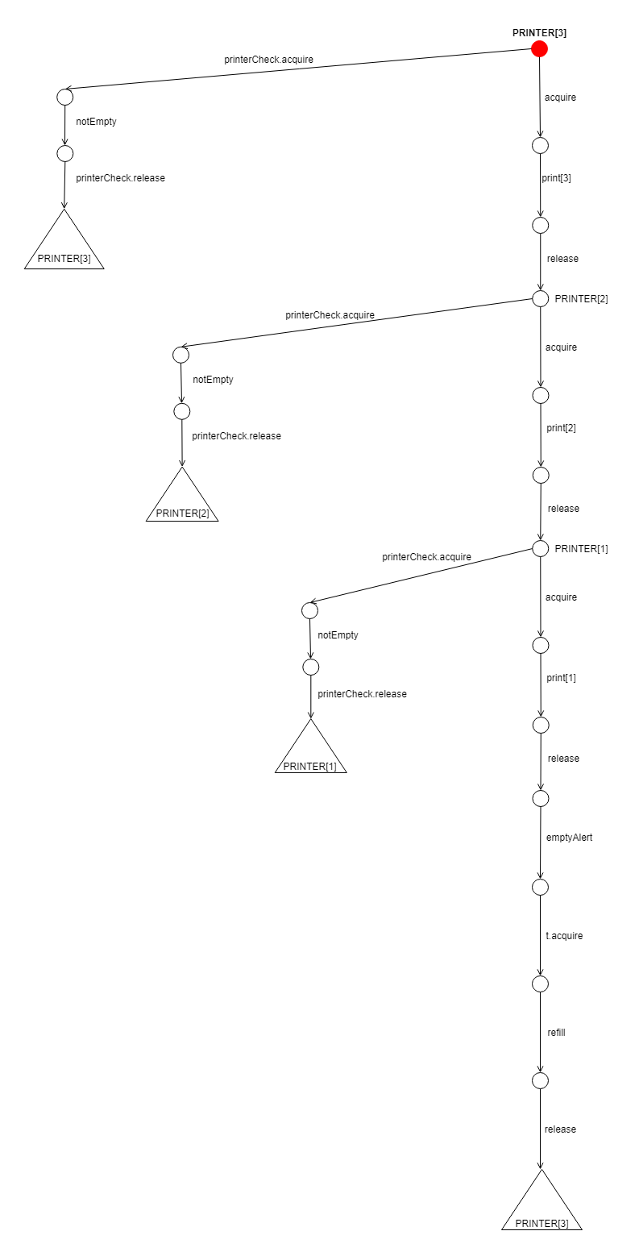
Explanation of the Trace Tree
- The printer is initialized with 3 papers in its paper tray.
- Whenever the printer is not acquired, either a student or a technician can access it.
- Technician can acquire the printer to check whether it has run out of paper.
- If the printer is not empty always technician will release the printer and the PRINTER process will be repeated from the point where it was stopped, with the available number of papers.
- For an example, if the technician checks for paper availability after printing on the 3rd paper in paper tray, 2 papers are left inside the tray. Hence, the tray is not empty. Then it will return to the point where there are two papers left ( PRINTER[2] ), in the process.
- If the printer is acquired by a student, student must first print it on the 3rd paper left in the tray initially, then on the 2nd paper and lastly on the only paper that is left.
- When the printer runs out of paper, technician is alerted and technician acquires the printer, refills papers in it and releases the printer.
- Then again, the PRINTER process is repeated.

