**Arduino Based AI Farmer Assistant Robot**

1. **Introduction**

The revolution of technology has upgraded our lifestyle in every sector. Now a days, most of the farmers are changing their occupation due to various reasons and thus, the agriculture sector in Bangladesh is facing problems on the way of it’s growth. The most significant reasons are:

**Natural Disaster:** Natural disaster like flood, drought, excessive rain and other natural disaster are barrier to meet the expected level of production. Specially the natural disasters mentioned above are mostly harm crop production.

**Soil and Environment Testing:** There is no testing lab, certification, quality management and monitoring excess costs, small and medium sized enterprise (SMEs) in Bangladesh. Lack of cost-benefit analysis (market analysis/research) and product diversity are also bottlenecks in that sector.

**Lack of Agricultural Labor :** The number of agricultural labor has decreased in a great extend. For this reason in rural areas many rich land owners face that problem during the peak season.

**Loosing Fertility & Excessive Land Use:** As we have less land and more population so the land gets excessive pressure on it. More cultivation is done in a single piece of land that is a reason of loosing fertility of land.

**Improper & Excessive Use of Fertilizer & Pesticides :** Farmers use more pesticide and fertilizer that harms environment and land looses its natural fertility. If the process goes in that way finally we will loose the fertility of land which is alarming. At the same time we are loosing many fishes as the pesticide mixed land water finally mixes with the water of river, canals and ponds.

**Inefficient water use :** The pump irrigation cost is US$ 518 per hectares and the Diesel cost is high especially during the irrigation season where 90%9 pumps are run by diesel. Water use efficiency in Bangladesh is extremely low. On the average, 25-30% of irrigation water is used by crops and the rest is lost due to faulty flood irrigation system.

**Farmer’s life safety:** During natural calamities, it becomes very hard for farmer to visit the field for pump operation or observation of the field. Every year many farmers are died in this case from storm or thunder strike.

Smart farmer assistant robot uses set of various sensors and processor, which combinedly take various values from the field and determines the condition of the soil, weather and gives required measures to be taken by the farmer. In automatic mode, the robot can operate the field condition by itself, like operating the water pump, spreading fertilizer or pesticide in required amount in the absence of the farmer. This robot communicates with the farmer’s mobile phone and sends regular feedback about the field condition.

1. **Methodology**

This smart farmer assistant robot works with Arduino. Various sensors for soil, air and water are attached with it, which feeds the required data to the Arduino processor. The Arduino processors then determine the condition and decisions to be taken for the specific field. The robot sends primary analyzed data to the mobile device or smartphone of the farmer, so that the farmer can take immediate decisions. Again, the robot sends the data to agriculture research center, or in the central server, which further analyses the data with machine learning algorithm for getting future predictions and probable values and measures to be taken for upgrading the agriculture sector.

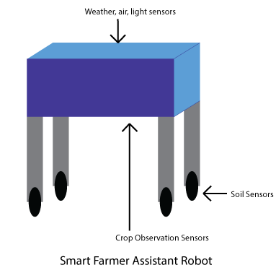

There are 13 different types of sensors present in this device. Accumulating all of their data, the processor determines the accurate condition of the field. The sensors are:

1. **Soil Moisture sensor:** Determines the moisture level and amount of water in soil.

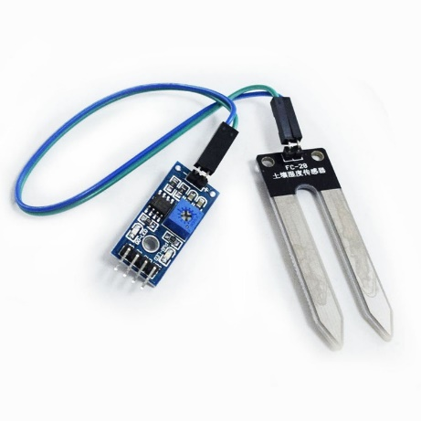

1. **Sonar Sensor:** Ultrasonic HC-SR04 sensor uses ultrasonic reflection to measure distance. This sensor will help the robot in locomotion and detecting object nearby.

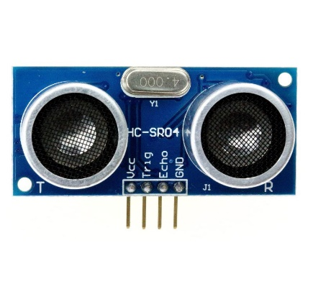

1. **Sound Detector:** Sound sensor detects nearby sound level and the program determines the weather condition or nearby animals using the sound feedback.

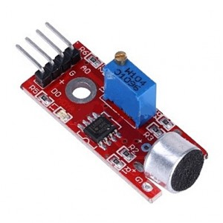

1. **Gas & CO2 sensor:** Weather air quality is very important for any kind of cultivation. This sensor determines the level of carbon dioxide, monoxide, presence of harmful gases or total air quality.

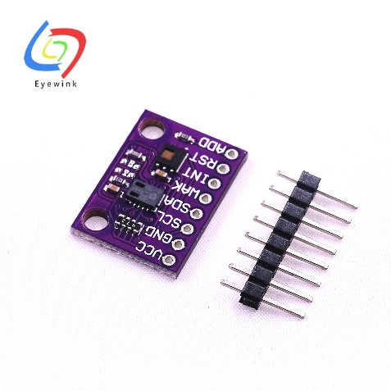

1. **LDR:** Light Dependent Resistor determines the day or night for irrigation.

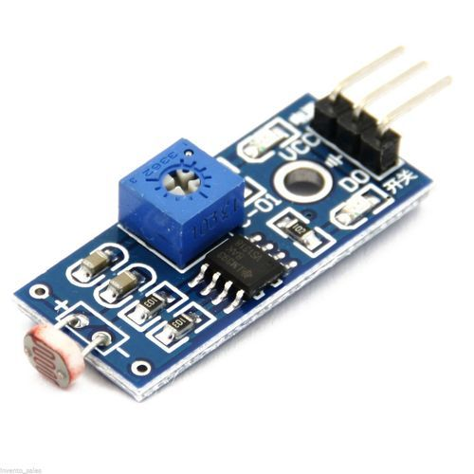

1. **Motion Detector:** PIRMotion detector is able to detect the presence of any live object, animal or human being inside the perimeter of field.

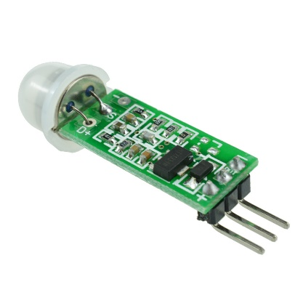

1. **Gyroscope:** X-Y-Z axis gyroscope is used to detect the tilt or rotation of the robot, which contributes the locomotion of the robot.

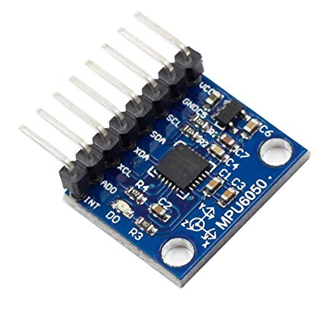

1. **Raindrop Sensor:** Rain is another most important factor in cultivation. This sensor determines the presence of rain or the amount of rain.

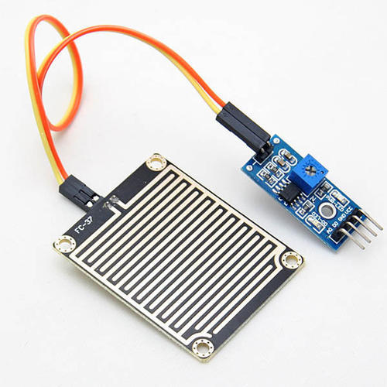

1. **Water sensor:** This sensor determines the water amount in field and controls the irrigation pump accordingly.

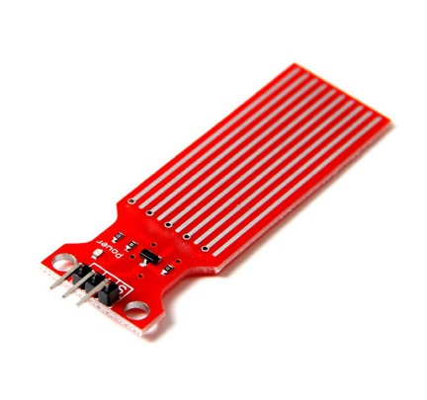

1. **Air Humidity sensor:** Air moisture level plays vital role in cultivation and weather. This sensor determines the air moisture and temperature which is used to create the weather forecast.

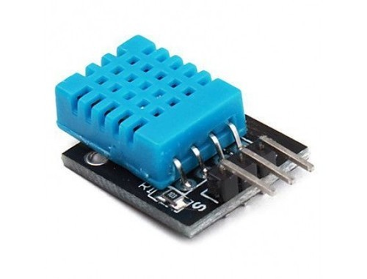

1. **Weather temperature sensor:** Weather temperature plays role in controlling the dryness or water level in soil. This sensor gives accurate temperature value.

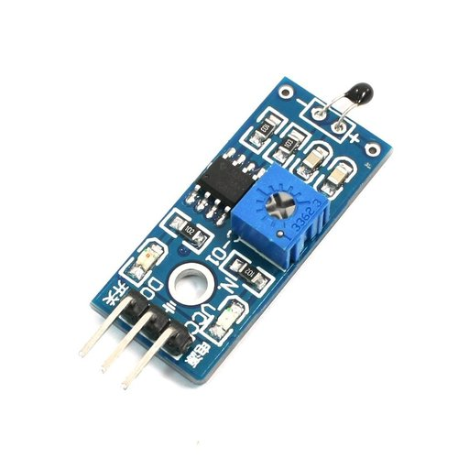

1. **Soil Quality Sensor:** Quality of soil, level of nutrients, minerals are very important for determining the fertilizer to be applied. This sensor gives proper value for determining the amount.

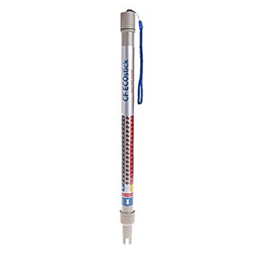

1. **Soil pH & Temperature sensor:** pH level and soil temperature is also important for the amount of fertilizers to be applied.

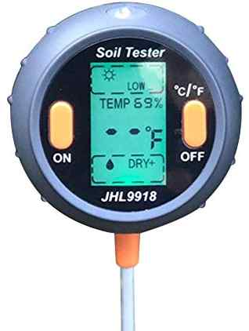

Besides, the robot contains more segments for its perfect locomotion, processing & communication:

**Timer:** Timer provides the current time for the robot.

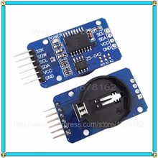

**LCD Module:** LCD module is used here for displaying necessary information regarding the soil, air, weather statement.

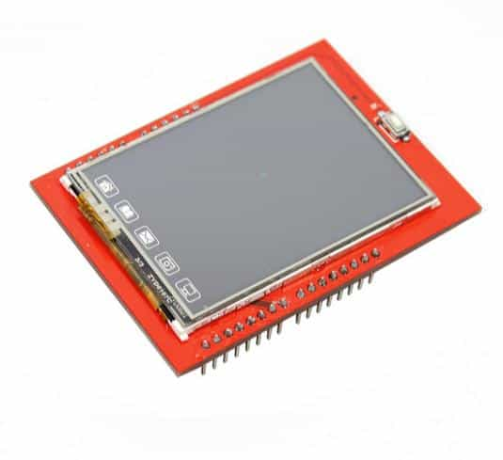

**HC-05 Bluetooth module:** Bluetooth module is used for communicating with Farmer’s mobile device.

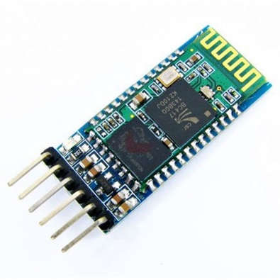

**Buzzer module:** Buzzer is used for sending alarm or important signal.

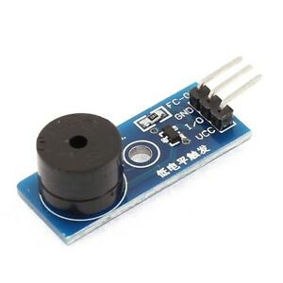

**Relay Module:** Relay module is used for controlling the water pump.

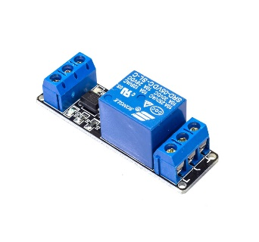

**Wireless Module:** Wireless module uses radio frequency for communication. Here’s one sender and one receiver. This module completes communication between water pump and the robot.

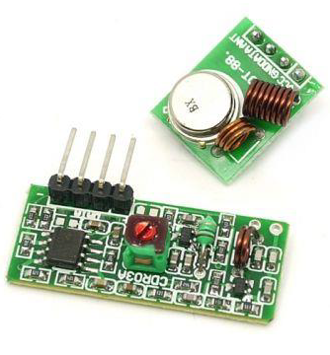

**LiPo Battery:** LiPo battery of 11.1v is used for providing the power supply to the robot.



**Metal Gear Motor:** Metal gear motor is used for locomotion of the robot.

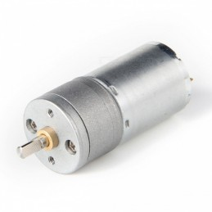

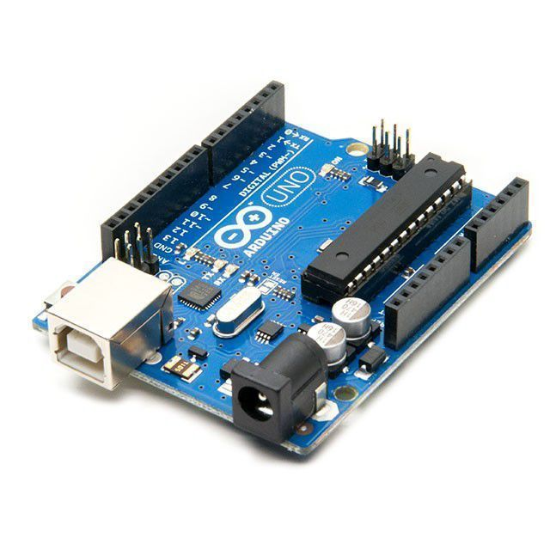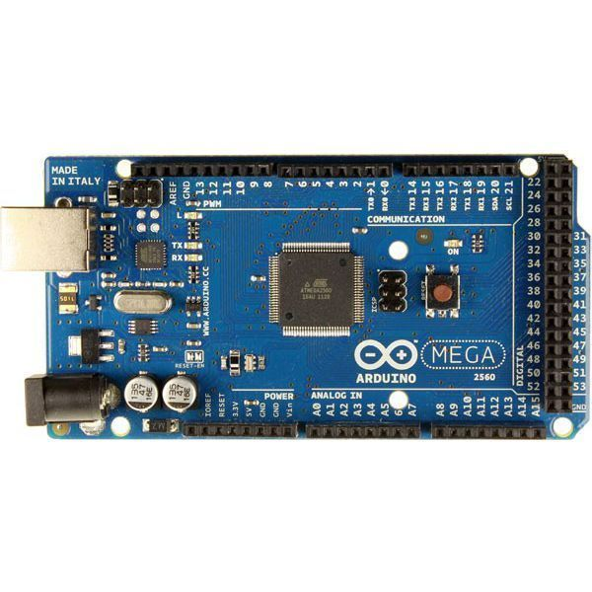**Arduino Uno & Mega:** In this project, Arduino uno and mega is used as microcomputer.

**GSM Module:** GSM module communicates with target mobile and research server for sending necessary data in right time. Target mobile alerts the farmer about instant decisions to be taken and the server analyses the data in machine learning algorithm for future predictions.

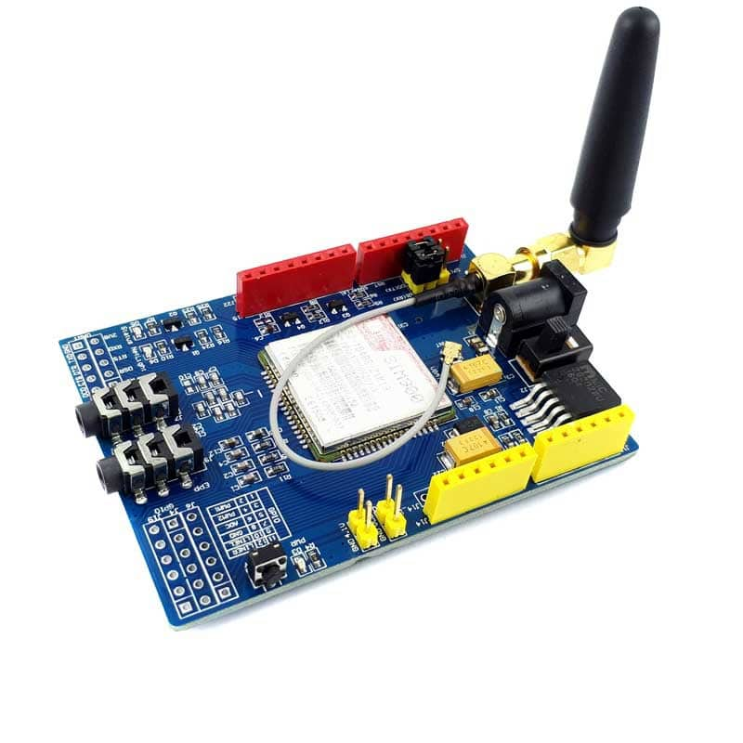

1. 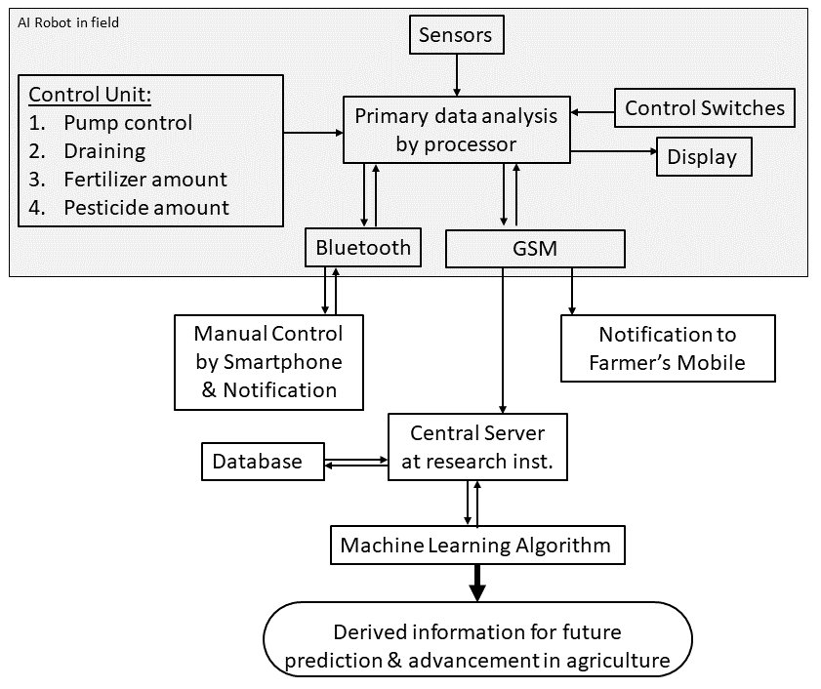**Working Principle**
2. **Conclusion**

Our AI Farmer Assistant Robot is the future.

We cannot skip the farming, as this is the prime source of our food. Again, due to technological advancement and various reasons, farmers are leaving this profession. So, for their assistance and as well researching every field practically, we need this robot. This robot will be capable of sending very important sensor data to central server, which will be the key to the future of agriculture. Using machine learning algorithm this system will draw very important information for further advancement of agriculture as well saving the crops from unwanted natural disasters.