Im =
1 0 0 0 0 0 0 0 0 1
0 1 0 0 0 0 0 0 1 0
0 0 1 0 0 0 0 1 0 0
0 0 0 1 0 0 1 0 0 0
0 0 0 0 1 1 0 0 0 0
0 0 0 0 1 1 0 0 0 0
0 0 0 1 0 0 1 0 0 0
0 0 1 0 0 0 0 1 0 0
0 1 0 0 0 0 0 0 1 0
1 0 0 0 0 0 0 0 0 1

h =
0 1 1
-1 0 1
-1 -1 0

figure;imshow(conv2(Im,h,"same"))


Original image (Im) result of convolution
As you can see:
- detects 45° edge
- but shift it
- add width of edge

We can use other second differentiations that simple Laplacian:

LA=[2 -1 -1;-1 2 -1;-1 -1 2]
LA =

2 -1 -1
-1 2 -1
-1 -1 2
Home=imread("home.png");
Home=rgb2gray (Home);
Home=im2double (Home);
g=fspecial("gaussian",7,1);//Gaussian
GH=conv2(Home,g,"same");//smoothing
RL=conv2(GH,LA,"same");
figure;imshow(RL);title ("RL")

Result is detecting 45⁰ edges using LA instead usual Laplacian:
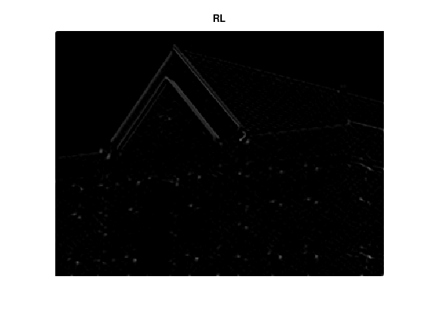
If you use usual L which is:
1 1 1
1 1 1
1 -8 1
Then you get this:
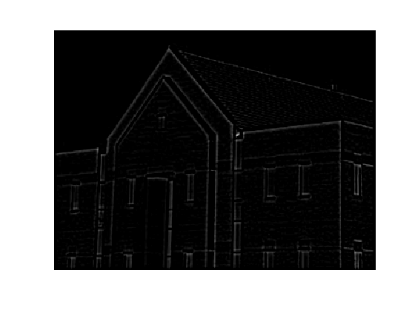

1 1 1 1 1 1 1 -8 1

