Contrast stretching

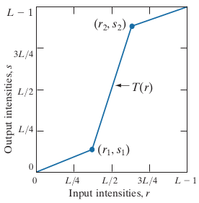

Pay attention that line segment between [0,0] and [r₁,s₁], spans [0,r₁] to [0,s₁].

- Cuts levels in interval [0,r₁] and spans those to [0,s₁]
- Cuts levels in interval [r₂,1] and spans those to [s₂,1]
- Stretches what is remained, which is in [r₁,r₂], into the [s₁,s₂]

The purpose is expanding intensity levels in available range of data type for maximizing contrast over image.

Also when transformation is monotonically increasing, we can be sure there no intensity artifact be created.

Examples



Histogram of above image is:
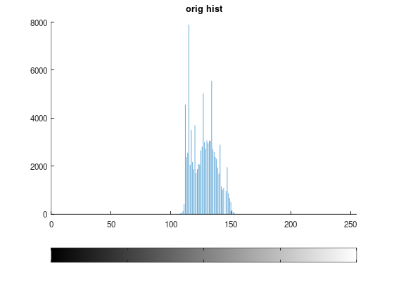
As you can see, histogram shows these equivalent ideas:
- contrast of image is low
- intensity levels are near
So a contrast stretching may be useful.

At first we try with (r₁ , s₁ ) = (r_{min} , 0) and (r₂ , s₂ ) = (r_{max} , L − 1). For this I used imadjust command:

> Biological=imread ("Biological.png");
> Biological=rgb2gray(Biological);
> min=min(min(Biological))
min = 106
> min=double(min)/256
min = 0.4141
> max=max(max(Biological))
max = 156
> max=double(max)/256
max = 0.6094
> ad=imadjust (Biological,[min max],[0 1],1);

Now we get this output:

> figure;imshow(ad);title("adjusted Biological")

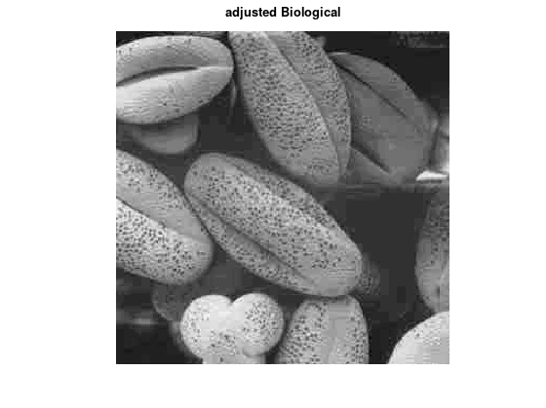

And this is it hist:

> figure;imhist(ad);title ("stretched hist")

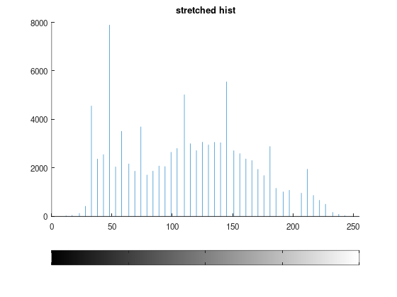
As you can see levels are stretched and the number of pixels in each level and its stretched are same. This is because our transformation is “monotonically increasing” so pixels of each level are mapped to unique level and relation is 1-1.

Its histogram was:

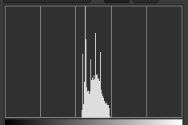
And I did this transformation:
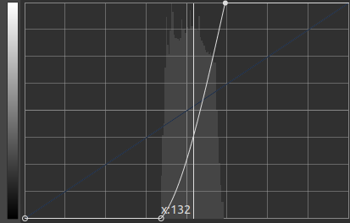
And histogram of result is:
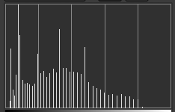

But if levels of image span the range [0,255], then above way is not effective. For example for
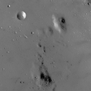

histogram of original image:
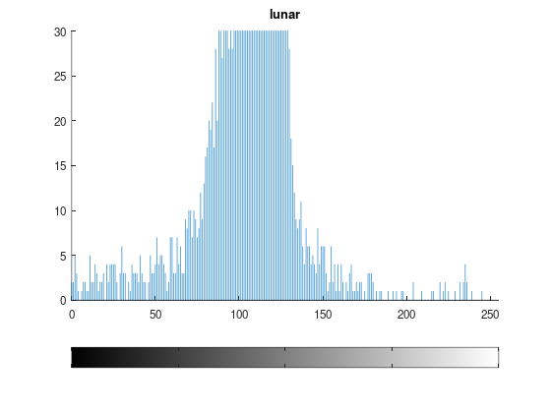

I try to to do these steps:
- cut levels in [0,50] and compress those in [0,30]
- cut levels in [180,255] and compress those in [235,255]
- cut what levels that are remained in [50,180] and expand them in [30,235]

Its diagram is:

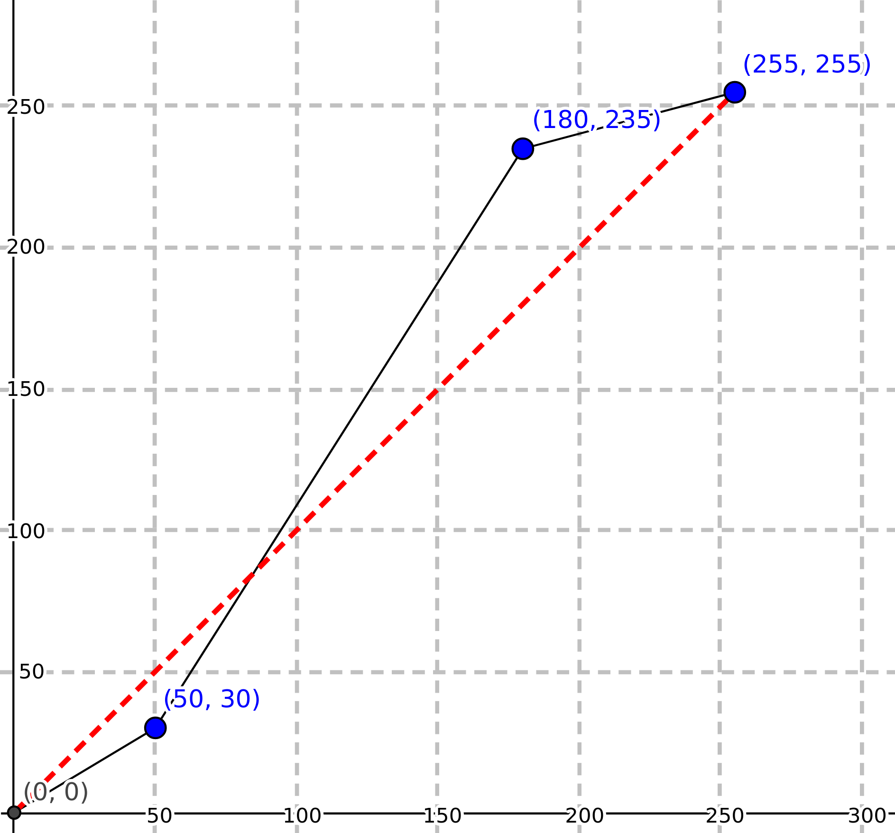

Note:
Although expanding [50,180] to [30,235] seems to be done as second step; but I do it as last step to avoid intensity artifact. Because if I move [50,180] to [30,235] some levels may be mapped to values more than 180 which is in [30,235] and then will be moved again during compressing [180,255] to [235,255].

> str=lunar;
> str(str<50)=double(3/5)*str(str<50);
> str(str >= 180 & str < 256)=double(20/75)*(str(str >= 180 & str < 256) - 180) + 235;
> figure;imhist(str);title ("str")
> str(str >= 50 & str < 180)=double(205/130)*(str(str >= 50 & str < 180) - 50) + 30;
> figure;imhist(str);title ("str")

After first moving:
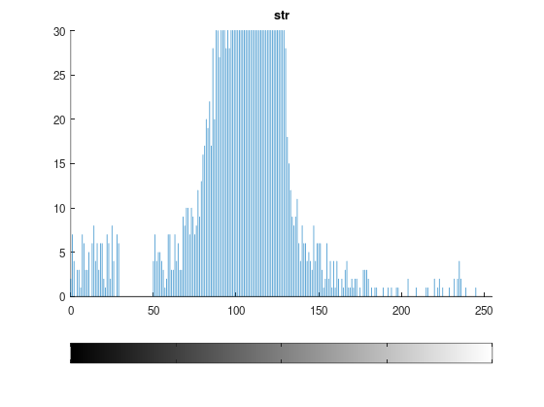
Second:
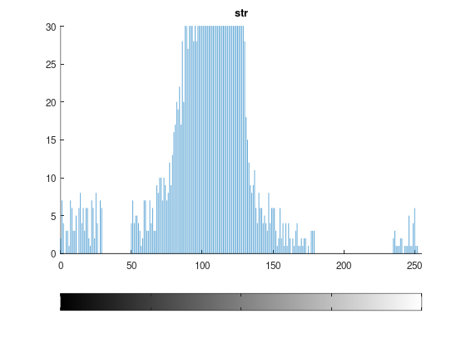
Third:
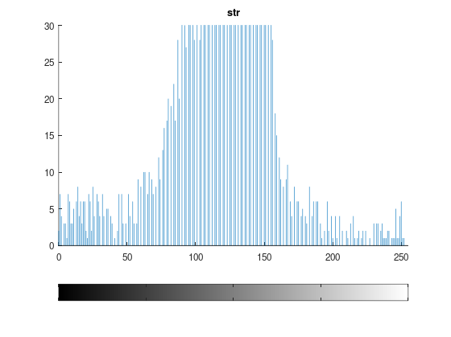

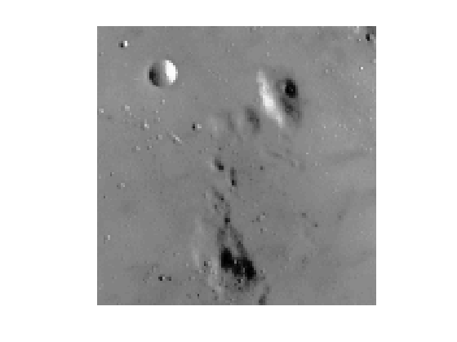

Note:
To avoid intensity artifact, you can read data from original image, do operation on them and store results in another matrix. Then the order of steps are not important:

> str=lunar;
> str(str<50)=double(3/5)*lunar(lunar<50);
> str(str >= 180 & str < 256)=double(20/75)*(lunar( lunar >= 180 & lunar < 256) - 180) + 235;
> figure;imhist(str);title ("str")
> str(str >= 50 & str < 180)=double(205/130)*(lunar( lunar >= 50 & lunar < 180) - 50) + 30;
> figure;imhist(str);title ("str")

Another way is accumulating some small low and high levels together separately. In this way, instead of compressing [0,50] into the [0,30], we compress those in level 0 ! And instead of compressing [180,255] into the [235,255], we compress those to 255 ! So we have more space for expanding [50,180] which will be [0,255]. You can achieve this by imadjust command:

> ad=imadjust(lunar,[double(30/255) double(180/255)],[],1);

But in this way your transformation will not be a 1-1 function. You can detect this by looking into the histogram; as height of lines for levels 0 and 255 are increased. So meaning of some pixels may be lost. This way may be useful if you compress regions which have not large number of pixels.

Changes of histogram after contrast stretching

If transformation is 1-1, ideally the height of each intensity level and height of its map under transformation must be the same. The only thing that changes is the position of lines of histogram. This ideal may be violated by lost of data precision during mathematical operation. For example a transformation may map r₁ to 120 and r₂ to 120.4. But for storing data as uint8 data type, both will be mapped to 120 and its height will be the sum of population of r₁ and r₂ (or possibly greater than it).

Another example

Consider this image and its histogram:

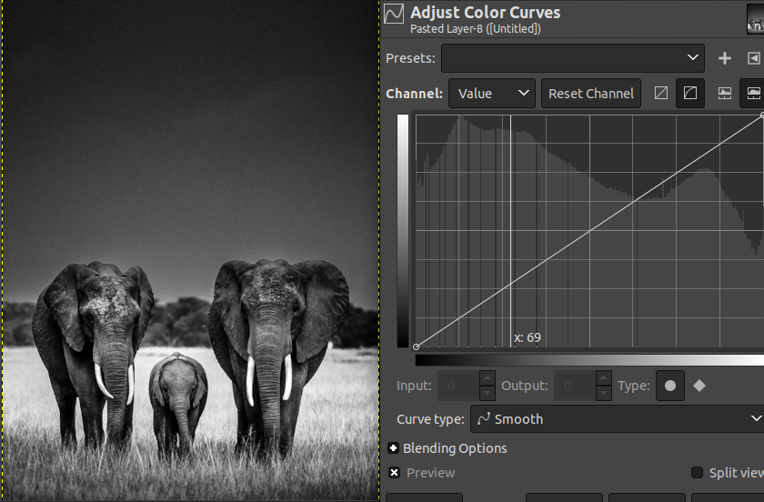
Now we try to stretch histogram bins by this transformation:

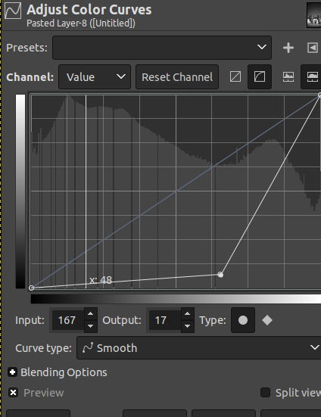
The result and its histogram will be:

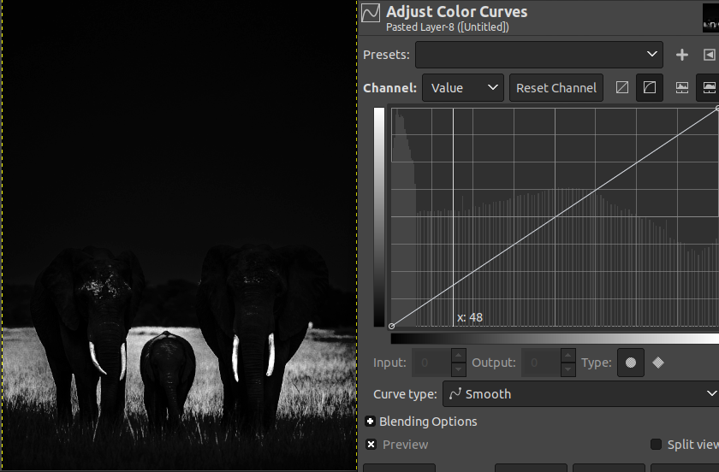

As you can see the transformation compresses bins in the red area to the blue area as y result in y (that is not visible in “before” part, before applying the changes to image) axis which can be seen in the result (after part) in blue area:
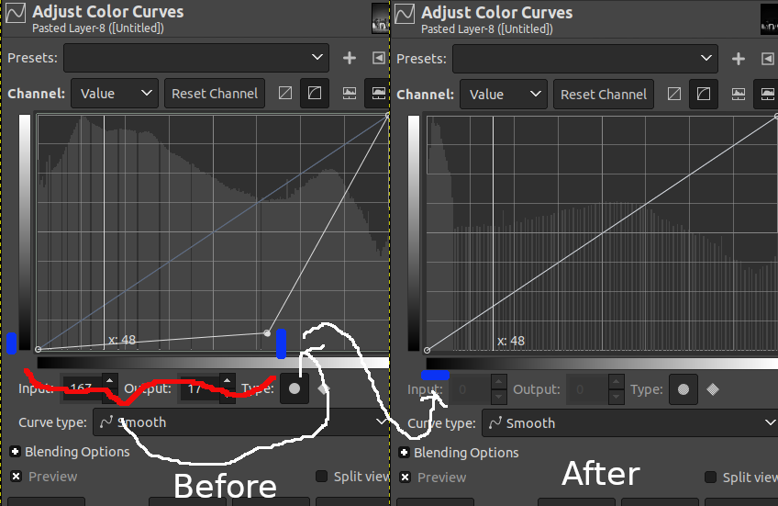
Also hence bins in the red area in “before” part has large number of pixels (integral of area) and those are mapped to the small part with low intensity, the result image is darker.

