Shape of histogram and PDF?

│
│ (r0,MN*PDF(r0))
│ ┼
│
│
│
│
│
│
└─────────────────────
r0
For each bin of intensity levels, for example r0 in above diagram, histogram maps that to number of pixels in image with intensity equal to r0. Also we know for discrete random variable, PDF is the Probability of each bin which for r0 is:
(number of pixels in image with intensity r0) / (number of pixels in image)
So when size of image is M*N we can say:
Histogram maps each intensity bin to MN*PDF(r0), thus the shape of histogram is a scale of the PDF:
histogram = PDF * MN

Doing HE and obtaining histogram of result

- Im2double ← optionally
- Write “r bins” of source
- p_{r}(r) for all bins of source
- (number of pixels with intensity=r)/MN
- get “s bins”
- for r bins T(r) = (L-1)\int_0^r p_{r}(w) dw
- round “s bins” ← optionally when
- image is of class uint8 or uint16 or binary
- when s bin exceeds range of data type
- calculate p_{s} for all s₀ in “s bins”
- sum all p_{r} which T(r)=s₀ (there may be more than one “r”, because of loss of data during mathematical operations)

How does HE change the histogram?

You can guess the result of histogram equalization with attention to the diagram of its transformation, exactly like what we do for “contrast stretching” and “piecewise transformation”.

But this is obvious that if T(r) be a 1-1 increasing function, then number of intensity bins and their height will not change after HE. The only thing that may be changed is the level of intensity. It means that the total shape of histogram does not change except of some possible widening or narrowing or sparsing.

If T(r) be increasing but not 1-1, some bins may be merged after HE and their height will be added.

Also some times merge may be occurred as result of rounding or data loss during mathematical operations.

What does the value of T(r) depend on?
T(r) only depends on
- CDF
number of pixels in image with intensity level less than or equal to the r
- data type of image
- number of pixels in image
This is because of:

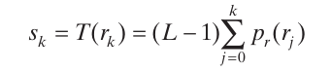
We can say,:
S_{k}=(L-1)CDF_{r}(k)
As a special result, T(r) does not depend on its intensity.

So for example suppose you have two images with the same number of pixels (even with different image sizes) and there are two pixels with different intensity levels; but their CDF s are equal, both pixels will be mapped to the pixels with the same intensities after HE!

Also all pixels in the same bin will have the same intensities in equalized image after HE.

A question
With attention to this transformation:
the value of S_{(L-1)} must be 1. But in usual histograms, the height of the last bar in histogram is not 1. Why?
Answer:
It is because the S_{k} is the intensity level of output for each pixel and its value is shown in horizontal axis of diagram. The height of bar is number of pixels in each bin:
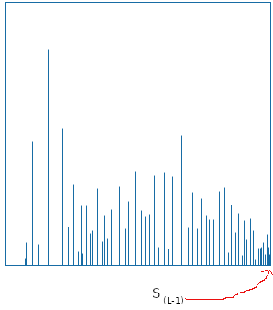

A=eye(10);
B=histeq(A);
subplot(2,2,1);imshow(A);title("A")
subplot(2,2,2);imshow(B);title("B=histeq(A)")
subplot(2,2,3);imhist(A);title("imhist(A)")
subplot(2,2,4);imhist(B);title("imhist(B)")

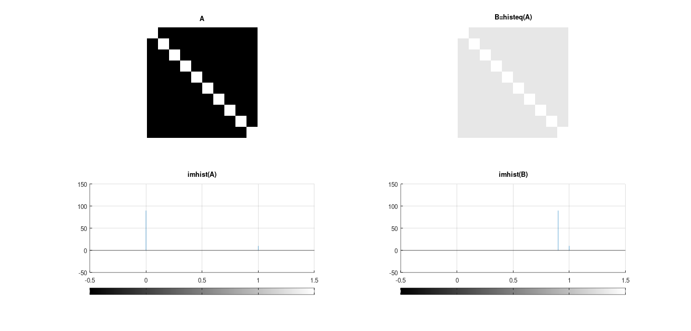

As a result, for two images with the same pixel number if you can find a strictly monotonic increasing function between intensity bins of two images and height of bins be the same between a bin and its mapped bin, then the histogram of result of HE on both will be the same, regardless of color of each pixel in original images. This is because strictly monotonic function between bins and same bin height guarantees the same CDF for all intensity levels.

Note:
In above situations, often the output of HE for each image will be different; because position of pixels of the relative bins in images are different. But histogram of outputs will be the same.

For example consider the below code in Octave:

A=[0.1,0.1,0.1,0.2,0.2,0.2,0.5,0.5,0.5,0.5,0.9,0.9,0.95,0.8,0,1];
B=A;

B(A==0) = 0.5;
B(A==0.1) = 0.6;
B(A==0.2) = 0.7;
B(A==0.5) = 0.75;
B(A==0.8) = 0.8;
B(A==0.9) = 0.85;
B(A==0.95) = 0.95;
B(A==1) = 1;

A = A(randperm (numel (A)));
B = B(randperm (numel (B)));

AE=histeq (A);
BE=histeq (B);

figure;
subplot(2,3,1);imshow(A);title ("A");
subplot(2,3,2);imshow(AE);title ("AE");
subplot(2,3,3);imhist(AE);title ("h AE");
subplot(2,3,4);imshow(B);title ("B");
subplot(2,3,5);imshow(BE);title ("BE");
subplot(2,3,6);imhist(BE);title ("h BE");

Above bins of A and B are different:
- For A: 0.1,0.2,0.5,0.9,0.95,0.8,0,1
- For B: 0.5,0.6,0.7,0.75,0.8,0.85,0.95,1
But we can find an increasing 1-1 map between those which keeps the height and hence keeps the CDF:
- 0 > 0.5;
- 0.1 > 0.6;
- 0.2 > 0.7;
- 0.5 > 0.75;
- 0.8 > 0.8;
- 0.9 > 0.85;
- 0.95 > 0.95;
- 1 > 1;
So although the input images, bins and output of each HE are different, but the histogram of result of HE on both images, bins of HE s and their height are the same:
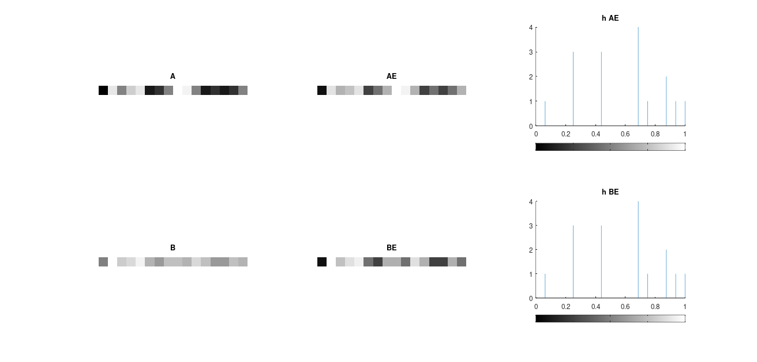

But for below code, although for each bin in each image we can map it to a bin in another image which the height of bins be same; but histogram of result of HE on images is not the same; because the map is not strictly monotonic increasing. For example for same bin height we have to map 0 to 180 and 100 to 10 which obviously is not a strictly monotonic increasing map:
> A=[0,100,20;50,12,200;0, 20,100]
> A=mat2gray (A)
> AE=histeq (A);
> B=[180,10,90;250,140,0;180,90,10]
> B=mat2gray (B);
> BE=histeq (B);

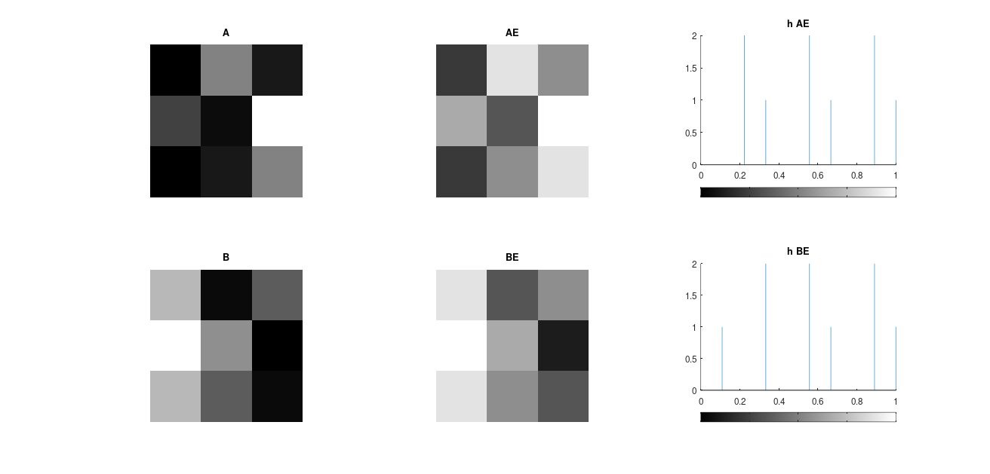

Also another example:

A=[0,100,20;50,12,200;0, 20,100];
A=uint8(A);
AE=histeq (A);
B=[180,10,90;250,140,0;180,90,10];
B=uint8(B);
BE=histeq (B);

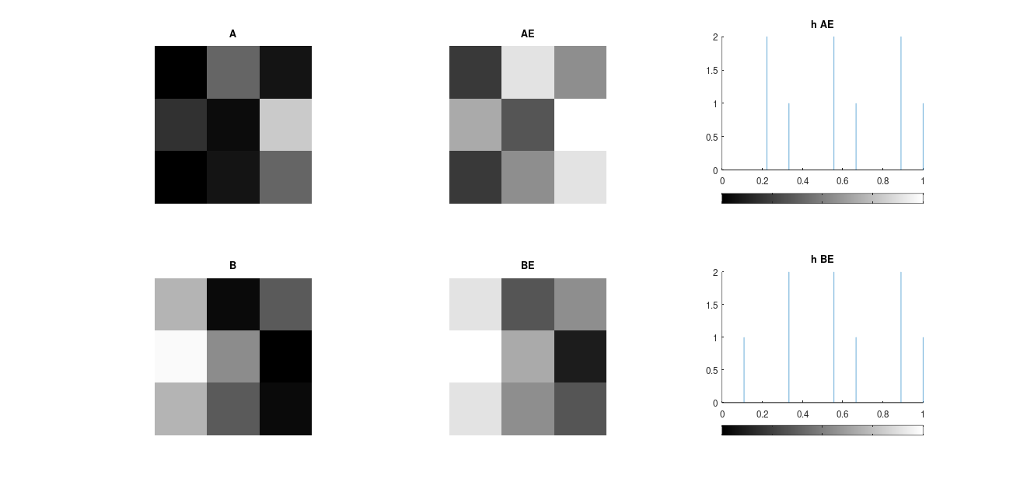

Another example:

> A=rand(1,100);
> B=A(randperm (numel(A)));
> figure;
> subplot(2,2,1);imshow(A);title ("A");
> subplot(2,2,2);imhist(A);title ("hist A");
> subplot(2,2,3);imshow(B);title ("B");
> subplot(2,2,4);imhist(B);title ("hist B");

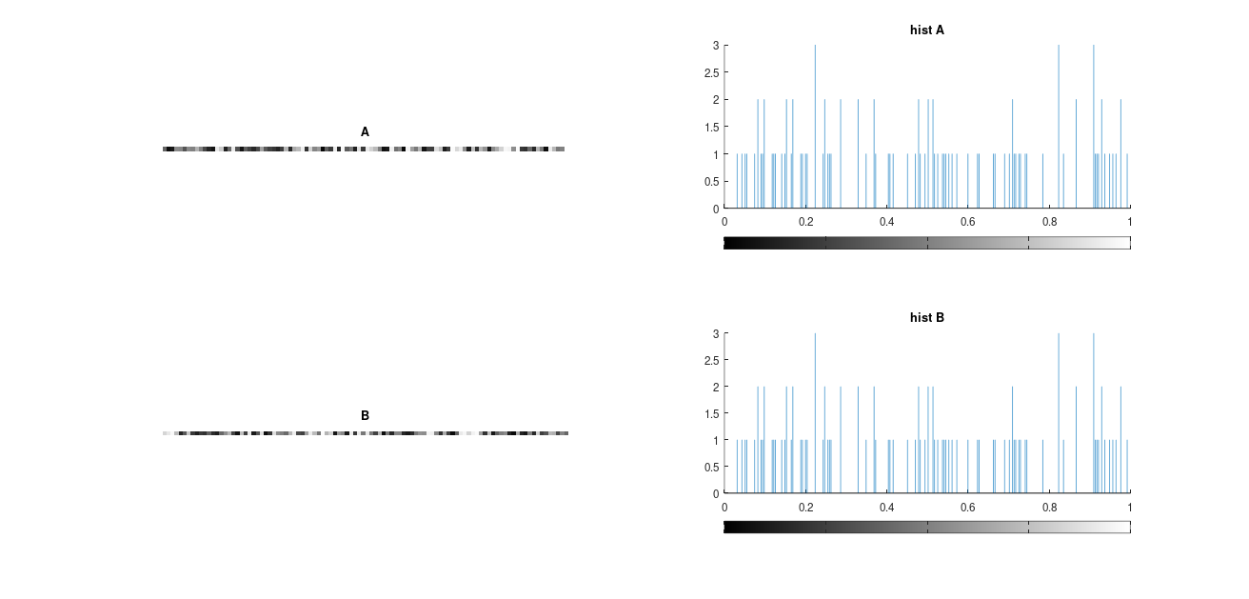

A question for researching and examining

Also A.^2 is not monotonically increasing in [0,1]. But, what is not the output of HE on this example is not same?
> A=rand(1,100);
> A_HE=histeq(A);
> B=A(randperm (numel(A)));
> B=B.^2;
> B_HE=histeq(B);
> figure;
> subplot(2,3,1);imshow(A);title ("A");
> subplot(2,3,2);imhist(A);title ("hist A");
> subplot(2,3,3);imhist(A_HE);title ("hist A_HE");
> subplot(2,3,4);imshow(B);title ("B");
> subplot(2,3,5);imhist(B);title ("hist B");
> subplot(2,3,6);imhist(B_HE);title ("hist B_HE");

A real uniform image

> A=linspace(0,255,256);
> G=mat2gray (A);
> imhist(G);
> figure;
> subplot (1,2,1);imshow(G);title("G");
> subplot (1,2,2);imhist(G);title("G hist");

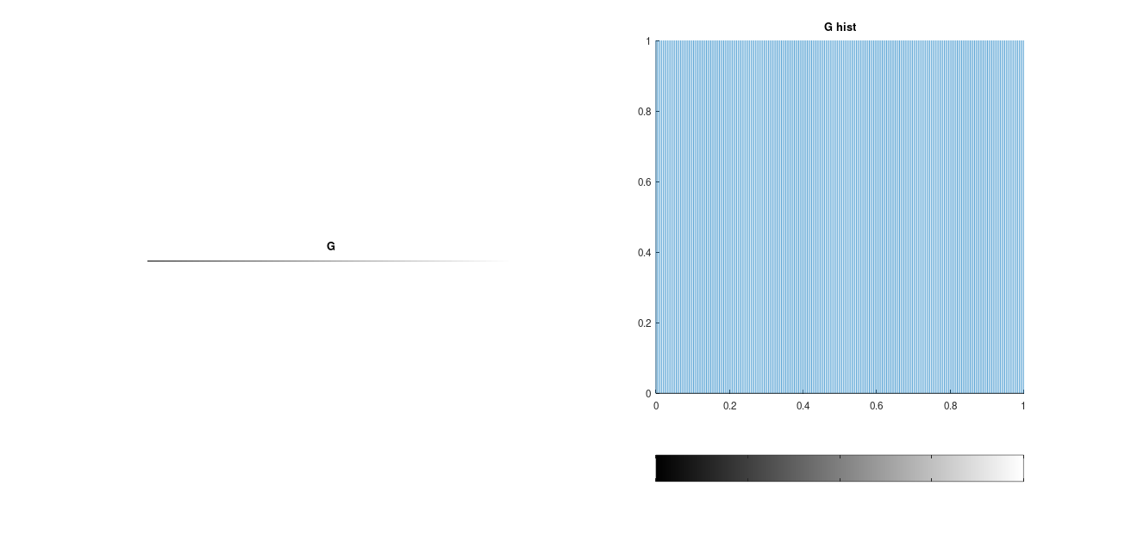

Inverse of HE transformation

If you do not consider lost of data during mathematical operations, … then HE transformation will be strictly monotonically increasing and so 1-1 and invertible. Now suppose this discrete HE transformation:
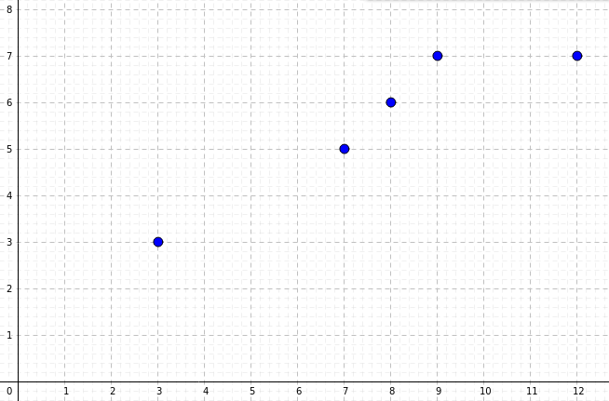
If you extend domain of transformation to all integers diagram will be look like this:

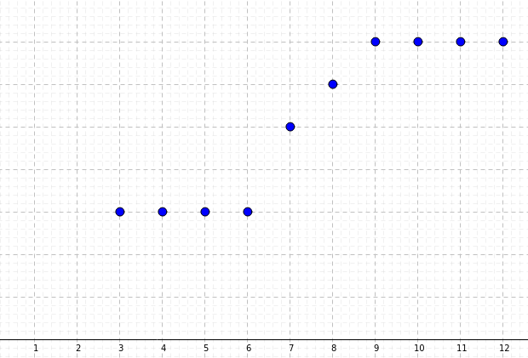
And if you extend points of discrete diagram to all points in [0, L-1] and connect them, you will get a step diagram like this for T transformation:
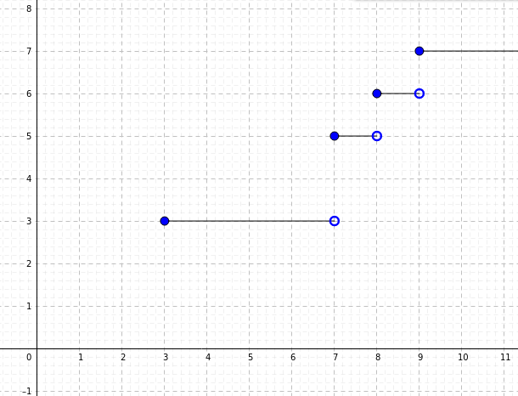
Gonzalez uses this diagram which obviously is not a function:
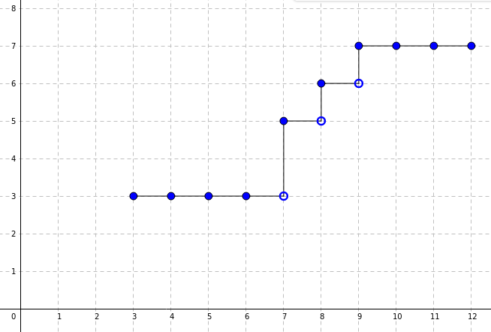

Above diagrams show there is no pixels with intensities equal to 4, 5, 6, 10.

Mathematically, if for two consecutive intensity levels (in [0, L-1]), for example i-1 and i, image has not a pixel related to intensity i and you extend the domain of T, then we have T(i-1) = T(i). Hence T is not invertible.
But above situations does not cause any problem for finding T⁻¹(s). Because we really know there are no pixels with intensity equal to i. In practice if we write all outputs of T for all integers in [0,L-1], if T(r₁) = T(r₂), as above diagram shows, we have to consider T⁻¹(T(r₁)) to be the min(r₁,r₂).
In practice the real problem is about limits of computer on doing mathematical operations which causes two distinct intensity level have the same output (caused by rounding, loss of data during division, …). In this case, with respect to above situation, we create a convention that is:
In general case, if T(r₁) = T(r₂), as above diagram shows, we have to consider T⁻¹(T(r₁)) to be the min(r₁,r₂).

Plot Transformation Curve for Histogram Equalization

Do not forget that histeq is applicable for gray scale images.

MATLAB
Use [J,T] = histeq(I) T is the transformation that maps the gray component of the input grayscale image.

Octave
Currently histeq of Octave does not return the transformation. You can use this way:
> pkg load image;
> I = imread("cell.png");
> I = mat2gray(I);
> [nn, xx] = imhist (I, 64); // or 256 ← defines number of bins for imhist
> Icdf = 1 / prod (size (I)) * cumsum (nn);
> plot(Icdf)
Above Icdf is the transformation. I found this way by asking this question and then looking to the histeq.m file of Octave (currently in /usr/share/octave/packages/image-2.12.0/histeq.m)

By my .m file
I created a “.m” file with name “myHisteq.m” which does HE on image and returns the result, based on the formula in book of Gonzalez and also draws the HE transformation:

> source=imread ("source.png");source=rgb2gray(source);
> my_histeq=myHisteq(source); % also draws the transformation
> figure;imshow(my_histeq);title("source")
> figure;imshow(source);title("histogram equalized")

By diagram of histogram
In this case, we have to select enough points from diagram and use them for calculating p_{r},CDF_{r} and round((L-1)*CDF_{r}).

For example the book has this diagram as histogram:

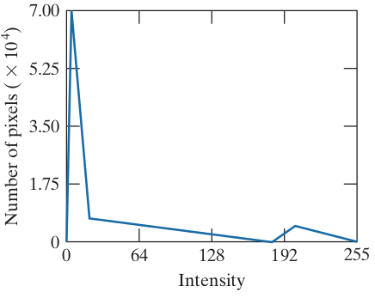
Now I select these points and guess their coordinates:

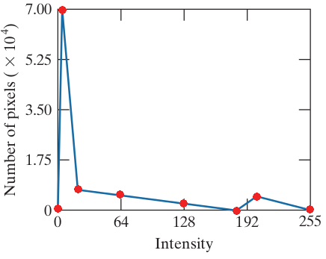
Then I put coordinates in a spreadsheet:

And if you plot (bin,value), you will get this:

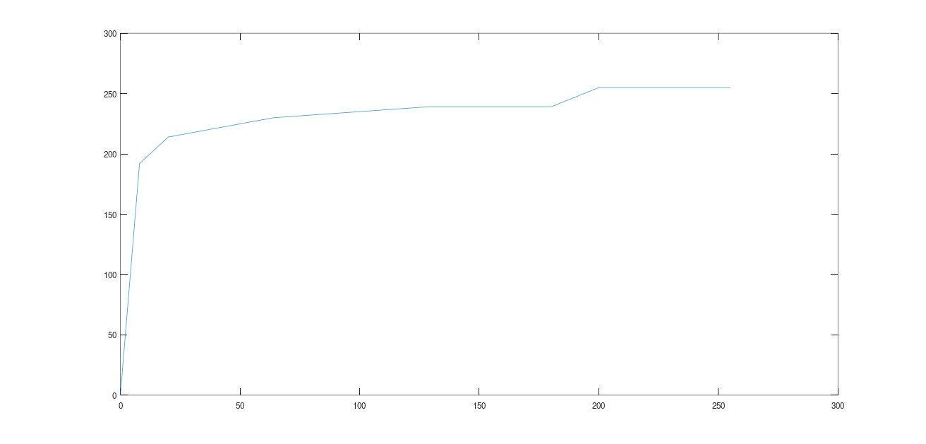

Which is similar to what book presented:

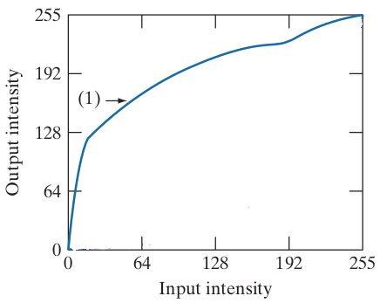

Note:
More selected points and more accurate guess for coordinates cause better calculating HE transformation.

Here we are speaking in about discrete random variables.
Although Wikipedia uses (cdf(v)/M*N); but it seems it uses cdf as number of pixels, as it is visible in the table which shows cdf(v) and h(v) (which is Equalized v). note: I did not use cdf, I used CDF.

