I created a “.m” file which does histogram matching: “histMatch.m”. It also draws the histogram matching transformation:
> pkg load image
> J=imread ("cell.png");J=rgb2gray(J);
> I=imread ("14.jpg");I=rgb2gray(I);
> hM=histMatch(I,J);
> figure;
> subplot(2,3,1);imshow(I);
> subplot(2,3,4);imhist(I);
> subplot(2,3,2);imshow(J);
> subplot(2,3,5);imhist(J);
> subplot(2,3,3);imshow(hM);
> subplot(2,3,6);imhist(hM);

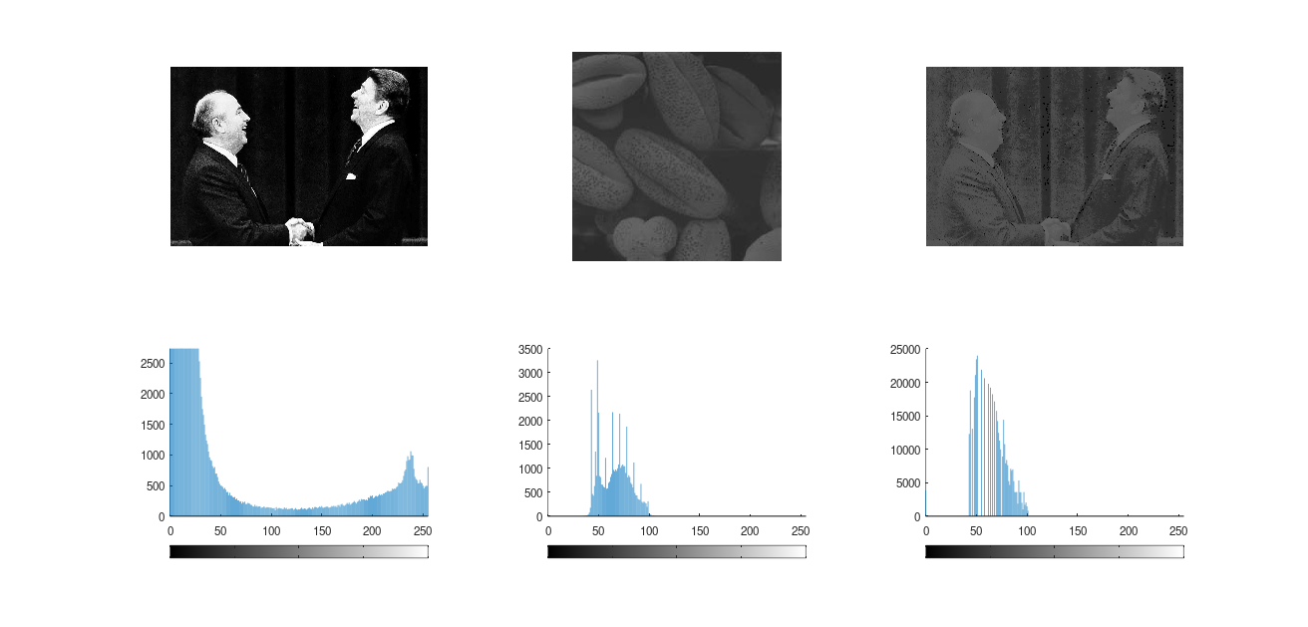

Usually we call the original image as source, the image which we want to change histogram of origin look like to it as reference:

source=imread ("source.png");source=rgb2gray(source);
reference=imread ("reference.png");reference=rgb2gray(reference);
hM=histMatch(source,reference);
figure;
subplot(2,3,1);imshow(source);title("source")
subplot(2,3,4);imhist(source);
subplot(2,3,2);imshow(reference);title("reference")
subplot(2,3,5);imhist(reference);
subplot(2,3,3);imshow(hM);title("result")
subplot(2,3,6);imhist(hM);
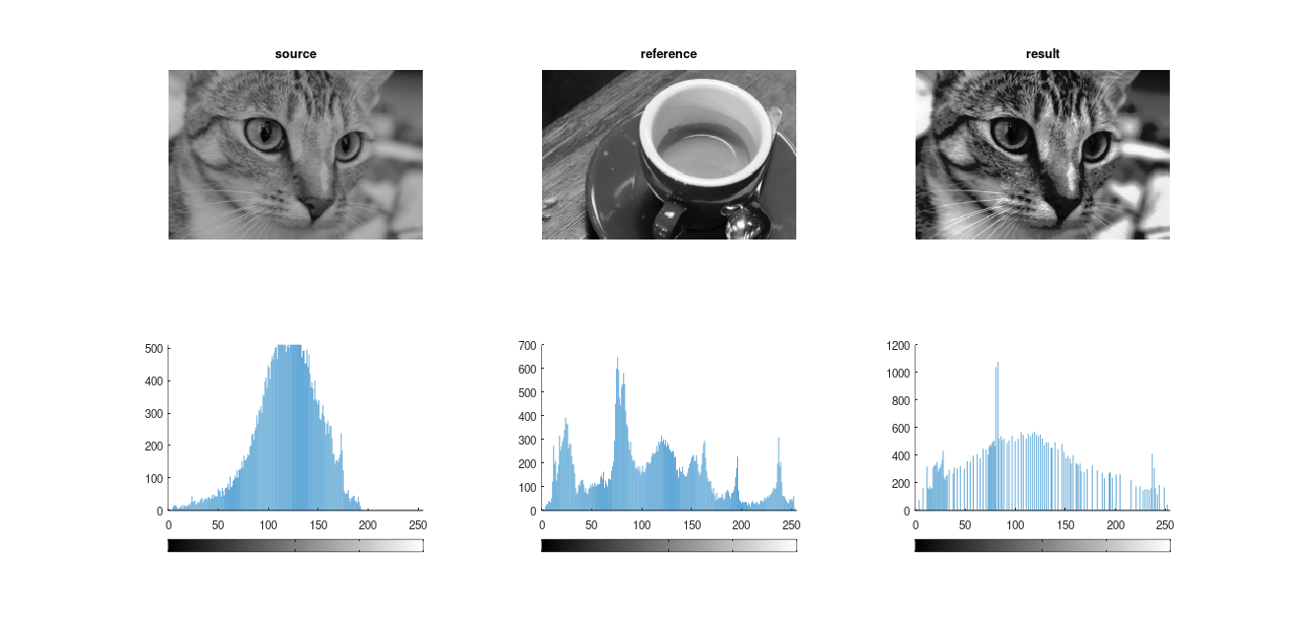

Again the transformation G⁻¹(T(r)) is monotonically increasing. But I guess often it is not 1-1 and merge bins. So the shape of histogram of result will change, that was our goal!

For example for above figure, the transformation is:
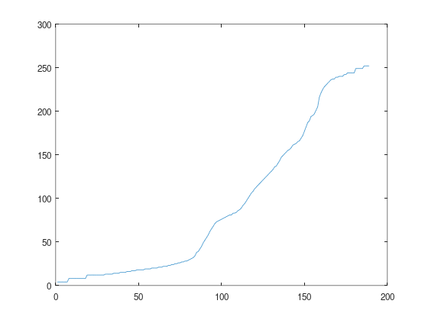
Diagram of transformation shows:
- max expanding (widening) is occurred for bins in range in about [75,175] which is mapped to [25, 240].
- mapping from bins of [75,175] are nearly 1-1.
- mapping for ranges [0,75] and [175,255] is narrowing and probably not 1-1.
For example, as you can see multiple bins in range [0,5] are mapped to 2 or bins in range in about [5,15] are mapped to in about 5.
Pay attention that some times diagram of HE transformation also seems to be not 1-1; but there usually horizontal lines of function are in ranges which the height bins of histogram are 0 (no pixel with those intensities). But here we have multiple bins with height more than 0 in range [5,15].

