Second Derivation (Laplacian)

The Laplacian method searches for zero crossings in the second derivative of the image .

> A=[0 1 0;1 -4 1;0 1 0]
> B=[1 1 1;1 -8 1;1 1 1]

> North_Pole=imread("Moon_North_Pole.png");
> North_Pole=im2double(rgb2gray(North_Pole));

> RA=conv2(North_Pole,A,"same");
> Sharpened=North_Pole-RA;
> imwrite(Sharpened,"SharpenedRA.png");

> RB=conv2(North_Pole,B,"same");
> Sharpened=North_Pole-RB;
> imwrite(Sharpened,"SharpenedRB.png");

Note
As center element of both kernels are negative, we subtract result of derivatives from original image.

You can guess that RA is more smoother than RB, because RB also emphasizes on diagonal derivatives:

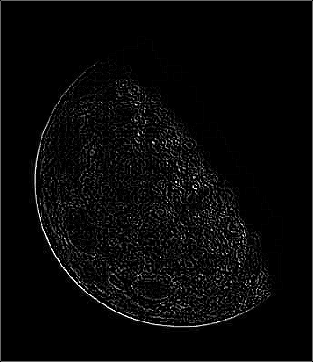 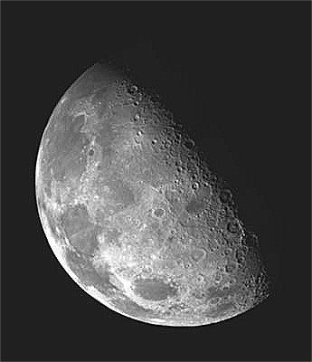 RA sharpened by RA
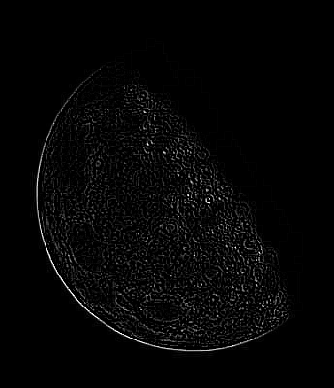 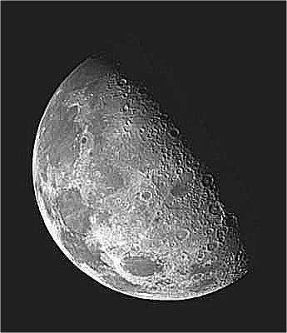 RB sharpened by RB

As sum of derivative kernel is 0, so sum of result of pixels under kernel must be 0 too. This means that result for some pixels will be negative. As negative value will be cutoff and displayed as 0, you are losing data when you try to display result of derivative. We can do some operations on result of derivation to avoid that losing. For example:
- sharpening the image by doing I + c×d(I) is a way.
- Another way is doing d(I)-min(d(I)) which in Octave and Matlab must be done as d(I) – min(min(d(I))) (because Octave and Matlab find min for each row or column and return an array from min for a 2D matrix).
Again pay attention to the result of derivative of “moon-north-pole” and its negative and compare those with d(I)-min(I):
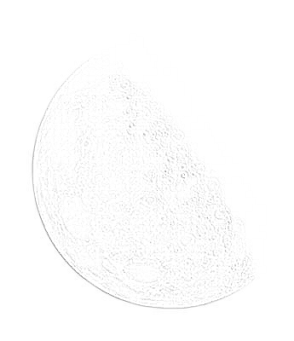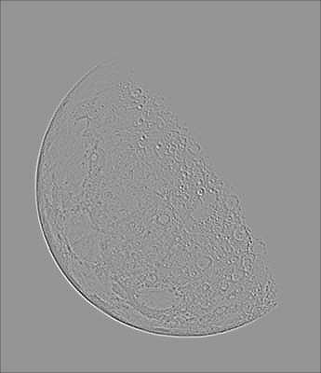
d(moon-north-pole) negative of d(moon-north-pole) d(moon-north-pole) - min(d(moon-north-pole))
As you can see, d(moon-north-pole) – min(d(moon-north-pole)) has more details than two others. This is true even for computer, as I tried with GIMP. This means there are some gray pixels which are cutoff to 0 or 255 during showing result of derivation as image and during negativing it.

Unsharp masking
Steps are:
- Blur the image
- mask=I – blur
- sharpened=I+mask

> G=fspecial("gaussian", [31 31],5);
> Blurred=conv2(text,G,"same");
> Mask=text-Blurred;
> UnsharpMaskingResult=text+Mask;
> imwrite(UnsharpMaskingResult,"UnsharpMaskingResult.png");



Sharpening the same image by second differentiation:

> A =
0 1 0
1 -4 1
0 1 0
> text=imread("text.png");
> text=im2double (rgb2gray (text));
> d_text=conv2(text,A,"same");
> differentiation_sharpening=text-d_text;
> imwrite(differentiation_sharpening, "text_differentiation_sharpening.png");


original sharpened by differentiation

