> I = imread("1.png");
> I=rgb2gray (I); % conv2: A and B must be 1-D vectors or 2-D matrices
> kernel=ones(3)/9;
> Is3 = conv2(I,kernel);

When you use convolution, it will add some padding to the image. Those 0s are visible as black border around the result:

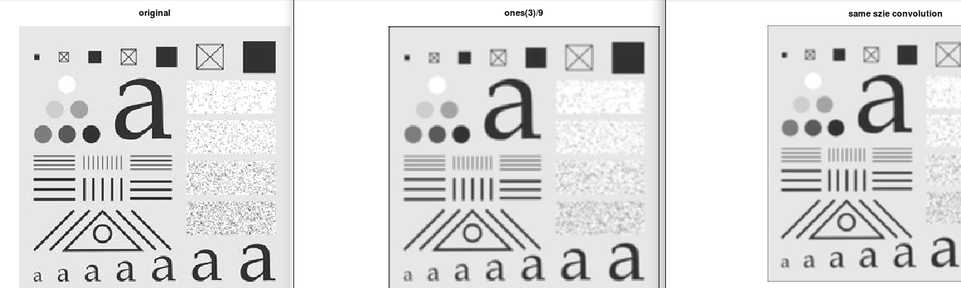
As you can see the border of filtered image with the same kernel; but in the “same size” mode is thinner than border of the filtered with default method (“full”).

A kernel with greater array will result in more smoother image.

If you use smaller constant than normalizing constant:

> kernel=ones(5)/25;
> figure;imshow(conv2(I,kernel));title ("(ones(5)/25")
> figure;imshow(conv2(I,kernel/25));title ("(ones(5)/25)/25")

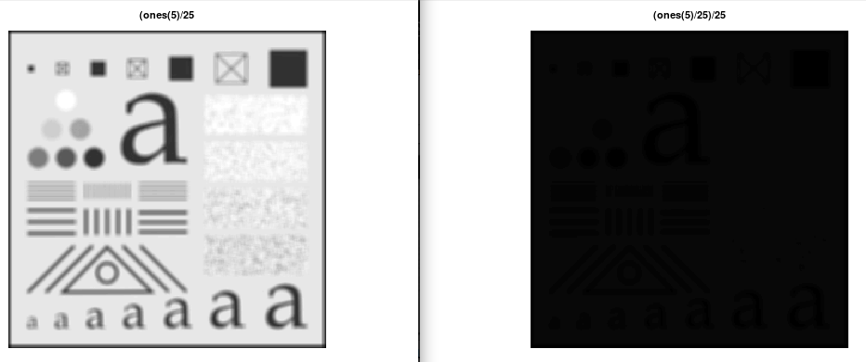
As you can see the result is more darker and dark things will grow.

If you use a row vector in kernel
> kernel=ones(1,5)/5;
> figure;imshow(conv2(I,kernel));title ("(ones(1,5)/5")

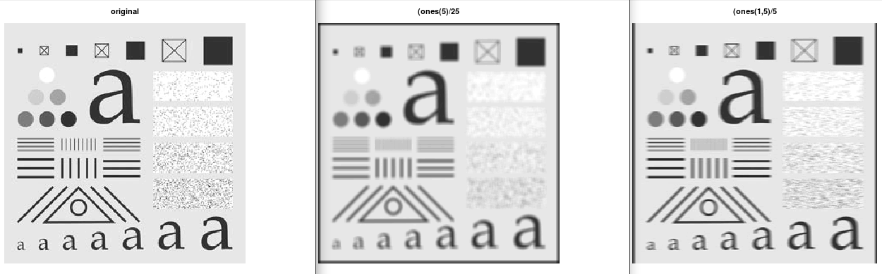

As you can see in above image, third one is shaked horizontally.

If you use a columnar vector in kernel

- Vertical shake
- top, bottom border
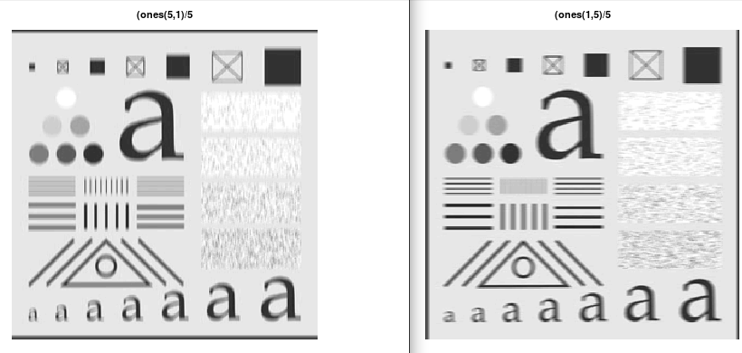

Subtracting result of horizontal box from vertical box

> subtracked = conv2(I,ones(1,5)/5,"same") - conv2(I,ones(5,1)/5,"same");
> figure;imshow(subtracked)

You can guess the result, as I could!

An edge detector! I create this, without any help from others or books!

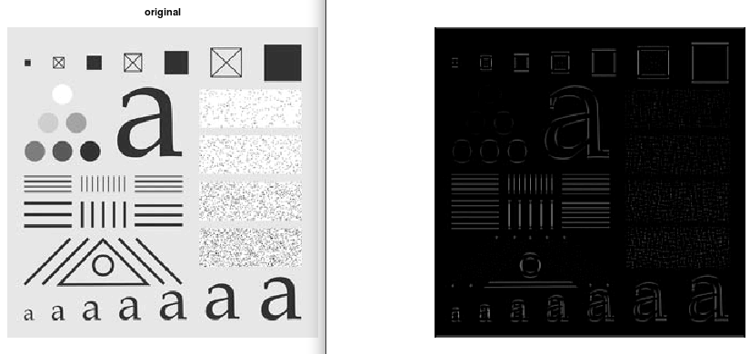
As you can see, it could not detect “diagonal” and skewed edges.
Note:
I used “same size” method for doing convolution; because in default mode size of results were not be the same.

Subtracting with smaller vectors

I try again with smaller vectors:

subtracked = conv2(I,ones(1,2)/2,"same") - conv2(I,ones(2,1)/2,"same");
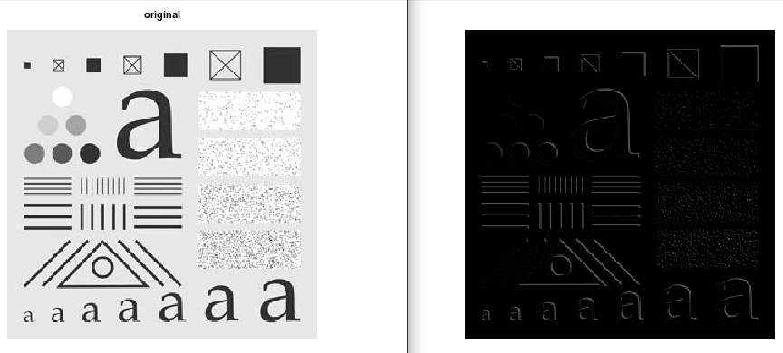

I could not guess the result.

It seems it finds edges and smooth those from top right to the bottom left!

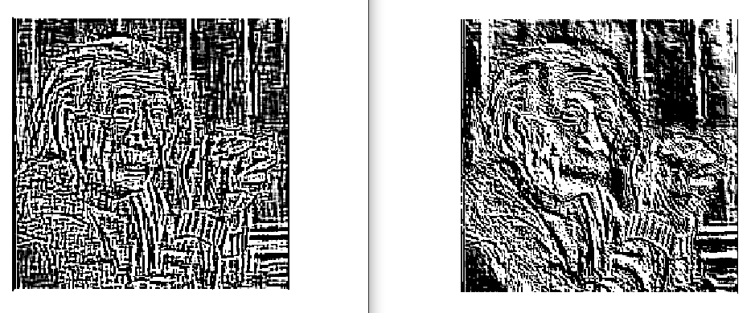

Or it may add more depth to edges by lightening from top right of image.

