> Coins=imread("coins.png");
> Coins=im2double(rgb2gray(Coins));
> result=medfilt2 (Coins,[111 111]);
> imwrite(result,"median_result_111*111.png");

Gonzalez book says:
Isolated clusters of pixels that are light or dark with respect to their
neighbors, and whose area is less than m^2/2 (one-half the ﬁlter area), are
forced by an m × m median ﬁlter to have the value of the median intensity of the
pixels in the neighborhood. So small objects (not only their edges) will be
deleted!

But Octave “medfilt2” command adds a padding to the image; which its default is 0. So if you do median filter when a dark cluster (on white background) is close to the edge, it will expand the dark cluster to the edge.
For example you can cover the upper coin in above of left image by a 77*77 square. So If size of media kernel be 111, then it must clear the upper coin. But will be the right image:
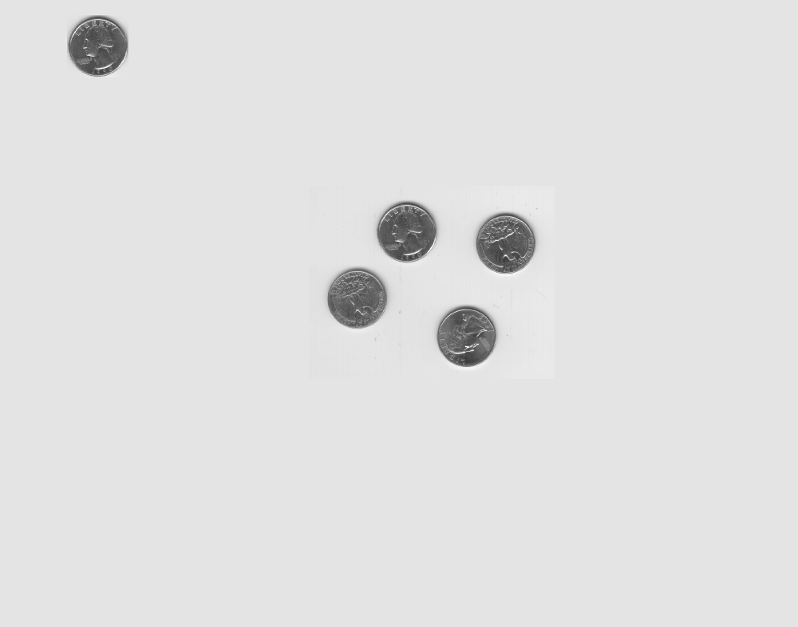
As you can see, center coins are cleared; but the upper one is expanded to the top of image. As another example you can see the result of 111 media kernel for a single coin which can be covered by a 77*77 square:
