Predictive Design, computational chemistry, machine learning, material discovery

Exec Summary of Workflow so far (April 2026):
5. SVM with 25 +ves and 10 -ves
(Stage 2 recomm)
3. One Class SVM –
Ranked coremof db
(Stage 1 recomm)
1. 23 PFOA & 13 PFOS positive MOFs

4. Simulation on mix of 12 coremofs. Only 2 worked
(Stage 1 results)
2. Zeo++ Database - coremof:
PLD, LCD, GSA, VoidFrac, PoreVolume.

8. Simulation on mix of 28 MOFs from 3 databases combined..
Energy Scores obtained
(Stage 3 results)
7. SVR with energy from 30 MOFs
(Stage 3 recomm)
6. Simulation on mix of 30 MOFs from 5 databases..
Energy Scores obtained
(Stage 2 results)

Schematic of approach:
Validate Experimentally/ Exit
ML model makes prediction
Yes
Sufficient discernability
Enrich Data using Simulation
No

Refine model with new data.

Prediction_i = f(data_i-1)
Prediction_1 = f(descriptors)
Prediction_2 = f(descriptors + simulation-1_binary)
Prediction_3 = f(simulation-2_energy)

Details on Exec summary:
1.
2. Zeo Database
3. OCSVM nu = 0.15.
Low discrimination: On the coremofs database,
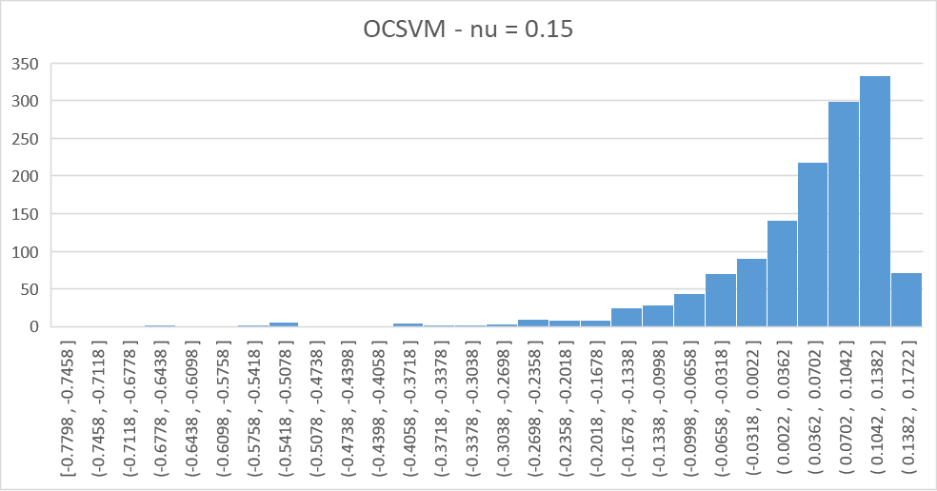

4. The simulation output can be summarised as follows:
- Top OCSVM scores/ mofs most central to the region defined by the starting dataset, did not work as it was suggested they had small PLD (less than 5 um/nm)
- However, the 3 mofs chosen from the worst scores also did work despite having the largest PLD (all three > 10)
- 2 borderline mofs (scores near zero) worked, each with small and larger PLD
Next steps:
- Retrain new model with new data
- Good to prioritise large PLDs (> 5)

5. SVM C = 1.0
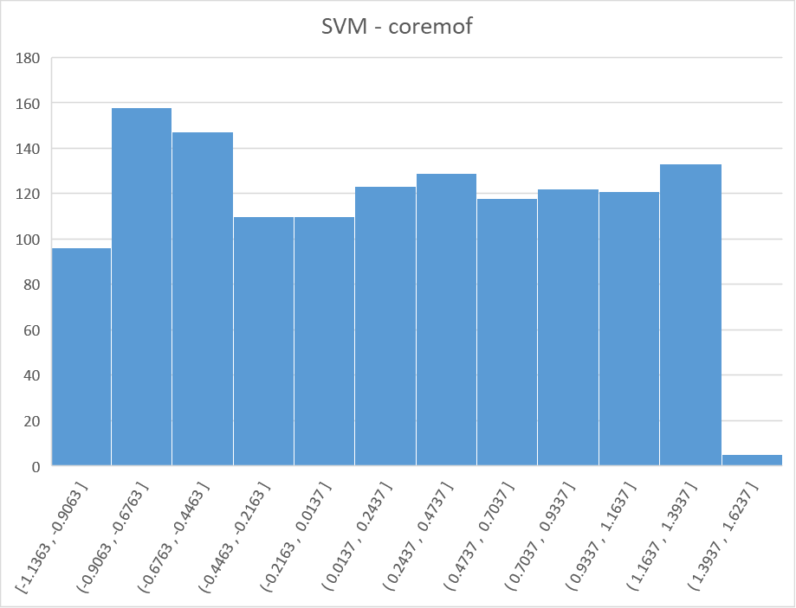

While discernability remains low (759 / 1372) positive within region, it was decided to:
- Go ahead and simulate a “spread” of high SVM scores, high SVM+OCSVM scores with PLDs larger than 5.
- 4 additional data sets were introduced.

6. Simulation provided energy scores of 30 mofs across 5 databases
7. SVR model:
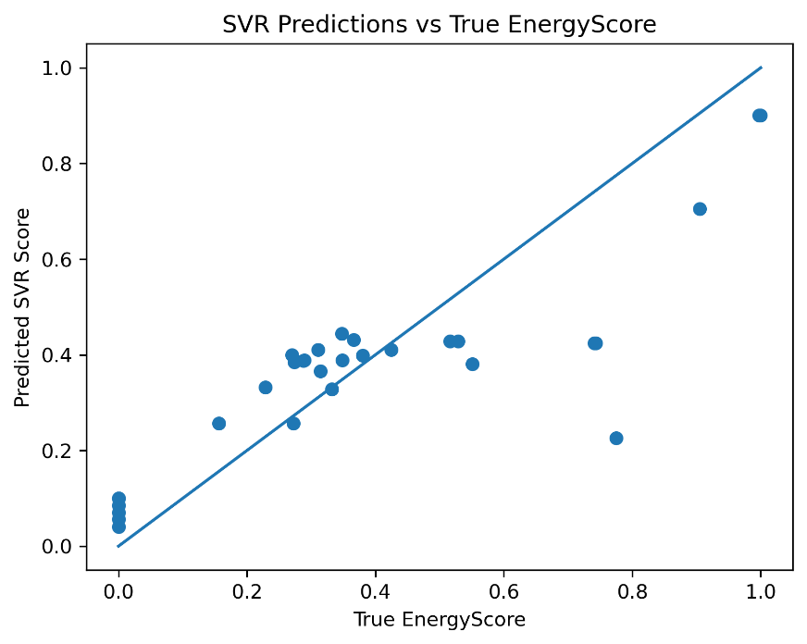
At this point the following discussions and decisions happened:
- Introduction of further features (topology and metal) – this was dismissed due to the combined reasons of lack of data and topological knowledge in 2 datasets.
- NCR and occupancy datasets were removed.
Next step:
- It was decided to simulate 25 mofs with a SVR prediction cutoff > 0.3 while covering a good mix of metal_ions.

8. The simulation results are in – pending analysis.

Introduction
..

Data
We have, from literature, a set of known MOFs capable of PFAS removal. 23 (38) MOFs are known for PFOA removal and 13 (17) for PFOS removal. In the absence of a standardised protocol to measure removal efficiency, the numerical results available can not be used to compare the efficiency of these MOFs in PFAS removal. We call this DataSet_GroundTruth. We also have a set physical descriptors for each of these MOFs: LCD, PLD, Void Fraction etc.
Furthermore, we have a few datasets from the various Databases that hold MOFs and their characteristics:
Dataset Name | Number of MOFs present
coremof | 1372
coremof_FSR | 1192
Coremof_ION | 100
Coremof_NCR | 3,692
Coremof_occupancy | 309

Metal ION part
Three datasets (coremof, coremof_FSR and coremof_ION) share the same MOF naming convention, e.g. 2022[Zr][lvt]3[ASR]1.
The datasets coremof_NCR and coremof_occupancy share a different naming convention, e.g. d1dt02515e2_1_FSR_pacman.
We are therefore able to extract the Metal ION part from the names of the MOFs in the first three datasets. A total of 132 metal ions are observed in the three datasets. These metal ions and the number of MOFs in each of the three datasets they occur in is found in the below table:

UniqMetal | coremof | coremof_FSR | coremof_ION
U | 16 | 12 | 1
Y | 3 | 3 | 1
V | 14 | 10 | 0
Hf | 5 | 5 | 0
Eu | 7 | 6 | 4
Tb | 11 | 12 | 5
Th | 5 | 3 | 0
Ag | 43 | 39 | 3
Zn | 24 | 21 | 20
In | 6 | 7 | 1
Co | 16 | 14 | 5
Cu | 304 | 274 | 7
Zr | 26 | 24 | 0
Mn | 188 | 187 | 2
Ce | 54 | 21 | 0
La | 14 | 10 | 3
Np | 1 | 1 | 0
Pr | 9 | 8 | 0
Ga | 54 | 48 | 0
Cd | 2 | 3 | 11
Fe | 3 | 4 | 0
Ni | 2 | 2 | 2
Bi | 6 | 5 | 1
Tm | 18 | 16 | 0
Ti | 12 | 10 | 0
Pb | 21 | 18 | 0
Er | 1 | 1 | 0
Cr | 19 | 16 | 0
Sm | 4 | 4 | 3
Gd | 0 | 0 | 2
Dy | 0 | 0 | 2
Ho | 0 | 0 | 0
Lu | 0 | 2 | 0
Al | 1 | 1 | 0
Nd | 1 | 1 | 5
Sc | 0 | 1 | 0
Rh | 1 | 1 | 0
Mg | 0 | 1 | 0
Yb | 1 | 1 | 2
Mo | 0 | 3 | 0
YK | 0 | 0 | 1
Sr | 0 | 0 | 1
Ca | 0 | 0 | 1
CdK | 2 | 2 | 0
NiW | 0 | 1 | 0
UEu | 2 | 0 | 1
CrMn | 166 | 132 | 0
ZnCo | 36 | 30 | 0
ZnCe | 3 | 4 | 0
FeAu | 145 | 133 | 0
CuSb | 22 | 13 | 0
TbIn | 3 | 2 | 0
CrZn | 12 | 10 | 0
CuCe | 7 | 7 | 0
CuSc | 3 | 2 | 0
YbCu | 1 | 1 | 0
TmCo | 1 | 0 | 0
CuPr | 0 | 0 | 0
CoPr | 5 | 5 | 0
ErCo | 0 | 1 | 0
CoDy | 1 | 1 | 0
HoCo | 0 | 1 | 0
CoCe | 0 | 2 | 0
ZnMn | 0 | 1 | 0
GeNi | 0 | 1 | 0
ZnPb | 0 | 1 | 0
NiCo | 1 | 1 | 0
TiCu | 0 | 1 | 0
CuEu | 1 | 1 | 0
CuIn | 0 | 1 | 0
CuSi | 1 | 1 | 1
CdSi | 0 | 1 | 0
CrFe | 1 | 1 | 0
GdZn | 2 | 2 | 0
GdCu | 0 | 2 | 0
FeAl | 5 | 6 | 0
TbNi | 1 | 1 | 0
CoMg | 0 | 1 | 0
CuNd | 0 | 1 | 0
NiMn | 0 | 1 | 0
ZrCu | 0 | 1 | 0
CuMn | 0 | 1 | 0
ZnSi | 1 | 1 | 0
CuTi | 1 | 1 | 0
FeZn | 1 | 1 | 0
MnSi | 0 | 1 | 0
CoSi | 6 | 3 | 0
FeCo | 3 | 1 | 0
FePd | 0 | 1 | 0
SiZr | 0 | 1 | 0
CeCu | 0 | 1 | 0
ZnCr | 1 | 2 | 0
CeZn | 2 | 0 | 0
CuGd | 7 | 0 | 0
GaCu | 1 | 0 | 0
InTb | 1 | 0 | 0
CuZr | 1 | 0 | 0
FeZr | 1 | 0 | 0
CoTm | 1 | 0 | 0
CuYb | 1 | 0 | 0
DyCo | 1 | 0 | 0
PrCu | 1 | 0 | 0
PrCo | 1 | 0 | 0
CeCo | 1 | 0 | 0
NiGe | 1 | 0 | 0
CoMn | 1 | 0 | 0
NiZr | 1 | 0 | 0
InCu | 1 | 0 | 0
CuCd | 1 | 0 | 0
FeCr | 2 | 0 | 0
ZnGd | 1 | 0 | 0
InAg | 1 | 0 | 0
ZnFe | 1 | 0 | 0
AlFe | 1 | 0 | 0
SiMn | 1 | 0 | 0
CoFe | 1 | 0 | 0
PdFe | 0 | 0 | 0
ZnMo | 1 | 0 | 2
ZnTi | 0 | 0 | 1
ReAg | 0 | 0 | 1
GaNi | 0 | 0 | 1
LiZn | 0 | 0 | 1
CoNa | 0 | 0 | 1
CdNa | 0 | 0 | 1
AlAg | 0 | 0 | 2
CrAg | 0 | 0 | 1
FeAg | 0 | 1 | 1
GaAg | 1 | 0 | 1
CoAg | 0 | 0 | 1
MoCuAs | 11 | 10 | 0
CuAsMo | 1 | 0 | 0
CoPtPd | 0 | 0 | 1

The most frequently occurring are:
UniqMetal | coremof | coremof_FSR | coremof_ION
Zn | 304 | 274 | 20
Co | 188 | 187 | 5
Cu | 166 | 132 | 7
Cd | 145 | 133 | 11
Ni | 54 | 48 | 2
Eu | 43 | 39 | 4
Zr | 54 | 21 | 0
Mn | 36 | 30 | 2
In | 26 | 24 | 1
Tb | 24 | 21 | 5
Sc | 21 | 18 | 0
Fe | 22 | 13 | 0
Mg | 19 | 16 | 0
Al | 18 | 16 | 0
Ag | 16 | 14 | 3

Topology
The topological information can be extracted from the MOF names in the same three datasets likewise. 126 different topologies are observed according the below frequencies:
Topology | coremof | coremof_FSR | coremof_ION | Total
nan | 475 | 417 | 25 | 917
sql | 188 | 174 | 11 | 373
pcu | 83 | 87 | 1 | 171
hcb | 45 | 43 | 5 | 93
kgd | 36 | 36 | 7 | 79
dia | 36 | 37 | 0 | 73
pts | 34 | 33 | 3 | 70
crb | 19 | 19 | 0 | 38
tfz | 19 | 18 | 0 | 37
bpq | 16 | 16 | 0 | 32
srs | 15 | 15 | 1 | 31
flu | 13 | 8 | 6 | 27
rtl | 13 | 12 | 1 | 26
fsc | 12 | 13 | 1 | 26
nbo | 19 | 6 | 0 | 25
sqc | 10 | 8 | 4 | 22
tbo | 17 | 5 | 0 | 22
nia | 10 | 11 | 0 | 21
bcu | 14 | 4 | 1 | 19
bey | 8 | 11 | 0 | 19
fcu | 10 | 8 | 0 | 18
mog | 9 | 9 | 0 | 18
skl | 9 | 9 | 0 | 18
scu | 14 | 3 | 0 | 17
acs | 9 | 7 | 0 | 16
qtz | 7 | 7 | 2 | 16
rob | 8 | 8 | 0 | 16
hex | 8 | 7 | 0 | 15
fmz | 10 | 5 | 0 | 15
sod | 7 | 7 | 0 | 14
hxl | 7 | 7 | 0 | 14
bnn | 7 | 3 | 4 | 14
lon | 9 | 4 | 0 | 13
csq | 8 | 5 | 0 | 13
gra | 6 | 7 | 0 | 13
ant | 6 | 5 | 1 | 12
neb | 6 | 6 | 0 | 12
ith | 5 | 5 | 1 | 11
lvt | 8 | 2 | 0 | 10
kgm | 5 | 5 | 0 | 10
fes | 6 | 4 | 0 | 10
apo | 4 | 4 | 0 | 8
sra | 4 | 3 | 1 | 8
sqp | 4 | 3 | 0 | 7
fgl | 3 | 3 | 0 | 6
ctn | 3 | 3 | 0 | 6
nuc | 3 | 1 | 2 | 6
fon | 3 | 3 | 0 | 6
bcg | 3 | 3 | 0 | 6
lcv | 3 | 3 | 0 | 6
ths | 3 | 3 | 0 | 6
dmp | 2 | 3 | 1 | 6
fet | 0 | 0 | 6 | 6
she | 3 | 1 | 1 | 5
bcs | 3 | 2 | 0 | 5
hww | 0 | 0 | 5 | 5
gfy | 0 | 0 | 5 | 5
hcp | 2 | 2 | 0 | 4
eea | 2 | 2 | 0 | 4
kag | 2 | 2 | 0 | 4
llj | 2 | 2 | 0 | 4
sea | 2 | 2 | 0 | 4
ato | 2 | 2 | 0 | 4
ins | 2 | 2 | 0 | 4
bbf | 2 | 2 | 0 | 4
ftw | 4 | 0 | 0 | 4
eta | 1 | 3 | 0 | 4
sit | 2 | 1 | 1 | 4
cag | 2 | 2 | 0 | 4
umc | 3 | 0 | 0 | 3
stp | 2 | 1 | 0 | 3
fit | 1 | 1 | 1 | 3
pyr | 2 | 0 | 1 | 3
rna | 1 | 2 | 0 | 3
cds | 1 | 1 | 1 | 3
unc | 1 | 2 | 0 | 3
lcy | 2 | 0 | 0 | 2
nod | 1 | 1 | 0 | 2
urx | 1 | 1 | 0 | 2
noa | 1 | 1 | 0 | 2
gar | 1 | 1 | 0 | 2
shp | 1 | 1 | 0 | 2
cco | 1 | 1 | 0 | 2
ssa | 1 | 1 | 0 | 2
met | 1 | 1 | 0 | 2
jaj | 1 | 1 | 0 | 2
llz | 1 | 1 | 0 | 2
lil | 1 | 1 | 0 | 2
snz | 1 | 1 | 0 | 2
hea | 1 | 1 | 0 | 2
mmt | 1 | 1 | 0 | 2
djg | 1 | 1 | 0 | 2
etb | 1 | 1 | 0 | 2
scn | 1 | 1 | 0 | 2
svk | 1 | 1 | 0 | 2
zst | 1 | 1 | 0 | 2
buh | 1 | 1 | 0 | 2
crs | 1 | 1 | 0 | 2
cem | 2 | 0 | 0 | 2
mcm | 1 | 1 | 0 | 2
dmc | 1 | 1 | 0 | 2
muo | 1 | 1 | 0 | 2
mab | 1 | 1 | 0 | 2
uoc | 1 | 1 | 0 | 2
bex | 1 | 1 | 0 | 2
hbt | 1 | 1 | 0 | 2
vtx | 1 | 1 | 0 | 2
hms | 1 | 1 | 0 | 2
tcs | 1 | 0 | 0 | 1
hmc | 1 | 0 | 0 | 1
sjt | 1 | 0 | 0 | 1
agw | 1 | 0 | 0 | 1
fjh | 1 | 0 | 0 | 1
soc | 1 | 0 | 0 | 1
ceq | 1 | 0 | 0 | 1
fog | 1 | 0 | 0 | 1
lig | 1 | 0 | 0 | 1
esg | 1 | 0 | 0 | 1
sxb | 1 | 0 | 0 | 1
mrc | 1 | 0 | 0 | 1
utp | 1 | 0 | 0 | 1
cru | 1 | 0 | 0 | 1
gwg | 1 | 0 | 0 | 1
unj | 0 | 1 | 0 | 1
tfw | 0 | 1 | 0 | 1
hwx | 0 | 0 | 1 | 1

