Arrays and Strings

Hash Tables
- Array based
- Highly efficient lookup.
- There are balanced Binary Search Tree implementations that saves space but losing performance(time)

Creation
- Compute HashCode --> generally int or long
- Collision: Hash code can be same for two different key
- Map HashCode to an array index through a hash function. i.e. hash(key)/array_length
- Store thew value in relative index: Collided items can be maintained via a linked list or tree
Collisions:
- two different key with same hash code
- two different has codes mapped to the same index

Retrieve
- Compute hash code
- Compute index
- Search through linked list for the item

Asymptotic Complexity Analysis
- Depends on the collisions.
- Worst Case is O(N) where N is number of keys
- Generally lookup is O(1), Amortized complexity is O(1).

ArrayList & Resizable Arrays
- Arrays are fixed sized objects(language dependent)
- One might need to resize array by appending elements
- While resize each element should be copied, So it is O(N) operation. Occurs rarely.
- Amortized insert is O(1)
- Resizing factor can be used to decide when to resize array on both insert and delete.

StringBuilder
- Concatenation of String is problematic since it is immutable and needed to be copied.
- Concatenation on a list of string which has X length is O(XN^2)
- StringBuilder its mutable format which keep a list of resizable strings.
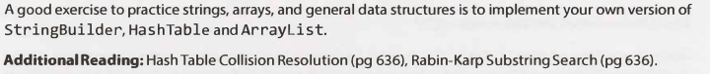

Linked Lists
- Represents sequence of nodes.
- Each node contains pointer/s to the following nodes.
- Cannot provide constant access to an index
- Adding/removing from beginning is constant
- It is important to know whether it is singly or doubly linked list in interview.
- It is important to know whether linked list sorted or not

Creation
- class has a Node member as head which is an inner class that contains the pointer/s and data

Delete a Node from linked list
- control for null is crucial
- if necessary update head or tail
- arrange pointers to maintain integrity of the list

Runner technique
- Using a second pointer while iterating over list
- According to question runner pointer might shift with different speed than original pointer.
- It is useful to find middle of list
- Generally Recursive solutions are applicable
- All recursive algorithms take at least O(n) space where n is depth of recursive call stack

Stacks and Queues
- Tricky questions
- Modifications or more complex

Implementation of a Stack
- LIFO
- Pop()
push(item)
peek()
isEmpty()
- Can be implemented with linked list
- Linear time access and Constant time add remove operations
- Useful in recursive algorithms
- Can be used to implement a recursive algorithm as iterative algorithm

Implementation of a Queue
- FIFO
- add(item)
remove()
peek()
isEmpty()
- Can be implemented with linked list
- Useful in implementing breadth-first search
- Useful in implementing a cache

Trees and Graphs
- Trickiest questions
- Do not assume it is a binary search tree. Ask for binary, balanced etc.
- Searching complicated than linearly organized data structure
- Worst case, average case vary
- Fluency of implementing them is essential

Types of Trees
- Each tree has a root node (contradict with graph theory, but it is for programming and interviews
- Root node has at least 0 child node
- Each child has at least 0 child node
- Node has 0 child is a leaf
- Cannot contain cycles
- Nodes may have backward links to its parent
- Questions contains ambiguous details
- Questions contains incorrect assumptions
- For any issues seek clarification

Tree vs Binary Tree
- In binary tree a Node can contain at most 2 children
- There are occasions you need a Tree instead of Binary Tree. i.e phone numbers 10-ary tree

Binary Tree vs Binary Search Tree
- Binary Search Tree(BST) has a specific ordering property that for any node:
left descendants value < node's value < right descendants value
- Duplicate elements can occur. It must be clarified with interviewer.

Balanced vs Unbalanced
- Ask for clarification on balance
- Balance does not mean perfect balance
- Ensure O(logn) insert and search
- i.e. Red-black trees and AVL trees

Complete Binary Trees
- Each level has to be fulfilled completely except leaf level, which is filled from left to right

Full Binary Trees
- Tree that no node contains one child, either 0 or 2

Perfect Binary Tree
- Each level fulfilled completely
- Each leaf node at the same level
- 2^{k}-1 node where k is height of the tree

Binary Tree Traversal
- In-order
- Post-order
- Pre-order
- Be comfortable with each of them

In-Order Traversal
- Visit left
- Visit current
- Visit right
- In binary search trees yields to ascending order
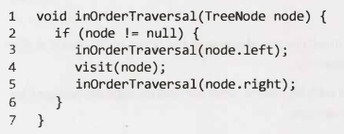

Pre-Order Traversal
- Visit current
- Visit left
- Visit right
- Root always visited first
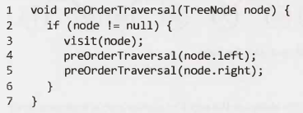

Post-Order Traversal
- Visit left
- Visit right
- Visit current
- Root always visited last
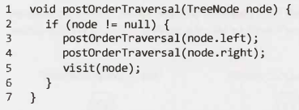

Binary Heaps (Min-Heaps and Max-Heaps)
- Book discuss min-heaps
- Min-heap is a complete binary tree
- Root is minimum element
- 2 operations: insert and extract_min

Insert

- Insertion is done by maintaining complete tree property(bottommost-rightmost place)
- To find its location we swim up-bubble up on this object until minimum heap property restored
- Insert take O(log n) time

Extract Minimum Element
- Remove minimum element-root.
- Swap it with the last element in the tree (bottommost-rightmost element)
- Then sink-bubble down this element until minimum heap property restored
- Sink operation should be done with the smaller child.
- Extract_min take O(log n) time

Tries (Prefix Trees)
- It comes up a lot in interviews
- it is in the form of n-ary tree where each node store a character.
- Each path down may contain a word
- Generally used to store entire (English) language for quick prefix look-ups
- Hash-table used to find a word is valid or exist while Trie used to quick retrieve of prefix existence
- * null node are often used to indicate a complete word.
i.e. MANY* traversal indicates MANY is a word. Existence of MA indicates that there is at least a word where MA is prefix.
- Special type of child can be used for * termination. TrieNode --> TerminatingTrieNode
- Instead of * just using a boolean flag in parent node is viable
- Children count is parallel to the alphabet_size. 0th index can be used as *
- through prefix search a reference to the current node can be passed to prevent excessive starting from root traversals.

Graphs
- A graph is a collection of Nodes(vertices) with edges between(some of) them
- Can be directed or undirected. Undirected edges are two way access
- Can contain cycles if it is not a “acyclic graph”
- 2 commons way to represent:

Adjacency List
- Every vertex stores a list of adjacent vertices
- In an undirected graph (a,b) would be stored twice; one for a, one for b
- A wrapper Graph class is necessary in implementation since it might not be possible to traverse all nodes from a single node.
- An array or hash-table of lists can store adjacency list

Adjacency Matrices
- An NxN matrix where N is the number of nodes.
- A true value at matrix[i][j] indicates an edge from i to j
- In an undirected graph adjacency matrix is always symmetric while in directed graph it is not necessary.
- All algorithms can be performed as adjacency list. However, in list iteration of neighbors is possible while in matrix each node should be traversed toknow a nodes neighbors.

Graph Search
- 2 common way: Depth-first search(DFS) and breadth-first search(BFS)
- DFS: start at a node to explore each branch before moving to the next, which is go deep first before go wide. Generally used where we want to traverse all nodes in the graph, since its simpler with DFS than BFS
- BFS: start at a node to explore neighbors before going to their children, which is go wide before go deep. Generally If we want a path between two nodes BFS is better than DFS.
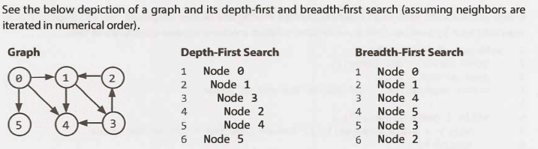
- If it is necessary to state close to starting vertex bfs is relatively quick.

Depth-First Search(DFS)
- when starting with vertex a to go b, b's neighbor's will be visited first.
- Tree traversals are a form of DFS. When implementing for a graph it must be checked that a vertex visited or it is possible to stuck in an infinite loop
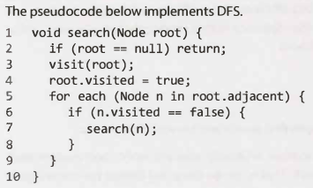

Breadth-First Search (BFS)
- Less intuitive
- BFS is not recursive but instead it uses a queue
- When starting from vertex a before visiting any other each of a's neighbors visited.
- An iterative solution with a queue usually works best
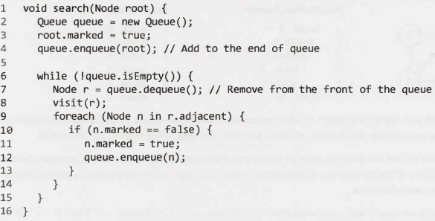

Bidirectional Search
- Used to find the shortest path between two vertices.
- Runs two simultaneous bfs for each of two vertices. When search collide path is found
- For distance d from one vertex to other
  - using bfs yields to O(k^{d}) where k is the number of the nodes.
  - Using bidirectional search yields to O(k^{d/2}) from approximately 2 k^{d/2} operations.

Bit Manipulation
- Some questions ask for it.
- Easy to make mistakes
- Need to be comfortable with it

Two's Complement
- Generally computers use to store numbers in this way.
- 3 = 0011, 5 = 0101, -3 = 1101. In order to swap 2 way exist
  - Invert absolute equal and add 1. ~3+1 = -3
  - For n bit number absolute sum equals 2^{n-1}. N=4 --> |5|+|-3| = 8 --> 5=0101, -3 = 1101

Arithmetic vs. Logical Right Shift
- Logical >>> vs Arithmetic >>
- For n=-75
  - n>>>1 = 90 --> 10110101 >>> 01011010
  - n>>1 = -38 --> 10110101 >> 11011010

Common Bit Tasks

GetBit
- can create a filter and AND a number to check whether a specific bit is 0 or 1.
- 00010000 & num != 0 --> ((num & (1 < i)) != 0

SetBit
- Can create a filter to OR a number to make a specific bit to 1.
- 00010000 | num --> num | (1 << i)

ClearBit
- Can create a filter to make a specific bit/s on a number 0
- 11101111 & num --> num & ~(1 << i)
- 00001111 & num --> num & (1 << i) -1
- 11110000 & num --> num & (-1 << (i +1))

UpdateBit
- Can clear then set it to either 1 or 0
- (11101111 & num) | 000n0000 --> (num & 11101111) | (n << i)

Math and Logic Puzzles
- Many company banned
- If asked, it is just a math question, no word trick
- Don't panic with a brainteaser and show your process and Talk
- Note the rules you found and your approach
- If you find a worst case with intuition process it to a best case
- If you are stuck use Base Case, Build or DIY(Do it yourself) approaches

Object-Oriented Design
- Sketch out your classes and methods
- Not necessarily related with design patterns
- Elegant and maintainable code is necessary
- Performance is a must

How to Approach

Step 1: Handle Ambiguity
- Understanding what will be implemented is crucial
- Who will use it
- How it will be used?
- Six Ws: who, what, where, when, how, why

Step 2: Define the Core Objects
- Find most necessary items/objects

Step 3: Analyze Relationships
- Don't make assumptions on relationships. Clarify them
- Interface
- Inheritance
- one-to-many
- many-to-one

Step 4: Investigate Actions
- Create test cases
- Follow objects/look for necessary new Objects
- Update your design

Design Patterns
- Generally out of scope
- Singleton and factory methods widely used
- Do not try to find a design pattern fits best, find a pattern works and develop on it

Singleton Class
- Exactly one instance at any time
- Many people dislike and says “anti-pattern”, since it can interfere with unit testing

Factory Method
- Offers abstraction for creating an instance of a class.
- Can be concrete or abstract
- If concrete needs a parameter to know which class will be initialized

Recursion and Dynamic Programming
- If problem can be built off of subproblems, it generally has a recursive solution
- Question can have signals:
  - Design an algorithm to compute nth ...
  - Write code to list the first n ...
  - Implement a method to compute all ...

How to Approach
- Need to find a repeating problem in subproblems
- Can find f(n) by add, delete, or change f(n-1), or solve half by half then merge

Bottom-Up Approach
- Intuitive
- Knowing smaller size solution, add on it to find a general solution

Top-Down Approach
- Understanding the problem help to find similar subproblems to divide into.
- Need to be careful with overlap between the cases

Half-and-Half Approach
- Dividing data in half can help for solution
- i.e. Binary search and Merge Sort

Recursive vs. Iterative Solutions
- Some algorithms easy to implement recursively.
- Implementation easiness can be discussed for solution
- Recursion stack creates a space inefficiency and uses at least O(n) memory

Dynamic Programming & Memoization
- Generally keeping track of overlap between the cases as “cache”
- Some people differs in terminology that:
  - Top-down --> Memoization
  - Bottom-Up --> dynamic programming
- Creating a tree for iterations can help to find overlaps

System Design and Scalability
- TODO

Sorting and Searching
- Efficiency is important
- Input size is important
- Input data may help with selection of algorithm

Common Sorting Algorithms

Bubble Sort
- O(n2) time complexity on average and worst case
- O(1) memory
- Starting with beginning swap elements if order is not halts

Selection Sort
- O(n2) time complexity on average and worst case
- O(1) memory
- Find smallest element and move to its position and so on

Merge Sort
- O(n log(n)) average and worst case
- O(n)
- Recursively halve the array sort and merge eventually

Quick Sort
- O(n log(n)) time complexity on average, O(n2) on worst case
- O(log(n)) ??? O(n) memory due to recursion
- Pick a pivot element and find its place by dividing array around that pivot

Radix Sort
- O(kn) time complexity
- O(k) memory for keeping counting at each space

Searching Algorithms
- Generally it is binary search
- Binary tree traversal might be an option
- A hash table might be an option

Testing

