Dominos Pizaa Sales

1. KPI’S

1. Total Revenue

* 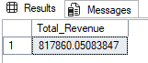Select SUM(total_price) as Total_Revenue from Dominos_pizza_sales

2. Average order_value

* 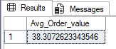SELECT SUM (total_price)/ COUNT(DISTINCT order_id) as Avg_Order_value from Dominos_pizza_sales

3. Total Pizza Sold

* 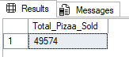SELECT SUM(quantity) as Total_Pizaa_Sold from Dominos_pizza_sales

4. Total order placed

* 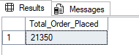SELECT count (Distinct order_id) as Total_Order_Placed from Dominos_pizza_sales

5 Average pizza per order

* 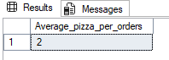SELECT sum(quantity) / count(distinct order_id) as Average_pizza_per_orders from Dominos_pizza_sales
* 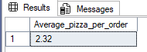SELECT cast (cast (sum(quantity) as decimal (10,2)) / cast ( count(distinct order_id) as decimal (10,2)) as decimal (10,2)) as Average_pizza_per_order from Dominos_pizza_sales

6. daily Trends pizza (just showing a week of record for undersatnding)

* 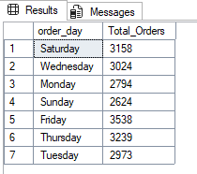select DATENAME(DW,order_date) as order_day , count(distinct order_id) as Total_Orders from Dominos_pizza_sales group by DATENAME (DW, order_date)

7. Monthly Trends pizza total orders

* 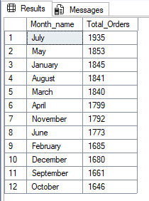select DATENAME(Month,order_date) as Month_name, count(distinct order_id) as Total_Orders from Dominos_pizza_sales group by DATENAME(Month,order_date) order by Total_Orders DESC

8. percentage of sales by pizza category

* select pizza_category, cast( sum(total_price)*100 / (select sum(total_price) from Dominos_pizza_sales) as decimal (10,2)) as total_sales_percentage from Dominos_pizza_sales group by pizza_category

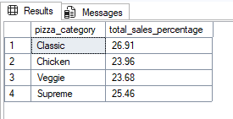

* select pizza_category ,sum(total_price) as Total_sales, sum(total_price)*100 / (select sum(total_price) from Dominos_pizza_sales where MONTH (order_date) =1) as total_sales_percentage from Dominos_pizza_sales

where MONTH (order_date) =1

group by pizza_category

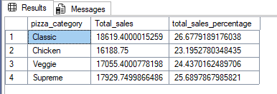

9. percentage of sales by pizza size

* 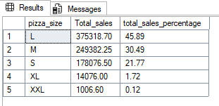select pizza_size , cast( sum(total_price) as decimal (10,2)) as Total_sales, cast (sum(total_price)*100 / (select sum(total_price) from Dominos_pizza_sales) as decimal (10,2)) as total_sales_percentage from Dominos_pizza_sales group by pizza_size order by total_sales_percentage desc

10. Top 5 Best Revenue of pizza

* select TOP 5 pizza_name, cast (sum(total_price) as decimal (10,2)) as Total_Revenue from Dominos_pizza_sales

Group by pizza_name

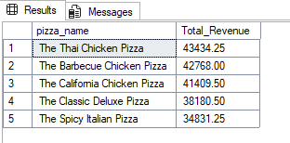order by Total_Revenue desc

11. . Bottom 5 Best Revenue of pizza

* select top 5 pizza_name, cast (sum(total_price) as decimal (10,2)) as Total_Revenue from Dominos_pizza_sales

Group by pizza_name

order by Total_Revenue asc

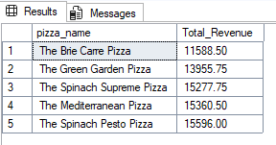

12. top 5 pizza total quantity

* select top 5 pizza_name, cast (sum(quantity) as decimal (10,2)) as Total_quantity from Dominos_pizza_sales

Group by pizza_name

order by Total_quantity desc

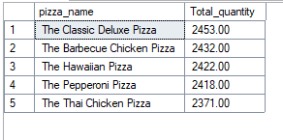

13. . bottom 5 pizza total quantity

* select top 5 pizza_name, cast (sum(quantity) as decimal (10,2)) as Total_quantity from Dominos_pizza_sales

Group by pizza_name

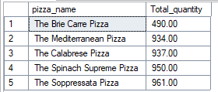order by Total_quantity asc

14. Top 5 pizza best orders

* select top 5 pizza_name, cast (count (order_id) as decimal (10,2)) as Total_orders from Dominos_pizza_sales

Group by pizza_name

order by Total_orders desc

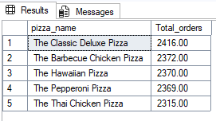

16. Bottom 5 pizza worst orders

* select top 5 pizza_name, cast (count (order_id) as decimal (10,2)) as Total_orders from Dominos_pizza_sales

Group by pizza_name

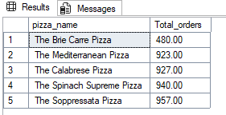order by Total_orders asc