MedBill D1 Agile Report
Product Backlog and Definition of Done

BSEF23-51 MedBill

Bachelors of Science in Software Engineering
(2023-2027)

By

Hasan Abdullah BSEF23M552
Irfan Saleem BSEF23M553

Supervised by:

Prof. Omair Babar
Primary Supervisor

FACULTY OF COMPUTING AND INFORMATION TECHNOLOGY,
UNIVERSITY OF THE PUNJAB, LAHORE.

Contents
1. Product Overview 2
2. System Design High Level 2
3. Features and Scope 3
4. Product Backlog 4
5. Prototype Demonstration 5
6. Progress Snapshot 7
7. Definition of Done 7
8. Development Approach 8
9. CI CD Plan Brief 8
10. Next Steps Semester 8 9

1. Product Overview
MedBill is a web-based medical billing and revenue-cycle system for small clinics and billing teams. The D1 rebuild establishes a working patient-to-claim flow and a tested architecture that can grow into payment posting, denial management, reporting, CMS-1500 export, and AI-assisted risk checking.
Problem. Small teams often split patient, claim, and payment work across spreadsheets or disconnected tools. That fragmentation makes missing insurance details and coding mistakes harder to detect before a claim is prepared.
Target users. The primary users are Billers who prepare and review claims and Administrators who control users and master data. The D1 demo uses synthetic records only.
D1 solution. The system stores structured patient and insurance data, builds claim drafts, and runs explainable backend rules. A draft either becomes Ready or remains Validation failed with messages the Biller can act on.

2. System Design High Level
MedBill uses a three-layer web architecture. React renders the interface, Django REST Framework exposes authenticated JSON APIs and owns business rules, and a relational database stores the records. The browser cannot bypass validation by changing a screen because claim checks execute in Django.
React browser interface | Django REST API | Relational database
Forms, worklists, dashboard | Authentication, validation, calculations | Patients, claims, audit-ready records
Technology choices
- Frontend: React 18, Bootstrap 5, Vite 8, and the browser Fetch API.
- Backend: Python 3.12, Django 5.2, and Django REST Framework 3.18.
- Database: SQLite for a reliable zero-setup D1 demo; MySQL remains the proposal-aligned deployment target.
- Verification: Django automated tests, Playwright browser tests, production build checks, and npm dependency audit.
- Deployment direction: Docker Compose and GitHub Actions after the D1 scope is accepted.

3. Features and Scope
Core epics
- Access and accountability
- Patient and insurance management
- Charge entry and claim preparation
- Rule-based and AI-assisted claim verification
- CMS-1500 preview and PDF export
- Payment, denial, and claim status management
- Dashboard, A R aging, revenue, and denial reports
D1 implementation boundary
Implemented | Partially implemented | Planned for Semester 8
Admin and Biller login | Role enforcement uses the Admin staff flag; user-management screens are not yet included | Full user and role administration
Patient and insurance capture | Editing, duplicate checks, search, and archive rules remain | Master data and audit expansion
Claim draft and four server-side validation checks | The lifecycle currently stops at Ready or Validation failed | Submission, payment, denial, and closing states
Dashboard counts and draft billed value | Only D1 metrics are calculated | A R aging, revenue, denial, and follow-up reports
Automated API and browser tests | CI configuration is documented but not yet hosted | GitHub Actions and deployment checks
 |  | CMS-1500 PDF and evaluated ML risk model
Direct payer submission, EDI 837 integration, live eligibility checking, payment gateways, mobile applications, autonomous coding, and production compliance certification are outside the approved D1 scope.

4. Product Backlog
The backlog uses Must, Should, and Could priorities. A story enters implementation only after its acceptance check is observable.
ID | Priority | User story and acceptance check | D1 status
AUTH-01 | Must | As a user, I can sign in and sign out. Valid credentials return a server token and invalid credentials are rejected. | Done
AUTH-02 | Must | As an Admin, I can manage user roles. A Biller cannot perform Admin-only work. | Partial
PAT-01 | Must | As a Biller, I can register a patient with insurer and member ID. The record persists and appears in the registry. | Done
PAT-02 | Must | As a Biller, I can search, edit, and archive patients without losing history. | Planned
CLM-01 | Must | As a Biller, I can create a claim draft for a patient with service date, diagnosis, procedure, and amount. | Done
CLM-02 | Must | As a Biller, I receive actionable validation messages for missing coverage, invalid code shape, or non-positive amount. | Done
CLM-03 | Must | As a Biller, I can preview and export a CMS-1500-style PDF from a validated claim. | Planned
PAY-01 | Must | As a Biller, I can post full or partial payments and keep outstanding balances correct. | Planned
DEN-01 | Must | As a Biller, I can record a denial reason and follow-up date. | Planned
RPT-01 | Must | As a manager, I can view reconciled A R aging, revenue, and denial reports. | Planned
AI-01 | Should | As a Biller, I see an explainable claim-risk flag only if an evaluated model meets the agreed baseline. | Experiment planned
OPS-01 | Should | As the team, we run builds and tests automatically on every protected-branch pull request. | Local checks done

5. Prototype Demonstration
The demonstration follows one Biller session. The Biller signs in, reviews the dashboard, creates a claim for the seeded synthetic patient, and receives either Ready or Validation failed from the backend. The second browser test deliberately submits bad codes and a zero amount to prove that the correction path works.
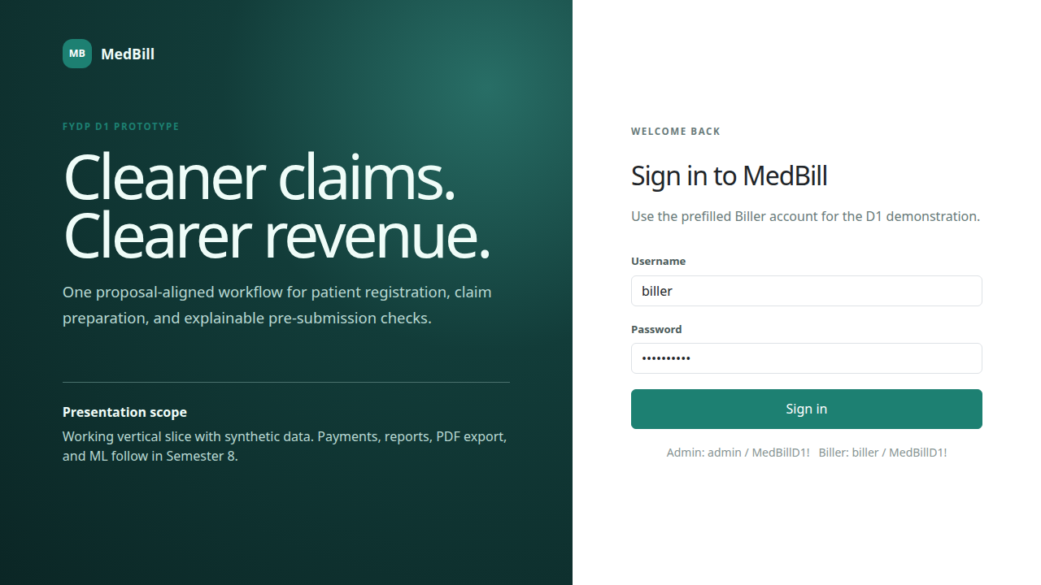
Figure 1 Role-based login and explicit D1 boundary
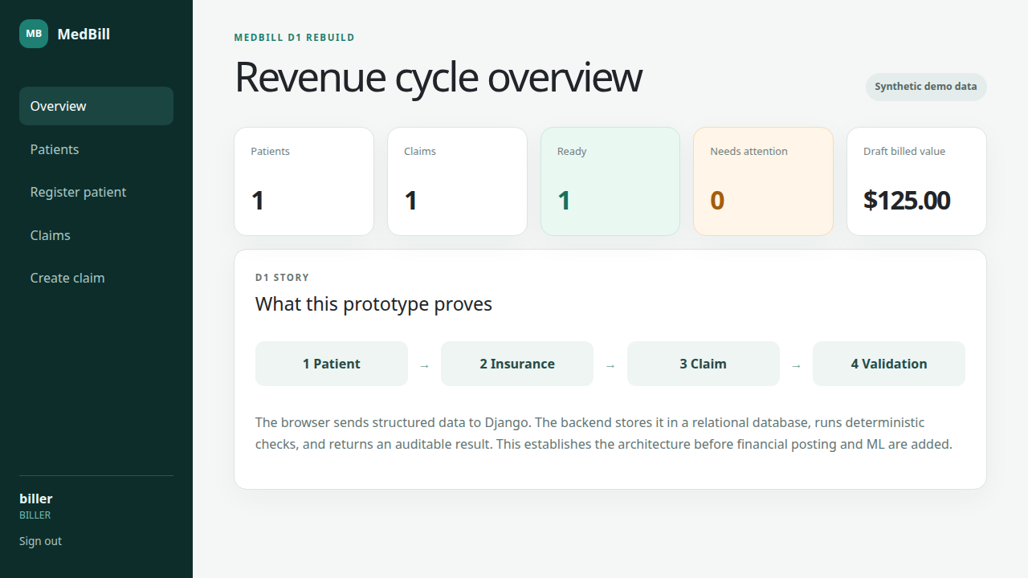
Figure 2 Dashboard after loading the seeded relational records
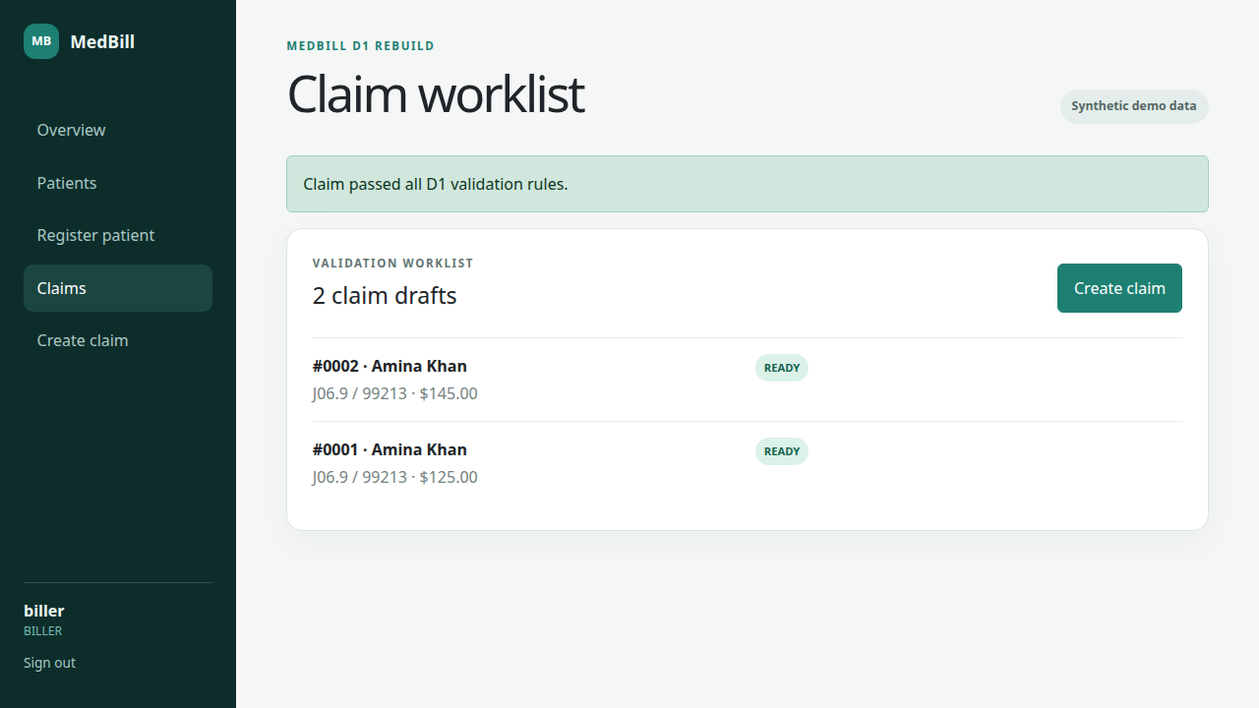
Figure 3 Claim worklist after a draft passes all current validation rules
Current limitations
- The local demo uses SQLite so it runs without a database server. MySQL configuration is present but has not yet been used for this clean rebuild.
- The D1 lifecycle stops after validation. CMS-1500 export, payment posting, denials, and financial reports remain planned.
- The AI component is not claimed as implemented. It requires an approved dataset, baseline comparison, leakage controls, and measured results.

6. Progress Snapshot
A new repository was initialized for the rebuild with a stable main branch and traceable baseline and documentation commits. A remote GitHub URL has not been published yet and should be added before submission.
Evidence | Result | Meaning
Django system check | Passed | No configuration errors
Migration drift check | Passed | Models and migration agree
Backend automated tests | 4 of 4 passed | Login support, public health check, valid and invalid claim paths, and dashboard count
Playwright browser tests | 2 of 2 passed | Happy path and actionable validation failure path
Frontend production build | Passed | React bundle compiles for deployment
npm dependency audit | 0 known vulnerabilities | No currently reported package advisories
The application runs locally with synthetic data. The README contains setup, demo accounts, architecture, scope, and verification commands.

7. Definition of Done
A backlog item is Done only when all applicable checks below pass. Visual presence alone is not sufficient.
- Acceptance criteria are written and linked to a backlog ID.
- Authorization and validation execute in the backend where applicable.
- The complete UI, API, and database path works with synthetic test data.
- Automated tests cover the happy path and the main failure path.
- The production frontend build succeeds without a runtime-blocking error.
- No secrets, real patient data, generated databases, or environment files are committed.
- A second team member reviews the change before it reaches main.
- README, backlog status, and D1 evidence match the demonstrated software.

8. Development Approach
The team will use two-week Scrum sprints. Each sprint begins with a small goal, implements one or more vertical slices, and ends with a review, retrospective, tested increment, and documentation update.
Branching strategy
- main contains stable, demonstrable releases.
- develop contains integrated work for the active sprint.
- feature or fix branches remain short-lived and map to backlog IDs.
Change workflow
Refine the story, create a branch, implement the complete path, run checks, open a pull request, review the evidence, merge to develop, demonstrate at sprint review, then promote a stable increment to main.
Team responsibilities
- Hasan Abdullah: Scrum Master, backend and AI lead.
- Irfan Saleem: Product Owner, frontend and database lead.
- Both students: requirements, acceptance criteria, code review, testing, demonstrations, and documentation.

9. CI CD Plan Brief
GitHub Actions will run on pull requests to develop and main. A change may merge only when the required checks pass.
Stage | Automated check | Failure response
Backend | Install Python dependencies, system check, migration drift check, and tests | Block merge
Frontend | npm clean install, dependency audit, and production build | Block merge
Browser | Playwright happy and failure paths against seeded synthetic data | Block release
Packaging | Docker Compose configuration and health checks | Block deployment
Deployment will be added after the database, secrets, HTTPS, backup, and recovery settings are reviewed. Local demonstration remains the fallback for evaluations.

10. Next Steps Semester 8
Target | Planned outcome
Sprint 1 | Complete Admin user management, master data, patient editing, search, duplicate handling, and audit events.
Sprint 2 | Add charge lines, documented claim-state transitions, and CMS-1500 preview and PDF export.
Sprint 3 | Implement payment, partial payment, adjustment, denial, follow-up, and outstanding-balance rules.
Sprint 4 | Build A R aging, revenue, denial, and dashboard reports and reconcile them against fixed examples.
Sprint 5 | Run the approved ML experiment, compare it with rules-only checks, document metrics, and integrate only if the agreed baseline is met.
Release | Add MySQL and Docker deployment, GitHub Actions, security checks, backup and restore rehearsal, user documentation, and UAT evidence.
The immediate presentation goal is to demonstrate the tested D1 flow, explain the three-layer architecture, show why backend validation matters, and state the remaining scope without overstating completion.

