MedBill D1 Agile Report
Claim Intake Validation and CMS Preview

BSEF23-51 MedBill

Bachelors of Science in Software Engineering
(2023-2027)

By

Hasan Abdullah BSEF23M552
Irfan Saleem BSEF23M553

Supervised by:

Mr Umair Babar
Primary Supervisor

FACULTY OF COMPUTING AND INFORMATION TECHNOLOGY,
UNIVERSITY OF THE PUNJAB, LAHORE.

Contents
1. Product Overview 2
2. System Design High Level 2
3. Features and Scope 4
4. Product Backlog 5
5. Prototype Demonstration 6
6. Progress Snapshot 7
7. Definition of Done 7
8. Development Approach 8
9. CI CD Plan Brief 8
10. Next Steps Semester 8 9

1. Product Overview
MedBill is a medical billing project for small clinics and billing teams. Our D1 increment implements the first usable claim-intake slice: a biller signs in, creates a claim manually or from a PDF, reviews the patient, insurance and service fields, runs explainable checks, saves the validated draft and opens a CMS-1500-style preview.
Problem. Claim information arrives in different forms, and manual re-entry can miss patient identifiers, insurance details, dates, diagnosis codes, procedure codes and charges. D1 needs one inspectable path that turns this information into a structured draft without claiming that the whole billing lifecycle is complete.
Target users. A biller creates and reviews synthetic draft claims. An admin can also open the preserved technical PDF workspace. Signed sessions and role checks protect the claim and document APIs. The public demonstration must still use synthetic data only.
D1 solution. Both input paths lead to the same editable claim, deterministic validation result, PostgreSQL record and printable CMS-1500-style preview. A validated draft means the required D1 format and presence checks passed; it does not mean a payer accepted the claim.

2. System Design High Level
One Next.js application serves the React interface and Node.js Route Handlers on Vercel. Signed demo sessions enforce Biller and Admin roles. Prisma stores patients, insurance records, claims and source-document metadata in Supabase PostgreSQL. Cloudflare R2 stores private PDFs. PDF.js reads embedded text and Tesseract.js handles scanned pages before the biller reviews every extracted value.
Next.js browser UI | Next.js Node.js API | Persistent services
Sign in, manual/PDF entry, review, validation, history, CMS preview | Signed sessions, extraction, validation, claim persistence, protected technical APIs | Prisma/PostgreSQL for records; private R2 for source PDFs
Technology choices
- Frontend: Next.js App Router, React and TypeScript with one guided claim workflow and a printable CMS-1500-style preview.
- Backend: Next.js Node.js Route Handlers for authentication, claim listing and creation, PDF extraction and the admin technical workspace.
- Database: Supabase PostgreSQL through Prisma ORM, with Patient, Insurance, Claim and Document entities.
- Files and extraction: private Cloudflare R2 storage; PDF.js embedded-text extraction and bundled Tesseract.js OCR. Extracted values always require human review.
- Deployment and checks: Vercel production, Prisma migrations, lint, TypeScript build and Playwright browser tests against local and production URLs.

3. Features and Scope
Core D1 capabilities
- Biller and Admin demo sign-in with an eight-hour signed session
- Manual patient, insurance and single-service claim entry
- PDF upload with embedded-text extraction or local OCR
- Human review and correction before validation
- Explainable required-field, code-format, date and amount checks
- PostgreSQL claim persistence and recent-claim history
- CMS-1500-style preview with browser print or Save as PDF
D1 implementation boundary
Implemented | Partial or limited | Remaining proposal work
Biller and Admin demo roles | Demo accounts, not production identity management | Organization users, password recovery and audit administration
Manual patient and insurance entry | Creates a new patient and policy per claim | Full patient search, edit, deduplication and eligibility
PDF extraction and human review | Label-based extraction; OCR can misread fields | Broader document formats and measured extraction accuracy
Claim validation and persistence | Presence and format checks only | Official code lookup, payer rules and electronic submission
CMS-1500-style printable preview | Not an official clearinghouse transaction | Certified export/submission and acknowledgement handling
Recent claims and technical evidence | No payment or denial lifecycle | Payments, denials, financial reports and measured ML
This increment does not submit claims to payers, verify eligibility, post payments, manage denials, reconcile finances or claim that a trained denial-risk model exists. The older AI document router remains available only to the Admin as technical evidence and is not the supervisor-facing D1 product flow.

4. Product Backlog
The Must stories below define the demonstrated claim-intake increment. Done refers only to the stated acceptance check. Later billing, integration and measured machine-learning work remains in the backlog.
ID | Priority | User story and acceptance check | D1 status
AUTH-01 | Must | As a biller or admin, I sign in and protected pages/APIs refuse unauthenticated access. | Done
PAT-01 | Must | As a biller, I enter the minimum patient and insurance fields needed for a draft claim. | Done
CLM-01 | Must | As a biller, I enter provider, service, diagnosis, procedure and charge information. | Done
PDF-01 | Must | As a biller, I upload a valid PDF and receive editable extracted fields; invalid files are refused. | Done
REV-01 | Must | As a biller, I review and correct all manual or extracted values before validation. | Done
VAL-01 | Must | As a biller, I see explainable checks and cannot save while required checks fail. | Done
DB-01 | Must | As a biller, I save a validated draft and find it in recent claim history. | Done
CMS-01 | Must | As a biller, I open a CMS-1500-style preview and print or save it as PDF. | Done
TECH-01 | Should | As an admin, I can open the older technical PDF workspace without exposing it to billers. | Done
PAY-01 | Later | As a biller, I post payments, adjustments and denial outcomes. | Planned

5. Prototype Demonstration
Open https://medbill-steel.vercel.app and sign in with the Biller demo account. First show manual entry: use synthetic patient and insurance data, enter one service line, review it, validate it and open the CMS-1500-style preview. Then upload the supplied synthetic claim PDF, confirm that the same editable form is populated, correct any extraction error and complete the same validation and preview path. Use the Admin role only if the supervisor asks to see the preserved technical workspace.
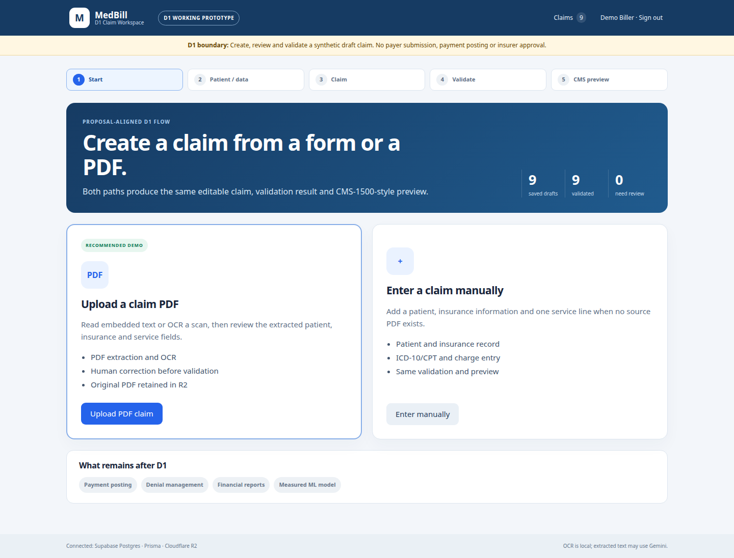
Figure 1 Deployed D1 claim workspace after production verification
Current limitations
- The public deployment is for synthetic data only. It has a 4 MB PDF upload limit and an eight-hour demo session.
- D1 checks validate required fields and recognizable formats. They do not verify insurer eligibility, medical necessity, official code-set status or reimbursement.
- The CMS-1500-style screen is a printable preview, not an official electronic claim submission. Payment posting, denials, financial reports and a measured denial-risk model remain later work.

6. Progress Snapshot
Live app: https://medbill-steel.vercel.app. GitHub: https://github.com/hasanabdullah919/medbill_bsef23-51. D1 runtime source: commit de3e418. Vercel production deployment: dpl_JD4EnQXRBKWBn3kcnQY5UvmnUsMa. Production verification was completed on 14 October 2026.
Evidence | Result | Meaning
Vercel health endpoint | Passed | Production PostgreSQL and R2 are reachable
Local lint and production build | Passed | ESLint, TypeScript and Next.js compilation succeeded
Local Playwright suite | 5 of 5 passed | Authentication, manual flow, PDF flow, invalid login and admin access
Production Playwright suite | 5 of 5 passed | The same complete behavior passed on the live URL
Prisma migration | Applied | Patient, Insurance and Claim tables exist in production PostgreSQL
Unauthenticated document API | HTTP 401 | Older PDF data is no longer publicly accessible
The evidence folder includes the live D1 workspace screenshot and the production test record. Synthetic PDFs support the extraction demonstration. The repository contains the active source, Prisma migration and browser tests without credentials, dependencies or generated build output.

7. Definition of Done
A story is Done only when its stated D1 behavior passes with synthetic data. This does not mean payer integration or the wider product is complete.
- Protected pages and APIs require a valid role-checked session.
- Manual and PDF inputs reach the same review, validation, persistence and preview path.
- Lint, build, migration, local tests and production tests pass.
- The interface and report state the D1 boundary and use no private data or secrets.

8. Development Approach
The proposal uses two-week Scrum sprints with planning, review and retrospective. This increment delivers one vertical slice from claim input to a stored, printable draft. Later sprints should extend that path with payer integration, payment and denial workflows, reporting and measured machine-learning evidence.
Branching strategy
- main contains the published D1 application and aligned submission documentation.
- Feature and fix branches remain the proposed path for isolated sprint work.
- Pull-request review, protected checks and a develop integration branch remain planned team controls.
Change workflow
Planned workflow: refine a story, implement a vertical slice, run lint/build/tests, obtain peer review, demonstrate the deployed behavior and update the report. Current production deployment uses Vercel CLI; automatic GitHub deployment and hosted CI are not enabled.
Team responsibilities
- Hasan Abdullah: proposed Scrum Master and backend/AI lead, as listed in the proposal.
- Irfan Saleem: proposed Product Owner and frontend/database lead, as listed in the proposal.
- Both students should be able to explain setup, rules, limitations, tests and the live demonstration.

9. CI CD Plan Brief
Current checks run before manual deployment. Hosted GitHub Actions and protected-branch gates remain planned. Vercel builds the Next.js application, while Playwright verifies the complete user flow against the deployed URL.
Stage | Check | Current state or planned gate
Local code | npm run lint; npm run build; npm test | Executed before deployment
Database | Prisma generation and migrations | Applied to production PostgreSQL
Live system | Playwright against production plus health/API checks | Executed after deployment
Hosted CI | GitHub Actions, peer review and protected branches | Planned

10. Next Steps Semester 8
Target | Planned outcome
Scope review | Confirm the D1 claim-intake, validation and preview slice against the proposal.
Sprint 1 | Add full patient/policy search, editing, deduplication and audit events.
Sprint 2 | Confirm official CMS-1500 export and payer submission requirements; add code and eligibility services.
Sprint 3 | Implement payment, adjustment, denial and outstanding-balance workflows with fixtures.
Sprint 4 | Build reconciled reports and an approved, measured denial-risk experiment.
Release | Add CI/review gates, operational identity controls, monitoring and privacy review.
Demonstrate the complete D1 claim-intake slice and request supervisor confirmation that this is the correct first increment. The next work should add official claim export or submission requirements, eligibility and code lookup, payments and denials, reconciled financial reports, and a properly evaluated denial-risk model.

