ASTON UNIVERSITY EXCEPTIONAL CIRCUMSTANCES AND ABSENCE FORM

This form should be submitted to your School Office as soon as possible and MUST be submitted by the date outlined on the Exceptional Circumstances webpage at the latest.

For further advice please see the Aston University Guide to Exceptional Circumstances, which is also available on MAP, and the advice included at the end of this form.

All claims for consideration of Exceptional Circumstances must be submitted on this form, with supporting evidence attached as appropriate. Please complete every section legibly. Forms must be signed and dated. See the Guidance Notes (overleaf).

Name: | Hasan Ahmed | Student Number: |  | (9 digit number)
  1 | 6 | 0 | 0 | 6 | 1 | 3 | 1 | 2

Year of Study (Please specify):

Programme: | Computer Science with multimedia (Final Year)

- Dates/duration of time when your work was or will be affected by your circumstances

From…20/03/2020…… To…10/04/2020…

- Nature of the circumstances

Due to Coronavirus lockdown, I was unable to access on campus equipment therefore impacting my ability to complete my coursework. Aston university main building was closed and did not have the means or equipment to complete my coursework for the above listed module(s) without the labs provided in the main building. The coursework required a computer system with high processing power (i3, i5 or i7) and the laptop I have does not fulfil these requirements.
Moreover, As I live in student accommodation, I also had some trouble during that period with internet connection, the internet was on and off for a period of around 3 weeks. When the internet did return, it was slow and inefficient for the levels of processing needed. The evidence provided will show this.
This matter could have been resolved if I was able to return to my family home however, as the university minister informed all students living in accommodation buildings to stay in their buildings, this was not applicable.

Also, an unfortunate incident that took place last year meant I am classed as vulnerable (you can refer to my EC form from last year). As I have a weak lung, this means I cannot leave my accommodation building and have been instructed to self-isolate due to my health being at risk.

I have discussed these issues with my lecturer and was informed that the best option is to file an EC which can also be seen from the evidence provided below.

- List of Assessments Affected

Module Code | Module Name | Format of Assessment | Date of Assessment/deadline | Assessment attended/submitted
CS3040 | Mobile Design and Development | Coursework | 27/03/2020 | N
 |  |  |  | Y/N
 |  |  |  | Y/N
 |  |  |  | Y/N
 |  |  |  | Y/N
 |  |  |  | Y/N

- In what way were assessments affected? Please be as precise as possible as to how each assessment was affected.

Unable to submit coursework for Module: Mobile Design and Development.
Due to lockdown and limited or no access to on campus computers and facilities. In these uncertain and challenging times, everyone has had to compromise their normal activities and in turn has created challenges that are unavoidable and excusable. If access were given to university labs, assessments would have been completed on time and to a good quality. Also, a lack of good internet hindered the progression of work from outside the labs.

- Please list all supporting evidence you would like us to consider, covering the dates/duration stated in section 1 and 4, and attach to this form. If you do not have all the evidence, cannot attach it, or are experiencing difficulties and/or delays in obtaining it, please state why, and when we can expect this.
Image 1: proof of internet connection problems and delays in student accommodation building.
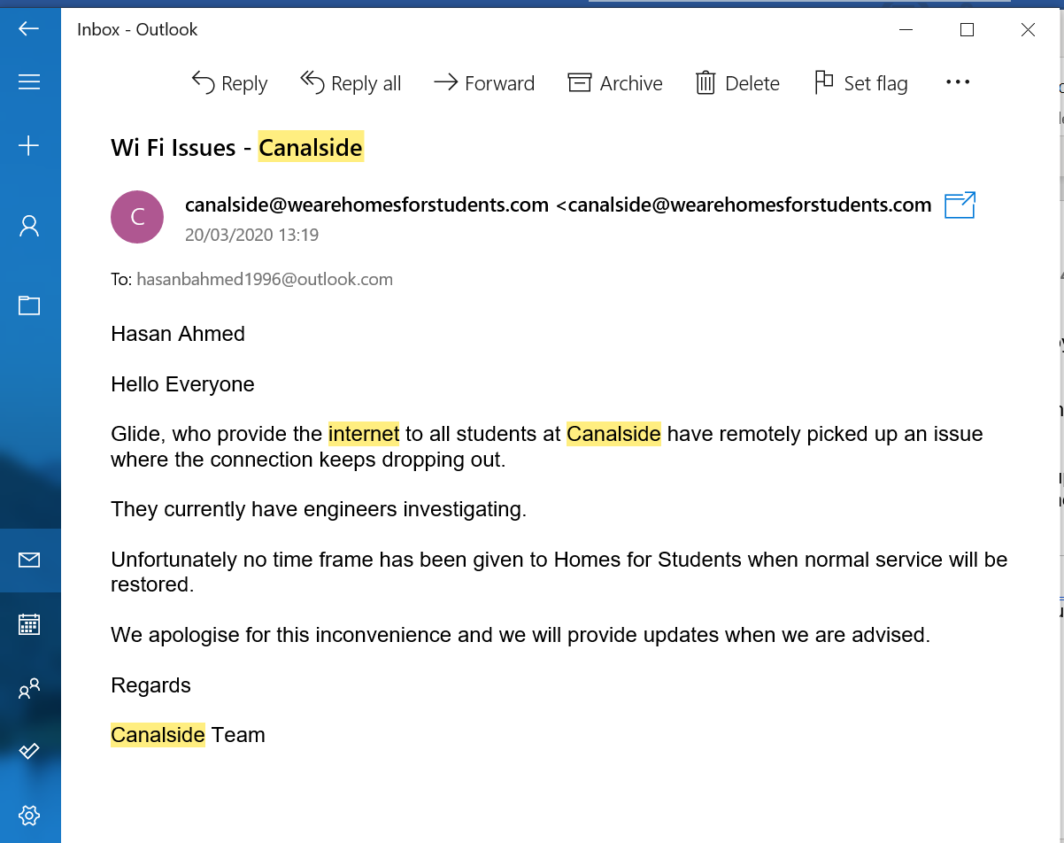

Image 2: discussion about filling in an EC form with lecturer
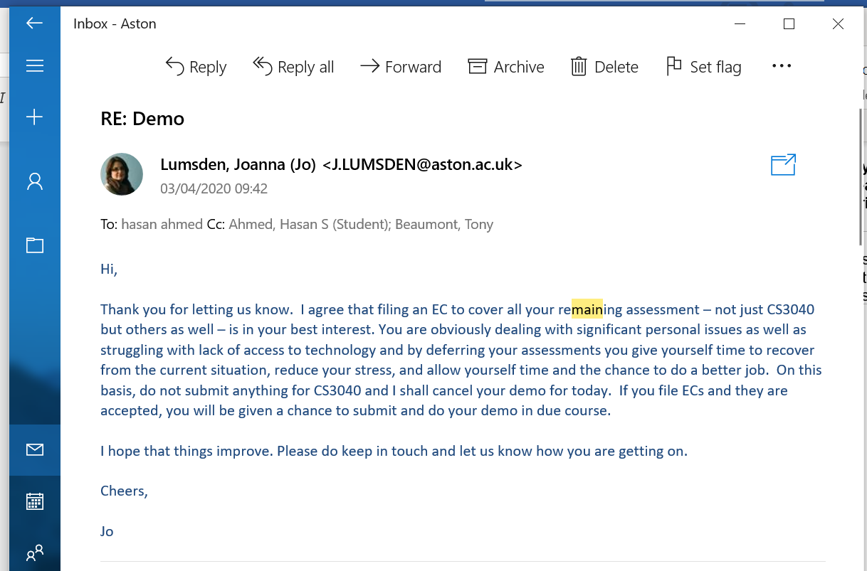

If you would like to review my previous EC form from academic year 2018/19 regarding health issues, you should be able to find it within your system, all proofs of treatment and description of condition will be found therein. I am sure you are aware of the main building closure so I will not provide proof of its closure.

It is expected that all claims will be evidenced. Evidence should be received by the Exceptional Circumstances and Absence Panel date specified on the website.
Please tick this box if you do not wish for us to share the information contained in this form with other departments within Aston University (such as The Hub). Please note that leaving this box unticked will help us process your form faster.
Information submitted on this form may be passed onto the relevant Officer if your Programme is covered by the Regulations on Fitness to Practise. Information submitted on this form may be passed onto an Academic Offences Officer if it indicates that there may have been a breach of the University's Regulations on Student Discipline.

Signature: | Hasan Ahmed | Date: | 10/05/2020

ASTON UNIVERSITY – EXCEPTIONAL CIRCUMSTANCES

Guidance notes for students

All forms must be signed and dated and submitted to your School Office by the appropriate School deadline which will be before the Exceptional Circumstances and Absence Panel (ECAP) meets. Information on these deadlines may be obtained from the Exceptional Circumstances webpage. Exceptional Circumstances forms submitted late will not be considered by the Exceptional Circumstances and Absence Panel.

Section 1: Duration of time affected by your circumstances.

- State the overall period of time that your work was/will be affected by your circumstances.

Section 2: Nature of the circumstances.

- Summarise the events or conditions that affected your work or assessment.
- Identify the way in which these are exceptional - that is, how are they beyond the normal range of events that might be expected day to day?

Section 3: List of Assessments Affected

- List the module codes, names and the elements of assessment which were affected. Please include dates of exams, and coursework deadlines, and whether the assessments were attempted/submitted.

Section 4: In what way were assessments affected?

- Explain how the circumstances affected your ability to complete the assessment successfully (for example were you unable to attend an examination, was your attendance through the module restricted, did you miss deadlines?). It is important that you are as specific as possible.

Section 5: List of supporting evidence. If none, explain why not.

- You must provide supporting evidence covering the dates previously stated. This can include medical certificates, letters from University support services, police incident numbers, copies of birth/death certificates (please see the Guide to Exceptional Circumstances for further details of forms of evidence). If you are unable to provide any supporting evidence you must explain why not. In most cases it will not be necessary to circulate copies of evidence at Examination Boards.

What does the ECAP do with this information?

The ECAP will consider the statements in your form and
- Determine if the circumstances meet the definition within University Regulations of Exceptional Circumstances.
- Consider whether the circumstances are likely to have significantly affected your performance the way you have described
- Evaluate the weight of supporting evidence.

When an ECAP accepts that the outcome of an assessment was adversely affected by Exceptional Circumstances no additional marks are awarded by the Examination Board. The outcome may be that a further opportunity to take an assessment without penalty is given. Exceptional Circumstances are one of the factors that the Examination Board will take it into account when making overall decisions on candidates such as the classification of their degree or whether they can progress to the next Stage of the programme.

Confidentiality

By signing this form you agree to allow your submission to be considered at the ECAP/Examination Board. All ECAP and Examination Boards are confidential. All copies of this form and accompanying evidence are retained by your School ECAP Officers.

The information you supply in this form is confidential, but confidentiality is not considered as an absolute. There are certain circumstances in which the University has a responsibility to break confidentiality:
- Where it is believed that you or third party is in serious danger;
- Where the University would be liable to civil or criminal court procedures if information was not disclosed.
Wherever possible in such situations you will be encouraged to pass on the information to the relevant agency. Should the situation arise that you are reluctant to do this, the University may in extreme cases pass on the information directly.
Information submitted on this form may be passed onto an University Discipline Officer if it indicates that there may have been a breach of the University's Regulations on Student Discipline

For independent, impartial and confidential advice students can contact Aston Students’ Union Advice & Representation Centre (ARC), 0121 204 4848 or email: advice@aston.ac.uk

