**School of Engineering and Applied Science**

**Takeaway assessment answer booklet**

**As with all graded assessments, you are required to undertake this assessment individually and adhere to the University Regulations on Student Discipline.**

**For your information, and awareness, below are statements describing plagiarism and collusion.**

PLAGIARISM: *“where a student uses, without acknowledgment, the work of other people and presents it as their own which may give an unfair advantage over others. Intentional and unintentional acts of plagiarism (whether reckless or otherwise) will be construed as offences.”*

COLLUSION: *"where two or more people have worked together without permission to produce a piece of work which is then submitted for assessment as the work of only one person, which may give an unfair advantage over others. Action may be taken against a student who has allowed their work to be used as well as against a student who submits work resulting from collusion."*

***By submitting my assignment I declare that:***

I have personally prepared this assignment and that it has not previously, in whole or in part, been submitted for THIS, OR any other degree or qualification.

The work described here is my own, carried out personally by me unless otherwise stated.

Where applicable all sources of information, including quotations, are acknowledged by means of reference, both in the final reference section, and at the point where they occur in the text.

I understand that plagiarism and collusion are regarded as offences within the University’s Regulations on Student Discipline and may result in formal disciplinary proceedings.

*I understand that by submitting this assessment, I declare myself fit to be able to undertake the assessment and accept the outcome of the assessment as valid*

Please add, your typed answers (where possible) to your takeaway assessment in this answer booklet.

Ensure you clearly indicate which question number your answer relates to, this includes any embedded images. Where applicable, the final reference section should be submitted at the end of the relevant question.

If you have any additional information related to a question, this also needs to be included in this answer booklet at the end of document, again clearly labelled with the corresponding question number.

Once completed, save this answer booklet as a PDF document and submit within the 24hr timeframe.

More detailed guidance related to this takeaway assessment can be found in the Takeaway assessment folder.

**Question 1**

The 3 types of orientation representation and the types of tasks they are suitable for

* **Matrix representation**
  + - Suitable for composition tasks such as scaling and rotating as it does not suffer from the gimbal lock problem and it is an easy composition.
* **Euler/Fixed angles** 
  + - Suitable for user interaction as it is intuitively understood by humans
* **Axis + Angle (Quaternions)**
  + - Suitable for composition and interpolation

**Question 2**

Keyframing a sunrise sketch

**Keyframe 60:**

**Position t = (5,5)**

**Keyframe 0:**

**Position t = (0,0)**

* First set the keyframe at the starting position (should be at a low position). Record this keyframe.
* Then increase the keyframes to an appropriate number, depending on the desired duration of the animation, in this case 60.
* On keyframe 60 position the sun object at the new position which is higher and more to the right. Record this new position on the keyframe.
* Interpolation will occur between the keyframes and sun will do a sunrise animation when played.

**Question 3**

Gimbal lock and when it occurs

* A gimbal lock occurs when 2 rotational axes coincide and rotate on the same plane. This results in a loss of one degree of freedom.

**Question 4**

1. Direct vertex manipulation
   * + This is the simplest of object deformation approaches. It deforms an object by displacing each individual vertex. In order to reduce the work/input of the modeller on the displacement of the vertices, the displacement of each vertex is propagated to nearby vertices, all while the magnitude of displacement is reduced. The further away from the original displaced vertex, the smaller the neighbouring vertexes displacement is.
2. A = 2,

B = 6 (4/10*15)

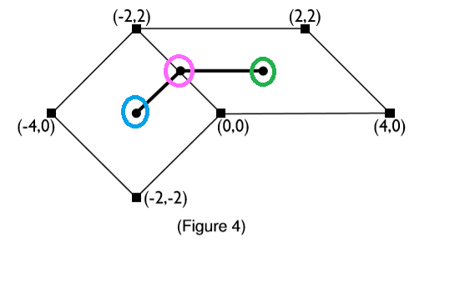4c) Bilinear interpolation

You need to use linear interpolation equation:

**y = y1 +(x-x1) * (y2 -y1)**

**(x2- x1)**

**Question 5**

How many parameters are needed to describe the conﬁguration of a rigid object in 3d space?

* **6 parameters are needed**, 3 parameters for the positioning of the object in space **(x, y, z).** 3 for the description of orientation **(yaw, pitch, roll).**

**Questions 6**

Animation techniques used for modelling the following:

**A)** A flying airplane = Keyframing the position and the orientation of the airplane.

**B)** A forest = L – Trees.

**C)** A humanoid robot walking = Skeleton deformation.

**D)** smoke coming out of an explosion = particle system to generate a smoke effect.

**E)** A bowling alley = a simulation.

**F)** An egg splatting against the wall = Free form deformation or vertex displacement.

**G)** A fly through a scene = Keyframing the cameras position.

**Question 7**

The 5 spaces that form part of the display pipeline

1. Object space
2. World space
3. Eye space
4. Image space
5. Screen space

**Questions 8**

Give deﬁnitions of forward and inverse kinematics. Which one is harder to achieve? Give an example of an animation task for which each technique is more suitable.

Forward kinematics

* + - The process of computing world space geometric data from degrees of freedom. For example, a robotic arm with the shoulder remaining at a fixed location.

Inverse kinematics

* + - The process of computing a set of degrees of freedom that causes a world space task to be complete. And example being ‘placing a hand on a doorknob’.
  + Inverse kinematics is generally more difficult to achieve than forward, as forward usually always has a closed form solution whereas, inverse may not always have one unique solution.

**Questions 9**

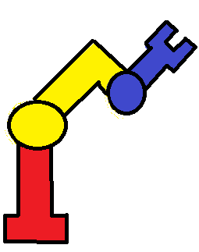Number of DOFs = 6DOF Robotic arm sketch

* Up-down
* Left-right
* Forward - backward
* Tilt up-down
* Turn left-right
* Tilt left-right

**Questions 10**

An interpolation that takes place on a rotation of -90 degrees to a rotation of +90 degrees will result is a bad matrix. This bad matrix will not be a mathematically valid solution because it does not give a valid rotation. This will result is an orthogonal which is not positive.

**Questions 11**

* Using interpolation to compute the interpolated translation matrix at time t = 22

|  |  |  |  |
| --- | --- | --- | --- |
| **t** | **20** | **30** | **22** |
| **Tx** | 9 | 15 | 10.6 |
| **Ty** | 7 | 4 | 6.4 |

* These values were calculated by using a formula on the x values and then separately on the y values. They were calculated using the following equation:

(30 – 20)

(22 – 20)

* + - It is the higher value – lower value / the desired value – lower value.
    - This is done for the x values and then for the y values.
    - These values need to fall between the values for TX and TY of time t = 20 and 30.

**Questions 12**

**Median filter**

* **X [1] = median [1 1 2] = 1 Y [1] = median [1 1 3] = 1**
* **X [2] = median [1 2 4] = 2 Y [2] = median [1 3 4] = 3**
* **X [3] = median [2 4 5] = 4 Y [3] = median [3 4 12] = 4**
* **X [4] = median [4 5 6] = 5 Y [4] = median [4 4 12] = 4**
* **X [5] = median [5 6 7] = 6 Y [5] = median [3 4 12] = 4**
* **X [6] = median [6 7 8] = 7 Y [6] = median [1 3 4] = 3**
* **X [7] = median [7 8 8] = 8 Y [7] = median [1 1 3] = 1**
  + **At t = 3, 4 keeps repeating itself for the next few frames.**

**Questions 13**

Describe the simulation loop employed in physics-based animation of rigid bodies.

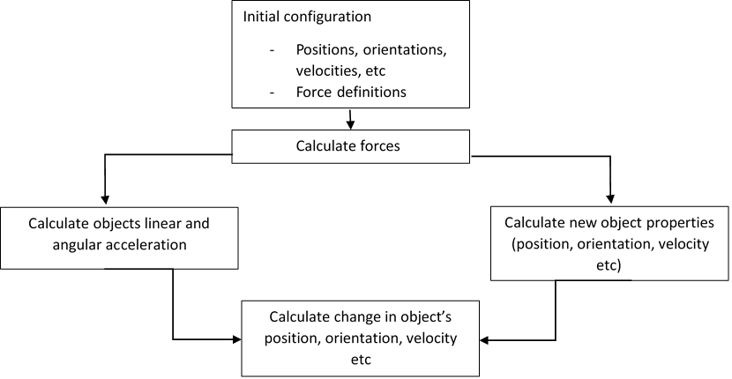

* The simulation loop is a process of calculations. It starts of in an initial configuration that records the position/velocities of objects and the definition of forces. It then calculates the forces. Then it proceeds to calculate the objects linear and angular accelerations, then calculates the change in the objects position, orientation and velocity. Then calculates the new object properties such as position and velocity, orientation etc.

**Questions 14**

Give the output of the initial state and the ﬁrst TWO iterations of the following L-system:

**Axiom F**

**F→F[+F] F angle = 60◦**

**String representation**

**Initial state = F**

**1st iteration = F[+F] F**

**2nd iteration = F[+F] F [+F] [+F] F [+F] F**

**Graphical form**

1st it: 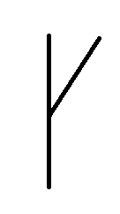 2nd it: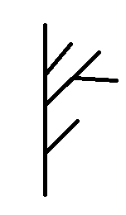

**Questions 15**

* Particle systems are a procedural system that can be used to model amorphous, dynamic and fluid objects. It is a collection of small point-like particles that change over time, move, is randomly generated and have everchanging characteristics. Examples of phenomena that can be produced using a particle system would be the generation of **fire**, **clouds** **smoke** etc.
* It is used by creating a new particle system. These particles are then assigned initial attributes such as position, velocity and colour. The particles that exceed their lifespan are destroyed and the remaining particles attributes are updated. The particles are then rendered.