**School AdministratorFormsOverview**

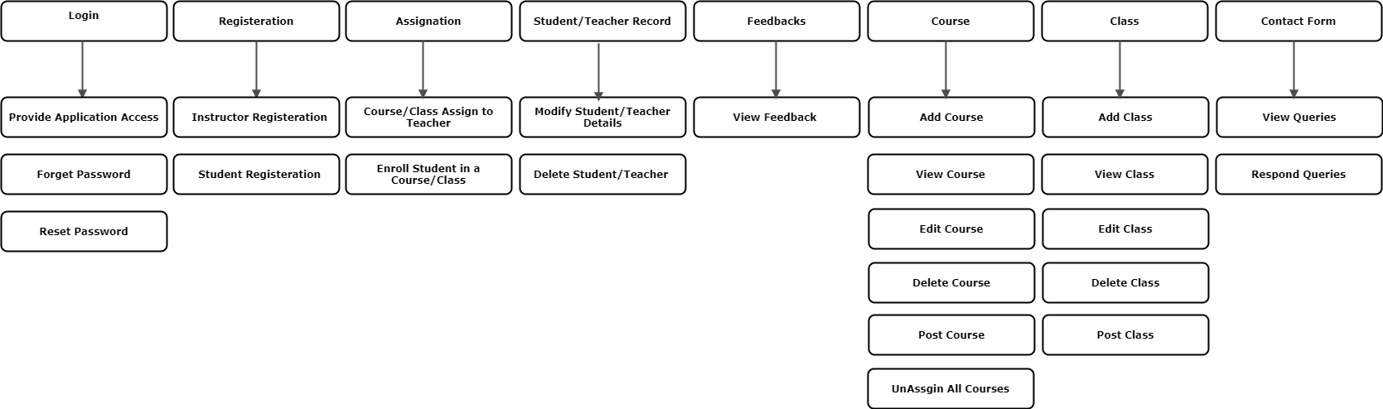

**School Teacher FormsOverview**

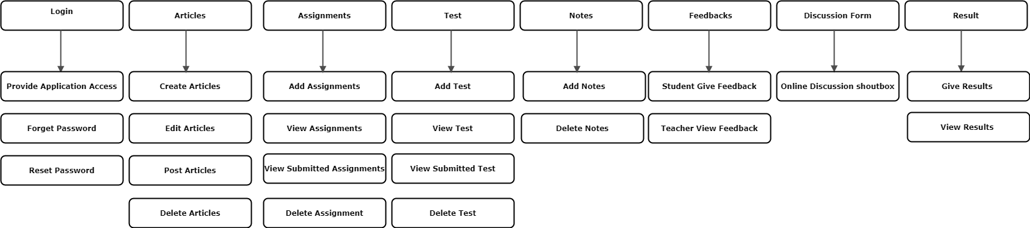

**School Student FormsOverview**

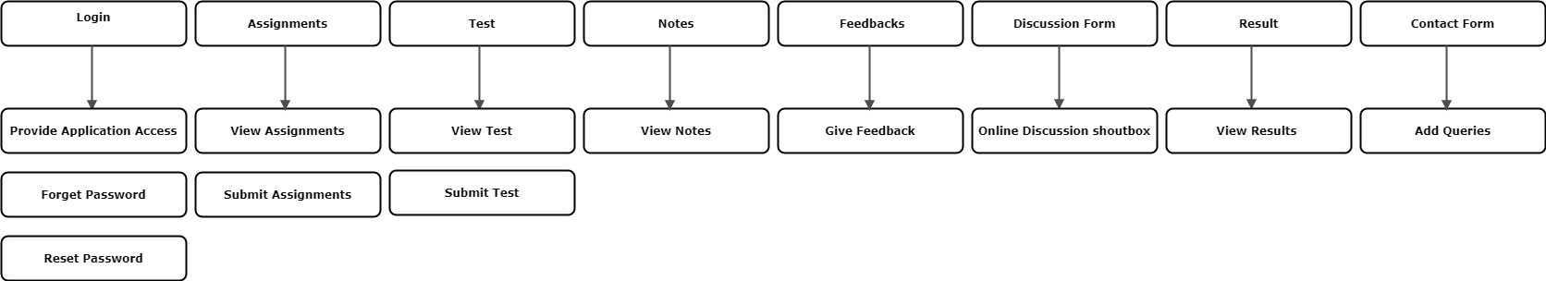

**SuperAdmin And Client FormsOverview**

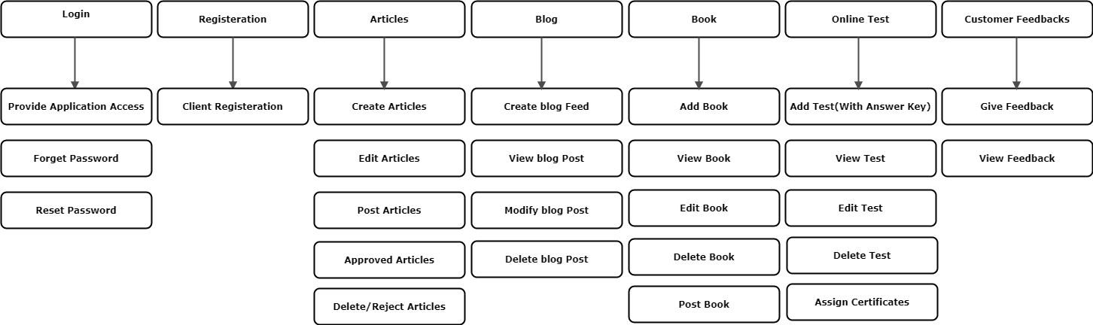

**Fundamental Requirements – User View**

|  |  |
| --- | --- |
| **Client** | |
| Login | The Client can login using his email and password |
| Forgot Password | The Client can reset his password via request |
| Registration | The Client can create an account using student registration |
| Dashboard | The Client can view all the most recent activity in his dashboard |
| User Profile | The Client can view his profile data and make some changes to it if needed |
| Articles | The Client can write, edit, publish articles and also send articles for approval from administration. |
| Online Test | The Client can view online test uploaded by administrator. |
| Result | The Client can view Result and apply for Certificate |
| Announcements | The Client can view daily basis announcements uploaded by an admin. |
| Complain | The Client can submit complain to administrator via complain form. |
| Customer Feedback | The Client can give feedback to admin about course. |
| Logout | The Client can logout of the system |

|  |  |
| --- | --- |
| **SuperAdmin** | |
| Login | The admin can login into the system |
| Forgot Password | The admin can reset his password via request |
| Admin Profile | The admin can view his profile data and make some changes to it if needed |
| User Accounts | The admin can approve user account registration. He can also edit / delete existing accounts |
| Account Settings | The admin can change his account settings such as profile picture and account password etc |
| Course | The administrator can add/view / edit / delete/post Course. |
| Articles | The administrator can add/view / edit / delete articles posted by Clients. He will also approve the articles before publishing them and he will also post articles. |
| Blog | The administrator can add blog feed /edit blog/delete blog and delete articles from the blog. |
| Event | The administrator can add event/edit /delete event. |
| Callobrations | The administrator can add event/edit /delete callobration. |
| Online Test | The administrator can add/view / edit / delete online test.And on the basis of grading he will assign certificates to students. |
| Queries | The administrator can respond to customer queries (entered via contact form) |
| Website Information | The administrator can update information on the main website such as announcements. |
| Logout | The admin can logout of the system |
| Add School | Admin can add school. |

|  |  |
| --- | --- |
| **Administrator** | |
| Login | The admin can login into the system |
| Forgot Password | The admin can reset his password via request |
| Account Settings | The admin can change his account settings such as profile picture and account password etc |
| Registration | The administrator can register/view/modify/remove registered teachers and students |
| Records | The administrator can view according to classes/edit / delete staff and students. |
| Course | The administrator can add /edit /delete and unassigned courses |
| Course Assignation | The administrator can assign courses to teacher and enroll Students in courses. |
| Class | The administrator can add/view/upload/edit/ delete class. |
| Support | The administrator can respond to student queries (entered via contact form) |
| Complain | The Client can submit complain to administrator via complain form. |
| Logout | The admin can logout of the system |

|  |  |
| --- | --- |
| **Teacher** | |
| Login | The teacher can login using his email and password |
| Forgot Password | The teacher can reset his password via request |
| Registration | The administrator can register relevant students |
| Dashboard | The teacher can view all the most recent activity in his dashboard |
| Online class | The teacher can give live lectures. Upload recorded lectures and reference related video tutorial links. |
| Attandence | The teacher can take/view attandence. |
| Assignments | The teacher can add/view uploaded assignments/view submitted assignments/delete assignments. |
| Online Test | The teacher can add/view uploaded test/view submitted test/delete test. |
| Lectures | The teacher can add/view/delete lectures which is taken from book. |
| Calender | The teacher can create/delete events. |
| Customer Feedback | The teacher can view feedback about course. |
| Discussion Form | The teacher can answer to queries which is post on shout box. |
| Account Settings | The teacher can change his account settings such as profile picture and account password etc |
| Result | The teacher can add/view/edit results and generate transcript of students in pdf. |
| Logout | The teacher can logout of the system |

|  |  |
| --- | --- |
| **Student** | |
| Login | The student can login using his email and password |
| Forgot Password | The student can reset his password via request |
| Dashboard | The student can view all the most recent activity in his dashboard |
| Online class | The students can join live streaming leactures. view/download recorded lectureses nand video tutorials. |
| Attandence | The students can view their attandence. |
| Calender | The students can view about their upcoming events and activities. |
| Assignments | The student can view/submit assignments uploaded by teacher. |
| Online Test | The student can view/submit online test uploaded by teacher. |
| Notes / Lecture | The student can view/download upload lectures which is taken from book. |
| Customer Feedback | The student can give feedback to teacher about enrolled course. |
| Complain | The student can contact to administrator via complain form. |
| Account Settings | The student can change his account settings such as profile picture and account password etc |
| Discussion Form | The student can about their queries on shout box. |
| Result | The student can view results uploaded by teacher. |
| Logout | The student can logout of the system |

**TeacherForm Fields:**

**Settings:**

profile(name,contact number,image)

**Registration:**

**Add Student:**

* Name
* Image
* Email
* Contact
* Date
* Address(TextArea)
* Class

**View Student:**

Table(Name,Image,Email,Contact,Date,Address,Class)

**Online class:**

**Live:**

* Stream

**Recorded lectures:**

* upload
* download
* modify
* delete

**view lectures:**

Table(Upload,Download,Modify,Delete)

**video tutorial:**

* upload(Links)
* download
* delete

**view:**

Table(upload,download,delete)

**Attendance:**

**Add:**

* take(Check mark)
* edit
* delete

**view:**

Table(Take,Edit,Delete)

**Calender:**

**Add:**

* create event
* delete event

**view:**

Table(Create,Delete)

**Notifications:**

* post
* submission

**view:**

Table(Post,Submission)

**Online Test:**

**Add:**

* Course(Dropdownlist)
* Class(DropDownlist)
* Duration
* Question(TextArea)
* OptionName
* Add Option(Button)
* Add(Button)

**View:**

Table(Course,Class,Duration,Action,Date,Action)

**Test File:**

**Add:**

* Course(Dropdownlist)
* Class(DropDownlist)
* Duration
* Choose File(pdf,word,etc)
* Add(Button)

**View:**

Table(Course,Class,Duration,Date,Action)

**Test:**

* Test Create(DropDownlist((1)Create Mcqs→Online Test Form,(2)Add File→Test File Form)
* Add(Button)

**Assignment:**

**Add:**

* Assignment Name
* Class(DropDownlist)
* Course(DropDownlist)
* Assignment Url(choose file pdf,word)
* Duration
* Add(Assignment)

**View:**

Table(Date,Course,Class,AssignmentName,Duration ,Action)

**Lecture:**

**Add:**

* Lecture Name
* Course(DropDownList)
* Class(DropDownlist)
* Lecture Url(choose file pdf,word)
* VideoLink
* Add Lecture

**View:**

* Table(Date,Course,Class,LectureName ,Action→Lecture Detail Form)

**LectureDetailForm :**

* Table(LectureFile,VideoLink)→Lecture Detail Form)

**Result:**

* **AddStudent Marks(Button→Student Result Form):**

**Student Result Form:**

* Student Registeration No(Drop Down list)
* Name
* Email
* Course(DropDown list)
* Class(DropDown List)
* Total Marks
* Marks Obtained

**Generate TranscriptPdf:**

Table(Student Name,Course,ClassName,RegisterationNumber,Action)

Generate Pdf (Button on top left side)

**StudentForm Fields:**

**Settings:**

profile(name,contactnumber,image)

**class:**

**view:**

* Table(Time,ClassName,Duration,ClassLink,Action→JoinClass)

**Join:**

* Join(Link)

**Attendance:**

**View:**

* Table(Date,Time,ClassName,Duration,Action→Generate attendance pdf)

**Assignment:**

**View:**

* Table(Date,AssignmentName,AssignmentFile,Duration,Action→Submit Form)

**Submit:**

* Submit Assignment(choose file pdf,word,textfileetc)
* Submit(Button)

**Test:**

**View Online Test:**

Table(Course,Duration,Action)

**View Uploaded Test**:

Table(Course ,Duration,Action→(Submit Test Form))

**SubmitTest Form**:

* Submit Test(choose file pdf,word,textfileetc)
* Submit(Button)

**Lecture :**

* View Lecture(Date,Course,View→Lecture Detail Form)

**LectureDetailForm :**

* Table(Date,Course,LectureUrl,VideoLink)→Lecture Detail Form)

**Feedbacks:**

**Add:**

* Course(DropDownList)
* Comment(TextArea)

**View:**

Table(Date,Course,Comment)

**Discussion Form:**

**Add:**

* Username
* Course(DropDownList)
* Description(TextArea)
* Date
* Submit(Button)

**View:**

Table(Course,Reply,Date,Action→DetailForm)

**Detail Form**:

* Reply(Text Area)
* Submit(Button)

**Calender:**

* view:(StartDate,EndDate,Action→EventDetails)

**Notifications:**

* view(alert,Action→RedirectToPost)

**Complain Form:**

**Add:**

* Query (TextArea)

**View:**

Table(Date,Reply,Action→DetailForm)

**Detail Form**:

* Reply(Text Area)
* Submit(Button)

**Result Form:**

Table(Course Code, Name,Course ,Action→Generate Pdf(Button on top left side))

**AdministratorForm Fields:**

**Settings:**

profile(name,contactnumber,image((choose file)))

**Registration:**

**Add Teacher:**

* Name
* Image(choose file)
* Address(TextArea)
* Email
* Contact
* Designation

**Add Student:**

* Name
* Image(choose file)
* Email
* Contact
* Date
* Address(TextArea)
* Class

**View Student:**

Table(Date,RegisterationNumber,Name,Image,Email,ContactNo,Class)

**View Staff:**

Table(Date,Name,Image,Email,Designation,Contact No)

**Class:**

**Add:**

* Class Code
* Name

**View :**

Table(Date,ClassCode,Name)

**Course:**

**Add:**

* Code
* Name
* Description
* Class

**Course Statistic:**

* **Select Class(DropDown list)**
* **Table(Code,Name,Teacher)**

**UnAssigned Courses:**

**Unassigned course(Button)**

**Course Assignation:**

* Class(DropDownlist)
* Teacher(Dropdownlist)
* Course(dropdownlist)
* Name

**Enrollment:**

* Registeration Number(DropDownlist)
* Name
* Email
* Class(DropDownList)
* Course(Dropdownlist)
* Date

**Feedback:**

**View :**

Table(Date,StudentName,Class,Course,Feedback)

**Support Form:**

**Add:**

* Response(text area)

**View:**

Table(Date,Complain,Action→DetailForm)

**Detail Form**:

* Reply(Text Area)
* Submit(Button)

**Article Form:**

* Type
* HeadLine
* Image/Video
* Short Description
* Long Description
* Date
* Add(Button)

**Complain Form:**

**Add:**

* Query (TextArea)

**View:**

Table(Date,Reply,Action→DetailForm)

**Detail Form**:

* Reply(Text Area)
* Submit(Button)

**SuperAdmin Form Fields:**

**Event:**

**Add**:

* Date
* Title
* Event Start Time
* Event End Time
* Description
* Venue
* VenueImage

**Callobration:**

**Add**:

* Title
* Date
* Image
* Date
* Description

**Settings:**

profile(name,contactnumber,image((choose file)))

**Announcements**:

**Add**:

* Topic
* Description
* Date
* Add(Button)

**School**:

**Add**:

* Name
* Image(Choose File)
* Number
* Address
* Contact Number
* Add(Button)

**View**:

Table(Date,Name,Image,Number,Address,Contact Number)

**Support Form:**

**Add:**

* Response(text area)

**View:**

Table(Date,Complain,Action→DetailForm)

**Detail Form**:

* Reply(Text Area)
* Submit(Button)

**Blog**:

**Add**:

* Type
* HeadLine
* Image/Video
* Short Description
* Long Description
* Date
* Add (Button)

**Article**:

**Add**:

* Type
* HeadLine
* Image/Video
* Short Description
* Long Description
* Date
* Add(Button)

**Approval**:

**Client approval:**

Table(Date,ClientName,Approve/Reject)

**Client /school approve articles:**

Table(Date,Type,HeadLine,Image/Video,ShortDescription,LongDescription,Approve/Reject)

**Course approval:**

Table(Date,ClientName,Course,Approve/Reject)

**Test:**

**Add:**

* Course(Dropdownlist)
* Class(DropDownlist)
* Duration
* Question(TextArea)
* OptionName
* Add Option(Button)
* Add(Button)

**View:**

* Table(Course ,Duration,Action,Date,Action)

**Course:**

* CourseName
* Category
* Duration
* Short Descripton
* Long Descripton
* Image Link
* Video Link

**Certificate Issues:**

table(bank name,acctno,mode of transcation,action)

**ClientForm Fields:**

**Settings:**

profile(name,contactnumber,image((choose file)))

**Article**:

* Type
* HeadLine
* Image/Video
* Short Description
* Long Description
* Date
* Add(Button)

**Course:**

Table(Date,Courname,Approve/Reject)

**Result**:

Table(Date,Course,Duration,Apply For Certificate→Payment Form)

**Payment Form:**

* Bank Name(DropDownlist)
* Account No
* Mode Of Transaction(dropdownlist→(instrument,cash,onlinetranscation))
* Transaction Slip Number
* Upload File Slip
* Submi(Button)

**Feedback Form:**

* Course (DropDownlist)
* Commment(TextArea)

**Complain Form:**

**Add:**

* Query (TextArea)

**View:**

Table(Date,Reply,Action→DetailForm)

**Detail Form**:

* Reply(Text Area)
* Submit(Button)