1. Write the following numbers in normal decimal notation:
   1. 103e-4
   2. 1.2345e+6
   3. 123.45e+3
2. Write the following numbers in C scientific notation.
   1. 1300
   2. 123.45
   3. 0.00426
3. Write a very simple C program which has #define preprocessor directive and declarations for constant macro PI (3.14159) and variables radius, area, circumf declared as double; variable num_circ as integer and variable circ_name as char.
4. Show the output displayed by the following program lines when the data entered as 5 and 7:

#include <stdio.h>

int main(void)

{

int m, n;

printf("Enter two integers: ");

scanf("%d%d", &m, &n);

m = m + 5;

n = 3 * n;

printf("m = %d\nn = %d\n",m,n);

return 0;

}

1. Write a program that asks the user to enter the radius of a circle and then computes and displays the circle’s area. Use the formula

$$Area=Pi×Radius×Radius$$

where PI is the constant macro 3.14159.

Home Exercise

Write a program to assist in the design of a hydroelectric dam. Prompt the user for the height of the dam and for the number of cubic meters of water that are projected to flow from the top of the dam each second. Predict how many megawatts (1MW= ${10}^{6}W$) of power will be produced if 90% of the work done on the water by gravity is convereted to electrical energy. Note that the mass of one cubic meter of water is 1000 kg. Use 9.80 m/ $\sec^{2}$ as the gravitational constant g. Be sure to use meaningful names for both the gravitational constant and the 90% efficiency constant.

For one sample run, use a height of 170 m and flow of $1.30 × {10}^{3}m^{3}/s$. The relevant formula is

$$w=mgh$$

where w is work, m is mass, g is gravity and h is height.

ANSWERS:

1. Write the following numbers in normal decimal notation:
   1. 103e-4 --- 0.0103
   2. 1.2345e+6 --- 1234500.0
   3. 123.45e+3 --- 123450.0
2. Write the following numbers in C scientific notation.
   1. 1300 --- 1.3e+3
   2. 123.45 --- 1.2345e+2
   3. 0.00426 --- 4.26e-3
3. Write a very simple C program which has #define preprocessor directive and declarations for constant macro PI (3.14159) and variables radius, area, circumf declared as double; variable num_circ as integer and variable circ_name as char.

#include <stdio.h>

#define PI 3.14159

int main(void)

{

double radius, area, circumf;

int num_circ;

char circ_name;

/* executable statements omitted */

}

1. Show the output displayed by the following program lines when the data entered as 5 and 7:

#include <stdio.h>

int main(void)

{

int m, n;

printf("Enter two integers: ");

scanf("%d%d", &m, &n);

m = m + 5;

n = 3 * n;

printf("m = %d\nn = %d\n",m,n);

return 0;

}

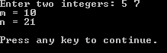

1. Write a program that asks the user to enter the radius of a circle and then computes and displays the circle’s area. Use the formula

$$Area=Pi×Radius×Radius$$

where PI is the constant macro 3.14159.

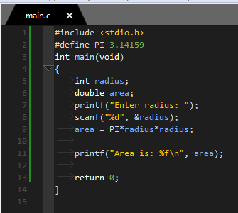

Home Exercise Sln

