# EE321 Lab 5 Report

# S025015

$$Timer Period= \frac{Prescaler Value × Timer Register Increment}{Input Clock Frequency}$$

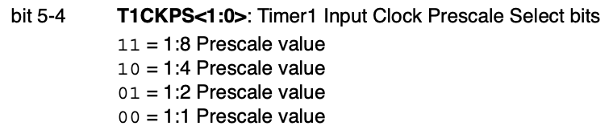

For the prescalers which is created before, T1CON.T1CKPS1 = 0 ;T1CON.T1CKPS0 = 0. This means 1:1 scale. And we set prescalers T1CON.T1CKPS1 = 1 ;T1CON.T1CKPS0 = 1. This means 1:8 scale.

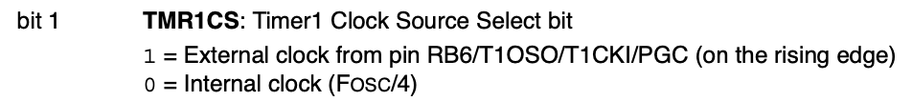

Set the internal clock as the clock as the source Timer1:

T1CON.TMR1CS = 0;

Set the most significant byte of the timer/counter register:

TMR1H = 0xC2;

Set the least significant byte of the timer/counter register

TMR1L = 0xF7;

Turn timer on:

T1CON.TMR1ON = 1;

Clear the Timer1 interrupt flag:

PIR1.TMR1IF = 0;

Now we have a timer and interrupt. When the timer overflows, the interrupt will be activated, calling the interrupt function within our program.

The equation that I used to find starting point for when prescaler is 8:

$$2^{16}-\frac{{10}^{6}}{4×8}=49911=C2F7$$