Data Structures and Algorithms

**LAB-01**

1. SEPT-2023

Hasan Amin

374866

**Long_rivers:**

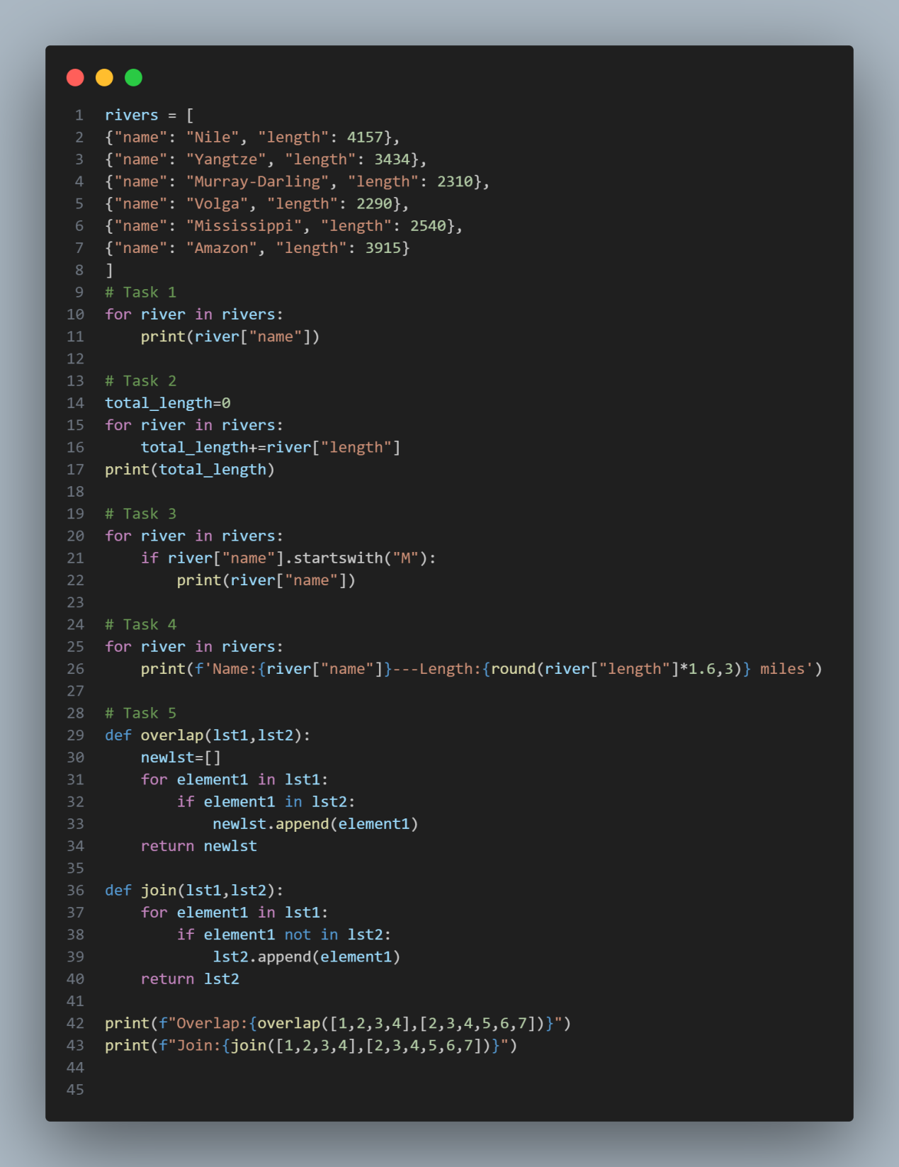

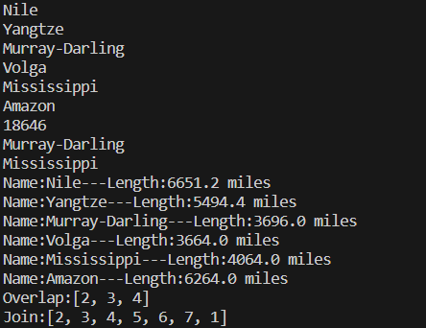

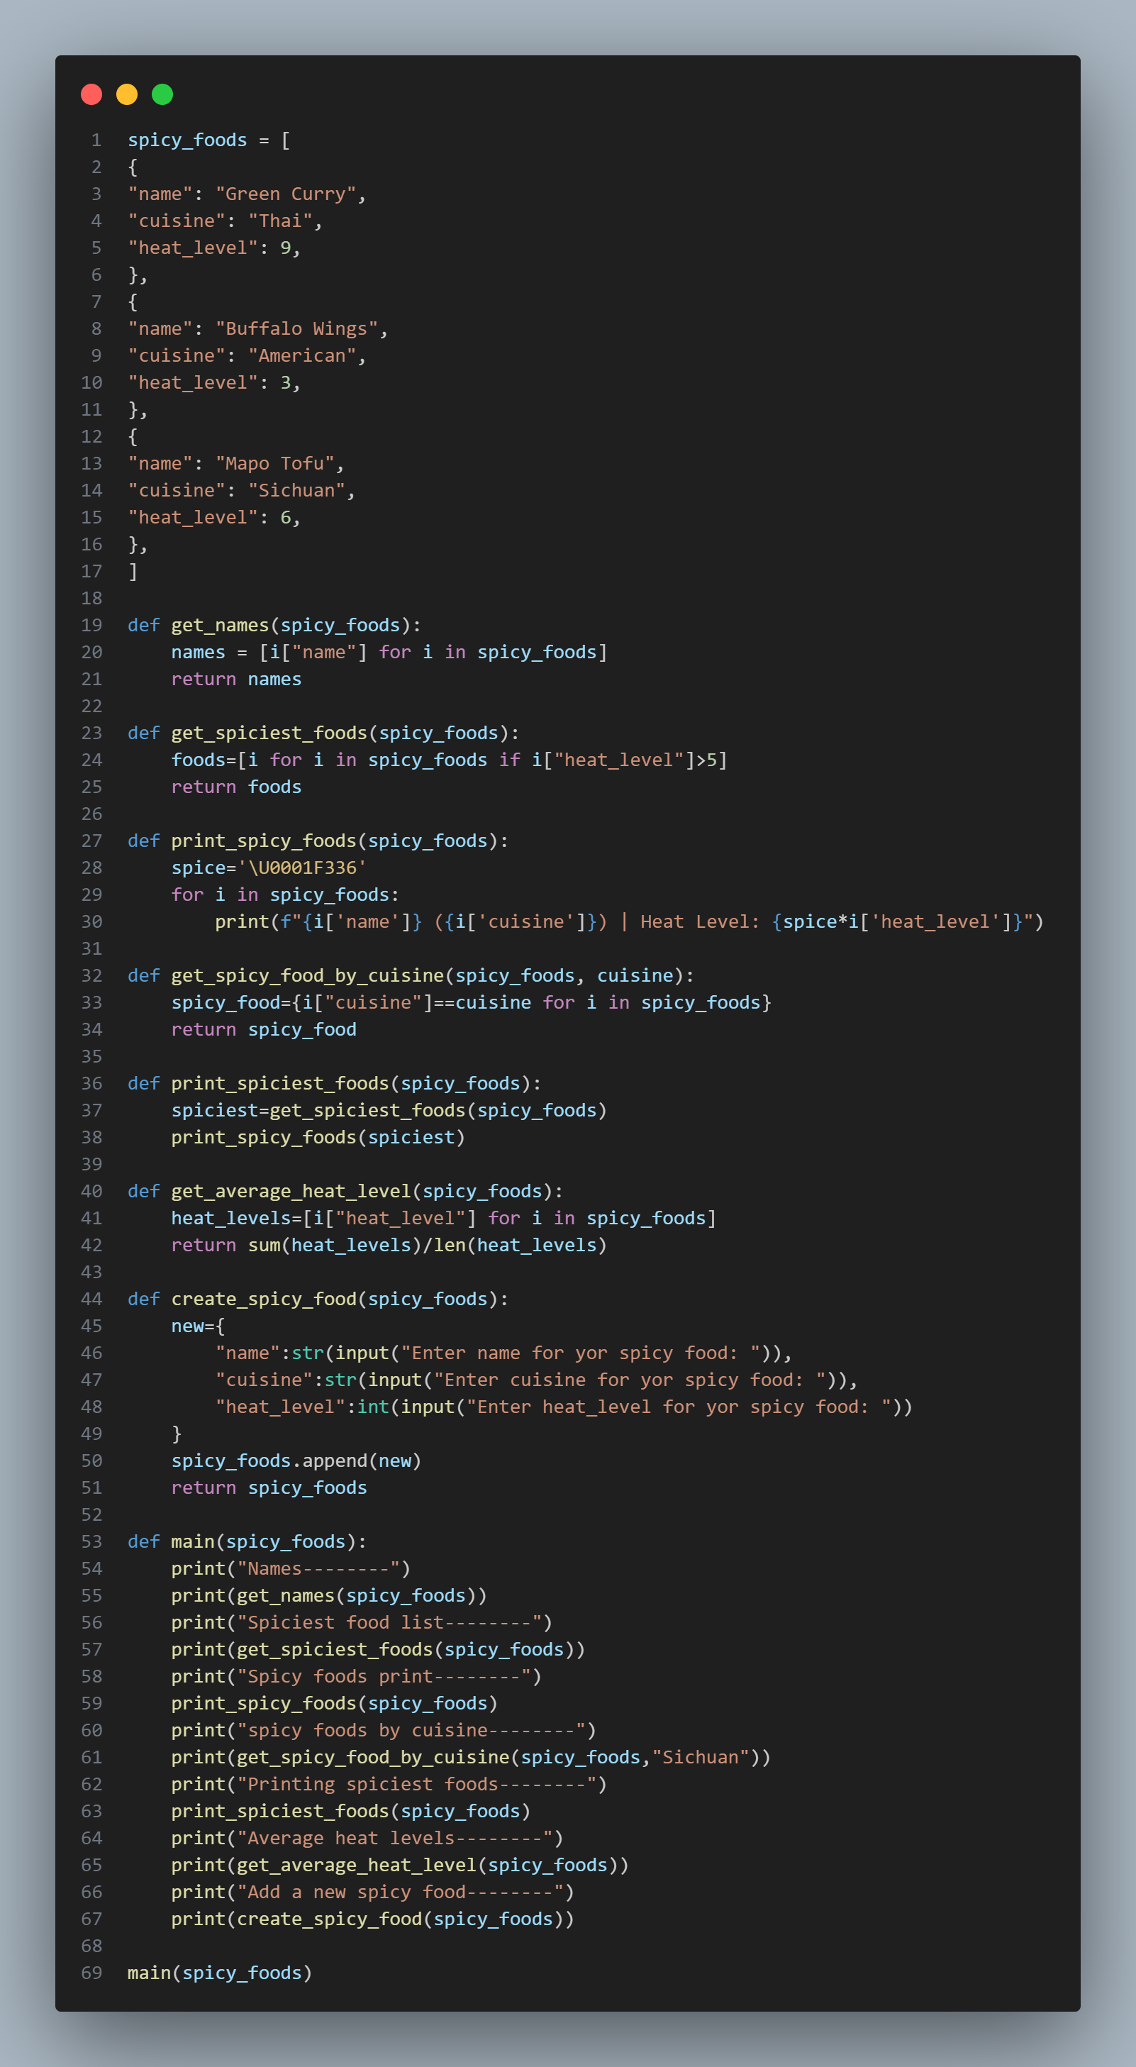**Spicy Foods**

