# Automated Teller Machine System (ATM)

## Abstract

This project aims to create an ATM system which will store data of the customer including his/her credentials and allow him to make transactions according to his/her account balance.

## Entity Relationship Diagram

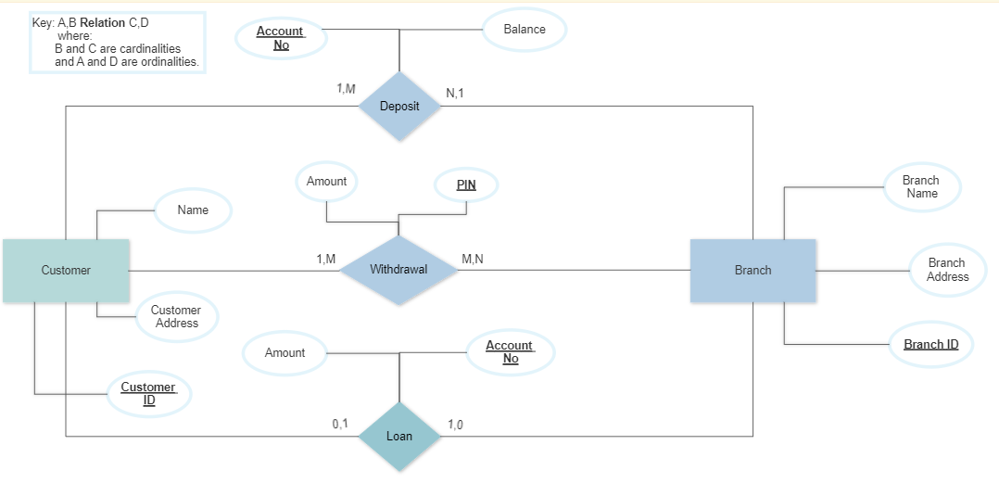Normalization

### 0NF

Customer[Customer_ID,Name,Address]

Branch[**Branch_ID**,Branch_Address,Branch_Name]

Deposit[**Account_no**,Amount]

Loan[**Account_no**,Amount]

Withdrawal[**Account_no,**Amount]

### 3NF

Customer[**Customer_ID**, fname, lname, house_no, street_no, area, city, country]

Branch[**Branch_ID**,Branch_Name,plot_no, street_no, area, city, country]

Bank_Accounts[**Account_no,**PINCustomer_ID(FK),Branch_ID(FK),Account_Balance]

Deposit[**Account_no(FK)**,Amount,Branch_ID(FK)]

Loan[**Account_no(FK)**,Amount, Branch_ID(FK)]

Withdrawal[**Account_no(FK)**,Amount, Branch_ID(FK)]