**Lab 1: Using Java from the Command Line**

# Exercise 1: Creating your Bitbucket Account

1. Open the following link using your browser:

# <https://bitbucket.org/>

1. Click

button and enter your email address in the specified

**“**[**Get started for free**](https://bitbucket.org/account/signup/)**”**

field, then enter your full name and password as well. Then click the “Continue” button.

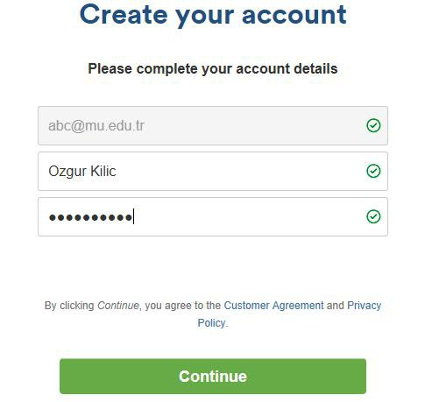

1. You will receive email from Atlassian. Open the email and verify your email address by clicking the button.
2. Your username should be in the following format: **U##########** where U is followed by your school id. If your school id is 123456789 then your user account should be **U123456789**.

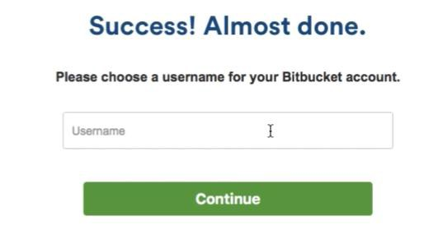

1. Search and find the template repository by typing tugbasuzek/dblab2019 in the Bitbucket toolbar:

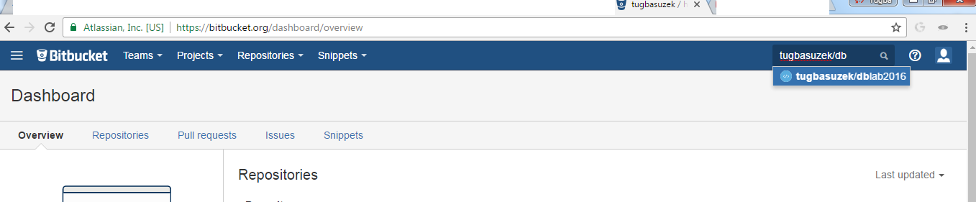

1. You should see a page that looks like this:

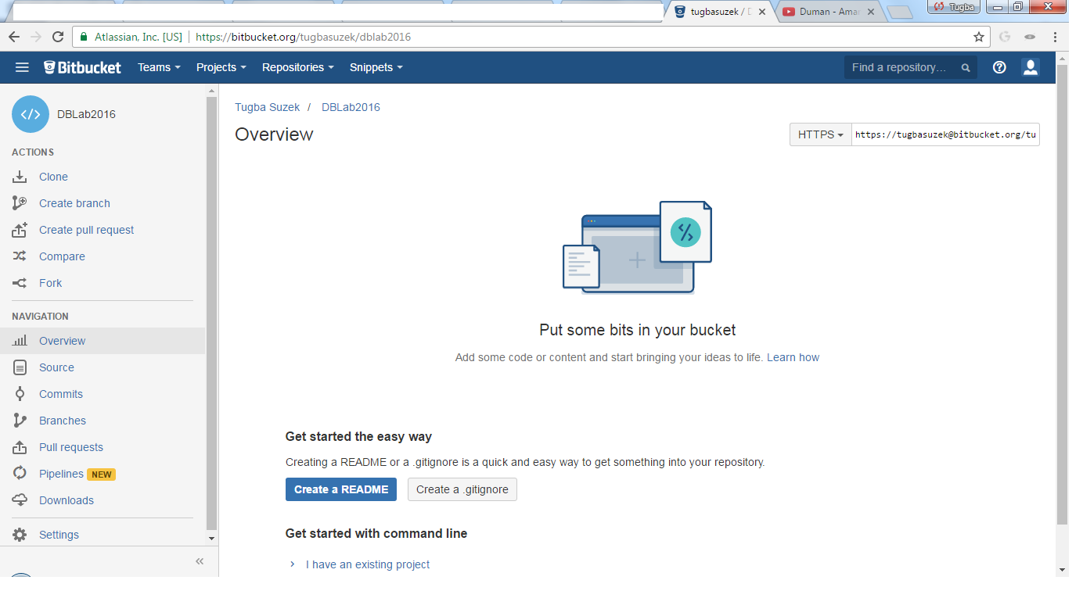

1. In the left navigation panel, click on **Fork** to create your own repository based on this template.

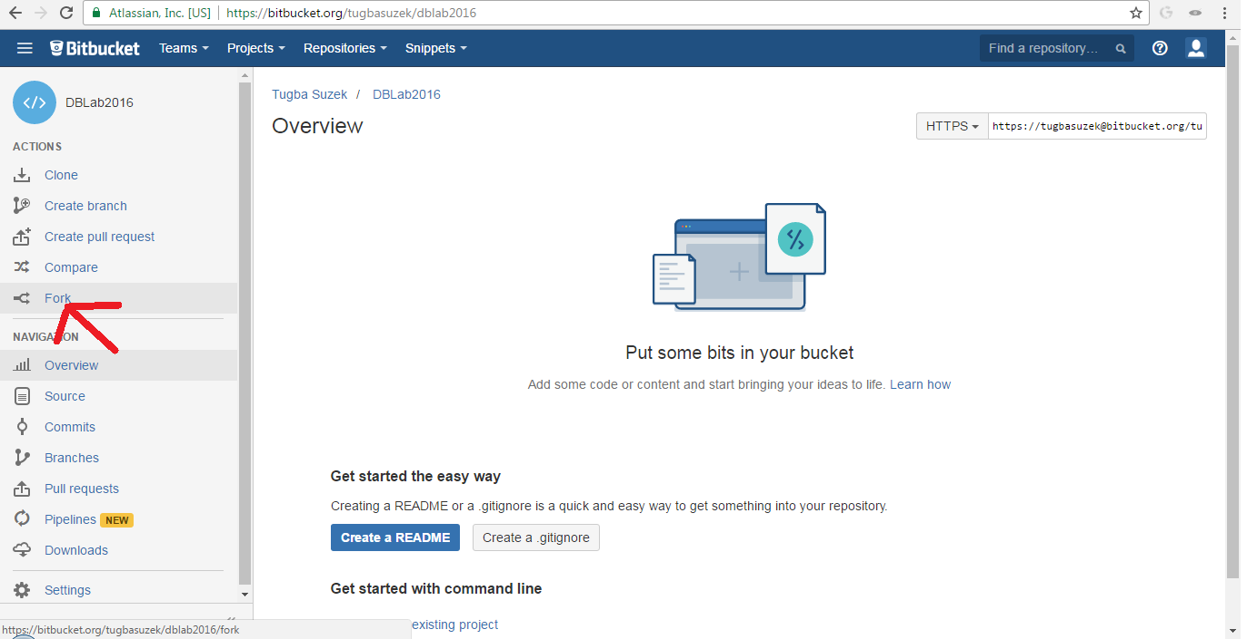

* 1. Clone lab repository to your machine
     + Create a directory named workspace in your home folder
     + In workspace folder enter the following command, but replace username with your actual user

git clone <https://username@bitbucket.org/username/lab.git>

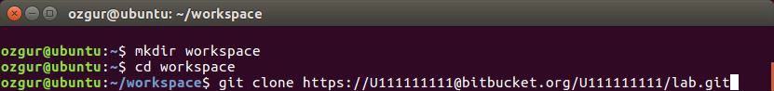

* + - A folder named “lab” will be created after executing the command.

Git is already installed on linux lab machines. If you are using a machine running windows OS you can install git from <https://git-for-windows.github.io/>

* 1. Make sure you have the Java installed on your system by issuing the following commands: java -version

javac -version

* 1. Go into a subdirectory (of the “lab” directory) named "lab1" and open the HelloWorld.java

public class HelloWorld{

public static void main(String[] args){ System.out.println("Hello World");

}

}

* 1. In the command compile the HelloWorld.java by executing the “javac HelloWorld.java”
  2. List the files in lab1 directory. Run the HelloWorld class by issuing the “java HelloWorld” command in the lab directory.

# Exercise 4 : Write a Class Which Prints Your Name

1. Create a file named Me.java
2. Implement the main method of the Me class to print your name.
3. Compile and run Me class

# Exercise 5 : Committing your source back to Bitbucket

1. Execute the following commands in the given order (say for the user Ozgur Kilic)

git add Me.java

git config --global user.email "[ozgurkilic@mu.edu.tr](mailto:ozgurkilic@mu.edu.tr)" git config --global user.name "OzgurKilic"

git commit -m "Initial commit" git push -u origin master

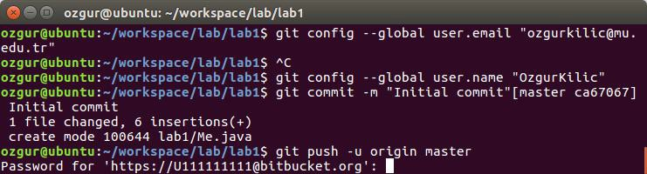

2. Enter your bitbucket password

3. Check your repository using the Bitbucket Web site

