

COMSATS University Islamabad

Department of Computer Science

Mobile App Development

Submitted To: Ma’am Qanetah Ahmad

Submitted By:

Sahibzada Hasanat Ahmad FA23-BCS-088

Muhammad Rayyan Taimor FA23-BCS-072

Nouman Zahid FA23-BCS-085

MTAG Queue Skipper

1. Project Overview
MTAG Queue Skipper is a Flutter-based mobile application designed to streamline bike registration and token management for users. The app provides a complete offline-first workflow covering user account management, bike registration, and token tracking — all persisted locally on the device without requiring a backend server.

1.1 Purpose and Scope
The application simulates a full user lifecycle for the MTAG (Motor Transport Authority Gateway) queue management system. It was developed as a local-first prototype to demonstrate the core flow before backend API integration. Key capabilities include:
- User account registration and login with multi-user support
- Bike registration with full owner and vehicle detail capture
- Automated token generation and real-time status tracking
- Persistent storage of user and bike data across sessions
- Profile viewing and session management

1.2 Core User Journey
The primary flow a user follows through the application:

Step 1 | User opens the app and views the animated splash screen
Step 2 | User logs in with existing credentials or registers a new account
Step 3 | User lands on the Home Screen dashboard
Step 4 | User registers their bike with owner and vehicle details
Step 5 | App generates a token and displays token metadata and status
Step 6 | User can view bike details, check token status, and manage profile

2. Technical Stack
The application is built using the Flutter framework with a lean set of dependencies chosen for stability and offline capability.

Component | Technology | Notes
Framework | Flutter | Cross-platform mobile SDK
Language | Dart (>=3.11.0 <4.0.0) | Strongly typed, compiled to native
State Management | Provider (ChangeNotifier) | Lightweight reactive state
Persistence | shared_preferences | Local key-value device storage
Input Masking | mask_text_input_formatter | CNIC, phone number formatting

3. Application Architecture
The project follows a lightweight layered architecture separating UI, state, data models, and design constants into distinct folders. This ensures maintainability and clear separation of concerns.

3.1 Layer Structure

UI Layer | lib/screens/* — All screen widgets and user interface components
State Layer | lib/providers/* — ChangeNotifier-based state management classes
Data Models | lib/models/* — Serializable entity classes (User, BikeDetails)
Design System | lib/constants/* — Colors, fonts, and theme definitions

3.2 Provider Architecture
Two root-level providers are initialized in lib/main.dart and injected into the widget tree via MultiProvider:

AuthProvider | Manages current user session, registration, login/logout, and persisting the user directory
BikeDetailsProvider | Manages in-memory bike details, token state, and per-user persistence of bike/token data

3.3 Folder and File Map

File / Directory | Responsibility
lib/main.dart | App bootstrap, provider registration, named route configuration
lib/models/user.dart | User entity: name, CNIC, phone, email, password
lib/models/bike_details.dart | Bike and owner registration field definitions
lib/providers/auth_provider.dart | Registration, login, logout, session loading
lib/providers/bike_details_provider.dart | Bike/token in-memory state and per-user persistence
lib/screens/splash_screen.dart | Animated intro, 5-second delay, navigates to login
lib/screens/login_screen.dart | Email/password login form
lib/screens/register_screen.dart | New user registration form
lib/screens/home_screen.dart | Main dashboard with entry points to all features
lib/screens/bike_register_screen.dart | Bike and owner detail collection
lib/screens/token_status_screen.dart | Token display and status tracking
lib/screens/bike_details_screen.dart | Registered bike information view
lib/screens/profile_screen.dart | Logged-in user profile display
lib/constants/app_colors.dart | Brand color palette
lib/constants/app_fonts.dart | Typography presets
lib/constants/app_theme.dart | Full ThemeData definitions (pending wiring)

4. Screen-by-Screen Behavior
This section describes the behavior and purpose of each screen in the application.

4.1 Splash Screen
Displays an animated introduction sequence with the app branding. After a 5-second delay, it automatically navigates the user to the Login Screen. Future improvement: auto-redirect to Home if an active session is detected.
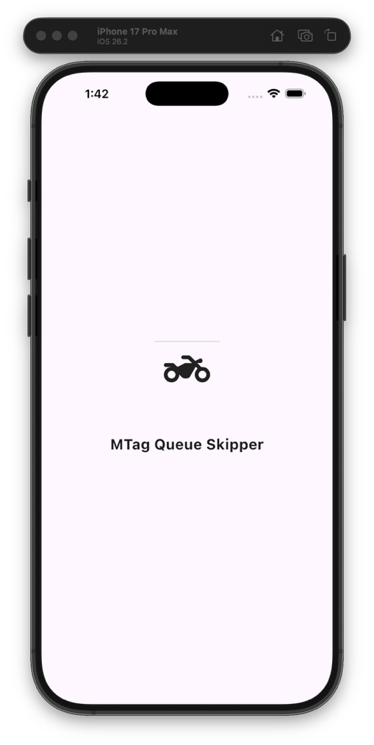

4.2 Login Screen
Presents a form with email and password fields. On submission, AuthProvider.login() is called. Upon successful authentication, the user's bike and token data are loaded via BikeDetailsProvider.loadForUser(email), and the user is navigated to the Home Screen.
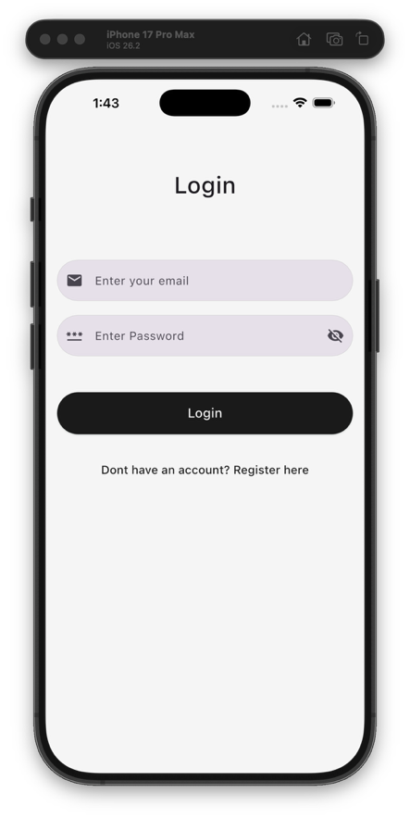

4.3 Register Screen
Collects full user profile information: full name, CNIC (masked input), phone number, email, and password. On successful registration, the session is set to the new user and the app navigates to the Home Screen with a clean state.

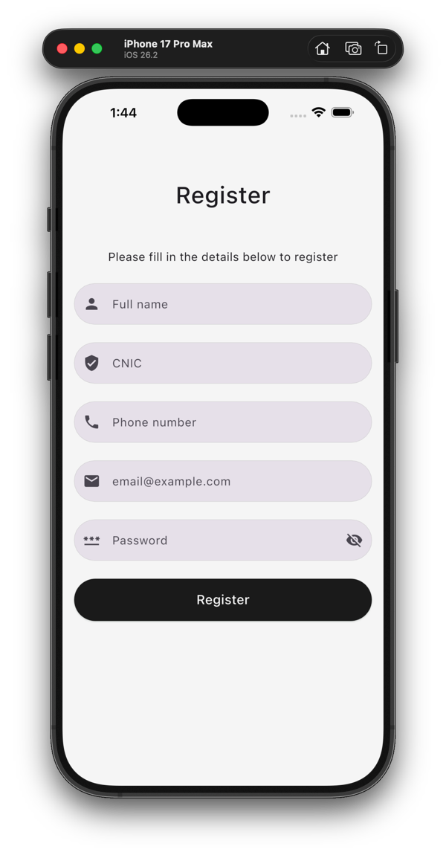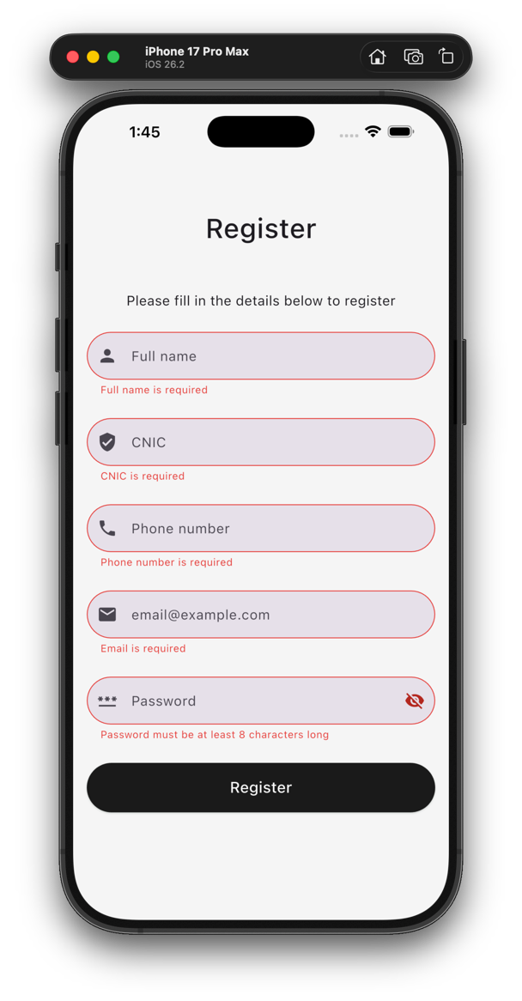

4.4 Home Screen
The central dashboard of the application. It greets the logged-in user by name and provides navigation entry points to: Bike Registration, Token Status, Bike Details, and the User Profile.

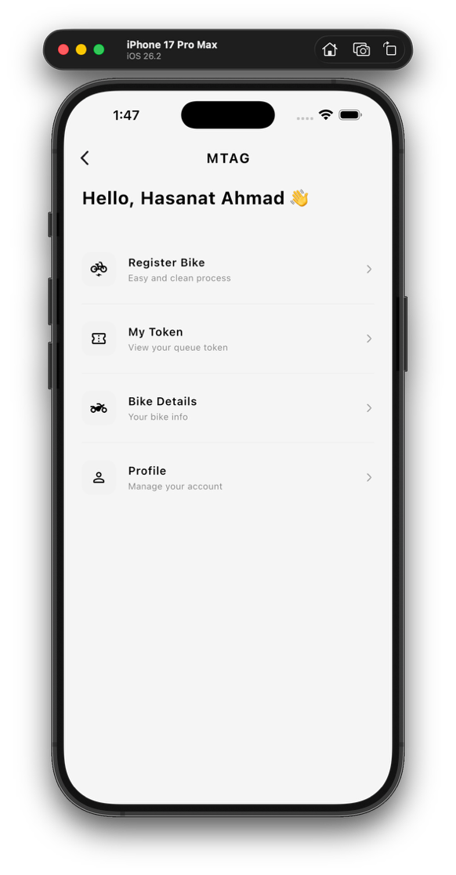

4.5 Bike Register Screen
A multi-field form that collects both owner details and vehicle information. Upon submission, token metadata is generated, stored in BikeDetailsProvider, and persisted to local storage using saveForUser(email). The user is then navigated to the Token Status Screen.

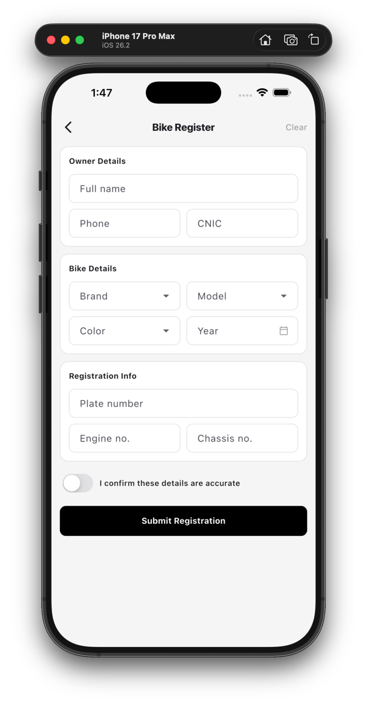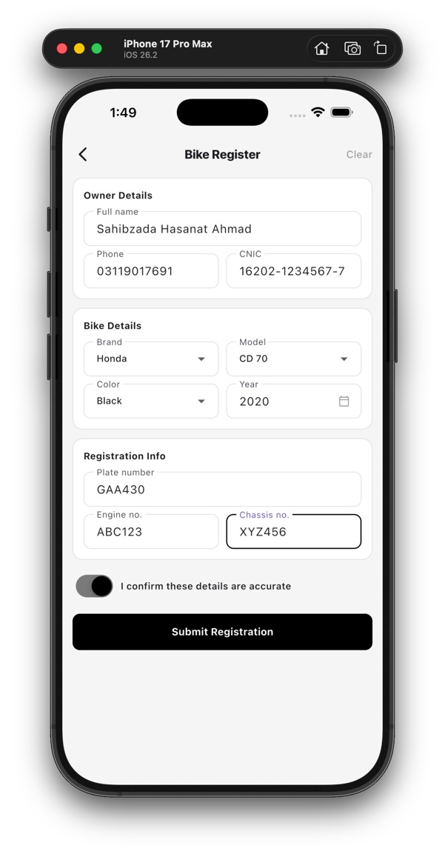

4.6 Token Status Screen
Displays the generated token number along with associated metadata such as token status, estimated processing time, and generation timestamp. If no token is present, a call-to-action is shown prompting the user to register their bike. Token data is sourced from route arguments if available, otherwise from provider state.

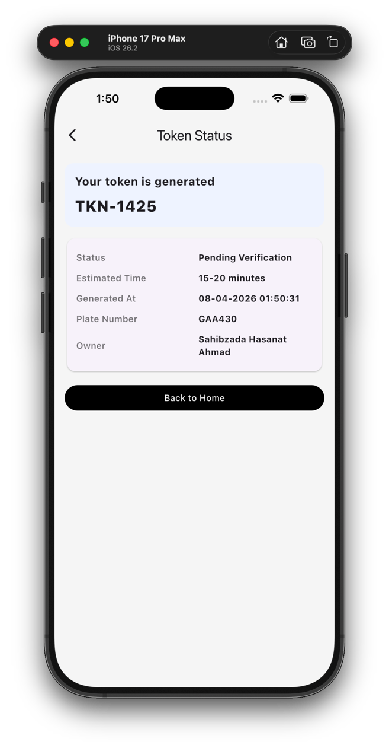

4.7 Bike Details Screen
Shows a complete summary of the registered bike and owner information pulled from BikeDetailsProvider. Displays an appropriate empty state if no bike has been registered yet.

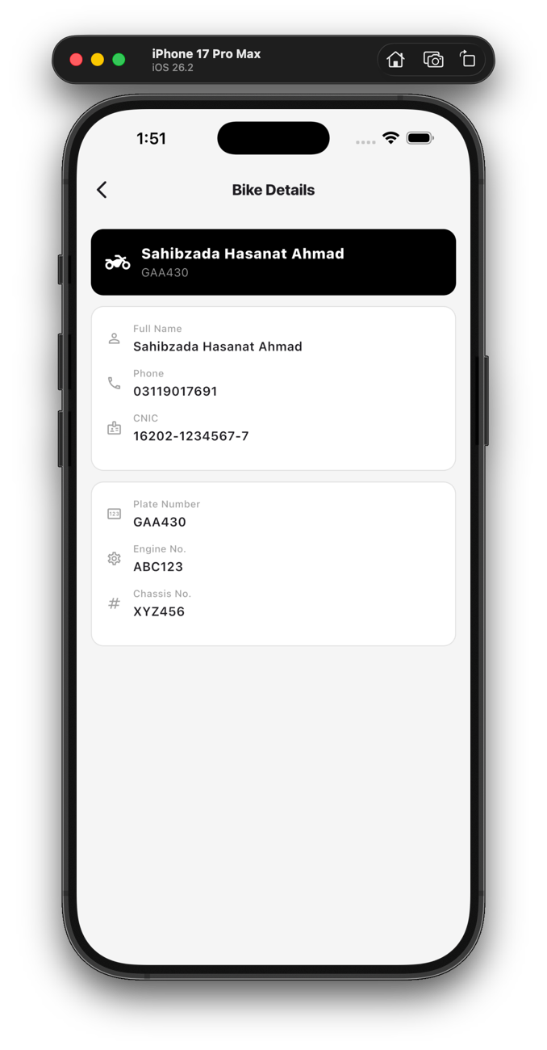

4.8 Profile Screen
Renders the currently logged-in user's account details as stored in AuthProvider. Displays name, email, CNIC, and phone number.
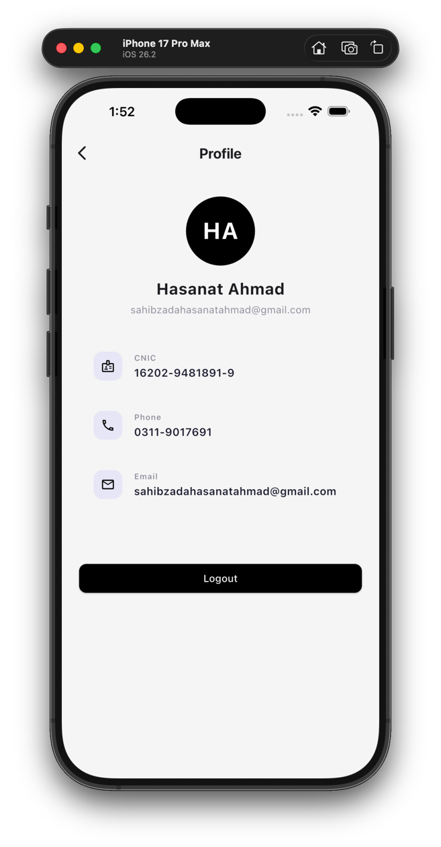

5. Data Models and Local Storage

5.1 Data Models
Both models are fully serializable via toMap/fromMap and toJson/fromJson methods for local persistence.

User | name, cnic, phoneNumber, email, password — used in auth, session, and profile display
BikeDetails | Bike and owner registration fields — stored as part of BikeDetailsProvider payload

5.2 Persistence Keys
The following keys are used in SharedPreferences for local storage:

users_v1 | JSON map of all registered users, keyed by normalized email
current_user_email | Email of the currently active session user
bike_data_<email> | Per-user bike and token data, keyed by normalized email

5.3 Multi-User Support
The app supports multiple user accounts without data collision. Each user's bike and token data is stored under a unique key derived from their email address. A legacy single-user key (user) is detected and migrated in-memory for backward compatibility.

6. Routing and Navigation
Navigation is handled via Flutter's named route system configured in lib/main.dart. The SplashScreen is set as the initial home route.

Route | Screen
/login | Login Screen
/register | Register Screen
/home | Home Screen
/profile | Profile Screen
/bike-register | Bike Register Screen
/bike-details | Bike Details Screen
/token-status | Token Status Screen

7. Known Limitations and Roadmap

7.1 Current Limitations
- No backend or API integration — all data is stored on the local device only
- Passwords are stored as plain text in local storage (prototype level)
- Splash screen does not auto-redirect based on detected active session
- Limited global error reporting and retry strategy
- No dedicated repository or service layer — providers handle persistence directly

7.2 Suggested Improvements
- Introduce secure auth storage with token-based authentication and encryption
- Add session-aware splash routing (load user and conditionally navigate)
- Implement a proper logout action that clears only in-memory user-linked state
- Move persistence logic into dedicated service and repository classes
- Wire app_theme.dart into MaterialApp for consistent global theming
- Add unit and integration tests for multi-user flows, bike/token restore, and validation
- Connect to a backend REST API for real user and bike lifecycle management

8. Project Dependencies
The following packages are declared in pubspec.yaml:

Package | Type | Purpose
flutter | Core SDK | Base Flutter framework
cupertino_icons | Runtime | iOS-style icon assets
provider | Runtime | State management (ChangeNotifier)
mask_text_input_formatter | Runtime | Input masking for CNIC, phone
shared_preferences | Runtime | Local key-value storage
flutter_test | Dev | Unit and widget testing framework
flutter_lints | Dev | Recommended linting rules

End of Document

