Program Development Test (Question 1) | [10] points
Code Objective:
[describe the coding problem here]

Bucket of Instructions: [For your help, you are given a bucket of shuffled instructions which contains only the correct instructions. You need to arrange them in the correct order on the coding canvas (shown below); and select the correct instructions order from the provided four options.]

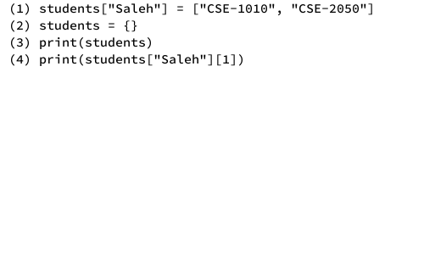

Coding Canvas:

Coding Canvas
Instructions: Write code instructions from the bucket in the correct order (top-to-bottom) in the canvas shown below. Also, write their corresponding line numbers. For example, the instruction, “(3) print(students)”, from the bucket goes like this:
3 | print(students)
Line Nos. | Code Instructions

Choose the correct instructions order from the following four options and provide your answer in the answer sheet:

- 5,7,3,8,4,2,6,1 | - 2,6,7,1,4,5,8,3 | - 7,6,2,5,3,1,8,4 | - 4,8,6,3,7,5,2,1

Blank sheet for your rough work.
Your Name: __________________________

