

PAMUKKALE ÜNİVERSİTESİ
MÜHENDİSLİK FAKÜLTESİ
ELEKTRİK-ELEKTRONİK MÜHENDİSLİĞİ

EEEN 360 FPGA İLE SAYISAL TASARIM
BÖLÜM II VİZE SINAVI

Ad: Hasan Burak
Soyad: Çiftci
No: 20247020

Diyagram:
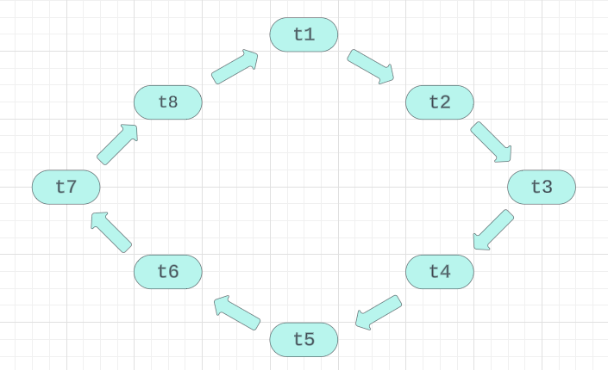
Tablo:
 |  | KI |  |  | DI |  |  | GI |  |  | BI
 | K | S | Y | K | S | Y | K | S | Y | K | S | Y
t1 | 0 | 1 | 0 | 1 | 0 | 0 | 1 | 0 | 0 | 0 | 1 | 0
t2 | 0 | 0 | 1 | 1 | 0 | 0 | 1 | 0 | 0 | 1 | 0 | 0
t3 | 0 | 1 | 0 | 0 | 1 | 0 | 1 | 0 | 0 | 1 | 0 | 0
t4 | 1 | 0 | 0 | 0 | 0 | 1 | 1 | 0 | 0 | 1 | 0 | 0
t5 | 1 | 0 | 0 | 0 | 1 | 0 | 0 | 1 | 0 | 1 | 0 | 0
t6 | 1 | 0 | 0 | 1 | 0 | 0 | 0 | 0 | 1 | 1 | 0 | 0
t7 | 1 | 0 | 0 | 1 | 0 | 0 | 0 | 1 | 0 | 0 | 1 | 0
t8 | 1 | 0 | 0 | 1 | 0 | 0 | 1 | 0 | 0 | 0 | 0 | 1

Işık Süreleri:
 |  | KI |  |  | DI |  |  | GI |  |  | BI
K S Y | 30s | 6s | 24s | 46s | 6s | 8s | 44s | 6s | 10s | 48s | 6s | 6s

VHDL Kodları:
library ieee;
use ieee.std_Logic_1164.all;
use ieee.numeric_std.all;

entity TRI is
port(
--inputs
Clk : in std_logic;
--outputs
KI : out unsigned (2 downto 0);
BI : out unsigned (2 downto 0);
DI : out unsigned (2 downto 0);
GI : out unsigned (2 downto 0));
end entity;

architecture Behavioral of TRI is

type durumlar is (t1,t2,t3,t4,t5,t6,t7,t8);
signal durum : durumlar := t1;
constant Clk_freq : integer := 12e6;
signal Cnt : integer range 0 to Clk_freq*60 := 0;

begin
process (Clk)is
begin
if rising_edge(Clk) then
KI <= "000";
DI <= "000";
GI <= "000";
BI <= "000";
Cnt <= Cnt+1;
case durum is
when t1 =>
KI <= "010";
DI <= "100";
GI <= "100";
BI <= "010";
if Cnt = Clk_freq*3-1 then
Cnt <= 0;
durum <= t2;
end if;

when t2 =>
KI <= "001";
DI <= "100";
GI <= "100";
BI <= "100";
if Cnt = Clk_freq*24-1 then
Cnt <= 0;
durum <= t3;
end if;

when t3 =>
KI <= "010";
DI <= "010";
GI <= "100";
BI <= "100";
if Cnt = Clk_freq*3-1 then
Cnt <= 0;
durum <= t4;
end if;

When t4 =>
KI <= "100";
DI <= "001";
GI <= "100";
BI <= "100";
if Cnt = Clk_freq*8-1 then
Cnt <= 0;
durum <= t5;
end if;

When t5 =>
KI <= "100";
DI <= "010";
GI <= "010";
BI <= "100";
if Cnt = Clk_freq*3-1 then
Cnt <= 0;
durum <= t6;
end if;

When t6 =>
KI <= "100";
DI <= "100";
GI <= "001";
BI <= "100";
if Cnt = Clk_freq*10-1 then
Cnt <= 0;
durum <= t7;
end if;

When t7 =>
KI <= "100";
DI <= "100";
GI <= "010";
BI <= "010";
if Cnt = Clk_freq*3-1 then
Cnt <= 0;
durum <= t8;
end if;

When t8 =>
KI <= "100";
DI <= "100";
GI <= "100";
BI <= "001";
if Cnt = Clk_freq*6-1 then
Cnt <= 0;
durum <= t1;
end if;

end case;
end if;
end process;
end architecture;

