

Faculty of Engineering

Department of Civil Engineering

2017-2018 Spring Semester

**CE 0337 Water Resources Management**

**Crashing Homework**

Prepared By  
1600006183 Tuğçe Altınkaynak

**Dr. K. Emre Can**

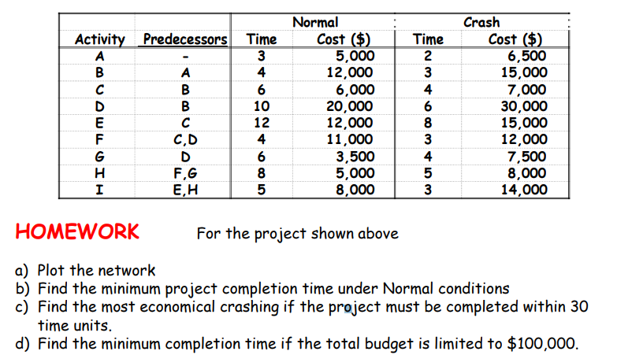

**Solution:**

**a)** Plot the network

2

1

3

5

9

A

B

C

D

E

F

G

H

I

3

4

6

10

6

8

4

0

0

5

8

6

12

4

7

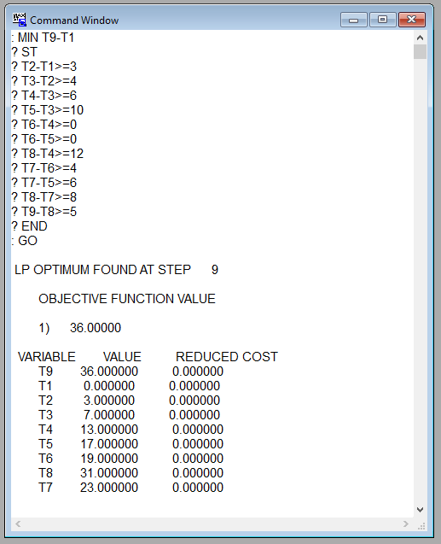**b)** Find the minimum project completion time under Normal conditions

T2-T1>=3 T2-T1=3-0=3  
 T3-T2>=4 T3-T2=7-3=4  
 T4-T3>=6 T4-T3=13-7=6  
 T5-T3>=10 T5-T3=17-7=10  
 T6-T4>=0 T6-T4=19-13=6  
 T6-T5>=0 T6-T5=19-17=2  
 T8-T4>=12 T8-T4=31-13=18  
 T7-T6>=4 T7-T6=23-19=4  
 T7-T5>=6 T7-T5=23-17=6  
 T8-T7>=8 T8-T7=31-23=8  
 T9-T8>=5 T9-T8=36-31=5

T9* = 36 time units,

Critical Path: A-B-D-G-H-I

2

1

3

5

9

A

B

C

D

E

F

G

H

I

3

4

6

10

6

8

4

0

0

5

8

6

12

4

7

: Critical path

**c)** Find the most economical crashing if the project must be completed within 30 time units.

|  |  |  |  |
| --- | --- | --- | --- |
| **Activity** | **Normal Time** | **Crash Time** | **Unit Cost of Crashing (****$)** |
| A | 3 | 2 | 1500 |
| B | 4 | 3 | 3000 |
| C | 6 | 4 | 500 |
| D | 10 | 6 | 2500 |
| E | 12 | 8 | 750 |
| F | 4 | 3 | 1000 |
| G | 6 | 4 | 2000 |
| H | 8 | 5 | 1000 |
| I | 5 | 3 | 3000 |

$$unit cost of crashing= \frac{crash cost-normal cost}{normal time-crash time}$$

Z= 500(3-TA) +3000(4-TB) +500(6-TC) +2500(10-TD) +750(12-TE) +1000(4-TF) +2000(6-TG) +1000(8-TH) +3000(5-TI)

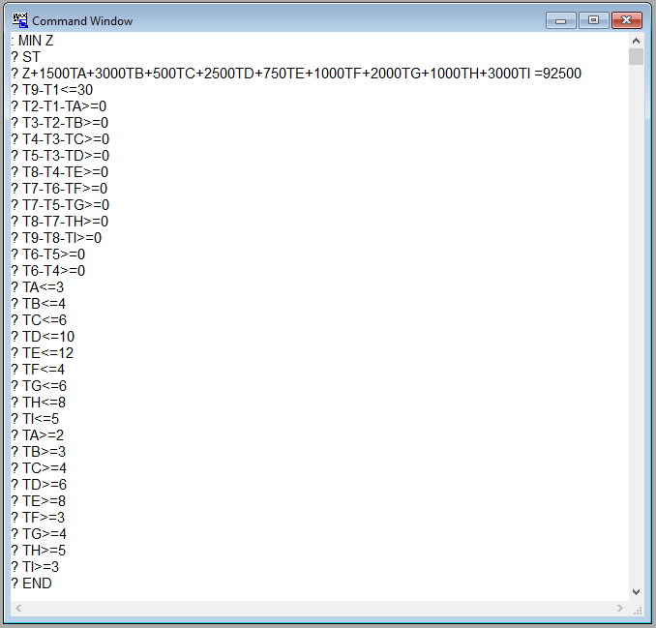

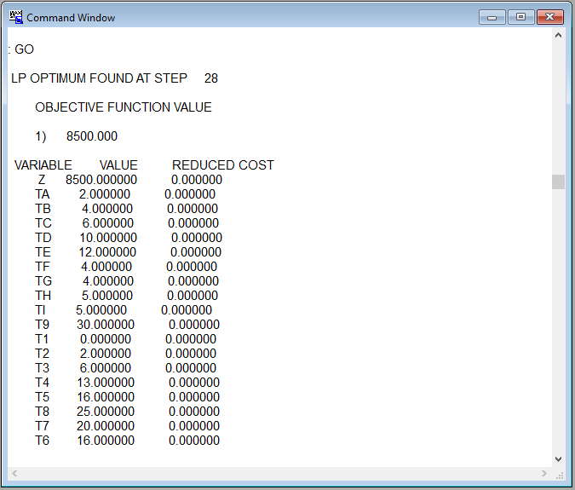

A -> 1 time unit, $1500  
G -> 2 time units, $4000 Total crashing cost= $8500  
H -> 3 time units, $3000

**d)** Find the minimum completion time if the total budget is limited to $100,000.  
  
