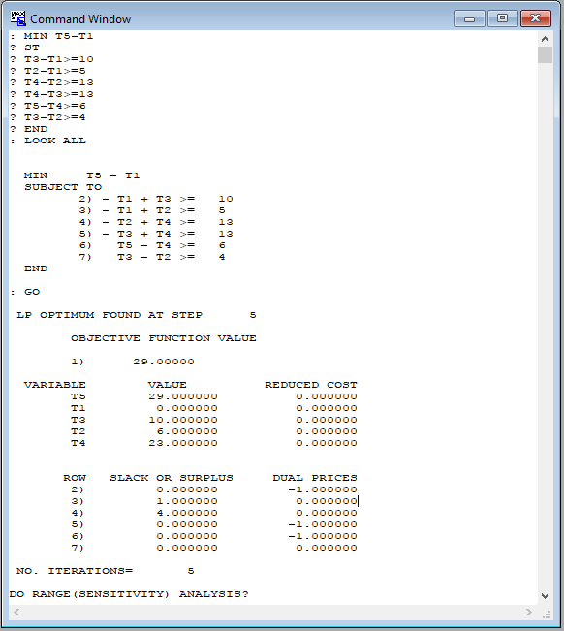

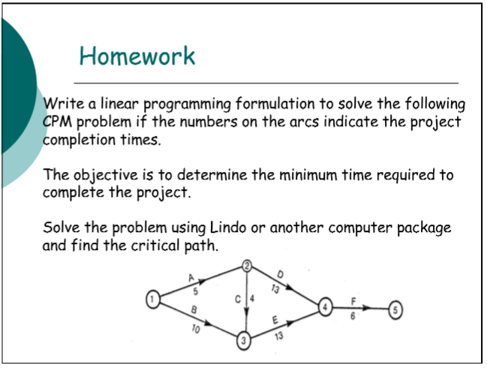

T3-T1>=10, T3-T1= 10  
 T2-T1>=5, T2-T1= 6  
 T3-T2>=4, T3-T2= 10-6= 4  
 T4-T2>=13, T4-T2= 23-6= 17  
 T4-T3>=13, T4-T3= 23-10= 13  
 T5-T4>=6, T5-T4= 29-23= 6

OPTIMAL SOLUTION:

1 🡪 3 🡪 4 🡪 5