TECH TIPS INDEX
- TIP - 1
- TIP - 2
- TIP - 3
- TIP - 4
- TIP - 5
- TIP - 6
- TIP - 7
- TIP - 8
- TIP - 9
- TIP - 10
- TIP - 11
- TIP - 12
- TIP - 13
- TIP - 14
- TIP - 15
- TIP - 16
- TIP - 17
- TIP – 18
- TIP - 19
- TIP - 20
- TIP - 21
- TIP - 22
- TIP - 23
- TIP - 24
- TIP - 25
- TIP - 26
- TIP - 27
- TIP - 28
- TIP - 29
- TIP - 30
- TIP - 31
- TIP - 32
- TIP - 33
- TIP - 34
- TIP - 35
- TIP - 36
- TIP - 37
- TIP - 38
- TIP - 39
- TIP - 40
- TIP - 41
- TIP - 42
- TIP - 43
- TIP - 44
- TIP - 45
- TIP - 46
- TIP - 47
- TIP - 48
- TIP - 49
- TIP - 50
- TIP - 51
- TIP - 52
- TIP - 53
- TIP - 54
- TIP - 55
- TIP - 56
- TIP - 57
- TIP - 58
- TIP - 59
- TIP - 60
- TIP - 61
- TIP - 62
- TIP - 63
- TIP - 64
- TIP - 65
- TIP - 66
- TIP - 67
- TIP - 68
- TIP – 69
- TIP – 70
- TIP – 71
- TIP – 72
- TIP – 73
- TIP – 74
- TIP – 75
- TIP – 76
- TIP – 77
- TIP – 78
- TIP – 79
- TIP – 80
- TIP – 81
- TIP – 82
- TIP – 83
- TIP – 84
- TIP – 85
- TIP – 86
- TIP – 87
- TIP – 88
- TIP – 89
- TIP – 90
- TIP – 91
- TIP – 92
- TIP – 93
- TIP – 94
- TIP – 95
- TIP – 96
- TIP – 97
- TIP – 98

TECH TIP FOR CA - 1 💡
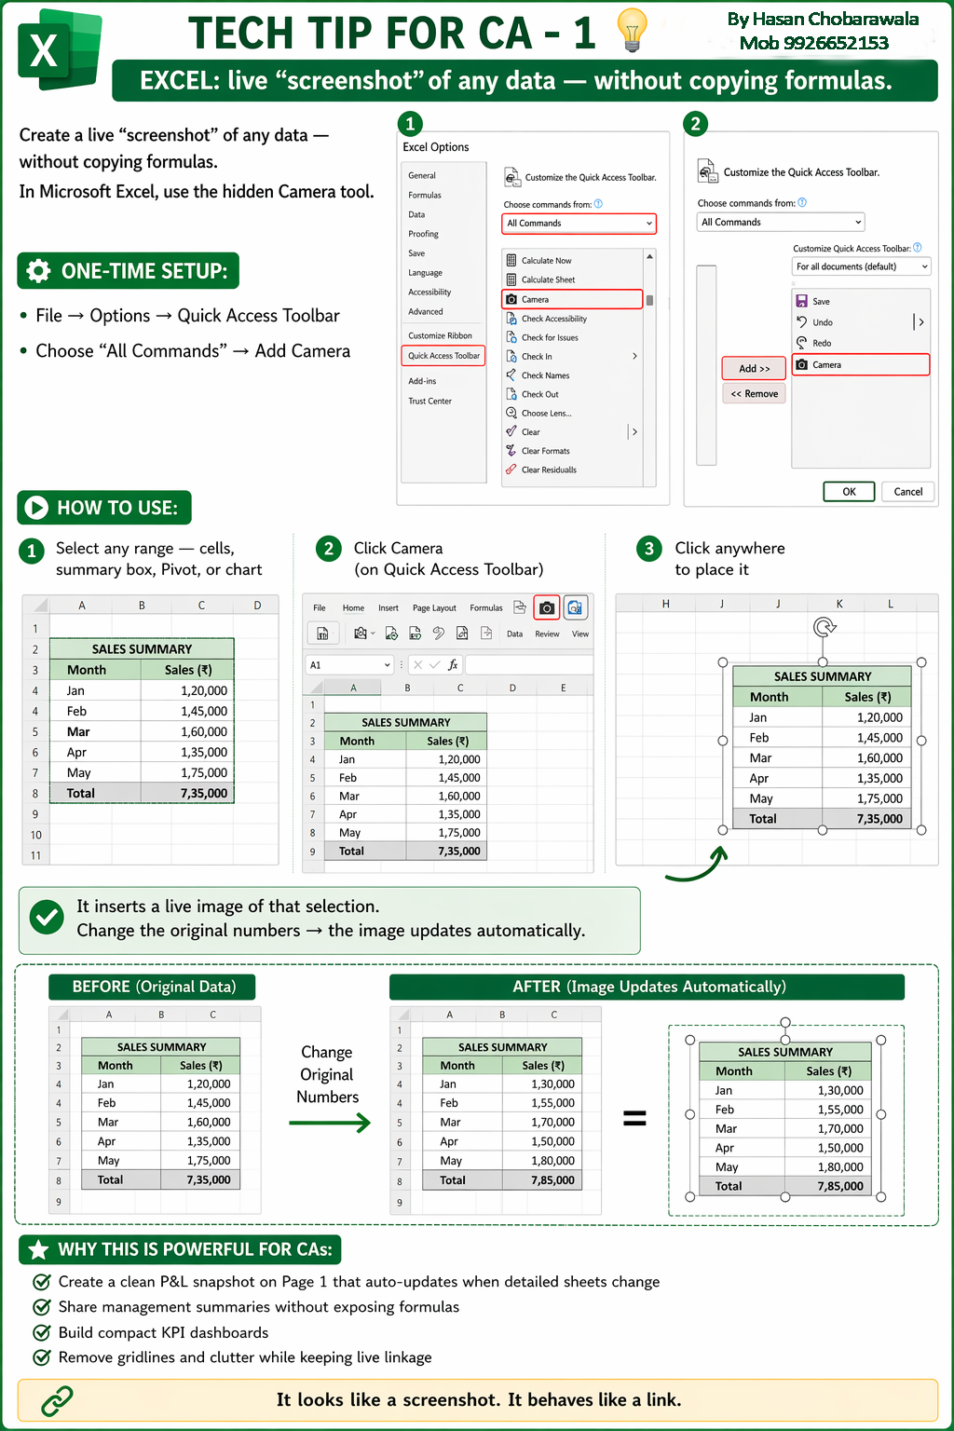
← Back to Index

TECH TIP FOR CA - 2 💡
← Back to Index

TECH TIP FOR CA - 3 💡
← Back to Index

TECH TIP FOR CA - 4 💡
← Back to Index

TECH TIP FOR CA - 5 💡
← Back to Index

TECH TIP FOR CA - 6 💡
← Back to Index

TECH TIP FOR CA - 7 💡
← Back to Index

TECH TIP FOR CA - 8 💡
← Back to Index

TECH TIP FOR CA - 9 💡
← Back to Index

TECH TIP FOR CA - 10 💡
← Back to Index

TECH TIP FOR CA - 11 💡
← Back to Index

TECH TIP FOR CA - 12 💡
← Back to Index

TECH TIP FOR CA - 13 💡
← Back to Index

TECH TIP FOR CA - 14 💡
← Back to Index

TECH TIP FOR CA - 15 💡
← Back to Index

TECH TIP FOR CA - 16 💡
← Back to Index

TECH TIP FOR CA - 17 💡
← Back to Index

TECH TIP FOR CA - 18 💡
← Back to Index

TECH TIP FOR CA - 19 💡
← Back to Index

TECH TIP FOR CA - 20 💡
← Back to Index

TECH TIP FOR CA - 21 💡
← Back to Index

TECH TIP FOR CA - 22 💡
← Back to Index

TECH TIP FOR CA - 23 💡
← Back to Index

TECH TIP FOR CA - 24 💡
← Back to Index

TECH TIP FOR CA - 25 💡
← Back to Index

TECH TIP FOR CA - 26 💡
← Back to Index

TECH TIP FOR CA - 27 💡
← Back to Index

TECH TIP FOR CA - 28 💡
← Back to Index

TECH TIP FOR CA - 29 💡
← Back to Index

TECH TIP FOR CA - 30 💡
← Back to Index

TECH TIP FOR CA - 31 💡
← Back to Index

TECH TIP FOR CA - 32 💡
← Back to Index

TECH TIP FOR CA - 33 💡
← Back to Index

TECH TIP FOR CA - 34 💡
← Back to Index

TECH TIP FOR CA - 35 💡
← Back to Index

TECH TIP FOR CA - 36 💡
← Back to Index

TECH TIP FOR CA - 37 💡
← Back to Index

TECH TIP FOR CA - 38 💡
← Back to Index

TECH TIP FOR CA - 39 💡
← Back to Index

TECH TIP FOR CA - 40 💡
← Back to Index

TECH TIP FOR CA - 41 💡
← Back to Index

TECH TIP FOR CA - 42 💡
← Back to Index

TECH TIP FOR CA - 43 💡
← Back to Index

TECH TIP FOR CA - 44 💡
← Back to Index

TECH TIP FOR CA - 45 💡
← Back to Index

TECH TIP FOR CA - 46 💡
← Back to Index

TECH TIP FOR CA - 47 💡
← Back to Index

TECH TIP FOR CA - 48 💡
← Back to Index

TECH TIP FOR CA - 49 💡
← Back to Index

TECH TIP FOR CA - 50 💡
← Back to Index

TECH TIP FOR CA - 51 💡
← Back to Index

TECH TIP FOR CA - 52 💡
← Back to Index

TECH TIP FOR CA - 53 💡
← Back to Index

TECH TIP FOR CA - 54 💡
← Back to Index

TECH TIP FOR CA - 55 💡
← Back to Index

TECH TIP FOR CA - 56 💡
← Back to Index

TECH TIP FOR CA - 57 💡
← Back to Index

TECH TIP FOR CA - 58 💡
← Back to Index

TECH TIP FOR CA - 59 💡
← Back to Index

TECH TIP FOR CA - 60 💡
← Back to Index

TECH TIP FOR CA - 61 💡
← Back to Index

TECH TIP FOR CA - 62 💡
← Back to Index

TECH TIP FOR CA - 63 💡
← Back to Index

TECH TIP FOR CA - 64 💡
← Back to Index

TECH TIP FOR CA - 65 💡
← Back to Index

TECH TIP FOR CA - 66 💡
← Back to Index

TECH TIP FOR CA - 67 💡
← Back to Index

TECH TIP FOR CA - 68 💡
← Back to Index

TECH TIP FOR CA - 69 💡
← Back to Index

